TRADEMARK REGISTRABILITY ASSESSMENT
Jurvanta
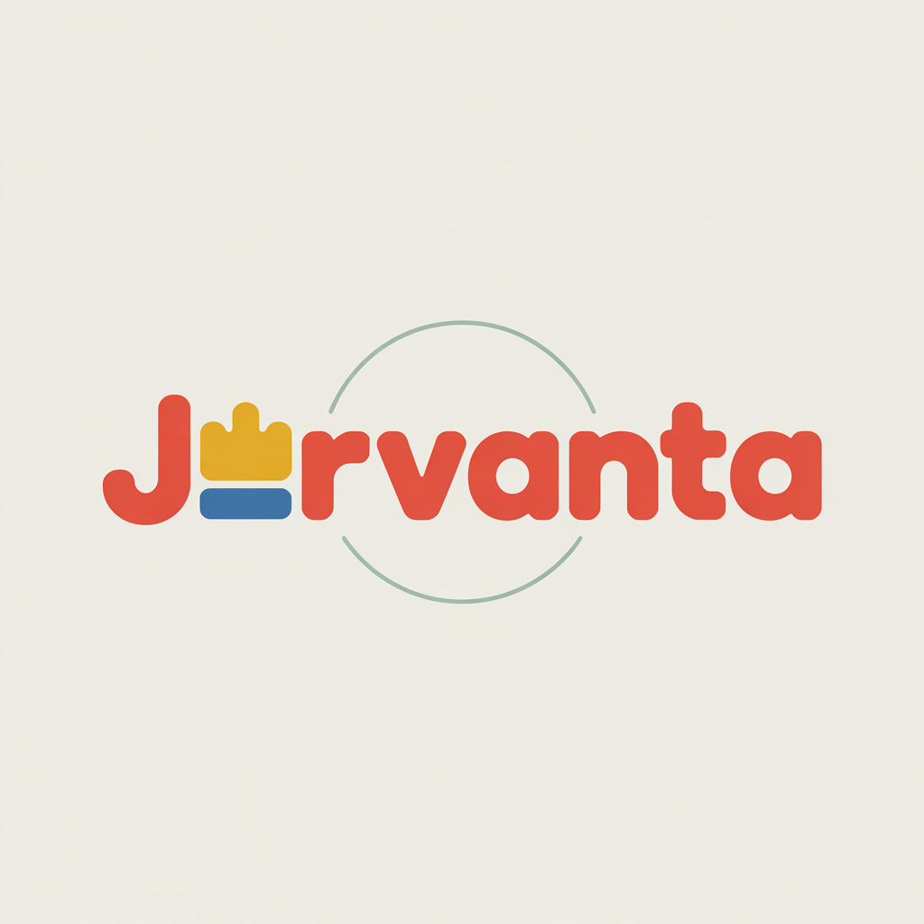
GB • NICE Classes: 28 • July 07, 2026
Trademark register — data as of: July 05, 2026 · United Kingdom — app 2026-07-05 / reg 2026-03-27 (pending + registered); WIPO — app 2026-07-02 / reg 2026-06-25 (pending + registered)
Applicant origin: Portugal
Practical Outlook
Registration Outlook:
Clear
No similar earlier trademarks and no problems under absolute grounds. The name has a strong chance of registration in the requested classes as-is.
Summary:
Your name is clear to register for toys in Class 28. The invented word "Jurvanta" has no descriptive or offensive issues, and its distinctive multi-color crown logo gives it a strong, unique commercial impression. The earlier UK toy marks "Gevanti" and "FURVANTI" only share a common "-vanti/-vanta" ending, but their different beginnings and your unique combined logo make confusion unlikely. "JUXTA" is entirely different and poses no concern. Overall this is a strong application with a good chance of proceeding smoothly.
What to do before filing:
1. File the composite "Jurvanta" mark with its distinctive multi-color crown logo to secure the strongest protection.
2. Retain evidence of the logo and word-beginning differences in case any earlier owner raises an informal query.
3. Specify the Class 28 goods to reflect the actual toys produced to keep the registration clean.

Per-Class Assessment

ⓘ | How registration works: The trademark office examines each class separately. If they find a similar mark in any class, they will send a provisional refusal. This is a normal part of the process and you can respond with arguments about why your services are different.
Class | Status | Prov. Refusal Chance | Success Chance | Key Obstacle
28 | No obstacles | — | 85% | The Class 28 marks "Gevanti" and "FURVANTI" share the common "-VANTI/-VANTA" ending, but this is a weak point of similar...

Detailed Analysis

Mark Analysis
Mark Type: | COMPOSITE
Distinctiveness Category: | FANCIFUL
Distinctiveness Scale
Generic | Descriptive | Suggestive | Arbitrary | Fanciful
← Weak | Strong →

ⓘ | • Generic: Common name for the goods/services category  • Descriptive: Immediately describes goods, services, or characteristics  • Suggestive: Hints at qualities but requires imagination to connect  • Arbitrary: Real word completely unrelated to the goods  • Fanciful: Invented word with no dictionary meaning
Reasoning:
"Jurvanta" is an invented, coined word with no dictionary meaning in English and no descriptive connection to toys. The logo presents the word in a rounded, playful multi-color typeface with a small crown-like device replacing part of a letter and a thin circular arc behind it, reinforcing its distinctive commercial impression. As a coined term applied to toys, it functions as a fanciful mark with strong inherent distinctiveness.

Assessment Summary
"Jurvanta" has a strong registrability outlook as a coined, fanciful mark presented in a distinctive multi-color logo, so it faces no absolute-grounds concerns for toys in Class 28. On the relative side, the earlier UK marks "Gevanti" and "FURVANTI" share only the weak, common "-VANTI/-VANTA" suffix, and the clearly different word beginnings combined with the unique composite crown logo make confusion unlikely. "JUXTA" is wholly different and poses no threat. Because the UK does not refuse on earlier marks ex officio, and the mark is easily distinguishable, the path to registration is clear. This is a low-risk filing with a high probability of success.
Registration Probability: 85%

Recommendations
• [DESIGN_ELEMENT] File and consistently use the current composite logo with the crown device and multi-color typeface — to reinforce the mark's distinctive commercial impression — expected impact: strengthen protection and differentiation from the cited word marks.
• [GOODS_SCOPE] Specify the Class 28 goods to the actual toy subcategories produced — to keep the registration precise — expected impact: a clean, well-defined registration.
• [FILING] Proceed with the application without material changes to the mark — given the low conflict risk — expected impact: efficient path to registration.
• [MONITORING] Monitor the register for the cited "-VANTI/-VANTA" marks after filing — to be ready should any owner raise a query — expected impact: preparedness with minimal disruption.

ⓘ | Absolute grounds are inherent registrability criteria examined by the trademark office independently of any existing marks. These are legal requirements that every trademark must satisfy on its own merits.

Absolute Grounds Assessment
Overall Absolute Risk: N/A
Ground | Risk Level | Reason
Inherent Distinctiveness  Whether the mark is distinctive enough to identify the source of goods/services | No Risk Identified | -
Deceptive/Misleading  Whether the mark could mislead consumers about the nature or quality of goods | No Risk Identified | -
Public Order Morality  Whether the mark contains content contrary to public order or accepted moral principles | No Risk Identified | -
Prohibited Elements  Whether the mark includes state emblems, flags, official symbols or other prohibited elements | No Risk Identified | -
Geographic Indications  Whether the mark contains protected geographic indications or misleading geographic terms | No Risk Identified | -
Linguistic/Cultural  Whether the mark has negative or problematic meanings in local languages or cultures | No Risk Identified | -
Personality Rights  Whether the mark infringes on another person's name, image, or identity rights | No Risk Identified | -
Well-Known Marks  Whether the mark conflicts with well-known marks that enjoy broader protection | No Risk Identified | -

ⓘ | Relative grounds assess potential conflicts with existing registered or pending marks. An examiner or third party may oppose your trademark if it is confusingly similar to a prior mark in the same or related goods/services.

Relative Grounds Assessment
Overall Relative Risk: LOW
Analysis Notes: None of the cited marks poses a meaningful conflict. "Gevanti" and "FURVANTI" share only the weak, common "-VANTI/-VANTA" suffix, while the clearly different word beginnings and the distinctive multi-color crown logo of "Jurvanta" set it apart. "JUXTA" is wholly dissimilar. Goods overlap was inferred from NICE class 28 as no goods_services text was provided.
Similar Marks Analysis:
Vis — Visual | Phon — Phonetic | Conc — Conceptual | Goods — Goods and services Overlap
Mark | Class | Vis | Phon | Conc | Goods | Risk
Gevanti | 7, 28 | LOW | LOW | N/A | IDENTICAL | LOW
Although both marks are coined words ending in "-VANTA"/"-VANTI" in the Class 28 toy sector, the shared suffix is a weak point of similarity and the marks differ clearly in their opening syllables ("Jur-" vs "Ge-") and overall impression. Combined with the distinctive multi-color crown logo of "Jurvanta", the marks are readily distinguishable and confusion is unlikely. Both being fanciful, conceptual comparison does not apply.
TMView: GB500000918197908
FURVANTI | 28 | LOW | LOW | N/A | IDENTICAL | LOW
"FURVANTI" shares only the common "-VANTI"/"-VANTA" suffix with "Jurvanta", while the distinct openings ("Fur-" vs "Jur-") and differing final vowels set the marks apart. The distinctive composite logo of "Jurvanta" further reduces any likelihood of confusion in the Class 28 toy field. Both marks are coined, so conceptual comparison is not applicable.
TMView: GB500000004396464
JUXTA | 28 | LOW | LOW | N/A | IDENTICAL | LOW
"JUXTA" shares only the initial "J" with "Jurvanta" but differs greatly in length, structure and sound. Despite the shared Class 28 toy sector, the marks are readily distinguishable and pose no meaningful confusion risk.
TMView: GB500000914731707

Assumptions and Limitations
Assumptions:
• ASSUMPTION: The Class 28 goods scope for both the target and the cited marks was inferred from the NICE class as no specific goods/services text was provided. | WHY: BUSINESS_DESCRIPTION was only "Toys production" and cited marks had empty goods_services. | IMPACT: affects goods_overlap and conflict_risk for cited marks "Gevanti" and "FURVANTI".
• ASSUMPTION: The crown-like device in the logo is a purely decorative stylization and not a representation of the Royal Crown. | WHY: The image shows a small stylized geometric crown shape used as a letter element, not a heraldic Royal Crown. | IMPACT: affects prohibited_elements risk_level (kept null).
Limitations:
• LIMITATION: The business description "Toys production" is broad and does not specify the exact toy subcategories. | CONSEQUENCE: goods_overlap and conflict_risk for the Class 28 cited marks may be over- or understated, affecting per_class_assessment. | WHAT WOULD REDUCE IT: Provide a specific description of your goods/services.

