TRADEMARK REGISTRABILITY ASSESSMENT
HELVETIA VAULT

CH • NICE Classes: 9, 36, 42 • July 07, 2026
Trademark register — data as of: July 03, 2026 · Switzerland — app 2026-07-03 / reg 2026-07-03 (registered only); WIPO — app 2026-07-01 / reg 2026-06-22 (pending + registered)
Applicant origin: Portugal
Practical Outlook
Registration Outlook:
Critical
An identical or near-identical earlier mark in the same field, or a strong absolute-grounds problem (e.g. descriptiveness). Filing the name as-is is very likely to fail — consider a different name or a substantial change.
Summary:
Filing HELVETIA VAULT in Switzerland as-is is very unlikely to succeed, and the problem starts with the name itself. 'Helvetia' is the official Latin name for Switzerland, and Swiss law only lets companies actually based in Switzerland use it — since your company is in Portugal, the trademark office will almost certainly reject the application as misleading about where your services come from. On top of that, 'Helvetia' is the brand name of one of Switzerland's largest insurance groups, which owns registrations covering exactly your services — financial services, payment processing, wallet-style software — in all three of your classes, and they would very likely oppose your application even if it got past the examiner. All three classes face the same core problems, so there is no 'safe' class to fall back on. The realistic options are to pick a new distinctive name (you could keep 'Vault'), or to establish a genuine Swiss base and negotiate with the Helvetia group — but simply filing this name from Portugal is close to a guaranteed rejection.
What to do before filing:
1. Replace 'Helvetia' with a distinctive invented name to remove both the Swiss-origin problem and the clash with the Helvetia insurance group's marks.
2. Redesign the shield logo to avoid a national coat-of-arms look, so the new brand doesn't raise the same Swiss-symbol concerns.
3. Narrow your Class 9 and 42 descriptions to digital-wallet software specifically, to reduce overlap with the broad software coverage of the existing 'helvetia' registrations.
4. Explore a consent or coexistence agreement with the Helvetia insurance group only if keeping a 'Helvetia'-style name is truly essential — and note this still won't fix the origin problem for a Portuguese company.

Per-Class Assessment

ⓘ | How registration works: The trademark office examines each class separately. If they find a similar mark in any class, they will send a provisional refusal. This is a normal part of the process and you can respond with arguments about why your services are different.
Class | Status | Prov. Refusal Chance | Success Chance | Key Obstacle
9 | Serious risk | 85% | 25% | The word 'HELVETIA' is a protected Swiss designation that a Portugal-based company cannot legitimately use, and the iden...
36 | Serious risk | 88% | 20% | Class 36 is the worst class: the Swiss-origin objection applies with full force to financial services (where Swiss origi...
42 | Serious risk | 85% | 25% | The Swiss-origin objection to 'HELVETIA' applies to technology services as well, and the 'helvetia' house mark plus 'HEL...

ⓘ | Estimated Timeline: Swiss trademark examination typically takes around 3–6 months for straightforward cases; here, an origin-related objection and a likely opposition after publication could extend the process to 12–24 months or more, most likely ending in refusal if filed unchanged.

Detailed Analysis

Mark Analysis
Mark Type: | COMPOSITE
Distinctiveness Category: | SUGGESTIVE
Distinctiveness Scale
Generic | Descriptive | Suggestive | Arbitrary | Fanciful
← Weak | Strong →

ⓘ | • Generic: Common name for the goods/services category  • Descriptive: Immediately describes goods, services, or characteristics  • Suggestive: Hints at qualities but requires imagination to connect  • Arbitrary: Real word completely unrelated to the goods  • Fanciful: Invented word with no dictionary meaning
Reasoning:
The mark combines 'HELVETIA' — the Latin national personification and protected designation of Switzerland — with 'VAULT', an English word that hints at security and safekeeping of money or digital assets, a quality of financial and wallet services requiring a small mental step. The shield/coat-of-arms device with a mountain motif reinforces the Swiss national symbolism. Both word components are weak: 'HELVETIA' is a geographic/national designation and 'VAULT' is a laudatory-suggestive security term widely used in fintech; the combination therefore sits at the low end of suggestive, and the weak-component rule raises the inherent distinctiveness floor. The composite shield element adds some visual distinctiveness but does not neutralize the Swissness issue attached to 'HELVETIA'.

Assessment Summary
The prospects for registering HELVETIA VAULT in Switzerland for a Portugal-based fintech are very poor. The primary absolute obstacle is that 'HELVETIA' is the protected national designation of Switzerland: under the MSchG and Swissness rules, a service provider without its seat and administration in Switzerland cannot use it, making refusal for misleading geographic origin and prohibited national designation highly likely, and the shield device in the logo reinforces the national-emblem impression. On relative grounds, the register is dominated by the Helvetia insurance group's family of marks — the identical house mark 'helvetia' covers identical software, financial and SaaS services across all three filed classes and constitutes the primary blocking citation, with 'Helvetica' (internet banking and software) and 'HELVETIA' (insurance and connected financial transactions) as additional blocking citations for Class 36. All three classes (9, 36 and 42) face HIGH combined risk, with Class 36 the weakest because Swiss origin is most material to financial services. The crowded 'HELVETIA' field does not help here, because the shared element is itself the problem: it is both a protected designation and the house mark of a single major rights holder rather than a diluted descriptive term. The realistic path forward is to replace 'HELVETIA' with a distinctive coined element while optionally retaining 'VAULT', or to establish genuine Swiss domicile and seek consent from the Helvetia group — otherwise filing as-is is very unlikely to succeed.
Registration Probability: 23%

Recommendations
• [MARK_MODIFICATION] Consider replacing 'HELVETIA' with a distinctive coined element (keeping 'VAULT' if desired) — to remove the misleading Swiss-origin claim driving the prohibited_elements, geographic_indications and deceptive_misleading objections, and to break the near-identity with the 'helvetia' house mark — expected impact: eliminates the dominant refusal grounds and the primary blocking citation.
• [FILING_STRATEGY] Consider that the crowded-field defense is unavailable here: the shared element 'HELVETIA' is a protected national designation and the house mark of the Helvetia insurance group, so the distinctive burden falls entirely on 'VAULT', which is itself weak for wallet services — a genuinely distinctive replacement element must be addressed on its own merits — expected impact: refocuses branding on an element that can actually carry registration.
• [COEXISTENCE] If retaining any 'Helvetia'-formative element is essential, consider seeking written consent or a coexistence arrangement with the Helvetia insurance group, whose 'helvetia', 'HELVETIA BANK' and 'HELVETIA BALOISE' registrations cover identical Class 9/36/42 services — to neutralize the most likely opposition sources — expected impact: reduces relative-grounds exposure, though it does not cure the Swissness objection for a non-Swiss applicant.
• [GOODS_SCOPE] Consider drafting the Class 9 and 42 specifications narrowly around digital-wallet software and its operation rather than broad software headings — to reduce overlap with the broad software/SaaS coverage of 'helvetia' and 'HELVETIA BANK' — expected impact: marginally improves differentiation arguments in opposition, though it does not resolve the geographic-origin objection.
• [DISTINCTIVENESS] Consider strengthening the replacement mark with the existing shield-and-mountain device redesigned to avoid coat-of-arms and Swiss-cross connotations — to avoid the national-emblem impression while keeping a security-themed visual identity — expected impact: supports overall distinctiveness without triggering prohibited-elements scrutiny.

ⓘ | Absolute grounds are inherent registrability criteria examined by the trademark office independently of any existing marks. These are legal requirements that every trademark must satisfy on its own merits.

Absolute Grounds Assessment
Overall Absolute Risk: HIGH
Ground | Risk Level | Reason
Inherent Distinctiveness  Whether the mark is distinctive enough to identify the source of goods/services | LOW | Both components are individually weak: 'HELVETIA' is a national/geographic designation and 'VAULT' is a common suggestive term for secure storage in finance. The combination with the shield device is likely distinctive enough overall, but the mark's scope of protection would be narrow.
Deceptive/Misleading  Whether the mark could mislead consumers about the nature or quality of goods | HIGH | The applicant is domiciled in Portugal (PT), while 'HELVETIA' together with a heraldic shield unmistakably signals Swiss origin to consumers in all Swiss languages. Under the MSchG and the Swissness legislation, use of a Swiss designation for services requires that the provider's seat and actual administration be in Switzerland; a non-Swiss applicant therefore faces a serious deceptiveness objection (misleading indication of source) under MSchG Art. 2(c) and Art. 47 et seq.
Public Order Morality  Whether the mark contains content contrary to public order or accepted moral principles | No Risk Identified | -
Prohibited Elements  Whether the mark includes state emblems, flags, official symbols or other prohibited elements | HIGH | 'HELVETIA' is the Latin name and national personification of Switzerland, protected under the Swiss indications-of-source regime, and the logo's shield device evokes a national coat-of-arms style emblem. For a Portuguese applicant, the IGE/IPI will treat the Swiss designation as inadmissible for services not originating in Switzerland, making a refusal on this ground highly likely.
Geographic Indications  Whether the mark contains protected geographic indications or misleading geographic terms | HIGH | 'HELVETIA' is directly understood in German, French, Italian and Romansh-speaking Switzerland as designating Switzerland itself; financial services are strongly associated with Swiss origin (Swiss banking reputation). The mark therefore conveys a clear geographic origin claim that the applicant, domiciled in Portugal, cannot substantiate.
Linguistic/Cultural  Whether the mark has negative or problematic meanings in local languages or cultures | MEDIUM | Checked in German, French, Italian, Romansh and English: 'HELVETIA' reads identically in all Swiss languages as the national name of Switzerland — this national/geographic reading, uniform across languages, drives the MEDIUM level. 'VAULT' is an English term widely understood in Swiss financial circles as denoting secure storage, giving the mark a descriptive flavor for wallet services; no offensive or negative connotation exists in any language.
Personality Rights  Whether the mark infringes on another person's name, image, or identity rights | No Risk Identified | -
Well-Known Marks  Whether the mark conflicts with well-known marks that enjoy broader protection | No Risk Identified | -

ⓘ | Relative grounds assess potential conflicts with existing registered or pending marks. An examiner or third party may oppose your trademark if it is confusingly similar to a prior mark in the same or related goods/services.

Relative Grounds Assessment
Overall Relative Risk: HIGH
Analysis Notes: The Swiss register is heavily crowded with 'HELVETIA'-formative marks, but the crowd is dominated by the Helvetia insurance group's own family of marks covering identical Class 36/9/42 services. The highest risks come from the house marks 'helvetia' (Classes 9, 28, 35, 36, 38, 41, 42, 45), 'HELVETIA BANK' and 'HELVETIA BALOISE', all covering identical financial, software and technology services; goods_overlap was assessed on the actual goods/services texts provided.
Similar Marks Analysis:
Vis — Visual | Phon — Phonetic | Conc — Conceptual | Goods — Goods and services Overlap
Mark | Class | Vis | Phon | Conc | Goods | Risk
  helvetia iSave | 36 | MEDIUM | MEDIUM | MEDIUM | ✓ | MEDIUM
Shares the dominant first element 'helvetia'; the composite logo shows 'helvetia' with a colored triangle device plus 'iSave'. Its specification is limited to life insurance, which is related but not identical to financial/wallet services. The shared leading element combined with related Class 36 services creates a moderate opposition risk from the Helvetia insurance group.
TMView: CH502012000056494
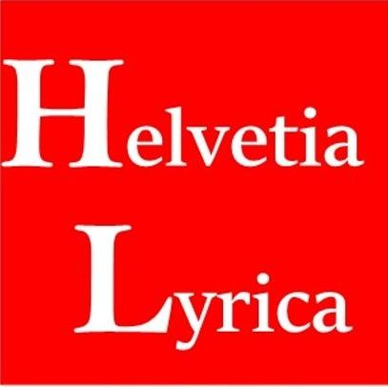  Helvetia Lyrica | 9, 41, 45 | MEDIUM | MEDIUM | MEDIUM | ✓ | MEDIUM
Shares the dominant 'Helvetia' element and covers Class 9, though its actual specification focuses on music-related media and software alongside broad Class 9 headings that overlap with wallet software. The music-oriented scope reduces but does not remove proximity in Class 9.
TMView: CH502021000019144
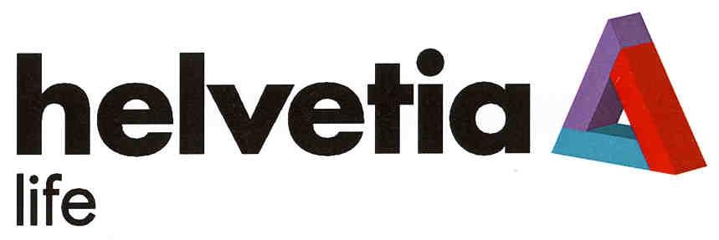  helvetia life | 36 | MEDIUM | MEDIUM | MEDIUM | IDENTICAL | HIGH
Same 'helvetia + weak suffix' structure; its Class 36 specification expressly covers insurance and financial/monetary affairs, effectively identical in scope to the target's financial services. Two MEDIUM similarity dimensions with identical services yield a high conflict risk.
TMView: CH502006000001988
  HELVETIA PATRIA | 12, 35, 25, 36, 16, 28, 18, 8, 42 | MEDIUM | MEDIUM | MEDIUM | IDENTICAL | HIGH
Shares the dominant 'HELVETIA' element and covers 'Finanzwesen; Geldgeschäfte' in Class 36 and data-processing services in Class 42, identical/near-identical to the target scope. Structure (HELVETIA + second word) is parallel, raising confusion risk with identical services.
TMView: CH501994000009282
HELVETIA BANK | 9, 28, 35, 36, 38, 41, 42, 45 | MEDIUM | MEDIUM | HIGH | IDENTICAL | HIGH
Identical structure ('HELVETIA' + finance-related noun) with a nearly identical concept — a Swiss financial institution/safekeeping. Its specification covers computer software (Class 9), financial and banking services (Class 36) and SaaS/software development (Class 42), identical to the target's scope across all three filed classes. This is a strong potential opposition source.
TMView: CH502026000002061
HELVETIA BALOISE | 14, 15, 16, 18, 20, 21, 22, 23, 24, 25, 26, 27, 34, 36, 39, 41 | MEDIUM | MEDIUM | MEDIUM | IDENTICAL | HIGH
Shares the dominant 'HELVETIA' element; Class 36 specification expressly covers financial services, banking services and monetary affairs, identical to the target's financial/wallet services. The additional element 'BALOISE' differs but the common leading house element drives association risk.
TMView: CH502025000005750
HELVETIA BALOISE | 9, 28, 35, 36, 38, 41, 42, 45 | MEDIUM | MEDIUM | MEDIUM | IDENTICAL | HIGH
Same shared 'HELVETIA' element; this registration covers computer software (Class 9), the full range of financial and banking services (Class 36) and SaaS/software services (Class 42) — identical to all three target classes. High opposition exposure from the merged Helvetia/Baloise insurance group.
TMView: CH502025000005752
HELVETIA BALOISE | 3, 5, 10, 36, 41, 44 | MEDIUM | MEDIUM | MEDIUM | IDENTICAL | HIGH
Another registration of the same house mark; its Class 36 specification again covers financial and banking services identical to the target's core services, so the same high conflict assessment applies for Class 36.
TMView: CH502025000005751
  SONIC HELVETIA | 42, 44 | LOW | LOW | MEDIUM | ✓ | LOW
'HELVETIA' appears in second position after the distinctive 'SONIC', changing the overall impression. Its Class 42 services are scientific/laboratory-oriented with software design mentioned generically; only weak proximity to the target's Class 42 scope, so conflict risk is low.
TMView: CH502024000003588
SONIC HELVETIA | 42, 44 | LOW | LOW | MEDIUM | ✓ | LOW
Duplicate registration of the same laboratory-focused mark; same low-risk assessment as the parallel 'SONIC HELVETIA' entry — different word order, different service focus.
TMView: CH502024000003581
SONIC HELVETIA | 42 | LOW | LOW | MEDIUM | ✓ | LOW
Class 42 only, focused on scientific/laboratory analysis with generic computer-design wording; the inverted word order and distinctive 'SONIC' element keep confusion risk low.
TMView: CH502023000003968
SONIC HELVETIA | 42 | LOW | LOW | MEDIUM | ✓ | LOW
Duplicate of the Class 42 'SONIC HELVETIA' registration; same low conflict assessment.
TMView: CH502023000003970
HELVETIA BALOISE | 1, 2, 4, 6, 7, 8, 11, 12, 13, 17, 19, 36, 37, 40, 42 | MEDIUM | MEDIUM | MEDIUM | IDENTICAL | HIGH
Further registration of the house mark covering financial/banking services in Class 36 and software design/development in Class 42, identical to the target's scope in those classes. Same high-risk conclusion as the other 'HELVETIA BALOISE' registrations.
TMView: CH502025000005748
HELVETIA BALOISE | 29, 30, 31, 32, 33, 36, 43 | MEDIUM | MEDIUM | MEDIUM | IDENTICAL | HIGH
Class 36 specification again covers identical financial and banking services; the shared 'HELVETIA' house element with identical services sustains a high conflict risk for Class 36.
TMView: CH502025000005749
  Tentamus Helvetia | 42 | LOW | LOW | MEDIUM | ✓ | LOW
'Helvetia' is in secondary position beneath the distinctive dominant element 'Tentamus' (confirmed by the logo). Class 42 covers scientific/technological services and software development of Swiss origin — related to the target's Class 42, but the different dominant element keeps risk low.
TMView: CH502018000079176
Helvetia Value Trend | 36 | MEDIUM | MEDIUM | MEDIUM | IDENTICAL | HIGH
Same 'Helvetia + descriptive tail' structure; Class 36 specification covers financial services, monetary transactions and banking — identical to the target's financial/wallet services. Two MEDIUM dimensions with identical services yield high risk.
TMView: CH502022000002975
  HelvetiaCom | 9, 36, 38, 42 | MEDIUM | MEDIUM | MEDIUM | IDENTICAL | HIGH
Shares the full 'Helvetia' element; its actual specifications include hardware wallets for cryptocurrencies (Class 9) and electronic payment processing (Class 36) — squarely identical to an online-wallet business. This is one of the closest conflicts on actual goods/services scope.
TMView: CH502025000003604
Helvetic Rise | 9, 28, 35, 36, 41, 42 | MEDIUM | MEDIUM | MEDIUM | IDENTICAL | HIGH
'Helvetic' is nearly identical to 'Helvetia' visually and phonetically in the leading position; specifications cover software (Class 9), finance and monetary affairs (Class 36) and software development (Class 42), identical to the target's scope. Multiple medium similarities with identical services produce a high conflict risk.
TMView: CH502020000010318
Helvetium | 36 | MEDIUM | MEDIUM | MEDIUM | IDENTICAL | HIGH
Single-word variant sharing the 'Helveti-' stem; Class 36 covers financial services, monetary transactions and banking services identical to the target's core scope, producing a high conflict risk in Class 36.
TMView: CH502022000014317
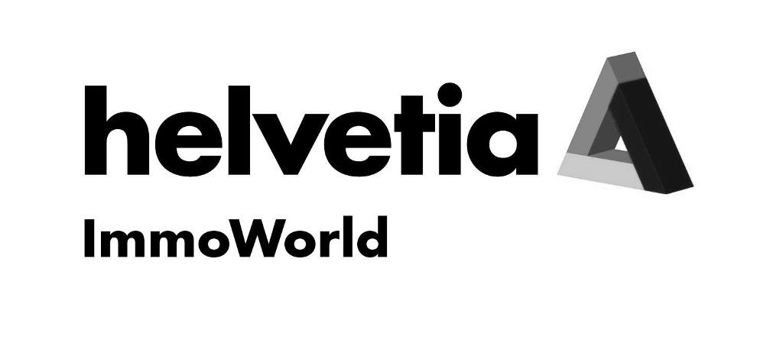  helvetia ImmoWorld | 16, 35, 36, 37, 42, 45 | MEDIUM | MEDIUM | MEDIUM | IDENTICAL | HIGH
Same 'helvetia + suffix' structure with the same triangle device as the Helvetia insurance house marks; its extremely broad Class 36 specification expressly includes online financial transactions, payment-related and crypto staking services, identical to the target's wallet/financial scope, plus financial software rental in Class 42.
TMView: CH502021000009163
HELVETICA | 16, 9, 42 | MEDIUM | MEDIUM | MEDIUM | ✗ | LOW
'HELVETICA' differs by one letter but its actual goods/services are strictly limited to typeface/font software and font-generation services — a different commercial sector from financial wallet software. Recordals show a provisional refusal (2024) later overcome by a statement of grant of protection (2025), so the mark IS protected in Switzerland; nonetheless the unrelated goods keep conflict risk low.
TMView: WO500000001752855
HELVETICA | 9, 16 | MEDIUM | MEDIUM | MEDIUM | ✗ | LOW
Specification is limited to typefaces and font designs stored on media — unrelated to financial services and wallet software, so despite name proximity the conflict risk is low.
TMView: CH502009000051603
  Helvetica | 36 | HIGH | HIGH | HIGH | IDENTICAL | HIGH
Differs from 'HELVETIA' in the target by only one letter and covers insurance, financial affairs, fiduciary matters, monetary affairs and wealth management in Class 36 — effectively identical services. This is a potential blocking citation for Class 36 due to near-identity of the dominant element combined with identical services.
TMView: CH502013000059332
HELVETICA | 9, 16 | MEDIUM | MEDIUM | MEDIUM | ✗ | LOW
Covers letters, characters and digitally stored fonts — the typography sector, unrelated to financial/wallet services; conflict risk is low despite the similar name.
TMView: CH501988000006506
  Helvetica | 9, 35, 36, 38 | HIGH | HIGH | HIGH | IDENTICAL | HIGH
One-letter difference from the target's dominant element, and its specifications cover computer software and mobile applications (Class 9) plus internet banking, credit cards and computerized financial services (Class 36) — identical to an online-wallet offering. This mark represents a potential blocking citation across the target's core classes; the stylized logo differs but the word element dominates.
TMView: CH502020000005176
Helvetia Smart Trend | 36 | MEDIUM | MEDIUM | MEDIUM | IDENTICAL | HIGH
Same 'Helvetia + English tail' pattern; Class 36 covers financial services, monetary transactions and banking identical to the target's scope, so high conflict risk applies in Class 36.
TMView: CH502023000008898
HELVETIA | 42 | HIGH | HIGH | HIGH | ✗ | LOW
Identical to the target's dominant element, but the specification is limited to insurance-linked outpatient clinics — a medical service unrelated to wallet technology services, keeping conflict risk low despite mark identity.
TMView: CH501995000008974
HELVETIA | 36, 16, 9, 41, 42 | HIGH | HIGH | HIGH | ✓ | HIGH
Identical dominant word; covers insurance (Class 36) plus data carriers and computer programs in the health/insurance field (Class 9). Insurance is closely related to financial services, and the identical word element with related services makes this a high conflict risk.
TMView: CH501995000005885
  helvetia | 9 | HIGH | HIGH | HIGH | ✗ | LOW
Identical word but the old specification covers only records, tape cassettes and compact discs of Swiss origin — sound carriers unrelated to wallet software, so conflict risk is low.
TMView: CH501987000007483
  Helvetia | 36, 41, 42 | HIGH | HIGH | HIGH | ✓ | HIGH
Identical dominant word covering insurance (Class 36) and data-processing program creation (Class 42). Insurance and programming services are related to the target's financial services and technology scope; identical word plus related services yields high risk.
TMView: CH501995000005886
  Helvetia | 42 | HIGH | HIGH | HIGH | ✗ | LOW
Identical word but limited to clinics, hospitals and healthcare services — unrelated to the target's software/fintech Class 42 scope, so risk remains low.
TMView: CH501995000008975
HELVETIA | 36 | HIGH | HIGH | HIGH | IDENTICAL | HIGH
Identical to the target's dominant element and covers insurance together with connected financial, monetary and real-estate transactions in Class 36 — identical services. This is a potential blocking citation for Class 36: near-identity across all similarity dimensions with identical services.
TMView: CH501995000002418
HELVETIA | 9, 42 | HIGH | HIGH | HIGH | ✓ | HIGH
Identical dominant word covering downloadable software and chatbot software (Class 9) and online software provision and software R&D (Class 42). Although oriented to e-government/AI, the broad software wording is related — arguably overlapping — with the target's wallet app and technology services, so risk is high in Classes 9 and 42.
TMView: CH502024000004008
  helvetia | 9, 28, 35, 36, 38, 41, 42, 45 | HIGH | HIGH | HIGH | IDENTICAL | HIGH
The Helvetia insurance group's modern house mark: identical word, and its specifications cover computer software and mobile apps (Class 9), the full range of financial and banking services (Class 36) and SaaS/software development (Class 42) — identical to every target class. This is the primary blocking citation: near-identity across all dimensions with identical goods and services.
TMView: CH502026000002058
HelvetIKS | 9, 36 | MEDIUM | MEDIUM | MEDIUM | IDENTICAL | HIGH
Shares the 'Helveti-' stem; covers business-process software (Class 9) and 'Finanzwesen' (Class 36) — identical to the target's financial scope. Medium similarity on multiple dimensions with identical services produces high risk.
TMView: CH502016000053279
  HELVETICK | 36, 9, 42 | MEDIUM | MEDIUM | MEDIUM | IDENTICAL | HIGH
Close variant of the 'Helveti-' stem; its specifications cover financial, monetary and banking services (Class 36), software and data-processing apparatus (Class 9) and software design (Class 42) — identical to all three target classes, so conflict risk is high.
TMView: CH502024000010832
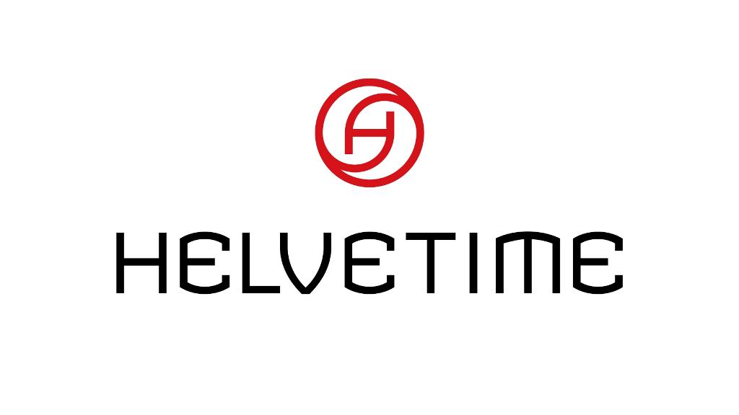  HELVETIME | 14, 9 | MEDIUM | MEDIUM | MEDIUM | ✓ | MEDIUM
Shares the 'Helveti-' stem; Class 9 broad heading includes software and data-processing devices, related to the target's wallet software, though the mark's evident focus (with Class 14) is watches. Moderate risk limited to Class 9.
TMView: CH502024000013326
HELVETING | 35, 42, 45 | MEDIUM | MEDIUM | MEDIUM | ✓ | MEDIUM
Shares the 'Helvet-' stem; its Class 42 services cover software development for engineering purposes, related to the target's Class 42 technology services though focused on a different (engineering) sector. Moderate risk confined to Class 42.
TMView: CH502006000061607
  HelvetiGo | 9, 35, 39, 42 | MEDIUM | MEDIUM | MEDIUM | ✓ | MEDIUM
Shares the 'Helveti-' stem with a 'Go' suffix and a transport-oriented logo; Class 9 (software, recorded media) and Class 42 (software design) headings are related to the target's scope even though the business focus appears to be mobility. Moderate risk in Classes 9 and 42.
TMView: CH502026000005549
BVLGARI VAULT | 9, 38, 42 | LOW | LOW | MEDIUM | N/A | LOW
Shares only the weak/suggestive tail 'VAULT'; the dominant element 'BVLGARI' is entirely different. No goods/services text is available and Classes 9/42 headings alone cannot confirm proximity to wallet software, so overlap cannot be reliably assessed; given the different dominant element, risk is low in any event.
TMView: CH502015000052787

Assumptions and Limitations
Assumptions:
• ASSUMPTION: The target's goods/services scope was taken as digital-wallet and financial-payment software (Class 9), financial and electronic-wallet services (Class 36) and related SaaS/software development (Class 42), based on the business description 'Financial service and online wallet'. | WHY: The description is brief and the exact specification wording was not provided. | IMPACT: Affects goods_overlap and conflict_risk for cited marks such as 'helvetia', 'HelvetiaCom' and 'Helvetica', and the per_class_assessment probabilities.
• ASSUMPTION: The applicant's services will not have their seat and actual administration in Switzerland, based on the stated Portuguese (PT) domicile. | WHY: Swiss indications-of-source rules for services turn on the provider's seat and administration; only the domicile code was given. | IMPACT: Drives deceptive_misleading, prohibited_elements and geographic_indications at HIGH; if the applicant established a genuine Swiss seat, these grounds and the overall verdict would improve materially.
• ASSUMPTION: 'BVLGARI VAULT' has no goods/services text, so its scope could not be confirmed against the target's wallet software. | WHY: The goods_services field for that mark is empty and Classes 9/38/42 headings alone are too broad. | IMPACT: goods_overlap was set to null and conflict_risk to LOW for 'BVLGARI VAULT'.
Limitations:
None specified.

