MULTI-COUNTRY TRADEMARK ASSESSMENT
Bardak
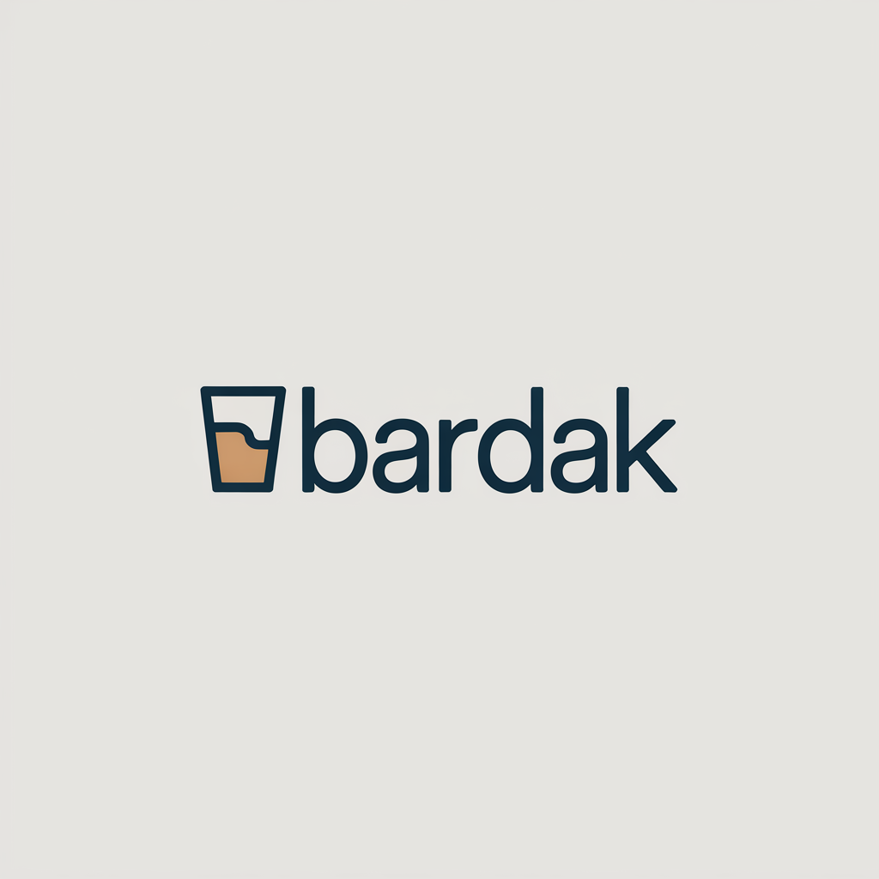
NICE Classes: 21, 35 • July 30, 2026

Bundle overview
15 of 15 countries assessed
Country | Registration Outlook | Absolute grounds | Relative grounds | High-risk classes
Canada | Clear | LOW | LOW | —
Switzerland | Fixable | LOW | MEDIUM | 21
Czechia | Fixable | LOW | MEDIUM | 21
Germany | Fixable | LOW | MEDIUM | 21
Spain | Fixable | LOW | MEDIUM | 21
France | Fixable | LOW | MEDIUM | 21
Croatia | Fixable | LOW | MEDIUM | 21
Netherlands | Fixable | LOW | HIGH | 21, 35
Poland | Fixable | LOW | MEDIUM | 21
Slovakia | Fixable | LOW | MEDIUM | 21, 35
United States | Fixable | LOW | No Risk Identified | 21
Australia | At Risk | LOW | HIGH | 21
United Kingdom | At Risk | LOW | HIGH | 21, 35
Italy | At Risk | LOW | HIGH | 21, 35
Türkiye | Critical | HIGH | MEDIUM | 21, 35
Contents
• Switzerland
• Netherlands
• United Kingdom
• Australia
• Croatia
• Italy
• France
• Germany
• United States
• Türkiye
• Czechia
• Spain
• Poland
• Slovakia
• Canada

Switzerland
TRADEMARK REGISTRABILITY ASSESSMENT
Bardak
CH • NICE Classes: 21, 35 • July 30, 2026
Trademark register — data as of: July 27, 2026 · Switzerland — app 2026-07-27 / reg 2026-07-24 (pending + registered); WIPO — app 2026-07-23 / reg 2026-06-22 (pending + registered)
Applicant origin: Portugal
Practical Outlook
Registration Outlook:
Fixable
The name can likely be registered, but something needs attention first — narrowing or changing the goods/services classes, adding a disclaimer, or adjusting an element of the mark. The name itself stays.
Summary:
Yes, "bardak" looks registrable in Switzerland, but it is worth tightening your goods and services wording before you file. The word means nothing in German, French, Italian or English, so the Swiss examiner has little reason to object to it, and the small glass symbol in your logo adds a further point of difference. Your main watch-out is an older Swiss mark called "bandar", registered for household brushware, cleaning cloths and similar items in the same class as your drinkware; the two names share a similar shape and rhythm. That is manageable, because Switzerland does not raise earlier marks against you on its own initiative, so the only real scenario is that the "bandar" owner objects after your mark is published, and their products are not bottles or mugs. Your Class 35 retail side looks clean, since the earlier Class 35 marks found cover food retail, advertising and business consultancy rather than drinkware retail.
What to do before filing:
1. Narrow your Class 21 list to bottles, vacuum flasks, thermos mugs, drinking vessels and drinkware, avoiding brushware, cleaning cloths and household cleaning items, so that it stays clearly apart from what "bandar" covers.
2. Specify your Class 35 services as retail and wholesale, including online, of bottles, thermos mugs and drinkware instead of using the broad class heading, which keeps you away from the food-retail and advertising services of "bajak" and "BARSAT".
3. File the mark in the composite form shown in your logo, with the glass device and the rounded lettering, so the overall look adds a further layer of difference from "bandar" and "BRITTEX".
4. Prepare a short note comparing your drinkware to the brushware and cleaning articles covered by "bandar", ready to use if that owner objects after publication.

Per-Class Assessment

ⓘ | How registration works: The trademark office examines each class separately. If they find a similar mark in any class, they will send a provisional refusal. This is a normal part of the process and you can respond with arguments about why your services are different.
Class | Status | Prov. Refusal Chance | Success Chance | Key Obstacle
21 | Provisional refusal possible | 45% | 72% | The earlier Swiss mark "bandar" covers household and cleaning articles in the same class and looks and sounds moderately like "bardak".
35 | No obstacles | — | 80% | Several earlier marks such as "bajak" and "BARSAT" also sit in Class 35, but their listed services (food and beverage retail, advertising, business management) are in different commercial fields from retail of your own drinkware.

Detailed Analysis

Mark Analysis
Mark Type: | COMPOSITE
Distinctiveness Category: | ARBITRARY
Distinctiveness Scale
Generic | Descriptive | Suggestive | Arbitrary | Fanciful
← Weak | Strong →

ⓘ | • Generic: Common name for the goods/services category  • Descriptive: Immediately describes goods, services, or characteristics  • Suggestive: Hints at qualities but requires imagination to connect  • Arbitrary: Real word completely unrelated to the goods  • Fanciful: Invented word with no dictionary meaning
Reasoning:
The logo combines the word "bardak" in a clean rounded lowercase typeface with a small stylized drinking-glass device partially filled with an amber liquid. For consumers in Switzerland, whose relevant languages are German, French, Italian, Romansh and English, "bardak" has no dictionary meaning and functions as an invented-looking, arbitrary sign; it is neither descriptive of nor laudatory for bottles, thermos mugs and drinkware, nor for retail services relating to them. The word is the dominant element; the small glass device is figurative reinforcement that is somewhat allusive to drinkware but too small and stylized to be decisive on its own. In Turkish "bardak" means "glass/tumbler", which would be descriptive for Class 21 drinkware, but Turkish is not an official or widely-used language of Switzerland, so this does not affect the Swiss reading; the same category applies to both filed classes.

Assessment Summary
The prospects for registering the composite "bardak" logo in Switzerland are good overall. On absolute grounds the mark is essentially clean: "bardak" has no descriptive, laudatory or geographic meaning in German, French, Italian, Romansh or English, and the only mildly weak feature is the small glass device that alludes to the goods without dominating the sign. On earlier rights, no cited mark comes close to identity; the closest is "bandar", which shares the "ba…d…a" structure and is registered for household brushware and cleaning articles in Class 21, followed at a distance by "bajak" and "BRITTEX". Class 35 is effectively clear because the Class 35 services of the cited marks lie in unrelated sectors such as food retail, advertising and business consultancy, while Class 21 carries the concentrated risk. Mitigating factors are that Switzerland does not examine earlier-mark conflicts on its own initiative, that the goods actually covered by "bandar" do not include drinkware, and that the figurative elements of the two signs are entirely different. The practical path is to keep the Class 21 and Class 35 wording tightly tied to bottles, thermos mugs and drinkware, and to keep the glass device in the filed representation to reinforce the visual difference.
Registration Probability: 76%

Recommendations
No specific recommendations.

ⓘ | Absolute grounds are inherent registrability criteria examined by the trademark office independently of any existing marks. These are legal requirements that every trademark must satisfy on its own merits.

Absolute Grounds Assessment
Overall Absolute Risk: LOW
Ground | Risk Level | Reason
Inherent Distinctiveness  Whether the mark is distinctive enough to identify the source of goods/services | LOW | For the Swiss public the word "bardak" has no descriptive meaning for drinkware or retail services, so the mark is inherently distinctive under the Swiss Trade Mark Protection Act. A minor residual point is the small glass device, which alludes directly to the goods and is therefore a weak figurative component; it does not undermine the distinctiveness of the dominant word element.
Deceptive/Misleading  Whether the mark could mislead consumers about the nature or quality of goods | No Risk Identified | -
Public Order Morality  Whether the mark contains content contrary to public order or accepted moral principles | No Risk Identified | -
Prohibited Elements  Whether the mark includes state emblems, flags, official symbols or other prohibited elements | No Risk Identified | -
Geographic Indications  Whether the mark contains protected geographic indications or misleading geographic terms | No Risk Identified | -
Linguistic/Cultural  Whether the mark has negative or problematic meanings in local languages or cultures | No Risk Identified | -
Personality Rights  Whether the mark infringes on another person's name, image, or identity rights | No Risk Identified | -
Well-Known Marks  Whether the mark conflicts with well-known marks that enjoy broader protection | No Risk Identified | -

ⓘ | Relative grounds assess potential conflicts with existing registered or pending marks. An examiner or third party may oppose your trademark if it is confusingly similar to a prior mark in the same or related goods/services.

Relative Grounds Assessment
Overall Relative Risk: MEDIUM
Analysis Notes: The cited landscape is dominated by marks that merely share the letters "BA" or the prefix "BAR" with the target, and almost all of them cover unrelated sectors (fashion, cosmetics, business services, construction, vehicle parts, cleaning textiles). The only cited sign that combines moderate visual and phonetic proximity with a Class 21 household-goods scope is "bandar", which drives the overall MEDIUM level; "bajak" and "BRITTEX" remain low. Goods overlap was determined from the actual goods and services texts supplied for every cited mark, and the relevant public is general consumers of bottles, mugs and drinkware (plus retail buyers), exercising an average degree of attention.
Similar Marks Analysis:
Vis — Visual | Phon — Phonetic | Conc — Conceptual | Goods — Goods and services Overlap
Mark | Class | Vis | Phon | Conc | Goods | Risk
bajak | 30, 35, 36 | MEDIUM | MEDIUM | N/A | ✗ | LOW
"bajak" and "bardak" share the opening "ba" and closing "ak" and have a similar rhythm, giving moderate visual and phonetic proximity, but the middle consonant cluster "rd" versus "j" is clearly audible. The cited registration covers coffee products (Class 30), retail of food and beverages and tea/coffee/cocoa (Class 35) and financial services (Class 36); the target covers drinkware in Class 21 and retail of its own drinkware in Class 35, which are different commercial sectors, so there is no meaningful goods proximity. Both marks are meaningless coinages for the Swiss public, so no conceptual comparison applies.
TMView: CH502015000057356
  BARSAT | 9, 16, 35, 38, 41, 42 | LOW | MEDIUM | N/A | ✗ | LOW
The shared element is only the prefix "BAR"; the endings "-dak" and "-sat" differ visually and the two-syllable rhythm creates no more than moderate aural proximity. The cited mark's Class 35 scope is advertising, business management, office functions and recruitment, which is a different commercial sector from retail of drinkware, and its other classes (media, telecoms, education, various services) are unrelated to Class 21 goods. The cited mark is presented as a red-and-black two-tone logo, further separating the overall impressions.
TMView: WO500000000710707
  bandar | 1, 3, 18, 20, 21, 24, 25, 28 | MEDIUM | MEDIUM | N/A | ✓ | MEDIUM
"bandar" and "bardak" both begin with "ba" and contain "a-d-a" with the letters r, d, a in common, producing moderate visual and aural similarity, although the endings ("-dar" versus "-dak") and the reversed position of the r/d differ. The cited mark's registered scope in Class 21 is brushware, cleaning cloths and special clothes pegs plus household textiles and body-care goods, so it does not cover drinkware, but it sits in the same household-goods field and is therefore related rather than identical. Its distinctive triangular device further separates the overall impressions, and the relevant public buying household and drinkware articles exercises average attention, so risk stays at a moderate level.
TMView: CH501992000006452
BAIDAS | 3, 21, 44 | MEDIUM | LOW | N/A | ✗ | LOW
The marks share the letters B, A, D, A and a similar length, but "BAIDAS" is pronounced with a diphthong and ends in a sibilant, which is clearly distinguishable in normal speech from "bardak". The cited Class 21 scope is limited to cosmetic brushes, cosmetic implements and make-up removal devices, and its other classes cover cosmetics and beauty care services, which are a different commercial sector from bottles, thermos mugs and drinkware. No conceptual comparison applies since both signs are meaningless in Swiss languages.
TMView: CH502021000017096
  braddock | 3, 9, 14, 18, 25, 35 | LOW | LOW | N/A | ✗ | N/A
"braddock" is a two-syllable surname-like word beginning with the cluster "br" and ending in "-ock", which differs clearly from "bardak" in both spelling and sound. Its goods are cosmetics, eyewear, jewellery, leather goods and clothing plus retail of those goods, with no drinkware. In addition, the registry records a total provisional refusal of protection in Switzerland confirmed in November 2018 with no later grant, so this mark is not protected there and poses no practical obstacle.
TMView: WO500000001349964
BRADDOCK | 25, 35 | LOW | LOW | N/A | ✗ | N/A
The word differs from "bardak" in structure (initial "br" cluster, doubled "d", ending "-ock") and in sound. This registration is protected in Switzerland following a statement of grant of protection in July 2020, but its scope is clothing and footwear plus retail and wholesale of fashion, cosmetics and related goods; the passing reference to household utensils in a long retail list does not create a meaningful commercial connection to a drinkware producer. There is therefore no realistic likelihood of confusion.
TMView: WO500000001480712
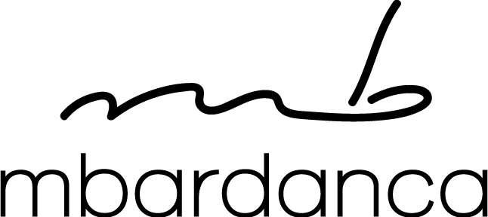  mbardanca | 18, 20, 25, 35, 40 | LOW | LOW | N/A | ✗ | N/A
Although "mbardanca" contains the letter string "bard", it is a three-syllable word beginning with the unusual "mb" cluster and ending in "-anca", so the overall visual and aural impressions differ markedly from the short two-syllable "bardak". Its registered scope is pet clothing, bags, dog beds, clothing, retail of clothing and accessories and knitting/dyeing services, none of which relates to drinkware. Its handwritten monogram device further distinguishes the overall impression.
TMView: CH502020000009615
BALINTAWAK | 35, 41, 44 | LOW | LOW | N/A | ✗ | N/A
"BALINTAWAK" is a long four-syllable word sharing only the initial "BA" and a final "-AK" with the target; the overall length and rhythm are very different. Its services are business and franchise consultancy, martial-arts education and therapy services, which have no commercial connection with drinkware or retail of drinkware. No meaningful conflict arises.
TMView: CH502014000057441
SARDA BANDA | 35, 39, 41 | LOW | LOW | N/A | ✗ | N/A
This is a two-word sign whose components differ from "bardak" in beginning, length and rhythm; the shared letters are incidental. Its Class 35 services are business information, market research, advertising and travel-sector referencing, and its other classes cover travel and cultural services, all far removed from drinkware or retail of drinkware. No meaningful conflict arises.
TMView: WO501000000828605
SARDA BANDA | 35, 39, 41 | LOW | LOW | N/A | ✗ | N/A
This parallel English-language filing of the same two-word sign is equally distant from "bardak" visually and aurally. The services are business information, advertising, travel organisation and education/entertainment, which do not touch drinkware or its retail. A partial provisional refusal is recorded for Switzerland, so its protection there is in any event limited; either way there is no conflict.
TMView: WO500000001875964
BRITTEX | 21 | LOW | LOW | N/A | ✓ | LOW
Beyond the initial letter B the marks differ throughout: "BRITTEX" has an initial "br" cluster, a doubled t and a hard "-tex" ending, so it is clearly distinguishable both on paper and in speech. The registered goods are synthetic cloth material for cleaning and polishing purposes, which sits in the same Class 21 household field as drinkware but is a different product category. With low similarity on all dimensions the conflict risk remains low.
TMView: CH501987000002161
BARTOKONZEPT | 6, 7, 9, 19, 35, 37, 40, 42, 44 | LOW | LOW | N/A | ✗ | N/A
"BARTOKONZEPT" is a long compound sign sharing only the opening "BAR"; its length and the descriptive German suffix "KONZEPT" give a completely different overall impression from the short word "bardak". It is protected in Switzerland since May 2018, but its scope covers gates, fences, barriers, drive mechanisms, control systems and related construction and gardening services, with Class 35 retail limited to fencing and building products. There is no commercial connection to drinkware.
TMView: WO500000001350190
  PARTECH VENTURES | 35, 36, 38, 41, 42 | N/A | N/A | N/A | ✗ | N/A
The sign consists of two words with a globe device and shares no meaningful letter sequence or sound with "bardak". Its services are business consultancy, venture-capital investment, telecoms information, conferences and technical evaluations, which are entirely unconnected with drinkware or its retail. No conflict arises.
TMView: WO500000001302034
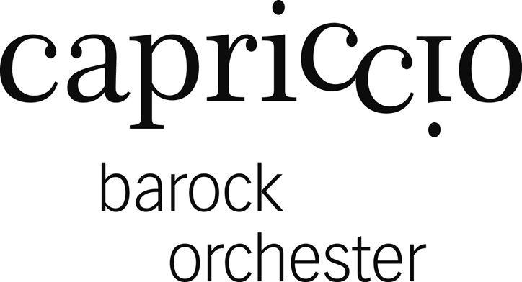  capriccio barock orchester | 9, 35, 41 | LOW | LOW | N/A | ✗ | N/A
The dominant element of this three-word sign is "capriccio" in a serif display face; the word "barock" is a secondary descriptive musical term that is only faintly reminiscent of "bardak" and, in any event, this is a non-dominant component. The registered scope is apparatus and instruments in Class 9, advertising and business administration in Class 35 and education, entertainment and cultural activities in Class 41, with no drinkware or drinkware retail. No conflict arises.
TMView: CH502010000051392
PROTEX | 21, 37, 39 | N/A | N/A | N/A | ✓ | N/A
"PROTEX" shares no letter sequence or syllable structure with "bardak" and the two signs are impossible to confuse aurally or visually. Its Class 21 goods are cleaning cloths, which lie in the same broad household class as drinkware, but with no sign similarity there is no likelihood of confusion. The mark is protected in Switzerland since March 2011, which does not alter this conclusion.
TMView: WO500000001030207
PROTEX | 1, 2, 3, 4, 5, 8, 9, 10, 11, 13, 14, 16, 17, 18, 19, 21, 22, 24 | N/A | N/A | N/A | ✓ | N/A
This broad older registration is verbally and visually remote from "bardak"; there is no shared prefix, suffix or rhythm. Its Class 21 entry covers sponges and brush-making materials rather than drinkware, and despite the wide class list no similarity of signs exists, so confusion is not plausible.
TMView: WO500000000244250
ProtectedPlanet | 9, 16, 35, 41, 42 | N/A | N/A | N/A | ✗ | N/A
The sign is a two-word English compound with a clear conservation meaning and bears no visual or aural resemblance to "bardak". Its Class 35 services are database management and business advice relating to environmental conservation, a different commercial sector from retail of drinkware, and its other classes cover publications, software and conservation-related services. No conflict arises.
TMView: WO500000001197584
PROTEXAMED | 3, 5, 21, 35 | N/A | N/A | N/A | ✓ | N/A
"PROTEXAMED" is a long four-syllable coinage with no letters or sounds in common with "bardak" beyond incidental vowels. Its Class 21 goods are toothbrushes and dental floss and its Class 35 services are retail of oral- and body-care products, which fall in the same broad household class but a clearly different product field. With no similarity of signs there is no conflict, notwithstanding its Swiss protection granted in October 2018.
TMView: WO500000001379256
  PROTECHNIC | 11, 12, 35 | N/A | N/A | N/A | ✗ | N/A
The sign consists of the laudatory prefix "PRO" and "TECHNIC" in a technical logo style and shares nothing meaningful with "bardak". Its goods and services concern vehicle lighting and braking components and the bringing together of those goods for sale, which have no connection with drinkware or drinkware retail. No conflict arises.
TMView: WO500000000900866

Assumptions and Limitations
Assumptions:
• ASSUMPTION: The Class 35 services were treated as retail and wholesale of the applicant's own drinkware products rather than general advertising or business-management services. | WHY: The business description mentions only production of bottles, thermos mugs and drinkware and does not spell out the service scope. | IMPACT: affects goods_overlap and conflict_risk for cited marks such as "bajak", "BARSAT" and "BRADDOCK", and the relative_risk and probabilities in per_class_assessment for class 35.
• ASSUMPTION: The Swiss public is assumed to read "bardak" as a meaningless coined word, since Turkish is not an official or widely-used language in Switzerland. | WHY: The word is a common noun meaning "glass/tumbler" in Turkish, which would be descriptive for drinkware if that language were relevant to the target public. | IMPACT: affects distinctiveness_category, inherent_distinctiveness.risk_level and linguistic_cultural.risk_level.
Limitations:
None specified.

Netherlands
TRADEMARK REGISTRABILITY ASSESSMENT
Bardak
NL • NICE Classes: 21, 35 • July 30, 2026
Trademark register — data as of: July 28, 2026 · BOIP — app 2026-07-28 / reg 2026-07-28 (registered only); EUIPO — app 2026-07-29 / reg 2026-07-03 (pending + registered); WIPO — app 2026-07-27 / reg 2026-06-25 (pending + registered)
Applicant origin: Portugal
Practical Outlook
Registration Outlook:
Fixable
The name can likely be registered, but something needs attention first — narrowing or changing the goods/services classes, adding a disclaimer, or adjusting an element of the mark. The name itself stays.
Summary:
Yes, your name can most likely be registered, but you should tighten your goods and services list before filing. The main challenge is "BARDAA", registered for kitchen cutting boards in the same class as your drinkware and differing from your name by a single letter, plus a family of "BARDANI" registrations that already covers household and kitchen containers and glassware. These are overcomable: the Dutch and Benelux office will not refuse your application because of them — a problem only arises if those owners actively object after your mark is published — and you have solid arguments, since you sell bottles and thermos mugs, your logo carries a distinctive glass symbol, and the name endings sound different. Your Class 35 side looks more comfortable, especially if you describe your services as retail of drinkware rather than leaving them broad. The name itself raises no real problem in Dutch, where "bardak" has no meaning and reads as an invented brand.
What to do before filing:
1. Narrow your Class 21 list to bottles, thermos mugs, drinking vessels and insulated containers, so it no longer collides with the broad household-utensils wording held by the BARDANI marks.
2. Rewrite your Class 35 services as retail and online retail of drinkware and insulated containers, to move away from the advertising and marketing services covered by BARDAF!.
3. File the logo exactly as designed, with the drinking-glass symbol and the navy rounded lettering, to add visual distance from the script-B BARDANI logos.
4. Prepare a short coexistence proposal for the owners of BARDAA and BARDANI in case they object, explaining that you sell drinkware while they sell cutting boards and general kitchen goods.

Per-Class Assessment

ⓘ | How registration works: The trademark office examines each class separately. If they find a similar mark in any class, they will send a provisional refusal. This is a normal part of the process and you can respond with arguments about why your services are different.
Class | Status | Prov. Refusal Chance | Success Chance | Key Obstacle
21 | Provisional refusal possible | 55% | 60% | "BARDAA" for kitchen cutting boards is only one letter away from your name in the same class, and the "BARDANI" family already covers household and kitchen containers and glassware.
35 | Provisional refusal possible | 45% | 72% | "BARDAF!" covers advertising and marketing consultancy in Class 35, and several other BAR- marks hold broad retail wording in the same class.

ⓘ | Estimated Timeline: A Benelux application is usually examined within a few months, with publication and a three-month window for third parties to object, so a smooth case typically completes in roughly 4 to 6 months. If an objection is filed and has to be answered or settled, add approximately 6 to 18 months.

Detailed Analysis

Mark Analysis
Mark Type: | COMPOSITE
Distinctiveness Category: | ARBITRARY
Distinctiveness Scale
Generic | Descriptive | Suggestive | Arbitrary | Fanciful
← Weak | Strong →

ⓘ | • Generic: Common name for the goods/services category  • Descriptive: Immediately describes goods, services, or characteristics  • Suggestive: Hints at qualities but requires imagination to connect  • Arbitrary: Real word completely unrelated to the goods  • Fanciful: Invented word with no dictionary meaning
Reasoning:
The logo combines the lowercase word "bardak" in a clean dark-blue rounded sans-serif with a small stylized drinking-glass device containing a tan liquid. "Bardak" has no meaning in Dutch, the relevant language of the Benelux territory, so for Dutch-speaking consumers it functions as an invented, arbitrary term for drinkware and retail services. It is worth noting that in Turkish "bardak" means "glass/tumbler", which would be directly descriptive of bottles, mugs and drinkware — but Turkish is not an official or generally understood language in the Netherlands, so the Benelux Office would not normally treat it as descriptive. The glass device reinforces the product idea but is a simple, commonplace figurative element, so the word remains the dominant and distinctive component.

Assessment Summary
The prospects for registering "bardak" as a composite logo in the Benelux territory are reasonably good, with the main uncertainty coming from earlier marks rather than from the mark itself. On absolute grounds the word has no meaning in Dutch and functions as an arbitrary term for drinkware, so only a mild reservation arises from the simple drinking-glass device and from the fact that Turkish-speaking consumers would read the word as "glass". The closest earlier rights are "BARDAA", registered for kitchen cutting boards in Class 21, and the "BARDANI" family, which covers household and kitchen utensils, containers and glassware in the same class; "BARDAF!" is a secondary concern for Class 35 services. Class 21 is therefore the more exposed part of the filing, while Class 35 looks more comfortable once the services are described precisely. Helpful factors include the Benelux practice of not citing earlier marks during examination, the distinctly different endings of the cited names, the strong figurative element in the BARDANI logos, and the crowded state of the BAR- register, which narrows each owner's scope of protection. The practical path is to file with tightly worded goods and services focused on drinkware and its retail, and to be ready to argue differentiation or negotiate coexistence if the owners of the closest marks react.
Registration Probability: 66%

Recommendations
• [GOODS_SCOPE] Consider narrowing the Class 21 wording to bottles, thermos mugs, drinking vessels and insulated containers instead of broad household or kitchen utensils — to reduce the overlap with the "BARDANI" registrations that claim household and kitchen utensils, containers and glassware — expected impact: shifts part of the overlap away from identical goods and strengthens any defence during the opposition window.
• [GOODS_SCOPE] Consider limiting the Class 35 services to retail and online retail services relating to drinkware and insulated containers — to move away from the advertising and marketing consultancy services covered by "BARDAF!" and the broad retail wording of "BRADDOCK" and "BRATEK" — expected impact: reduces the practical service overlap that drives the MEDIUM relative risk in this class.
• [DESIGN_ELEMENT] Consider filing the mark in the composite form shown, keeping the stylized drinking-glass device and the distinctive navy rounded lettering — to build visual distance from the script-B "BARDANI" logos and from the plain word mark "BARDAA" — expected impact: adds a further point of difference in the overall impression assessed in any conflict.
• [MARK_MODIFICATION] If maximum separation from "BARDAA" is desired, consider pairing "bardak" with a consistently used distinctive second element or house name — to move the overall impression further from a one-letter difference in the same class — expected impact: lowers the visual similarity that currently drives the highest conflict finding in Class 21.
• [COEXISTENCE] Consider preparing a coexistence proposal for the owners of "BARDAA" and the "BARDANI" portfolio, based on your limitation to drinkware and their focus on cutting boards and general household utensils — to resolve the Class 21 conflict without a contested dispute — expected impact: can remove the main obstacle to registration if an objection is raised.
• [DISTINCTIVENESS] Consider ensuring the word "bardak" is always presented as the dominant element rather than the glass symbol — to counter any suggestion that the mark merely depicts the goods, which is the residual point under inherent_distinctiveness — expected impact: supports the finding that the mark is distinctive for Dutch-speaking consumers.

ⓘ | Absolute grounds are inherent registrability criteria examined by the trademark office independently of any existing marks. These are legal requirements that every trademark must satisfy on its own merits.

Absolute Grounds Assessment
Overall Absolute Risk: LOW
Ground | Risk Level | Reason
Inherent Distinctiveness  Whether the mark is distinctive enough to identify the source of goods/services | LOW | For Dutch-speaking consumers "bardak" carries no meaning and is therefore distinctive for drinkware and related retail services. A minor residual concern is the simple drinking-glass device, which merely depicts the goods and adds little distinctive weight, and the fact that a part of the Dutch public with Turkish language knowledge would read the word as "glass"; neither point is likely to prevent registration under the Benelux Convention on Intellectual Property.
Deceptive/Misleading  Whether the mark could mislead consumers about the nature or quality of goods | No Risk Identified | -
Public Order Morality  Whether the mark contains content contrary to public order or accepted moral principles | No Risk Identified | -
Prohibited Elements  Whether the mark includes state emblems, flags, official symbols or other prohibited elements | No Risk Identified | -
Geographic Indications  Whether the mark contains protected geographic indications or misleading geographic terms | No Risk Identified | -
Linguistic/Cultural  Whether the mark has negative or problematic meanings in local languages or cultures | LOW | Assessed in Dutch, the language listed for the target territory: "bardak" has no Dutch meaning and no offensive or negative connotation; it merely reads as a short invented word. The only reading that could weaken the mark is the Turkish meaning "glass/tumbler", relevant only to a minority of the Dutch public and not to the general Dutch-speaking consumer, so Dutch drives the overall LOW assessment.
Personality Rights  Whether the mark infringes on another person's name, image, or identity rights | No Risk Identified | -
Well-Known Marks  Whether the mark conflicts with well-known marks that enjoy broader protection | No Risk Identified | -

ⓘ | Relative grounds assess potential conflicts with existing registered or pending marks. An examiner or third party may oppose your trademark if it is confusingly similar to a prior mark in the same or related goods/services.

Relative Grounds Assessment
Overall Relative Risk: HIGH
Analysis Notes: The register is crowded with BAR-prefixed marks, but only a handful come close in overall impression: "BARDAA" (cutting boards, Class 21) and the "BARDANI" family (household and kitchen utensils and containers, Class 21) are the main drivers of MEDIUM risk, together with "BARDAF!" in Class 35 advertising services. Goods overlap was assessed from the actual goods/services texts supplied for each cited mark rather than class numbers alone. The relevant public is general consumers of inexpensive everyday drinkware exercising average attention, plus trade buyers for the retail services.
Similar Marks Analysis:
Vis — Visual | Phon — Phonetic | Conc — Conceptual | Goods — Goods and services Overlap
Mark | Class | Vis | Phon | Conc | Goods | Risk
BARDAF! | 9, 35, 41 | MEDIUM | MEDIUM | N/A | ✓ | MEDIUM
Both marks share the first five letters BARDA; the final letter and exclamation mark in "BARDAF!" change the ending sound but the overall rhythm remains close. In Class 35 the cited mark covers advertising, marketing and promotional consultancy, which is related to, though not the same as, retail/marketing services for drinkware. No overlap arises with Classes 9 or 41, and neither mark carries a clear concept for Dutch consumers, so conceptual comparison is not applicable.
TMView: BX500000001418689
BARDAA | 21 | HIGH | MEDIUM | N/A | ✓ | HIGH
"BARDAA" and "bardak" share the identical first five letters and differ only in the final character, giving a very close visual impression, while pronunciation differs mainly at the very end. The cited registration is limited to cutting boards for kitchen use in Class 21; these are household/kitchen goods sold through the same channels as drinkware, so the overlap is related rather than identical. This proximity in a shared class makes the mark the principal relative-grounds obstacle, although the narrow cutting-board specification leaves clear room for differentiation.
TMView: BX500000001505082
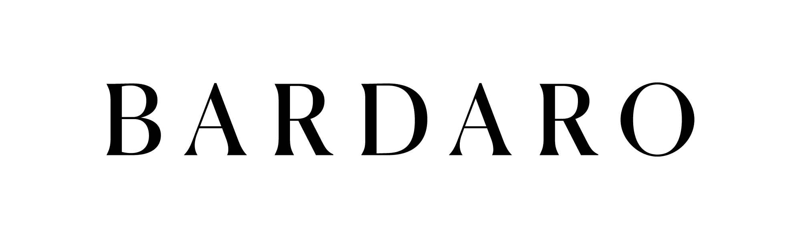  BARDARO | 3, 5, 14, 18, 25, 35 | MEDIUM | MEDIUM | N/A | ✗ | LOW
The cited word shares the BARDA opening but is longer and ends in -RO, and the elegant serif presentation differs from the target's rounded sans-serif with a glass device. Its Class 35 services are retail of clothing, footwear, perfumery, jewellery and supplements, and its goods classes cover cosmetics, pharmaceuticals, jewellery, bags and clothing — none of which touches drinkware or drinkware retail. With no goods proximity, the letter overlap alone does not create meaningful confusion risk.
TMView: EM500000019320328
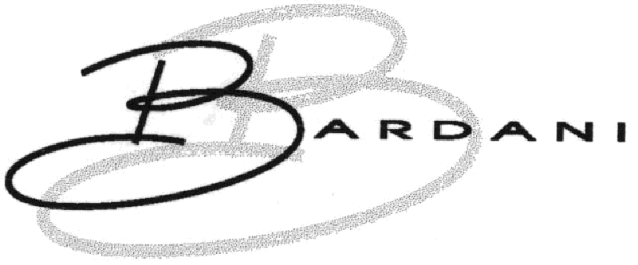  BARDANI | 18, 20, 21, 22, 25, 28 | MEDIUM | MEDIUM | N/A | IDENTICAL | MEDIUM
"BARDANI" shares the first five letters with the target but adds the -NI ending, and its logo is dominated by a large flowing script letter B, which distances the overall visual impression. In Class 21 it claims household or kitchen utensils and containers and glassware, which squarely covers bottles, mugs and drinkware, so the goods are effectively the same. Two moderate similarity dimensions combined with identical goods place this at MEDIUM; average consumer attention for everyday drinkware supports keeping it at that level.
TMView: EM500000010531952
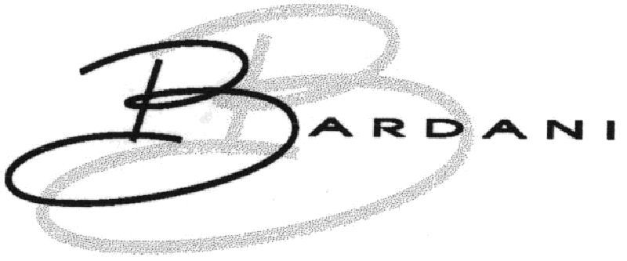  BARDANI | 5, 6, 8, 9, 12, 18, 20, 21, 22, 24, 25, 26, 27 | MEDIUM | MEDIUM | N/A | IDENTICAL | MEDIUM
This is a broader filing of the same BARDANI script mark, again claiming household or kitchen utensils and containers, glassware, chinaware and porcelain in Class 21, which covers the target's drinkware. The shared BARDA opening produces moderate visual and phonetic proximity, while the additional -NI syllable and the dominant handwritten B device reduce the overall impression of sameness. Identical goods in Class 21 keep the risk at MEDIUM.
TMView: EM500000016286262
BARDANI | 5, 6, 8, 9, 12, 18, 20, 21, 22, 24, 25, 26, 27 | MEDIUM | MEDIUM | N/A | IDENTICAL | MEDIUM
A further BARDANI registration with the same Class 21 wording covering household and kitchen utensils, containers and glassware, therefore overlapping the target's bottles, mugs and drinkware. Visual and phonetic similarity remain moderate because of the shared BARDA start against the distinctly longer three-syllable ending. The repeated presence of this family on the register signals an owner likely to watch new BARDA- filings during the opposition window.
TMView: EM500000016286239
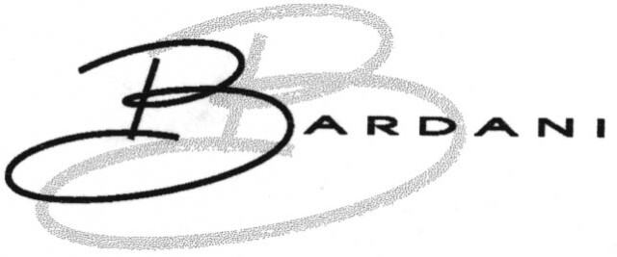  B BARDANI | 18, 20, 21, 22, 25, 28 | MEDIUM | MEDIUM | N/A | IDENTICAL | MEDIUM
The composite mark is dominated by the oversized script B merging into the word BARDANI, which the target's plain lowercase wording does not echo. Its Class 21 wording covers household and kitchen utensils and containers and glassware, which includes drinkware, so the goods are effectively identical. The combination of moderate word-level similarity with identical goods keeps the assessment at MEDIUM.
TMView: BX500000000992347
BARDOGGY | 9, 35, 38, 41, 43 | LOW | LOW | N/A | ✓ | LOW
Only the BARD sequence is shared; the -OGGY ending gives a clearly different length, rhythm and appearance. The Class 35 services concern advertising, marketing and database management for the entertainment and hospitality sector, which is only loosely connected to marketing and retail of drinkware. With low similarity across all dimensions, confusion is unlikely.
TMView: BX500000001313946
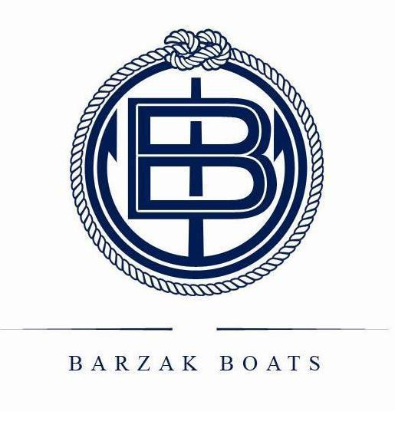  BARZAK BOATS | 12, 35, 39 | LOW | LOW | N/A | ✓ | LOW
The cited mark is a two-word composite with a prominent nautical rope-and-monogram device, and the word BARZAK differs from the target in its middle letters and pronunciation. Its Class 35 activity is advertising, import-export and retail of boats, clothing, sporting and diving equipment, which is only distantly related to drinkware marketing. The added word BOATS and the maritime imagery further separate the commercial impressions.
TMView: EM500000014543755
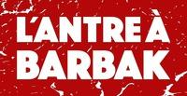  L'ANTRE À BARBAK | 35, 41, 43 | LOW | LOW | N/A | ✓ | LOW
The cited mark is a long French phrase presented in bold white lettering on a red distressed background, so its overall impression is far removed from the single word "bardak". Even isolating BARBAK, the double B changes both spelling and sound. Its Class 35 retail services concern food and beverages rather than drinkware, so no meaningful confusion arises.
TMView: WO500000001861856
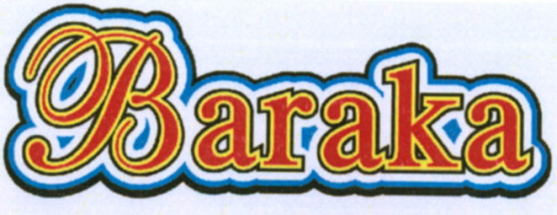  BARAKA | 9, 16, 28, 35, 38, 41 | LOW | MEDIUM | N/A | ✗ | LOW
"BARAKA" lacks the D of the target and is presented in an ornate multicoloured script, so the visual impression differs markedly, although the BAR-A-KA sound pattern is somewhat comparable. Its Class 35 services are advertising and promotion specifically in the lottery and gambling field, with no connection to drinkware or its retail. Absent goods proximity, the phonetic echo alone does not create actionable risk.
TMView: BX500000001097666
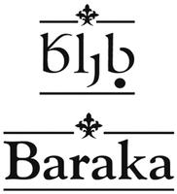  Baraka | 29, 30, 32, 35, 39 | LOW | MEDIUM | N/A | ✗ | LOW
This Baraka mark appears with Georgian script above the Latin word and decorative ornaments, giving a distinctive layout, and the missing D again separates it visually from the target. Its scope is foodstuffs, beverages, export agency and delivery services for food products, not drinkware or drinkware retail. The sectors are different enough that consumers would not connect the two.
TMView: WO500000001407465
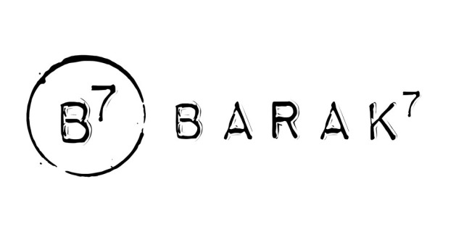  Barak 7 | 35 | LOW | MEDIUM | N/A | ✗ | LOW
The cited mark combines the word BARAK with a superscript 7 and a circular B7 device, so it is visually distinct from "bardak", and it lacks the D. Its only service is retail of furniture and decorative objects, which does not cover bottles, mugs or drinkware. The numeral element also gives it a memorable, separate identity.
TMView: BX500000001409655
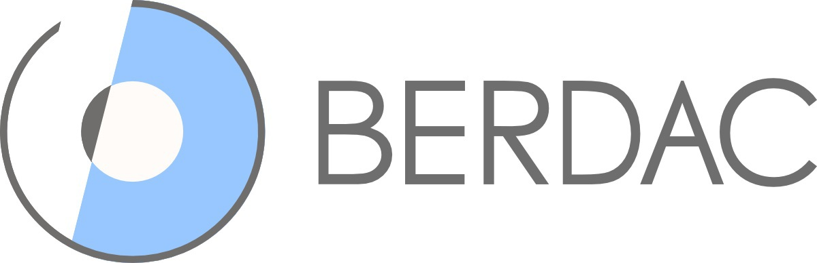  BERDAC | 35, 42 | LOW | MEDIUM | N/A | ✗ | LOW
BERDAC differs in its second letter and final consonant and is presented in grey capitals beside a blue circular device, so the overall impression diverges from the target. Its Class 35 wholesale and retail activity is limited to medicine dispensers, pill packaging and medicines, and Class 42 covers software design. There is no plausible commercial link to drinkware.
TMView: EM500000018198023
BARDOU | 3, 8, 35, 41, 44 | MEDIUM | LOW | N/A | ✗ | LOW
BARDOU shares the BARD opening but its -OU ending changes both the look and the pronunciation of the second syllable. Its services and goods concern hairdressing, beauty care, cosmetics, grooming implements and retail of those products, all clearly outside the drinkware sector. Without goods proximity, a single moderate similarity dimension does not generate meaningful risk.
TMView: EM500000015043862
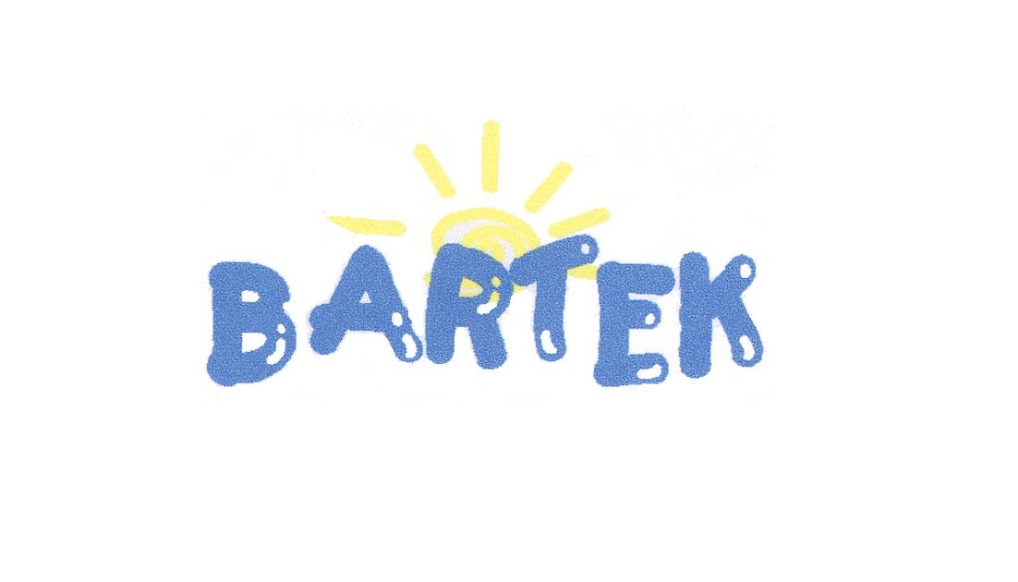  BARTEK | 10, 25, 35 | LOW | LOW | N/A | ✗ | LOW
BARTEK replaces the central D with T and uses a childlike blue lettering with a sun device, producing a very different overall impression. Its Class 35 activity is running shops selling footwear, clothing and leather accessories, and its goods are orthopaedic and general footwear. No relationship exists with bottles, mugs or drinkware.
TMView: EM500000004628137
BARSAT | 9, 16, 35, 38, 41, 42 | LOW | LOW | N/A | ✗ | LOW
Only the BAR opening is shared; SAT differs entirely from DAK in spelling and sound, and the mark is shown as a red-and-black two-tone block logo. Its Class 35 services concern advertising, media subscriptions and business administration in a broadcasting context. There is no overlap with drinkware or drinkware retail.
TMView: WO500000000710707
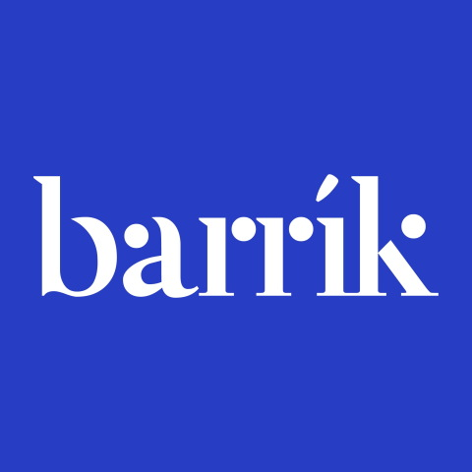  Barrik | 35, 41, 43 | LOW | LOW | N/A | ✗ | LOW
Barrik has a double R and no D, and appears in a white serif wordmark on a strong blue background, so it reads quite differently from the target. Its services are event marketing, seminar organisation and catering, not retail or marketing of drinkware products. The commercial fields do not meet.
TMView: BX500000001465631
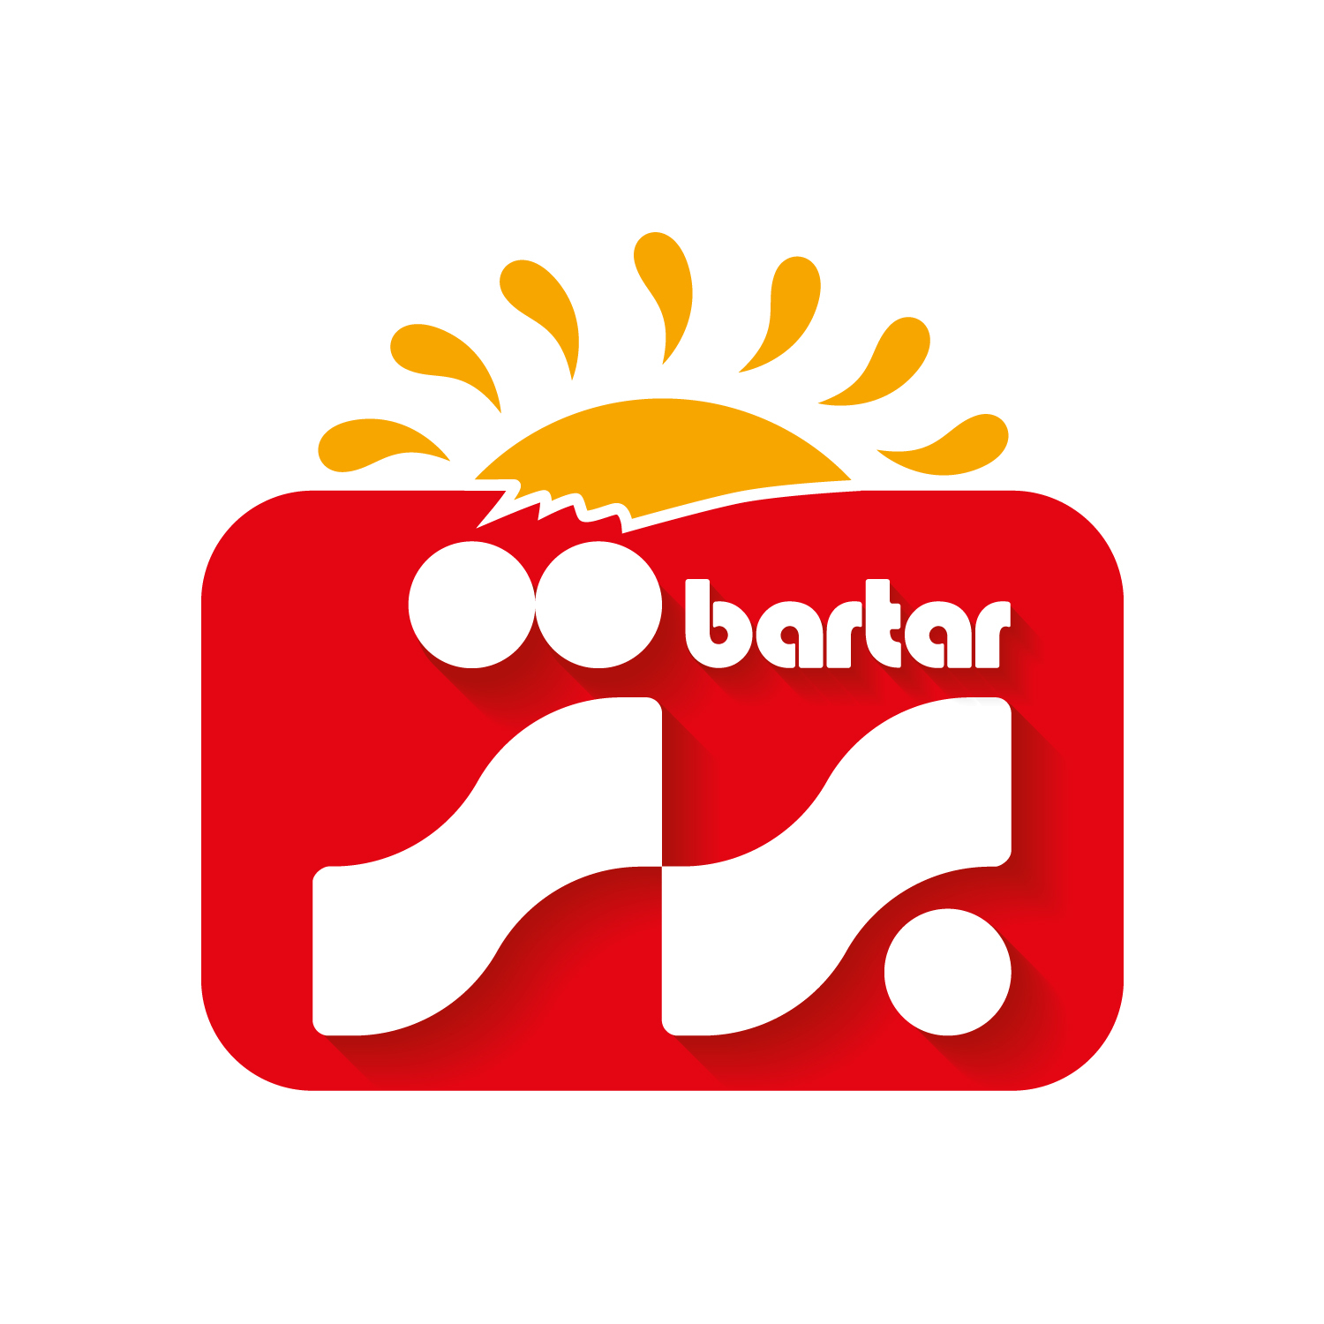  bartar | 29, 30, 31, 32, 35 | LOW | LOW | N/A | ✗ | LOW
The cited mark is a rich red-and-orange composite with a sun and wave device, and the word bartar ends in -TAR rather than -DAK. Its Class 35 service is retail of food, supporting its foodstuff and beverage goods. Drinkware as a product category is not covered, so confusion is not plausible.
TMView: EM500000017930586
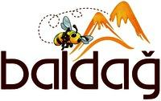  baldağ | 30, 35 | LOW | LOW | N/A | ✗ | LOW
baldağ shares only the initial B and A and is presented with a bee and mountain device in brown and orange tones. Its scope is honey and propolis and the retail bringing-together of those specific goods. There is no meaningful visual, phonetic or commercial connection with the target.
TMView: WO500000001476973
Bartuke | 21 | LOW | LOW | N/A | ✓ | LOW
Bartuke shares only the BAR opening; the -TUKE ending gives a different length and pronunciation from -DAK. Its Class 21 specification is confined to pet-care articles such as cages, litter boxes, pet feeders and pet bowls, which sit in the same class as drinkware but serve a different market. With low similarity throughout, the shared class alone does not create real confusion risk.
TMView: EM500000019067887
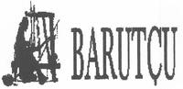  BARUTÇU | 5, 24, 25, 27, 35 | LOW | LOW | N/A | ✓ | LOW
BARUTÇU has a distinct middle and a cedilla-marked ending, shown beside a small figurative device, so it looks and sounds clearly different from the target. Its Class 35 wording includes a broad bringing-together of a variety of goods, which could in principle touch retail of many products, but its own goods are textiles, clothing, prayer rugs and diapers. The weak similarity keeps risk low despite the broad retail wording.
TMView: WO500000001397008
Baalbak | 33, 35 | LOW | LOW | N/A | ✗ | LOW
Baalbak has a doubled A and no R, so both spelling and pronunciation diverge substantially from "bardak" despite the shared final -AK. Its scope is alcoholic beverages and the retail and wholesale of alcoholic beverages, not drinkware articles. The goods sectors are distinct enough to exclude confusion.
TMView: EM500000018476310
BRADDOCK | 25, 35 | LOW | LOW | N/A | ✓ | LOW
BRADDOCK is longer, has no vowel after the initial B and ends in -DOCK, giving a clearly different appearance and sound. Its very broad Class 35 wording does mention retail of household utensils and beverages alongside fashion goods, so a limited relationship with drinkware retail exists. The marked difference in the word elements nevertheless keeps confusion risk low.
TMView: EM500000017999618
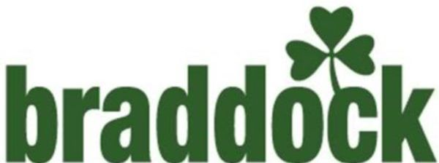  BRADDOCK | 3, 9, 14, 18, 25, 35 | LOW | LOW | N/A | ✓ | LOW
This second BRADDOCK filing appears in bold green lowercase with a shamrock device, further distancing it visually from the target's glass device and navy lettering. Its Class 35 retail wording includes household utensils and cooking utensils, creating a partial link with drinkware retail. The pronounced difference in the word elements means consumers are unlikely to confuse the two.
TMView: EM500000015502537
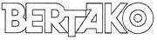  BERTAKO | 7, 16, 17, 35, 42 | LOW | LOW | N/A | ✗ | LOW
BERTAKO differs in its second letter and its three-syllable ending, and is shown as an outlined block logo. Its Class 35 services relate to advertising, import-export and retail of containers, packaging and machine tools — industrial packaging rather than consumer drinkware. The commercial context is clearly separate.
TMView: EM500000014784541
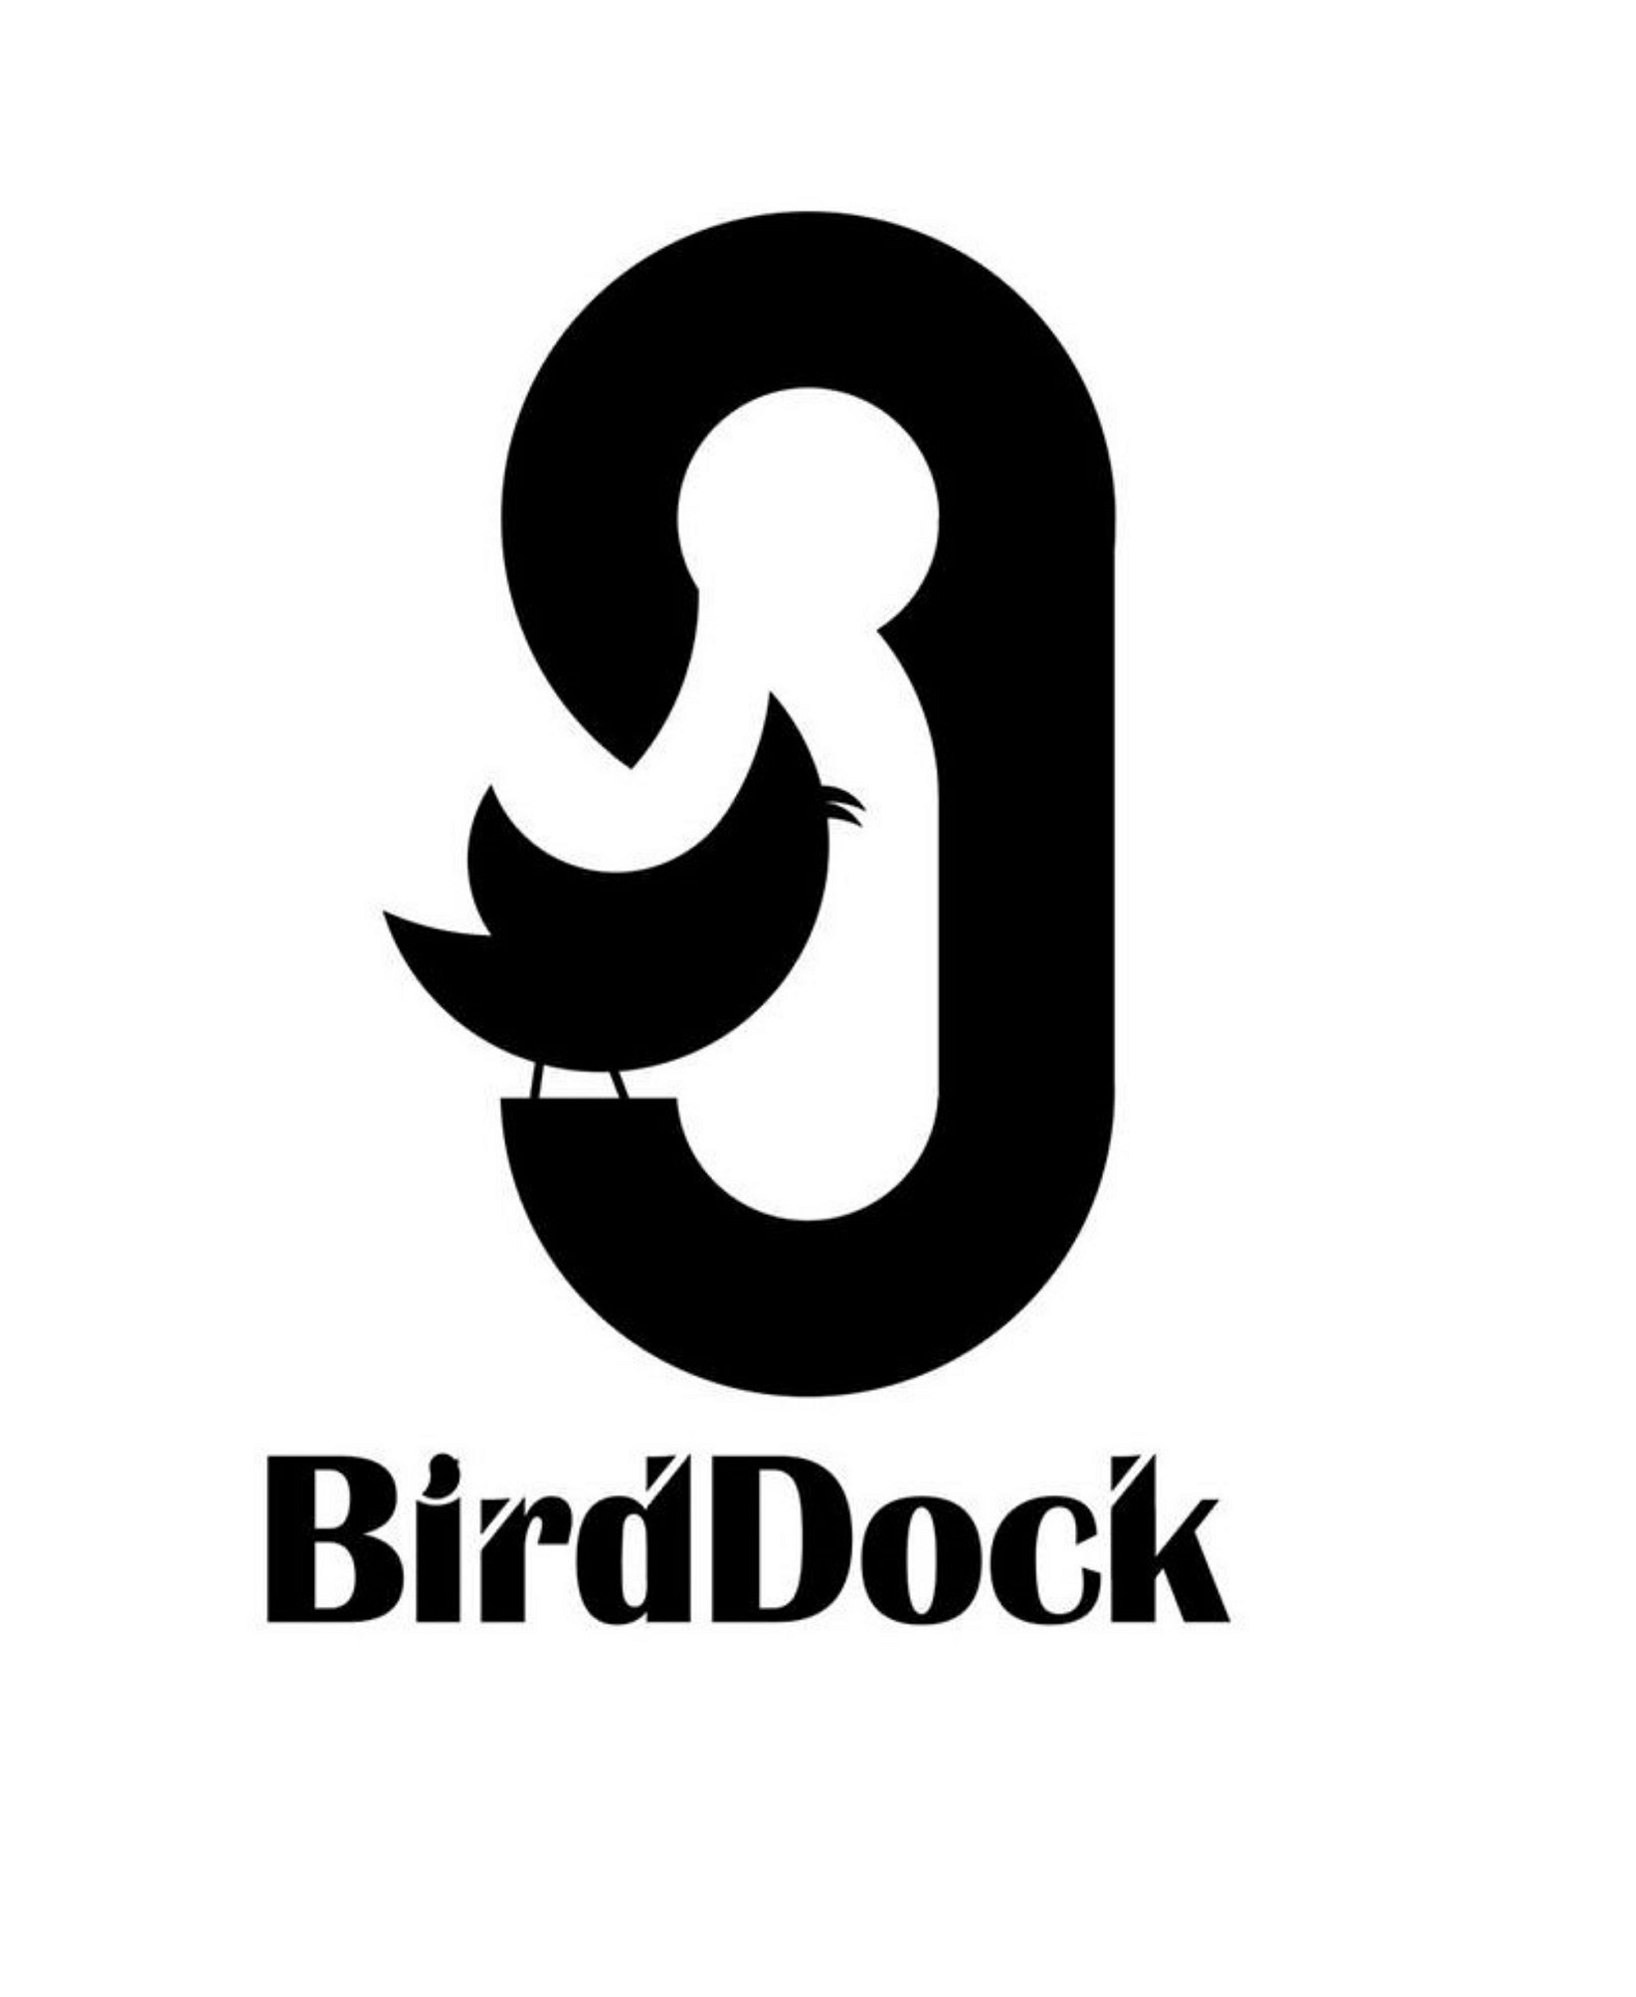  BirdDock | 21 | LOW | LOW | N/A | ✓ | LOW
BirdDock is a two-part compound with a large bird device and reads quite differently from "bardak" in both spelling and pronunciation. Its Class 21 goods are bird baths, feeders, cages, pet brushes and litter pans, which share the class with drinkware but address the pet-supplies market. Low similarity across all dimensions keeps the risk minimal.
TMView: EM500000018816715
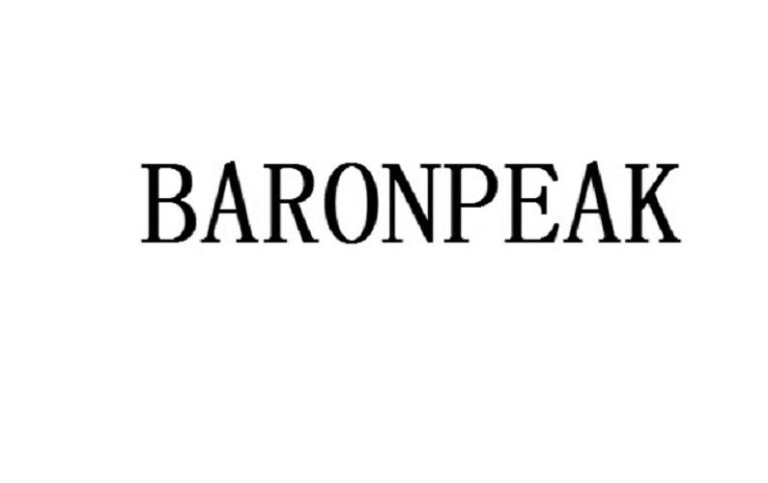  BARONPEAK | 3, 4, 5, 6, 7, 8, 9, 11, 12, 14, 16, 17, 18, 19, 20, 21, 25, 28 | LOW | LOW | N/A | IDENTICAL | LOW
BARONPEAK is a long two-element coinage in plain serif capitals; only the BAR opening is shared and the overall length, rhythm and impression differ substantially from the target. Its Class 21 list expressly includes drinking vessels, thermally insulated containers for food and insulating flasks, which is effectively the same scope as the target's bottles, thermos mugs and drinkware. Despite identical goods, the marks themselves are too different for confusion, so risk stays low.
TMView: EM500000019289904
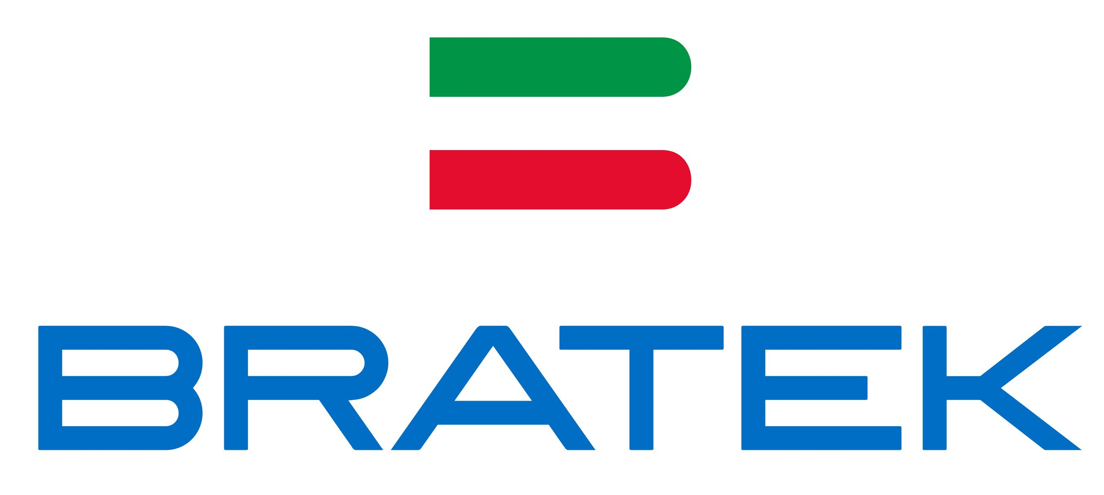  BRATEK | 9, 11, 35 | LOW | LOW | N/A | ✓ | LOW
BRATEK has no vowel after the initial B and ends in -TEK, and is presented in blue capitals with green and red bars, so it looks and sounds different from the target. Its Class 35 wording covers online marketplace provision, presentation of goods for retail purposes and business management of retail outlets, which is generically related to retail of drinkware. The clear difference between the word elements keeps confusion unlikely.
TMView: EM500000018794147
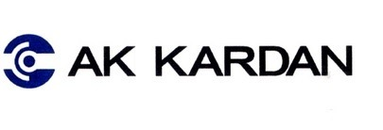  AK KARDAN | 7, 12, 35 | LOW | LOW | N/A | ✗ | LOW
The mark consists of two words preceded by a circular device; although KARDAN contains the letter string ARDA, the leading AK and the different beginning produce a wholly different overall impression. Its services and goods concern machine tools, vehicle transmission parts and the retail of those items. No commercial connection with drinkware exists.
TMView: EM500000013018023

Assumptions and Limitations
Assumptions:
• ASSUMPTION: The Class 35 filing is understood to cover retail and marketing services for the applicant's own drinkware products, since the business description mentions only production of bottles, thermos mugs and drinkware. | WHY: The description does not state which services are intended in Class 35. | IMPACT: affects goods_overlap and conflict_risk for service marks such as "BARDAF!", "BRADDOCK" and "BRATEK", and the per_class_assessment for Class 35.
• ASSUMPTION: "bardak" is treated as a meaningless invented word for the general Dutch-speaking public, with its Turkish sense of "glass" known only to a minority. | WHY: Dutch is the language indicated for the target territory and the mark's origin language is not stated. | IMPACT: affects distinctiveness_category, inherent_distinctiveness.risk_level and linguistic_cultural.risk_level.
Limitations:
None specified.

United Kingdom
TRADEMARK REGISTRABILITY ASSESSMENT
Bardak
GB • NICE Classes: 21, 35 • July 30, 2026
Trademark register — data as of: July 28, 2026 · United Kingdom — app 2026-07-28 / reg 2026-06-26 (pending + registered); WIPO — app 2026-07-27 / reg 2026-06-25 (pending + registered)
Applicant origin: Portugal
Practical Outlook
Registration Outlook:
At Risk
A significant conflict with an earlier mark, or a distinctiveness problem, was found. Registration is uncertain and the result depends on examiner discretion or possible opposition. Review the details before filing.
Summary:
The outcome here is uncertain, and it is worth knowing exactly why before you file. Your name "bardak" is strong in itself — it means nothing in English, so the trademark office is unlikely to object to it on its own merits. The problem is Class 21, where three registrations for "BARDANI" already cover household and kitchen containers and glassware, which is precisely what bottles, thermos mugs and drinkware are; several other Class 21 names such as BARAKI, BAYTAK, Barbar and Baodan are in the same space too. In the UK the office will not block you over these marks, but once your application is published the owner of BARDANI could formally object, and that is a real possibility given how close the first five letters are. Your Class 35 retail services are in much better shape, and tightening your wording in both classes plus a possible agreement with the BARDANI owner would meaningfully improve your odds.
What to do before filing:
1. Narrow your Class 21 goods to bottles, thermos flasks, thermos mugs and drinking vessels rather than all household or kitchen containers, so you sit further away from the BARDANI and BAYTAK specifications.
2. Reword your Class 35 services as retail and online retail of bottles, thermos mugs and drinkware, to avoid overlapping with BADRAY's retail of household utensils and glassware.
3. File the mark as the full logo with the navy lettering and glass symbol, so you have visual differences to point to if BARDANI objects.
4. Explore a written coexistence arrangement with the BARDANI owner covering drinkware only, since that single family of registrations is your biggest risk.

Per-Class Assessment

ⓘ | How registration works: The trademark office examines each class separately. If they find a similar mark in any class, they will send a provisional refusal. This is a normal part of the process and you can respond with arguments about why your services are different.
Class | Status | Prov. Refusal Chance | Success Chance | Key Obstacle
21 | Provisional refusal likely | 70% | 45% | Three "BARDANI" registrations cover exactly the goods you sell in Class 21 (household and kitchen containers and glassware), and several other Class 21 names such as BARAKI, BAYTAK, Barbar, Baodan and BADRAY sit in the same drinkware space.
35 | Provisional refusal possible | 50% | 68% | Several Class 35 registrations cover retail of household utensils, glassware or food and beverages, in particular BADRAY (retail of household and kitchen utensils and glassware) and BAITHAK (retail and wholesale of food and beverages).

ⓘ | Estimated Timeline: A straightforward UK application is usually examined within a few weeks and, if unopposed, registers in roughly four to six months. If the owner of a similar mark files an objection after publication, add anywhere from several months to well over a year depending on whether the matter settles.

Detailed Analysis

Mark Analysis
Mark Type: | COMPOSITE
Distinctiveness Category: | ARBITRARY
Distinctiveness Scale
Generic | Descriptive | Suggestive | Arbitrary | Fanciful
← Weak | Strong →

ⓘ | • Generic: Common name for the goods/services category  • Descriptive: Immediately describes goods, services, or characteristics  • Suggestive: Hints at qualities but requires imagination to connect  • Arbitrary: Real word completely unrelated to the goods  • Fanciful: Invented word with no dictionary meaning
Reasoning:
The logo combines the word "bardak" in a clean lower-case rounded sans-serif navy typeface with a small stylized drinking-glass device partially filled in tan. For English-speaking UK consumers "bardak" has no dictionary meaning, so it functions as an invented-looking, arbitrary sign for drinkware and related retail services. The glass device is thematically allusive to drinking vessels and is therefore a relatively weak, low-distinctiveness element on its own, but the word remains the dominant and memorable component. Because the figurative glass merely depicts the goods, the mark as a whole cannot be treated as wholly fanciful, yet the word element carries sufficient inherent distinctiveness.

Assessment Summary
"bardak" has a reasonable but not straightforward path to registration in the United Kingdom: the mark itself is easily strong enough, while the crowded Class 21 register is the real hurdle. On absolute grounds there is little to worry about, since the word has no meaning for UK English-speaking consumers and only the small drinking-glass device is weak because it depicts the goods. The main conflict comes from three "BARDANI" registrations whose Class 21 wording covers household and kitchen containers and glassware, exactly the applicant's field, with further moderate-risk Class 21 names including BARAKI, BAYTAK, Barbar, Baodan, BADRAY and Bartuke. Class 35 is noticeably safer, with only moderate proximity to retail services for household goods and food, while Class 21 carries the concentrated risk. Mitigating factors are the clear difference in the closing syllables against BARDANI, the very different script styling of that mark, and the sheer number of coexisting BAR- and BA-...-AK names in Class 21, which shows the register tolerates close neighbours in this space. The practical route forward is to keep the goods and services wording tightly focused on bottles, thermos mugs and drinkware, and to be prepared to differentiate from or reach an accommodation with the BARDANI owner.
Registration Probability: 57%

Recommendations
• [GOODS_SCOPE] Consider narrowing the Class 21 wording to bottles, thermos flasks, thermos mugs, drinking vessels and reusable drinkware instead of broad household or kitchen containers — to reduce the identical overlap with the Class 21 specifications of BARDANI, BAYTAK and BADRAY — expected impact: moves the overlap away from full identity and weakens the basis for an opposition.
• [GOODS_SCOPE] Consider limiting Class 35 to retail and online retail services relating to bottles, thermos mugs and drinkware — to keep a distance from BADRAY's retail of household utensils and glassware and BAITHAK's food and beverage retail services — expected impact: narrows the service overlap in the class that currently sits at medium risk.
• [DESIGN_ELEMENT] Consider filing the mark in the composite form shown in the logo, with the navy rounded lettering and the filled drinking-glass symbol, rather than as a bare word — to add visual separation from the script-style BARDANI logo and from Barbar and BARAKI — expected impact: strengthens the overall impression argument if the mark is challenged.
• [COEXISTENCE] Consider approaching the owner of the BARDANI registrations about a coexistence or consent arrangement limited to drinkware — to neutralise the strongest Class 21 citation before publication — expected impact: removes the single largest source of opposition risk in the worst-performing class.
• [MARK_MODIFICATION] Consider adding a distinctive second element to the wordmark, for example a short coined house term used consistently with "bardak" — to reduce the shared BARDA opening with BARDANI — expected impact: lowers visual and phonetic proximity to the closest cited mark, though it changes the brand presentation.
• [DISTINCTIVENESS] Consider ensuring the word element remains clearly dominant over the drinking-glass device in the filed representation — because a glass symbol merely depicts the goods and adds little distinctiveness — expected impact: keeps the inherent distinctiveness argument resting on the word, which is the strongest part of the mark.

ⓘ | Absolute grounds are inherent registrability criteria examined by the trademark office independently of any existing marks. These are legal requirements that every trademark must satisfy on its own merits.

Absolute Grounds Assessment
Overall Absolute Risk: LOW
Ground | Risk Level | Reason
Inherent Distinctiveness  Whether the mark is distinctive enough to identify the source of goods/services | LOW | The word "bardak" is meaningless to the average UK English-speaking consumer and therefore inherently distinctive for drinkware and retail of drinkware. The only weak element is the figurative drinking glass, which simply depicts the goods and adds little distinctiveness of its own. Under the Trade Marks Act 1994 absolute-grounds practice, the word element should be sufficient to carry the mark past descriptiveness objections.
Deceptive/Misleading  Whether the mark could mislead consumers about the nature or quality of goods | No Risk Identified | -
Public Order Morality  Whether the mark contains content contrary to public order or accepted moral principles | No Risk Identified | -
Prohibited Elements  Whether the mark includes state emblems, flags, official symbols or other prohibited elements | No Risk Identified | -
Geographic Indications  Whether the mark contains protected geographic indications or misleading geographic terms | No Risk Identified | -
Linguistic/Cultural  Whether the mark has negative or problematic meanings in local languages or cultures | No Risk Identified | -
Personality Rights  Whether the mark infringes on another person's name, image, or identity rights | No Risk Identified | -
Well-Known Marks  Whether the mark conflicts with well-known marks that enjoy broader protection | No Risk Identified | -

ⓘ | Relative grounds assess potential conflicts with existing registered or pending marks. An examiner or third party may oppose your trademark if it is confusingly similar to a prior mark in the same or related goods/services.

Relative Grounds Assessment
Overall Relative Risk: HIGH
Analysis Notes: The clearest obstacles are "BARDANI" (three registrations covering Class 21 household and kitchen utensils, containers and glassware) and, to a lesser degree, "BADRAY", "BARAKI", "Barbar", "Baodan", "BAYTAK" and "Bartuke" in Class 21. Goods overlap was assessed from the actual registry goods/services wording supplied for each cited mark rather than class numbers alone. The relevant public is general consumers buying inexpensive everyday drinkware, exercising an average and at times low degree of attention, which slightly increases confusion risk for the closest names.
Similar Marks Analysis:
Vis — Visual | Phon — Phonetic | Conc — Conceptual | Goods — Goods and services Overlap
Mark | Class | Vis | Phon | Conc | Goods | Risk
BARDANI | 18, 20, 21, 22, 25, 28 | MEDIUM | MEDIUM | N/A | IDENTICAL | HIGH
Both marks share the first five letters BARDA and the same opening two syllables; the endings -K versus -NI differ, giving medium rather than high similarity. The cited Class 21 specification covers household or kitchen utensils and containers and glassware, which squarely covers the applicant's bottles, thermos mugs and drinkware, so the goods are identical. The cited mark is presented as a highly stylized script logo while the target is a plain rounded typeface with a glass device, but in both marks the word is dominant, and with two medium dimensions plus identical goods the risk lands in the high band. The cited mark is arbitrary for its own goods, so it enjoys a normal to broad scope of protection and no downgrade applies.
TMView: GB500000910531952
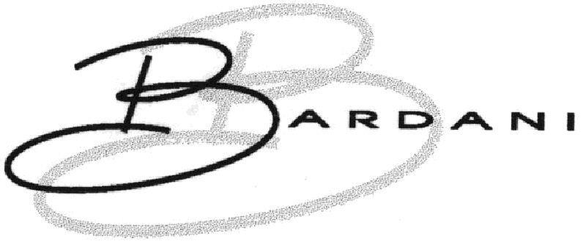  BARDANI | 5, 6, 8, 9, 12, 18, 20, 21, 22, 24, 25, 26, 27 | MEDIUM | MEDIUM | N/A | IDENTICAL | HIGH
This broader BARDANI registration again covers household or kitchen utensils and containers, glassware, chinaware, porcelain and earthenware in Class 21, which overlaps directly with bottles, mugs and drinkware. Shared BARDA opening with differing endings gives medium visual and medium phonetic similarity, and neither word conveys a meaning to UK consumers so conceptual comparison does not apply. Medium similarity on two dimensions combined with identical goods places this in the high band. No recordal events are recorded for this mark in the United Kingdom, so no status-based adjustment applies.
TMView: GB500000916286262
BARDANI | 5, 6, 8, 9, 12, 18, 20, 21, 22, 24, 25, 26, 27 | MEDIUM | MEDIUM | N/A | IDENTICAL | HIGH
A duplicate BARDANI filing with the same wide specification, including Class 21 household and kitchen utensils, containers and glassware, so the goods overlap with the applicant's drinkware is identical. Similarity analysis is the same as for the parallel BARDANI registrations: shared BARDA stem, differing endings, medium visual and phonetic similarity. The existence of several BARDANI registrations in the same family strengthens the owner's position and keeps the conflict risk high for Class 21.
TMView: GB500000916286239
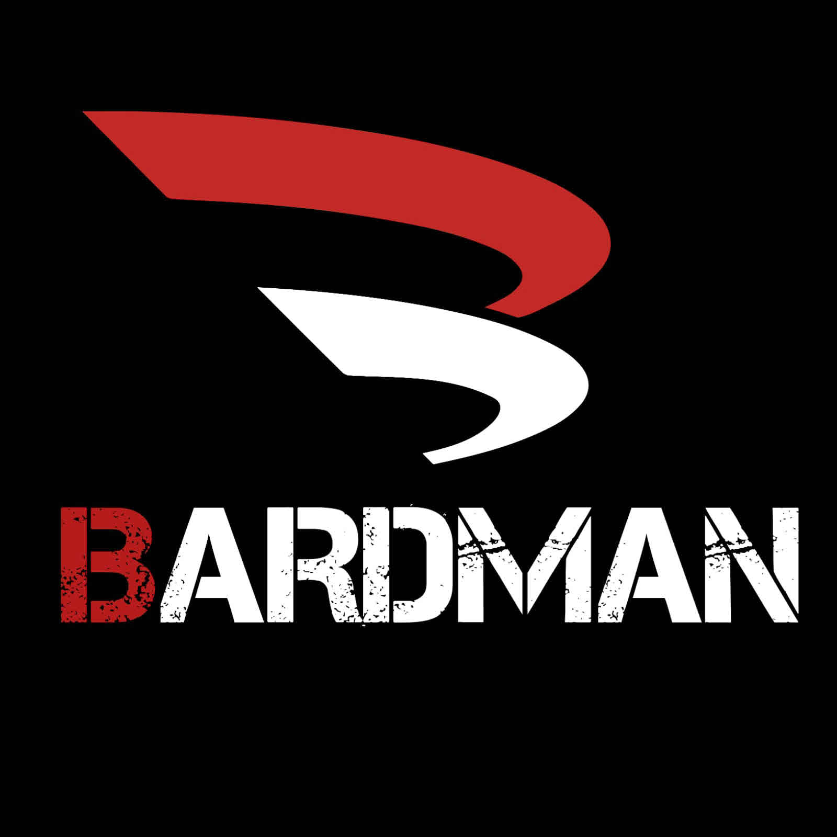  BARDMAN | 9, 14, 25, 35 | MEDIUM | MEDIUM | N/A | ✗ | LOW
BARDMAN shares the BARD opening but continues with -MAN, giving a clearly different rhythm and a masculine noun impression absent from the target. Its actual specification covers watches, jewellery, smartwatches, clothing and retail of wearable computers, none of which relates to drinkware or retail of drinkware. With unrelated goods and at most medium similarity, only a low residual risk remains.
TMView: GB500000004226188
BATAK | 9, 25, 28, 32, 35, 41, 45 | MEDIUM | MEDIUM | N/A | ✗ | LOW
BATAK is a five-letter word sharing the BA opening and the -AK ending with the target, which gives moderate visual and aural proximity, though the missing R and D change the middle of the word noticeably. Its services are loyalty schemes, internet advertising, TV and radio commercials, auctions, trade fairs and opinion polling in Class 35, plus games and sports goods elsewhere, which are commercially remote from retail of drinkware. Unrelated goods and services keep the risk low.
TMView: GB500000002501112
BARZAK BOATS | 12, 35, 39 | LOW | MEDIUM | N/A | ✗ | LOW
The dominant word BARZAK shares the BAR opening and -AK ending, giving some aural proximity, but the additional word BOATS and the prominent nautical rope-and-monogram device create a very different overall impression. The cited Class 35 services concern advertising and retail of sporting, diving, clothing and boating goods, not drinkware. With unrelated commercial sectors the risk stays low.
TMView: GB500000914543755
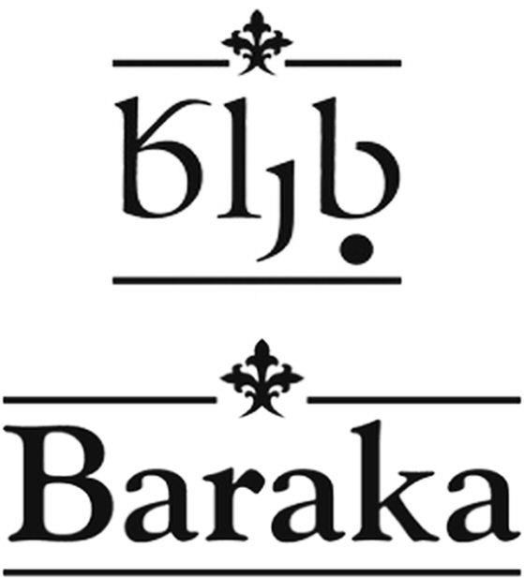  Baraka | 29, 30, 32, 35, 39 | MEDIUM | MEDIUM | N/A | ✗ | LOW
Baraka shares the BAR opening and a similar three-syllable rhythm but ends in an open -AKA and appears with an Arabic-script element above the Latin word, which distances the visual impression. The specification covers foodstuffs, beverages and food-related export and delivery services rather than drinkware or retail of drinkware. Different commercial sectors keep the conflict risk low.
TMView: GB500000801407465
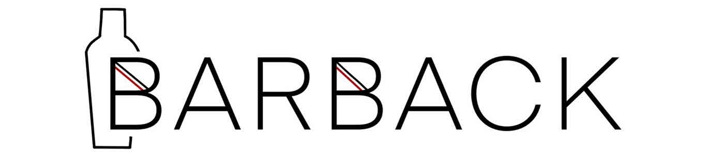  BARBACK | 35 | MEDIUM | MEDIUM | N/A | ✗ | LOW
BARBACK shares the BAR opening and a hard -CK ending sound, but its second syllable BACK is a familiar English word which the target lacks, and it appears with a cocktail-shaker outline device. Its Class 35 services are strictly temporary employment and recruitment agency services, which are entirely different from retail of drinkware, so the shared class number does not create overlap. In addition BARBACK is a known bar-trade job title and therefore weak in its own field, narrowing its protection further.
TMView: GB500000003674367
BARAKI | 21 | MEDIUM | MEDIUM | N/A | IDENTICAL | MEDIUM
BARAKI shares the BAR opening and the same three-syllable structure, but the absence of the D and the final -I vowel make it audibly distinguishable in normal English speech. Its Class 21 specification expressly covers water bottles, flasks, hip flasks, drinking vessels and barware, which is the same commercial space as the applicant's bottles, thermos mugs and drinkware, so goods are identical. Two medium dimensions with identical goods, moderated by the average attention of everyday drinkware buyers, place this in the medium band.
TMView: GB500000003389579
BERDAC | 35, 42 | MEDIUM | MEDIUM | N/A | ✗ | LOW
BERDAC and bardak share the consonant skeleton B-R-D-C and an -AC/-AK ending, so there is a moderate degree of visual and aural proximity, though the vowel sequence differs and the cited mark appears with a distinctive blue circular device. Its Class 35 services are wholesale and retail of medicine dispensers, pill dispensers, medicines and pharmaceutical packaging, and Class 42 software design, which are far from drinkware retail. Unrelated sectors keep the risk low.
TMView: GB500000918198023
BARDOU | 3, 8, 35, 41, 44 | MEDIUM | MEDIUM | N/A | ✗ | LOW
BARDOU shares the first four letters BARD with the target, giving medium visual and aural similarity, but the French-sounding -OU ending changes the closing impression. The specification is confined to cosmetics, hair and beauty implements, hairdressing training and salon services, and retail of those beauty goods, none of which relates to drinkware. With no plausible consumer association between beauty services and drinkware, risk is low.
TMView: GB500000915043862
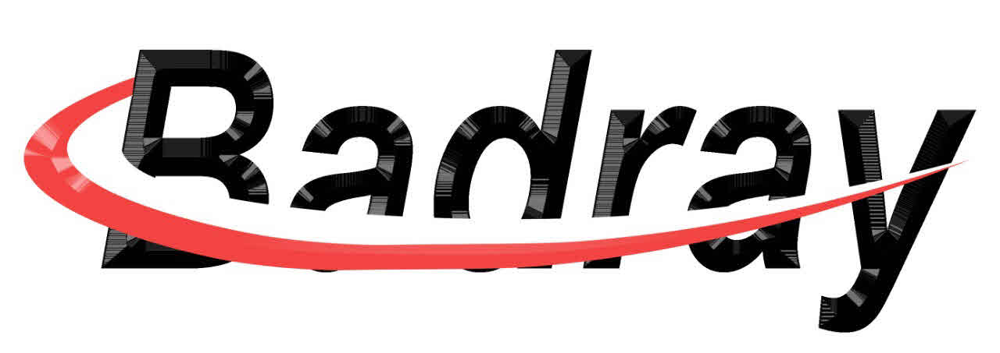  BADRAY | 11, 20, 21, 27, 35 | MEDIUM | LOW | N/A | IDENTICAL | MEDIUM
BADRAY uses the same five core letters B, A, D, R, A in a transposed order, which produces a moderate visual resemblance, but the pronunciation "bad-ray" is clearly distinguishable from "bar-dak" in English. Its Class 21 wording expressly includes household and kitchen containers such as bottles and cocktail shakers, and its Class 35 covers retail of household and kitchen utensils and glassware, so the goods and retail services overlap with the applicant's. One medium dimension combined with identical Class 21 goods places this in the medium band; the swirl device and cursive styling of the cited logo provide some additional separation.
TMView: GB500000003825771
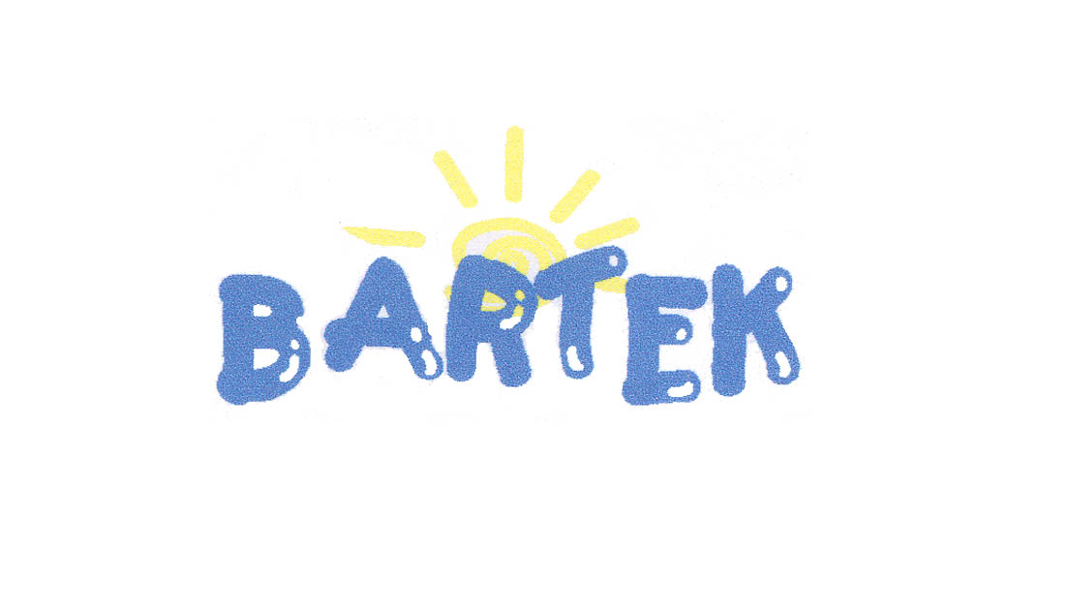  BARTEK | 10, 25, 35 | MEDIUM | MEDIUM | N/A | ✗ | LOW
BARTEK shares the BAR opening and a hard -K ending, giving moderate similarity, though the T and E in the middle change both look and sound. The cited registration is limited to orthopaedic footwear, clothing and footwear, and shops selling footwear, clothing and leather accessories, which does not touch drinkware or drinkware retail. Its childlike blue lettering with a sun device also creates a distinct visual identity, so risk remains low.
TMView: GB500000904628137
Barbar | 16, 21, 32 | MEDIUM | MEDIUM | N/A | IDENTICAL | MEDIUM
Barbar shares the BAR opening and a two-syllable structure, but its repeated -BAR ending is aurally distinct from -DAK and there is no D. Its Class 21 specification covers glassware, glass flasks, decanters, beverage glassware and drinking glasses, which are the same field as the applicant's drinkware, so goods overlap is identical. One clearly medium dimension paired with identical goods puts this in the medium band rather than higher.
TMView: GB500000913787957
bartar | 29, 30, 31, 32, 35 | MEDIUM | MEDIUM | N/A | ✗ | LOW
The word bartar shares the BAR opening and a similar two-syllable cadence, but the repeated T-A-R ending differs from -DAK and the cited mark is embedded in an elaborate red, white and orange sun-and-wave logo that dominates the visual impression. Its goods and services are food, spices, beverages and retail services relating to food, which do not extend to drinkware or drinkware retail. Unrelated sectors keep the risk low.
TMView: GB500000917930586
Baodan | 21 | MEDIUM | LOW | N/A | IDENTICAL | MEDIUM
Baodan shares the B-A opening and the letters D, A, N in a comparable six-letter frame, giving moderate visual proximity, but "bao-dan" and "bar-dak" are readily distinguished when spoken in English. Its Class 21 wording covers drinking glasses, teapots, kitchen containers and kitchen utensils, which overlaps directly with the applicant's drinkware, so goods are identical. A single medium dimension with identical goods yields a medium band outcome.
TMView: GB500000003567928
BAYTAK | 21 | MEDIUM | MEDIUM | N/A | IDENTICAL | MEDIUM
BAYTAK matches the target in length, in the BA opening and in the -AK ending, which produces moderate visual and aural resemblance, while the internal YT versus RD keeps them distinguishable. Its Class 21 goods are non-electric kettles, pressure cookers, woks, ice-bucket liners, picnic baskets and cleaning articles, which sit in the same household and kitchen container field as bottles and thermos mugs, so overlap is treated as identical. Two medium dimensions with identical goods would normally reach the higher band, but the clearly different middle consonants and the absence of any shared meaning support a medium assessment.
TMView: GB500000004261977
Bartuke | 21 | MEDIUM | MEDIUM | N/A | ✓ | MEDIUM
Bartuke shares the BAR opening and a hard K sound before its final E, giving moderate visual and aural similarity, though the U vowel and trailing E change the ending. Its Class 21 specification is devoted to pet accessories such as feeders, cages, litter boxes and pet drinking bowls, plus air fragrancing and indoor aquaria, which are adjacent household Class 21 articles rather than human drinkware, so overlap is related rather than identical. Multiple medium dimensions with related goods place this in the medium band.
TMView: GB500000004087685
BARUTÇU | 5, 24, 25, 27, 35 | MEDIUM | LOW | N/A | ✗ | LOW
BARUTÇU shares the BAR opening but the U vowels, the cedilla and the seven-letter length make both the look and the sound clearly different from bardak. Its specification covers textiles, clothing, prayer rugs, babies' diapers and advertising or general trade-fair and import-export services, none of which reaches drinkware or drinkware retail. The recordal history shows an early partial provisional refusal in the United Kingdom followed by a later statement of grant of protection, so the mark is currently protected and no status-based reduction is applied; the risk is nevertheless low because the sectors do not meet.
TMView: WO500000001397008
BAITHAK | 8, 16, 20, 21, 24, 29, 30, 32, 35, 39, 43 | MEDIUM | MEDIUM | N/A | ✓ | MEDIUM
BAITHAK shares the BA opening and the -AK ending with the target and has a comparable two-syllable stress pattern, giving moderate visual and aural similarity. Its Class 21 goods are branded food containers, foil takeaway packaging, lunchboxes, kitchen utensils, crockery and tableware, and its Class 35 covers retail and wholesale of food and beverages, so the fields are commercially adjacent to drinkware and drinkware retail rather than identical. Multiple medium dimensions with related goods produce a medium risk.
TMView: GB500000004255302
BRADDOCK | 25, 35 | LOW | LOW | N/A | ✓ | LOW
BRADDOCK is an eight-letter surname-style word with a double D and a -DOCK ending; only the loose B-R-D consonant sequence is shared, so both the look and the sound are clearly different. Its Class 35 wording does include retailing and wholesaling of household utensils and beverages, which touches the applicant's retail field, but the marks themselves are too far apart to create confusion. Low similarity on all dimensions keeps this at low risk.
TMView: GB500000917999618
BRADDOCK | 3, 9, 14, 18, 25, 35 | LOW | LOW | N/A | ✓ | LOW
This BRADDOCK filing is presented as a green lower-case wordmark with a shamrock device, giving a distinctly different overall impression from the navy bardak logo with its glass symbol. Its Class 35 services include retailing and wholesaling of cooking utensils and plates, which is adjacent to retail of drinkware, but the marks differ substantially in length, rhythm and ending. Low similarity across the board results in low conflict risk.
TMView: GB500000915502537
BRADDOCK | 35, 25 | LOW | LOW | N/A | ✓ | LOW
A further BRADDOCK registration with clothing and broad retail and marketplace services, including retailing of household utensils and beverages, so some retail proximity exists in Class 35. The words remain clearly distinguishable in appearance and pronunciation, with a double-D and -DOCK ending against the target's -DAK. The latest recordal is a statement of grant of protection, so the mark is in force in the United Kingdom, but the low mark similarity keeps the risk low.
TMView: WO500000001480712
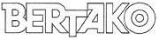  BERTAKO | 7, 16, 17, 35, 42 | MEDIUM | MEDIUM | N/A | ✗ | LOW
BERTAKO shares the B opening and an internal -TAK- sequence that echoes the target's ending, but the E vowel, the extra syllable and the final O make it noticeably different, and the cited mark appears in a boxed outline logo. Its goods and services are packaging materials, plastics, baling and filling machines and advertising, retail and design services for containers and packaging for industry, which are aimed at trade buyers rather than consumers of drinkware. Unrelated sectors and professional purchasers keep the risk low.
TMView: GB500000914784541
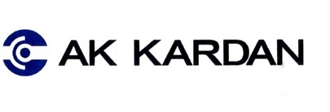  AK KARDAN | 7, 12, 35 | LOW | LOW | N/A | ✗ | N/A
AK KARDAN is a two-word automotive mark whose only link to the target is the internal letter string ARDA within KARDAN; the different beginning, extra word and circular device create an entirely different impression. Its goods and services are vehicle transmission parts, machine tools and the corresponding trade and retail services, sold to automotive professionals. There is no meaningful similarity and no goods proximity, so no conflict arises.
TMView: GB500000913018023
PARTAKUS | 35, 38, 42 | LOW | LOW | N/A | ✗ | N/A
PARTAKUS begins with a P, runs to eight letters and ends in -KUS, so it differs from bardak in first letter, length and ending, and shares no dominant element. Its services are business information, commercial intermediation, advertising, database access and software development, which have no connection with drinkware or its retail. There is no meaningful conflict.
TMView: GB500000918190484
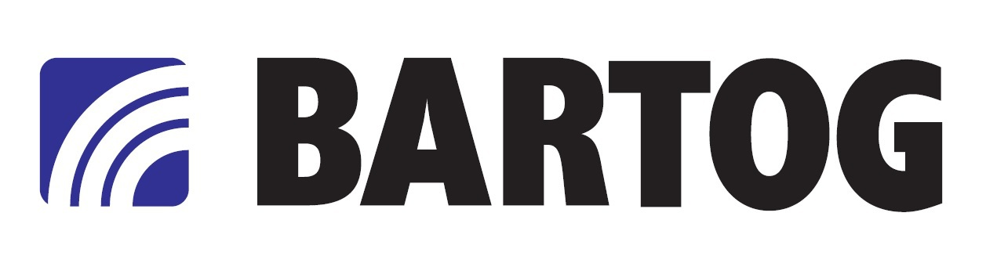  BARTOG | 3, 4, 12, 35 | MEDIUM | LOW | N/A | ✗ | LOW
BARTOG shares the BAR opening and a six-letter frame ending in a hard consonant, giving some visual proximity, but "bar-tog" and "bar-dak" are easily separated in speech. Its goods and services are inner tubes, wheel rims, screen-wash preparations, lubricants and retail or wholesale of vehicles and automobile parts, which are unrelated to drinkware retail. The bold black lettering with a blue arc device further separates the two logos, so the risk is low.
TMView: GB500000918171815
BARTOG | 3, 4, 12, 35 | MEDIUM | LOW | N/A | ✗ | LOW
A duplicate BARTOG registration with the same automotive-focused specification of tyres inner tubes, lubricants, screen cleaners and vehicle retail and wholesale services. The shared BAR prefix gives only moderate visual proximity, while the -TOG ending sounds clearly different from -DAK. With no goods or service proximity to drinkware, the risk remains low.
TMView: GB500000918171819
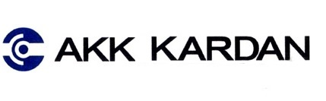  AKK KARDAN | 7, 12, 35 | LOW | LOW | N/A | ✗ | N/A
AKK KARDAN is a further two-word automotive mark in the same family, again sharing only the internal ARDA letter run and accompanied by a circular monogram device. Its scope is vehicle transmission components, machine tools and related trade services for professional buyers. No meaningful similarity and no goods overlap, so no conflict arises.
TMView: GB500000913018031
Breadwich | 21 | LOW | LOW | N/A | IDENTICAL | LOW
Breadwich shares only the B and R letters and evokes the English word bread, so it looks and sounds clearly different from bardak. Its Class 21 goods do include bowls, cups, drinking glasses, insulated flasks, bottles and food storage containers, which are the same field as the applicant's drinkware, so goods overlap is identical. Because the marks themselves are only remotely similar, identical goods alone do not raise this above low risk.
TMView: GB500000003942217

Assumptions and Limitations
Assumptions:
• ASSUMPTION: The Class 35 services were treated as retail and online retail services for the applicant's own drinkware products, since the business description mentions only production of bottles, thermos mugs and drinkware without naming the services. | WHY: The description does not specify what Class 35 activity is intended. | IMPACT: affects goods_overlap and conflict_risk for retail-focused cited marks such as BADRAY, BAITHAK and BRADDOCK, and the Class 35 entry in per_class_assessment.
• ASSUMPTION: "bardak" was assessed as a meaningless coined term for the UK English-speaking public, without importing any foreign-language meaning. | WHY: The country notes list English as the only relevant language, and the word has no English dictionary meaning. | IMPACT: affects distinctiveness_category, inherent_distinctiveness.risk_level and the conceptual similarity scores across relative_grounds.similar_marks.
Limitations:
None specified.

Australia
TRADEMARK REGISTRABILITY ASSESSMENT
Bardak
AU • NICE Classes: 21, 35 • July 30, 2026
Trademark register — data as of: July 28, 2026 · Australia — app 2026-07-28 / reg 2026-03-31 (pending + registered); WIPO — app 2026-07-23 / reg 2026-06-25 (pending + registered)
Applicant origin: Portugal
Practical Outlook
Registration Outlook:
At Risk
A significant conflict with an earlier mark, or a distinctiveness problem, was found. Registration is uncertain and the result depends on examiner discretion or possible opposition. Review the details before filing.
Summary:
Your name can probably be protected, but the outcome for the drinkware part is genuinely uncertain and you should prepare for a fight there. The main problem is an existing Australian trademark called "Bartan", registered for kitchenware and homeware including mugs, drinking glasses, vacuum bottles and water bottles, which is exactly what you make, and the two names share the first three letters and the same rhythm. It is not hopeless: the endings differ, your logo has its own drinking-glass symbol and lettering, and cutting your product list back to insulated bottles and thermos mugs makes the separation cleaner. Your retail and online-shop services class is in much better shape, because none of the earlier marks with similar wording actually sells drinkware, so that side should go through without much trouble.
What to do before filing:
1. Narrow your Class 21 wording to insulated bottles, thermos mugs and reusable drink bottles instead of broad mugs, glassware and containers, so the overlap with "Bartan" is as small as possible.
2. File the mark in the composite form shown in your logo, with the drinking-glass symbol and the distinctive lettering, so you have visual differences to point to against "Bartan".
3. Approach the owner of "Bartan" about a written consent or coexistence arrangement covering insulated drinkware, which is the most reliable way to clear the Class 21 objection.
4. Describe your Class 35 services specifically as retail and online retail of bottles, thermos mugs and drinkware to avoid unnecessary contact with the broad retail marks already on file.

Per-Class Assessment

ⓘ | How registration works: The trademark office examines each class separately. If they find a similar mark in any class, they will send a provisional refusal. This is a normal part of the process and you can respond with arguments about why your services are different.
Class | Status | Prov. Refusal Chance | Success Chance | Key Obstacle
21 | Provisional refusal likely | 75% | 45% | The Australian registration "Bartan" (used for kitchenware and homeware) covers mugs, drinking glasses, vacuum bottles and water bottles, which is essentially the same product range you sell, and the two names look and sound similar.
35 | No obstacles | — | 80% | Several earlier marks sit in Class 35 with broad retail wording, but none of them retails drinkware and none of the names is close enough to yours to cause real trouble.

Detailed Analysis

Mark Analysis
Mark Type: | COMPOSITE
Distinctiveness Category: | ARBITRARY
Distinctiveness Scale
Generic | Descriptive | Suggestive | Arbitrary | Fanciful
← Weak | Strong →

ⓘ | • Generic: Common name for the goods/services category  • Descriptive: Immediately describes goods, services, or characteristics  • Suggestive: Hints at qualities but requires imagination to connect  • Arbitrary: Real word completely unrelated to the goods  • Fanciful: Invented word with no dictionary meaning
Reasoning:
The logo combines the lowercase word "bardak" in a rounded dark-blue sans-serif typeface with a small stylized drinking-glass device partly filled in tan. For English-speaking Australian consumers "bardak" has no dictionary meaning and functions as an invented-looking term, so it is treated as arbitrary/coined for drinkware and retail services. The word element clearly dominates the overall commercial impression; the glass device is small and, because a drinking glass is a direct depiction of the goods (bottles, mugs, drinkware), it adds little distinctive weight on its own. In Turkish "bardak" means "glass/cup", which would be descriptive for drinkware, but Turkish is not an official or widely-used language of Australia, so this does not affect the Australian examination of inherent distinctiveness; the small figurative glass is nonetheless a weak, goods-depicting component.

Assessment Summary
"Bardak" has a realistic but uneven path to registration in Australia: the services class looks comfortable while the goods class faces a serious earlier-rights problem. On absolute grounds the mark is strong, since "bardak" carries no descriptive meaning for English-speaking Australian consumers and the only weak feature is the small drinking-glass symbol, which simply depicts the goods. The principal obstacle is the earlier Australian mark "Bartan", whose Class 21 specification expressly covers mugs, drinking glasses, vacuum bottles and water bottles, mirroring your product range, with "Bartuke" and the homeware BRITEX registration providing weaker secondary contact points in the same class. Class 35 is essentially clean because none of the cited Class 35 marks retails drinkware and none of them is phonetically close. Mitigating factors include the different word endings, your composite logo with its distinctive glass device and colour palette, and the ability to narrow the Class 21 wording to insulated bottles and thermos drinkware. The recommended approach is to file with a tightly drafted Class 21 specification, prepare differentiation arguments against "Bartan", and treat a consent or coexistence arrangement as a fallback.
Registration Probability: 63%

Recommendations
No specific recommendations.

ⓘ | Absolute grounds are inherent registrability criteria examined by the trademark office independently of any existing marks. These are legal requirements that every trademark must satisfy on its own merits.

Absolute Grounds Assessment
Overall Absolute Risk: LOW
Ground | Risk Level | Reason
Inherent Distinctiveness  Whether the mark is distinctive enough to identify the source of goods/services | LOW | As a whole "bardak" is arbitrary for English-speaking Australian consumers and should pass the distinctiveness test under the Trade Marks Act 1995. The only soft point is the small drinking-glass device, which merely depicts the goods and therefore contributes little distinctive character; protection will effectively rest on the word element.
Deceptive/Misleading  Whether the mark could mislead consumers about the nature or quality of goods | No Risk Identified | -
Public Order Morality  Whether the mark contains content contrary to public order or accepted moral principles | No Risk Identified | -
Prohibited Elements  Whether the mark includes state emblems, flags, official symbols or other prohibited elements | No Risk Identified | -
Geographic Indications  Whether the mark contains protected geographic indications or misleading geographic terms | No Risk Identified | -
Linguistic/Cultural  Whether the mark has negative or problematic meanings in local languages or cultures | No Risk Identified | -
Personality Rights  Whether the mark infringes on another person's name, image, or identity rights | No Risk Identified | -
Well-Known Marks  Whether the mark conflicts with well-known marks that enjoy broader protection | No Risk Identified | -

ⓘ | Relative grounds assess potential conflicts with existing registered or pending marks. An examiner or third party may oppose your trademark if it is confusingly similar to a prior mark in the same or related goods/services.

Relative Grounds Assessment
Overall Relative Risk: HIGH
Analysis Notes: The decisive citation is "Bartan" (B BARTAN KITCHENWARE HOMEWARE), whose Class 21 list expressly includes mugs, drinking glasses, vacuum bottles and water bottles that mirror the target's drinkware, and whose dominant word shares the BAR- opening and length of "bardak". Secondary, weaker points of contact come from "Bartuke" (pet articles in Class 21) and the second BRITEX registration (bowls and basins in Class 21), while the remaining marks sit in unrelated sectors. Overlap assessments were based on the actual goods and services text supplied for each cited mark, and the relevant public is general Australian consumers buying inexpensive everyday household drinkware, whose attention level is average.
Similar Marks Analysis:
Vis — Visual | Phon — Phonetic | Conc — Conceptual | Goods — Goods and services Overlap
Mark | Class | Vis | Phon | Conc | Goods | Risk
Baraka | 35, 39, 29, 30, 32 | MEDIUM | MEDIUM | N/A | ✗ | LOW
"Baraka" shares the BAR- opening and a three-syllable rhythm with "bardak", but the endings (-aka vs -dak) differ and the cited mark is presented with a decorative Georgian-script element above the word. Its actual goods and services cover food, beverages and export/logistics services for foodstuffs, with no drinkware in Class 21 and no retail of drinkware in Class 35, so the commercial sectors do not meet. The latest recordal confirms partial protection was granted in Australia, so status does not reduce risk further, yet the absence of goods proximity keeps the conflict risk low.
TMView: WO500000001407465
Baymak | 7, 9, 11, 35, 36, 37, 38, 40, 42 | MEDIUM | MEDIUM | N/A | ✗ | LOW
"Baymak" and "bardak" share the B-A start and the -AK ending, but the middle letters (-ym- vs -rd-) create a different rhythm and spelling. The cited specification is exclusively about heating, cooling, boilers, HVAC equipment and retail/wholesale of that equipment, which is a completely different commercial sector from bottles, thermos mugs and drinkware retail. Buyers of HVAC equipment are largely professional purchasers exercising high attention, further reducing any risk.
TMView: WO501000001062179
  baymak | 11, 35 | MEDIUM | MEDIUM | N/A | ✗ | LOW
This is the stylized version of the same Turkish heating-equipment brand, shown in blue italic lettering with a small device. The Class 35 wording is limited to bringing together heating, sanitary, electrical and data-processing apparatus for sale, which does not extend to drinkware retail, and Class 11 covers heating and sanitary apparatus rather than Class 21 household containers. The mark is protected in Australia per the grant recordal, but the lack of goods proximity keeps the risk low.
TMView: WO500000001399918
Bartuke | 21 | MEDIUM | MEDIUM | N/A | ✓ | MEDIUM
"Bartuke" and "bardak" both start with BAR- and are two-syllable words of similar length, giving a moderate visual and aural resemblance, although the -tuke ending sounds clearly different from -dak. Both sit in Class 21, but the cited specification is confined to pet products (litter boxes, pet feeders, pet bowls, grooming articles) while the target covers bottles, thermos mugs and drinkware for people; these are adjacent household goods sold through overlapping channels, so overlap is treated as related rather than identical. With one moderate similarity dimension and related-only goods, the risk sits at the medium end and can be argued down by pointing to the pet-specific wording.
TMView: AU500000002606116
braddock | 3, 9, 14, 18, 25, 35 | LOW | LOW | N/A | ✗ | N/A
"braddock" is a longer surname-style word presented in bold green lettering with a shamrock replacing the letter O, and it reads and sounds distinctly different from "bardak". Its goods cover cosmetics, jewellery, eyewear, leather goods and clothing, with Class 35 retail limited to clothing, footwear, perfumes and homeware items such as cooking utensils and plates. Even that homeware mention is embedded in a fashion-led list and the marks themselves are not confusable, so there is no meaningful conflict.
TMView: WO500000001349964
BarterDayz | 35 | LOW | LOW | N/A | ✗ | N/A
Only the BAR- opening is shared; "BarterDayz" is a two-word compound with a distinctive Z spelling and a clear bartering concept absent from "bardak". The service is an online marketplace platform rather than retail of drinkware, so the commercial sectors differ. No meaningful conflict arises.
TMView: AU500000002315118
PRODUX | 35 | N/A | N/A | N/A | ✓ | N/A
"PRODUX" shares no letters in the dominant positions with "bardak" and sounds entirely different. Its Class 35 wording covers broad retailing and wholesaling of goods, which formally touches the target's retail services, but with no similarity between the marks there is no likelihood of confusion.
TMView: AU500000001738597
PARTXA | 7, 35, 39 | LOW | LOW | N/A | ✗ | N/A
"PARTXA" shares only a loose A-R-T letter pattern and the unusual X ending makes it look and sound different from "bardak". Its services and goods concern mining, earthmoving and OEM machinery parts, remarketing and warehousing, which are far removed from drinkware and drinkware retail. No meaningful conflict.
TMView: AU500000002362349
BRITEX | 3, 5, 7, 21, 37 | LOW | LOW | N/A | ✗ | N/A
"BRITEX" shares only the initial B and R and ends in the distinctive -TEX suffix, so it neither looks nor sounds like "bardak". Its Class 21 entry is limited to cleaning wipes and the rest of the specification concerns carpet and upholstery cleaning products, machines and services, which do not touch bottles or drinkware. No meaningful conflict.
TMView: AU500000002325636
BRITEX | 6, 21 | LOW | LOW | N/A | ✓ | LOW
This second BRITEX registration does cover Class 21 vessels such as basins, stainless steel bowls and buckets, which are broadly related household containers, and so a formal points of contact exists in Class 21. However the marks differ markedly in spelling, length and sound, with the -TEX ending dominating the cited mark's impression. With all similarity dimensions low, only a residual low-level risk remains.
TMView: AU500000001946278
PORTACOM | 9, 35, 42 | N/A | N/A | N/A | ✗ | N/A
"PORTACOM" is a longer computing-oriented coined term with no visual or aural resemblance to "bardak". Its scope is computer hardware, computer retail and IT support, which is unrelated to drinkware and drinkware retail. No meaningful conflict.
TMView: AU500000000881880
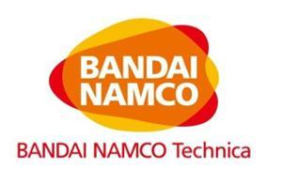  BANDAI NAMCO | 7, 9, 28, 35, 41 | LOW | LOW | N/A | ✗ | N/A
The cited mark is a multi-word logo in red and white for a well-known games and amusement business; only the loose BA- opening of "BANDAI" echoes "bardak". Its goods and services cover video game machines, vending machines, electronics and entertainment, together with retail of those goods, none of which relates to drinkware. No meaningful conflict.
TMView: AU500000001804594
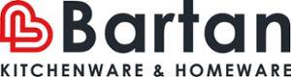  BARTAN KITCHENWARE & HOMEWARE | 21 | MEDIUM | MEDIUM | N/A | IDENTICAL | HIGH
The dominant element of the cited logo is the word "Bartan" (with a red B monogram device and the descriptive line "KITCHENWARE & HOMEWARE" below); comparison must therefore focus on BARTAN versus BARDAK. The two words share the first four positions B-A-R-, are the same length and two-syllable rhythm, and the D/T and N/K differences are subtle in casual speech, giving medium visual and medium phonetic similarity. Crucially the cited Class 21 specification expressly covers mugs, drinking glasses, vacuum bottles, water bottles and drinking vessels, which is effectively the same scope as the target's bottles, thermos mugs and drinkware, so the goods are identical and this is the main obstacle in Class 21 for buyers of inexpensive everyday household goods who exercise only average attention.
TMView: AU500000002278431
ProductPipeline | 9, 35, 42 | N/A | N/A | N/A | ✗ | N/A
"ProductPipeline" is a long descriptive-sounding compound with no resemblance to "bardak" in appearance or sound. Its services are database compilation, business information and SaaS, unrelated to drinkware or its retail. No meaningful conflict.
TMView: AU500000002605723
ProtectaChill | 21 | N/A | N/A | N/A | ✓ | N/A
"ProtectaChill" is a two-element English compound conveying cooling protection and bears no visual or phonetic resemblance to "bardak". Its Class 21 goods are ice packs for transporting food, which are loosely related to insulated drinkware, but with no similarity between the marks there is no likelihood of confusion.
TMView: AU500000001474699

Assumptions and Limitations
Assumptions:
• ASSUMPTION: The target's Class 21 goods are limited to bottles, thermos mugs and other drinkware, and the Class 35 services to retail/wholesale of those goods, as stated in the business description. | WHY: The description names the products but not a formal specification. | IMPACT: affects goods_overlap and conflict_risk for "Bartan", "Bartuke" and BRITEX, and the per_class_assessment scores for classes 21 and 35.
• ASSUMPTION: "bardak" will be read by Australian consumers as a coined word with no meaning rather than as the Turkish word for glass/cup. | WHY: English is the sole relevant language for the Australian public and Turkish is not widely spoken there. | IMPACT: keeps distinctiveness_category at ARBITRARY and inherent_distinctiveness at LOW rather than higher.
Limitations:
None specified.

Croatia
TRADEMARK REGISTRABILITY ASSESSMENT
Bardak
HR • NICE Classes: 21, 35 • July 30, 2026
Trademark register — data as of: June 11, 2026 · Croatia — app 2026-06-11 / reg 2026-03-23 (pending + registered); EUIPO — app 2026-07-29 / reg 2026-07-03 (pending + registered); WIPO — app 2026-07-27 / reg 2026-06-25 (pending + registered)
Applicant origin: Portugal
Practical Outlook
Registration Outlook:
Fixable
The name can likely be registered, but something needs attention first — narrowing or changing the goods/services classes, adding a disclaimer, or adjusting an element of the mark. The name itself stays.
Summary:
Yes, "bardak" can most likely be registered in Croatia, but you should tighten the goods list before filing. The main challenge is a group of earlier Croatian registrations for BARDANI, which cover household and kitchen containers and glassware, exactly the area where your bottles and mugs sit, and which share your first five letters. This is manageable: the Croatian office does not raise earlier marks on its own, so your file should sail through examination, and the risk is limited to the BARDANI owner objecting after your mark is published, at which point you can point to the different ending, the different logo style and your much narrower product focus. Your retail and wholesale services in Class 35 look comfortable, because the other similar-looking names on the register sell cosmetics, clothing, car parts or food rather than drinkware. One thing to keep in mind is that the small glass icon in your logo describes the product and adds little legal weight, so your protection will rest on the word itself.
What to do before filing:
1. Narrow your Class 21 wording to bottles, thermos mugs, insulated flasks and drinking vessels instead of claiming all household and kitchen utensils, so the area of overlap with BARDANI shrinks.
2. Spell out in Class 35 that your services are retail, wholesale and online retail of bottles, thermos mugs and drinkware, which keeps you clearly apart from the cosmetics, clothing, car-parts and food retailers already on the register.
3. File the mark in the composite form you supplied, with the glass device and the distinctive rounded lower-case lettering, so the visual difference from the BARDANI script logo is on record from the start.
4. Prepare a short coexistence argument, or a draft consent request to the BARDANI owner, in case an objection is raised after publication.

Per-Class Assessment

ⓘ | How registration works: The trademark office examines each class separately. If they find a similar mark in any class, they will send a provisional refusal. This is a normal part of the process and you can respond with arguments about why your services are different.
Class | Status | Prov. Refusal Chance | Success Chance | Key Obstacle
21 | N/A | — | 65% | The three BARDANI registrations cover household and kitchen utensils, containers and glassware in Class 21, which directly includes bottles, mugs and drinkware, and they share the first five letters with your name.
35 | N/A | — | 78% | Class 35 in Croatia is crowded with BAR-formative marks such as BARDARO, BARDOU, BARTOG, BATAK and BRADDOCK, but each of them covers retail in a clearly different sector (cosmetics, clothing, car parts, food), so none is a direct blocker.

ⓘ | Estimated Timeline: Straightforward Croatian applications are typically examined and published within roughly 4 to 8 months, followed by an opposition window of about three months. If the BARDANI owner objects, resolving the matter through argument, a narrowing of the goods list or a consent agreement can add a further 6 to 14 months.

Detailed Analysis

Mark Analysis
Mark Type: | COMPOSITE
Distinctiveness Category: | ARBITRARY
Distinctiveness Scale
Generic | Descriptive | Suggestive | Arbitrary | Fanciful
← Weak | Strong →

ⓘ | • Generic: Common name for the goods/services category  • Descriptive: Immediately describes goods, services, or characteristics  • Suggestive: Hints at qualities but requires imagination to connect  • Arbitrary: Real word completely unrelated to the goods  • Fanciful: Invented word with no dictionary meaning
Reasoning:
The logo combines the lower-case word "bardak" in a clean rounded navy typeface with a small stylized drinking-glass device partly filled with an amber liquid. "Bardak" has no meaning in Croatian, so for Croatian consumers it reads as an invented or foreign-sounding word and is arbitrary rather than descriptive for drinkware and related retail services. Note, however, that in Turkish "bardak" literally means "glass/cup", so for the Turkish-speaking segment the word would be generic for the very goods applied for; this segment is not the relevant public in Croatia and the Croatian Trademark Act examination is carried out from the perspective of Croatian consumers. The glass device is descriptive of the goods themselves and therefore contributes little distinctive character, so the word element carries the distinctiveness of the composite.

Assessment Summary
The composite "bardak" logo has a reasonable prospect of registration in Croatia, with the main issue being an earlier family of similar marks rather than any bar on the sign itself. On absolute grounds the word has no meaning for Croatian consumers and is arbitrary for drinkware, so only a low residual risk exists because the small drinking-glass device is itself descriptive of the goods and because a well-informed examiner might note the Turkish meaning of the word. The closest earlier rights are the three BARDANI registrations, whose Class 21 specifications for household and kitchen utensils, containers and glassware cover the applicant's bottles and mugs and which share the first five letters of the applicant's name. Class 35 is the cleaner of the two classes: the register is crowded with BAR-formative service marks but each covers retail in a distinct sector such as cosmetics, clothing, car parts or foodstuffs. Mitigating factors are that Croatia does not examine earlier-mark conflicts on its own initiative, that BARDANI is used as a script logo with a dominant calligraphic B and a longer three-syllable ending, and that BARONPEAK, PRODUX and Paardekooper, although covering identical goods, are not similar signs. A practical route is to file with a precisely worded Class 21 list focused on bottles, thermos mugs and drinkware and to keep the glass device in the mark as filed.
Registration Probability: 72%

Recommendations
No specific recommendations.

ⓘ | Absolute grounds are inherent registrability criteria examined by the trademark office independently of any existing marks. These are legal requirements that every trademark must satisfy on its own merits.

Absolute Grounds Assessment
Overall Absolute Risk: LOW
Ground | Risk Level | Reason
Inherent Distinctiveness  Whether the mark is distinctive enough to identify the source of goods/services | LOW | For Croatian consumers "bardak" has no dictionary meaning and is therefore arbitrary for bottles, thermos mugs and drinkware. The figurative drinking-glass element is itself descriptive of the goods and adds almost no distinctiveness, so protection will rest on the word. A residual low risk exists because a Croatian examiner aware of the Turkish meaning "glass/cup" could raise a descriptiveness query for Class 21 drinkware.
Deceptive/Misleading  Whether the mark could mislead consumers about the nature or quality of goods | No Risk Identified | -
Public Order Morality  Whether the mark contains content contrary to public order or accepted moral principles | No Risk Identified | -
Prohibited Elements  Whether the mark includes state emblems, flags, official symbols or other prohibited elements | No Risk Identified | -
Geographic Indications  Whether the mark contains protected geographic indications or misleading geographic terms | No Risk Identified | -
Linguistic/Cultural  Whether the mark has negative or problematic meanings in local languages or cultures | LOW | Croatian is the only relevant language: "bardak" carries no meaning, no offensive connotation and no negative association in Croatian, so the sign is neutral for the local public. The only linguistic point worth noting is that the word is the ordinary Turkish term for a drinking glass, which is not a language of the Croatian public and therefore does not create a descriptiveness bar in Croatia, though it slightly weakens the conceptual strength of the sign among multilingual consumers.
Personality Rights  Whether the mark infringes on another person's name, image, or identity rights | No Risk Identified | -
Well-Known Marks  Whether the mark conflicts with well-known marks that enjoy broader protection | No Risk Identified | -

ⓘ | Relative grounds assess potential conflicts with existing registered or pending marks. An examiner or third party may oppose your trademark if it is confusingly similar to a prior mark in the same or related goods/services.

Relative Grounds Assessment
Overall Relative Risk: MEDIUM
Analysis Notes: The register in Croatia is crowded with BAR-/BARD- formative marks, but none is close enough to "bardak" to be a blocking citation; the highest risks come from the three BARDANI registrations and BARONPEAK, which cover Class 21 household and kitchen utensils, containers, drinking vessels and insulating flasks identical to the applicant's drinkware. Goods overlap was assessed from the actual goods/services text supplied for every cited mark. The relevant public is general consumers buying inexpensive everyday drinkware plus trade buyers for the Class 35 retail services, with an average level of attention.
Similar Marks Analysis:
Vis — Visual | Phon — Phonetic | Conc — Conceptual | Goods — Goods and services Overlap
Mark | Class | Vis | Phon | Conc | Goods | Risk
BARDARO | 3, 5, 14, 18, 25, 35 | MEDIUM | MEDIUM | N/A | ✗ | LOW
Both signs share the sequence BARDA-, but the endings -K and -RO give clearly different lengths, rhythm and endings, and the cited mark is presented in an elegant serif capital typeface far removed from the applicant's rounded lower-case wordmark with a glass device. The cited Class 35 services cover retail of clothing, footwear, bags, perfumery, cosmetics, jewellery and dietary supplements only, with no drinkware or household goods, and no Class 21 registration exists, so the commercial sectors do not meet. Neither sign has a meaning for Croatian consumers, so conceptual comparison is not applicable.
TMView: EM500000019320328
BARDANI | 18, 20, 21, 22, 25, 28 | MEDIUM | MEDIUM | N/A | IDENTICAL | MEDIUM
The first five letters BARDA- coincide, but the applicant's mark ends in a hard -K single syllable while BARDANI ends in two additional syllables -NI, and the cited mark is a highly stylized script logo dominated by a large calligraphic B, which further separates the visual impressions. The cited Class 21 specification covers household or kitchen utensils and containers and glassware, which literally encompasses bottles, mugs and drinkware, so the goods in Class 21 are identical. Two moderate similarity dimensions combined with identical goods places this at MEDIUM; the cited mark is a coined term for its goods, so it enjoys a normal scope of protection and no downgrade is applied.
TMView: EM500000010531952
BARDANI | 5, 6, 8, 9, 12, 18, 20, 21, 22, 24, 25, 26, 27 | MEDIUM | MEDIUM | N/A | IDENTICAL | MEDIUM
This is a further registration of the same stylized BARDANI script logo with a broader specification, again covering household or kitchen utensils and containers, glassware, chinaware and porcelain in Class 21, which overlaps directly with bottles, thermos mugs and drinkware. Similarity remains moderate visually and phonetically because of the shared BARDA- opening, while the extra -NI ending and the dominant calligraphic B device differentiate the overall impressions. No Class 35 registration exists for this mark, so the applicant's retail services are not affected.
TMView: EM500000016286262
BARDANI | 5, 6, 8, 9, 12, 18, 20, 21, 22, 24, 25, 26, 27 | MEDIUM | MEDIUM | N/A | IDENTICAL | MEDIUM
A duplicate BARDANI filing with the same broad specification, including household or kitchen utensils and containers and glassware in Class 21, which is identical to the applicant's drinkware. The shared BARDA- beginning gives moderate visual and phonetic proximity, tempered by the different three-syllable ending and by the fact that the cited sign is used as a script logo. The presence of several parallel BARDANI registrations means the same proprietor is the single relevant obstacle in Class 21 rather than multiple independent owners.
TMView: EM500000016286239
BATAK | 35, 41, 43 | MEDIUM | MEDIUM | N/A | ✓ | LOW
BATAK and "bardak" share the B-A ... A-K skeleton and both end in -AK, but the applicant's mark contains the additional letters R and D which change the middle of the word and its pronunciation noticeably. The cited Class 35 specification is limited to generic advertising, commercial business management, commercial administration and office functions, which touches the applicant's retail-support activities only in a general way and does not cover retail of drinkware. With only moderate similarity and no genuine sectoral meeting, confusion is unlikely for consumers paying average attention.
TMView: HR502013000000018
BARZAK BOATS | 12, 35, 39 | LOW | MEDIUM | N/A | ✓ | LOW
BARZAK is phonetically somewhat close to "bardak" through the BAR-...-AK frame, but the additional word BOATS and the large nautical rope-and-monogram device dominate the cited composite and give it a completely different overall impression. Its Class 35 services concern retail of clothing, sporting, diving and boating equipment and import-export in the marine sector, not drinkware retail. The clearly maritime concept of the cited mark also pulls the two signs apart.
TMView: EM500000014543755
Baraka | 29, 30, 32, 35, 39 | MEDIUM | MEDIUM | N/A | ✓ | LOW
Baraka shares the BARA- opening and a similar rhythm, but ends in an open -KA syllable rather than the hard closing -DAK, and the cited logo pairs the word with Georgian script and fleur-de-lis ornaments. Its Class 35 services are export agency and marketing services for foodstuffs and beverages, a food-trade sector distinct from retail of bottles and drinkware. Overall the differences in ending, presentation and commercial field keep confusion risk low.
TMView: WO500000001407465
BERDAC | 35, 42 | MEDIUM | MEDIUM | N/A | ✗ | LOW
BERDAC and "bardak" share four letters in a similar order and a comparable two-syllable rhythm, but the vowel in the first syllable differs (BER vs BAR) and the endings -DAC and -DAK, while phonetically close, sit in words of different overall shape; the cited mark also appears with a distinctive blue half-circle device. The cited Class 35 services concern wholesale and retail of medicine dispensers, pill dispensers and pharmaceutical packaging, and Class 42 software design, which is a different commercial sector from drinkware retail. No overlap in the applicant's Class 21 goods exists.
TMView: EM500000018198023
BARDOU | 3, 8, 35, 41, 44 | MEDIUM | MEDIUM | N/A | ✗ | LOW
The signs share the BARD- stem, but BARDOU ends in an open -OU sound whereas the applicant's mark closes with the hard -AK, producing a different ending which consumers notice. The cited Class 35 services are strictly retail and online retail of soaps, perfumery, cosmetics, hair-care products and hairdressing implements, a beauty sector with no connection to bottles or drinkware, and there is no Class 21 registration. Neither term has a meaning in Croatian.
TMView: EM500000015043862
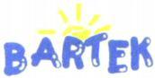  BARTEK | 10, 25, 35 | MEDIUM | MEDIUM | N/A | ✗ | LOW
BARTEK shares the BAR- opening and the -K ending with "bardak", but the middle consonant T instead of D and the vowel E instead of A change the sound, and the cited mark is presented as a childlike blue bubble script with a yellow sun. Its Class 35 services are shops and wholesale of footwear, clothing, leather goods and toys, and its product classes cover clothing and orthopaedic footwear, none of which relates to drinkware. Confusion risk is accordingly low.
TMView: WO500000000906595
BARTEK | 10, 25, 35 | MEDIUM | MEDIUM | N/A | ✗ | LOW
This is a parallel registration of the same childlike BARTEK sun logo, again limited to clothing, footwear, orthopaedic footwear and the running of shops selling those goods. The BAR-...-K frame creates a moderate degree of similarity, but the different middle consonant and vowel plus the very distinctive playful graphic treatment keep the overall impressions apart. There is no meeting of goods or services with bottles, thermos mugs or drinkware retail.
TMView: EM500000004628137
bartar | 29, 30, 31, 32, 35 | MEDIUM | MEDIUM | N/A | ✓ | LOW
bartar repeats the BAR- opening but ends in -TAR rather than -DAK, so the final syllable, which is where the applicant's mark carries its hard closing sound, is entirely different; the cited mark is moreover embedded in a large red-and-orange sun-and-wave device that dominates the composite. Its Class 35 services are retail services relating to food, a foodstuffs sector distinct from drinkware, and its product classes are food and beverage goods rather than containers. Confusion is unlikely.
TMView: EM500000017930586
baldağ | 30, 35 | LOW | LOW | N/A | ✓ | N/A
baldağ differs from "bardak" in the second consonant cluster (-LD- against -RD-) and ends in the soft ğ, so both the written form and the pronunciation are clearly distinguishable. The cited logo is further dominated by a bee-and-mountain device in brown and orange. Its services are limited to bringing together honey, bee glue and propolis for retail, a food sector with no connection to bottles or drinkware, so no meaningful conflict arises.
TMView: WO500000001476973
Bartuke | 21 | MEDIUM | MEDIUM | N/A | ✓ | LOW
Bartuke shares the BAR- start and contains the letters T-K, but the U vowel and the trailing -E create a three-syllable word ending in a vowel, clearly different from the two-syllable, consonant-final "bardak". Although both marks sit in Class 21, the cited specification is confined to pet and animal accessories such as pet feeders, litter boxes, birdcages and pet brushes together with air fragrancing apparatus and aquaria, so it is adjacent to but not the same as human drinkware. Same class number alone does not create identity here.
TMView: EM500000019067887
Baalbak | 33, 35 | MEDIUM | MEDIUM | N/A | ✓ | LOW
Baalbak shares the B-A opening and the -BAK/-DAK ending sound, giving a moderate degree of aural proximity, but the doubled AA and the absence of the R make the written forms clearly distinguishable. The cited Class 35 services are retailing and wholesaling of alcoholic beverages, and Class 33 covers wines and spirits, so the goods sold are drinks rather than the containers the applicant makes. The sectors are adjacent at most and confusion is unlikely for consumers of average attention.
TMView: EM500000018476310
BRADDOCK | 25, 35 | LOW | LOW | N/A | ✓ | LOW
BRADDOCK begins with the consonant cluster BR- rather than BAR-, contains a doubled D and ends in -OCK, so its length, rhythm and ending all differ from "bardak". Its very broad Class 35 specification does include retail of household utensils and of food preparation implements, which touches the applicant's retail sphere, but the marks themselves are too far apart for that overlap to generate real confusion. The applicant's Class 21 goods face no product-class citation from this mark.
TMView: EM500000017999618
BRADDOCK | 3, 9, 14, 18, 25, 35 | LOW | LOW | N/A | ✓ | LOW
This second BRADDOCK registration is presented as a bold green lower-case wordmark with a shamrock device, an impression far removed from the applicant's navy wordmark with a glass icon. Its Class 35 services include retailing and wholesaling of cooking utensils and plates, which is commercially adjacent to retail of drinkware, but the marks differ markedly at the beginning (BRA- against BAR-) and at the end (-OCK against -AK). On balance the risk of confusion remains low.
TMView: EM500000015502537
BERTAKO | 7, 16, 17, 35, 42 | MEDIUM | MEDIUM | N/A | ✗ | LOW
BERTAKO contains the -TAK- sequence and starts with BE- rather than BA-, and it adds a final -O syllable, so the two words are of different length and stress pattern; the cited mark is also shown as an outlined block-letter logo. Its Class 35 services relate exclusively to advertising, business management, import-export and retail of containers, packaging and machine tools for industrial packaging, a B2B packaging sector rather than consumer drinkware retail. No Class 21 registration exists.
TMView: EM500000014784541
BirdDock | 21 | LOW | LOW | N/A | ✓ | N/A
BirdDock is a two-element English compound with an evident bird-and-dock meaning reinforced by a large bird device, whereas "bardak" is a single meaningless word for Croatian consumers, so the signs diverge in structure, sound and concept. Although both are in Class 21, the cited specification covers bird baths, bird feeders, birdcages, pet brushes and litter pans, i.e. animal-related articles rather than human drinkware. No meaningful conflict arises.
TMView: EM500000018816715
BARONPEAK | 3, 4, 5, 6, 7, 8, 9, 11, 12, 14, 16, 17, 18, 19, 20, 21, 25, 28 | LOW | LOW | N/A | IDENTICAL | LOW
BARONPEAK shares only the BAR- opening; it is a long nine-letter compound of two recognisable English words and is pronounced in three syllables, whereas "bardak" is a short two-syllable word, so the overall impressions differ considerably. Its Class 21 specification does expressly cover drinking vessels, thermally insulated containers for food and insulating flasks, which is identical to the applicant's bottles and thermos mugs. Because the mark similarity is low on every dimension, however, identical goods alone do not create actionable confusion risk.
TMView: EM500000019289904
BRATEK | 9, 11, 35 | LOW | LOW | N/A | ✓ | LOW
BRATEK opens with the cluster BR- and has the vowel E in the second syllable, so both its written form and its pronunciation are clearly separable from "bardak"; the cited mark is further presented in a blue technical typeface with a green-and-red bar device. Its Class 35 services concern an online marketplace and consumer product information and management of retail outlets in the electrical and plumbing field, which only loosely touches the applicant's retail activity. Confusion is unlikely.
TMView: EM500000018794147
AK KARDAN | 7, 12, 35 | LOW | LOW | N/A | ✗ | N/A
AK KARDAN is a two-word sign beginning with the letters AK and combined with a circular technical device, so it neither looks nor sounds like the single word "bardak" despite the coincidental presence of the letters A, R, D and K. Its Class 35 services consist of bringing together machine tools, engines and vehicle transmission parts for sale, an automotive engineering sector entirely removed from drinkware. There is no meaningful conflict.
TMView: EM500000013018023
PARTAKUS | 35, 38, 42 | LOW | LOW | N/A | ✗ | N/A
PARTAKUS begins with P, runs to eight letters and three syllables and ends in -US, so it is clearly distinguishable from "bardak" in appearance and pronunciation. Its Class 35 services are business information, commercial intermediation, advertising and search engine optimisation, and its other classes cover database access and software, none of which relates to drinkware or to retail of drinkware. No conflict arises.
TMView: EM500000018190484
BARTOG | 3, 4, 12, 35 | MEDIUM | LOW | N/A | ✗ | LOW
BARTOG shares the BAR- opening but the second syllable -TOG differs in both consonants and vowel from -DAK, so the words sound clearly different when spoken. Its Class 35 services are retail and wholesale of vehicles, car accessories and automobile parts, and its goods are lubricants, windscreen cleaners and tyre inner tubes, an automotive sector unconnected to bottles and drinkware. Confusion is not realistic.
TMView: EM500000018171819
BARTOG | 3, 4, 12, 35 | MEDIUM | LOW | N/A | ✗ | LOW
This parallel BARTOG registration appears as a bold black wordmark with a blue arc device and covers the same automotive lubricants, windscreen cleaners, tyre tubes and vehicle retail services. The shared BAR- beginning produces some visual proximity, but the -TOG ending is aurally distinct from -DAK and the commercial fields do not meet the applicant's drinkware manufacture or retail. Risk remains low.
TMView: EM500000018171815
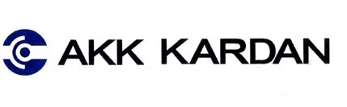  AKK KARDAN | 7, 12, 35 | LOW | LOW | N/A | ✗ | N/A
AKK KARDAN is another two-word automotive sign with the same circular technical device, beginning with AKK and covering machine tools, vehicle transmission parts and their retail. Neither the structure nor the sound resembles the single word "bardak", and the goods and services lie in the automotive engineering sector. No meaningful conflict exists.
TMView: EM500000013018031
PRODUX | 35, 42, 45 | N/A | N/A | N/A | ✗ | N/A
PRODUX has no letters in common with "bardak" at the beginning or end and is pronounced completely differently, so there is no visual, phonetic or conceptual similarity. Its services are business management, workflow and supply-chain management, SaaS data analytics and regulatory compliance, which have nothing to do with drinkware or its retail. This mark presents no conflict.
TMView: EM500000018401086
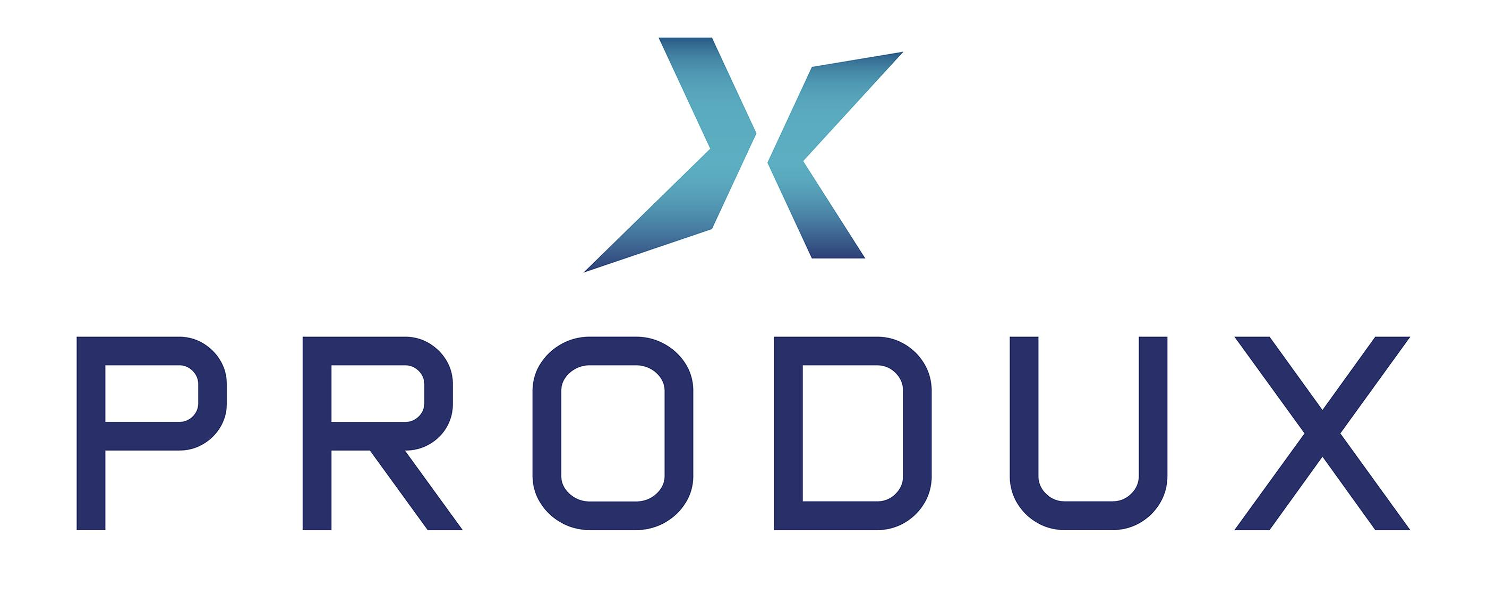  PRODUX | 8, 9, 11, 17, 21, 22, 25, 28, 35, 42 | N/A | N/A | N/A | IDENTICAL | N/A
Although this PRODUX registration covers household or kitchen utensils and containers in Class 21, identical to the applicant's drinkware, and retail services in Class 35, the signs themselves are entirely dissimilar: PRODUX is a five-letter word starting with PR- and ending in -UX, shown in a wide sans-serif capital layout with an X device. With no visual, phonetic or conceptual similarity, identical goods cannot generate confusion.
TMView: EM500000019016966
PRODUX | 8, 9, 11, 17, 21, 22, 24, 25, 28, 35, 42 | N/A | N/A | N/A | IDENTICAL | N/A
A further PRODUX registration with an almost identical specification, again covering household or kitchen utensils and containers in Class 21 and broad retail services in Class 35. The word itself bears no resemblance to "bardak" in spelling, sound or meaning, so despite the overlap in goods there is no basis for confusion.
TMView: EM500000018236792
Paardekooper | 6, 8, 9, 16, 20, 21, 35, 39, 42 | LOW | LOW | N/A | IDENTICAL | LOW
Paardekooper is a long twelve-letter Dutch surname pronounced in four syllables, which is structurally and aurally far removed from the short two-syllable "bardak" despite sharing some letters. Its Class 21 specification expressly includes plastic bottles and plastic and paper cups, identical to part of the applicant's drinkware, and its Class 35 covers wholesale and retail of packaging and disposable articles. Because the marks themselves are barely similar, the overlap in goods does not translate into a realistic likelihood of confusion.
TMView: EM500000018063274

Assumptions and Limitations
Assumptions:
• ASSUMPTION: The Class 21 goods were read as bottles, thermos mugs, insulated flasks and drinking vessels, and the Class 35 services as retail, wholesale and online retail of those goods, based on the short business description. | WHY: The description names the products but not the exact wording of the specification, particularly for Class 35. | IMPACT: affects goods_overlap and conflict_risk for the BARDANI, BARONPEAK, PRODUX and Paardekooper citations and the per_class_assessment scores for classes 21 and 35.
• ASSUMPTION: "Bardak" is treated as a meaningless, invented-sounding word for the Croatian public, notwithstanding its ordinary meaning of glass or cup in Turkish. | WHY: Croatian is the only language listed for the target country and Turkish is not a language of the relevant public there. | IMPACT: affects distinctiveness_category, inherent_distinctiveness.risk_level and linguistic_cultural.risk_level, which would rise to HIGH if the Turkish-speaking public were the relevant one.
Limitations:
• LIMITATION: The business description identifies the product range but not the precise goods and services wording intended for each class. | CONSEQUENCE: goods_overlap, conflict_risk and the per_class_assessment probabilities for classes 21 and 35 rest on a reasonable reading of that range rather than a final specification. | WHAT WOULD REDUCE IT: Provide the exact list of goods and services you intend to claim in classes 21 and 35.

Italy
TRADEMARK REGISTRABILITY ASSESSMENT
Bardak
IT • NICE Classes: 21, 35 • July 30, 2026
Trademark register — data as of: July 29, 2026 · Italy — app 2026-07-29 / reg 2026-03-17 (pending + registered); EUIPO — app 2026-07-29 / reg 2026-07-03 (pending + registered); WIPO — app 2026-07-27 / reg 2026-06-25 (pending + registered)
Applicant origin: Portugal
Practical Outlook
Registration Outlook:
At Risk
A significant conflict with an earlier mark, or a distinctiveness problem, was found. Registration is uncertain and the result depends on examiner discretion or possible opposition. Review the details before filing.
Summary:
Your name can be filed in Italy and the trademark office itself is very unlikely to object — "bardak" means nothing in Italian, so it works as a proper brand name for drinkware. The real problem is a company holding three earlier Italian registrations for BARDANI, and their registrations cover exactly your field: household containers and glassware. Because Italy does not check earlier names during examination, your application will most likely be accepted and published, and the danger is that the BARDANI owner objects during the three-month window that follows. That objection is arguable rather than fatal: the endings AK and ANI look and sound quite different, and your logo with the little drinking glass adds its own character, but with the same goods on both sides the outcome is genuinely uncertain. Your Class 35 retail services are in a better position, because the nearest name there, BARDARO, sells clothing, cosmetics and jewellery rather than drinkware.
What to do before filing:
1. Narrow your Class 21 wording to bottles, vacuum flasks, thermos mugs and drinking vessels instead of broad household utensils, so the overlap with BARDANI's glassware and kitchen-container registration is as small as possible.
2. Word your Class 35 services as retail and online retail of bottles, drinkware and vacuum flasks, which visibly separates you from BARDARO's clothing, cosmetics and jewellery retail.
3. Explore a written coexistence or consent arrangement with the owner of BARDANI before your application is published, since that removes the single biggest threat to Class 21.
4. Always use the name together with the drinking-glass symbol and the distinctive rounded lettering, so your commercial impression stays visibly different from the calligraphic BARDANI presentation.

Per-Class Assessment

ⓘ | How registration works: The trademark office examines each class separately. If they find a similar mark in any class, they will send a provisional refusal. This is a normal part of the process and you can respond with arguments about why your services are different.
Class | Status | Prov. Refusal Chance | Success Chance | Key Obstacle
21 | Provisional refusal likely | 55% | 50% | Three earlier BARDANI registrations cover Class 21 household containers and glassware, which directly includes bottles, mugs and drinkware, and they share the first five letters with your name.
35 | Provisional refusal possible | 45% | 70% | BARDARO and, to a lesser extent, BARDAZZI E MORELLI and BARUTÇU hold Class 35 registrations with broad advertising and retail wording, and BARDARO shares the same BARDA- opening.

Detailed Analysis

Mark Analysis
Mark Type: | COMPOSITE
Distinctiveness Category: | ARBITRARY
Distinctiveness Scale
Generic | Descriptive | Suggestive | Arbitrary | Fanciful
← Weak | Strong →

ⓘ | • Generic: Common name for the goods/services category  • Descriptive: Immediately describes goods, services, or characteristics  • Suggestive: Hints at qualities but requires imagination to connect  • Arbitrary: Real word completely unrelated to the goods  • Fanciful: Invented word with no dictionary meaning
Reasoning:
The logo combines the word "bardak" in a rounded lower-case dark-blue typeface with a small stylised drinking-glass device partly filled with an amber liquid. In Italian, the only relevant language for the Italian Patent and Trademark Office, "bardak" has no meaning and is therefore perceived as an invented or foreign word; it is not descriptive of bottles, thermos mugs or drinkware for the Italian public. In Turkish the word means "glass/tumbler", which would be descriptive for Class 21 drinkware, but Turkish is not a language of the Italian relevant public, so this does not affect distinctiveness in Italy. The glass device is a fairly banal depiction of the goods and adds little distinctive weight, so the word element dominates; overall the mark is arbitrary for the filed goods and retail services.

Assessment Summary
The mark has a realistic but not comfortable prospect of registration in Italy: it passes the absolute-grounds test easily but faces a genuine prior-rights problem in its core class. On absolute grounds there is no meaningful objection — "bardak" carries no meaning in Italian, so it functions as an arbitrary sign for drinkware, the only weak feature being the small drinking-glass device that merely depicts the goods. The principal obstacle is the family of three BARDANI registrations whose Class 21 wording covers household containers and glassware, identical to bottles, thermos mugs and drinkware, and which share the opening BARDA- string. Class 35 is materially safer: the closest citation there, BARDARO, covers retail of clothing, cosmetics and jewellery rather than drinkware, so a well-drafted retail specification largely separates the two. Mitigating factors are the crowded Italian register of BAR-initial marks, the different endings -AK versus -ANI, the applicant's distinctive rounded logotype with the glass symbol, and the fact that Italy does not examine earlier marks on its own initiative, so conflicts only materialise if a prior owner actually opposes. The practical path is to file with a tightly drafted drinkware-focused specification, prepare differentiation arguments against BARDANI, and consider approaching that owner about coexistence before publication.
Registration Probability: 60%

Recommendations
No specific recommendations.

ⓘ | Absolute grounds are inherent registrability criteria examined by the trademark office independently of any existing marks. These are legal requirements that every trademark must satisfy on its own merits.

Absolute Grounds Assessment
Overall Absolute Risk: LOW
Ground | Risk Level | Reason
Inherent Distinctiveness  Whether the mark is distinctive enough to identify the source of goods/services | LOW | For the Italian public "bardak" is a meaningless coined term and is fully capable of distinguishing drinkware and related retail services. The only weak component is the small drinking-glass device, which merely depicts the Class 21 goods and would be given little protective weight, so a low residual concern remains as to the figurative element alone rather than the mark as a whole.
Deceptive/Misleading  Whether the mark could mislead consumers about the nature or quality of goods | No Risk Identified | -
Public Order Morality  Whether the mark contains content contrary to public order or accepted moral principles | No Risk Identified | -
Prohibited Elements  Whether the mark includes state emblems, flags, official symbols or other prohibited elements | No Risk Identified | -
Geographic Indications  Whether the mark contains protected geographic indications or misleading geographic terms | No Risk Identified | -
Linguistic/Cultural  Whether the mark has negative or problematic meanings in local languages or cultures | No Risk Identified | -
Personality Rights  Whether the mark infringes on another person's name, image, or identity rights | No Risk Identified | -
Well-Known Marks  Whether the mark conflicts with well-known marks that enjoy broader protection | No Risk Identified | -

ⓘ | Relative grounds assess potential conflicts with existing registered or pending marks. An examiner or third party may oppose your trademark if it is confusingly similar to a prior mark in the same or related goods/services.

Relative Grounds Assessment
Overall Relative Risk: HIGH
Analysis Notes: The Italian register is crowded with BAR-initial marks, but the decisive citations are the three BARDANI registrations, which cover Class 21 "household or kitchen utensils and containers; glassware" — the same field as bottles, thermos mugs and drinkware — and share the sequence BARDA-. BARDARO and BARDAZZI E MORELLI create additional but weaker pressure, mainly in Class 35, while the remaining marks (BARZAK BOATS, Baraka, BERDAC, BARDOU, BARTEK, bartar, baldağ, Bartuke, BARUTÇU, Baalbak, BRADDOCK, BERTAKO, BirdDock, BARONPEAK, BRATEK, AK KARDAN, AKK KARDAN, PARTAKUS, BARTOG, PRODUX) differ sufficiently in wording, sound or commercial field. Goods overlap was assessed on the actual registry goods/services texts supplied for every cited mark. The relevant public is general consumers of inexpensive everyday household goods plus trade buyers for the retail services, with an average (for Class 21, rather low) degree of attention.
Similar Marks Analysis:
Vis — Visual | Phon — Phonetic | Conc — Conceptual | Goods — Goods and services Overlap
Mark | Class | Vis | Phon | Conc | Goods | Risk
BARDARO | 3, 5, 14, 18, 25, 35 | MEDIUM | MEDIUM | N/A | ✓ | MEDIUM
Both marks begin with the identical string BARDA- and have three syllables, giving medium visual and phonetic similarity, although the endings -AK and -ARO differ clearly and the elegant serif presentation of BARDARO contrasts with the rounded logotype plus glass device of the applicant. Its Class 35 retail scope covers clothing, cosmetics, jewellery and supplements, not drinkware, so the overlap is only broadly related through general advertising and retail-presentation services; the goods classes (3, 5, 14, 18, 25) do not touch drinkware. Neither mark carries a meaning for the Italian public, so conceptual comparison is not applicable.
TMView: EM500000019320328
BARDANI | 18, 20, 21, 22, 25, 28 | MEDIUM | MEDIUM | N/A | IDENTICAL | HIGH
The cited Class 21 specification covers "household or kitchen utensils and containers" and "glassware, porcelain and earthenware", which literally encompasses bottles, mugs and drinkware, so the goods are identical. The marks share the first five letters BARDA- and the same opening two syllables, producing medium visual and medium phonetic similarity, which with identical goods and the low attention paid to inexpensive household items yields a high risk of confusion. The cited figurative form is a large calligraphic B with the word ARDANI, so the word element remains dominant and the comparison rests on the words. The cited term is a coined surname-like sign with no descriptive content for its goods, so no weakening of its scope applies.
TMView: EM500000010531952
BARDANI | 5, 6, 8, 9, 12, 18, 20, 21, 22, 24, 25, 26, 27 | MEDIUM | MEDIUM | N/A | IDENTICAL | HIGH
This registration again covers Class 21 "household or kitchen utensils and containers; glassware, chinaware, porcelain and earthenware", identical in scope to bottles, thermos mugs and drinkware. The shared BARDA- opening gives medium visual and phonetic proximity and the dominant element of the cited stylised sign is still the word BARDANI. With identical goods and an average-to-low level of consumer attention for everyday drinkware, confusion is a realistic prospect and the cited mark is distinctive for its own goods, so its protection is not narrow.
TMView: EM500000016286262
BARDANI | 5, 6, 8, 9, 12, 18, 20, 21, 22, 24, 25, 26, 27 | MEDIUM | MEDIUM | N/A | IDENTICAL | HIGH
A parallel BARDANI registration with the same Class 21 wording covering household containers and glassware, hence identical goods to the applicant's drinkware. The shared initial BARDA- string and matching syllable rhythm give medium visual and phonetic similarity, and the identity of goods raises the overall risk to high. The presence of several BARDANI filings by the same interest strengthens the practical likelihood of an opposition in Class 21.
TMView: EM500000016286239
BARZAK BOATS | 12, 35, 39 | LOW | LOW | N/A | ✓ | LOW
Although BARZAK ends in -AK like the applicant's mark, the middle Z creates a clearly different sound and spelling, and the additional word BOATS plus the prominent nautical rope-and-monogram device give a very different overall impression. Its Class 35 activity concerns advertising and retail of boats, diving and sporting equipment, only loosely related to drinkware retail. Confusion is therefore unlikely.
TMView: EM500000014543755
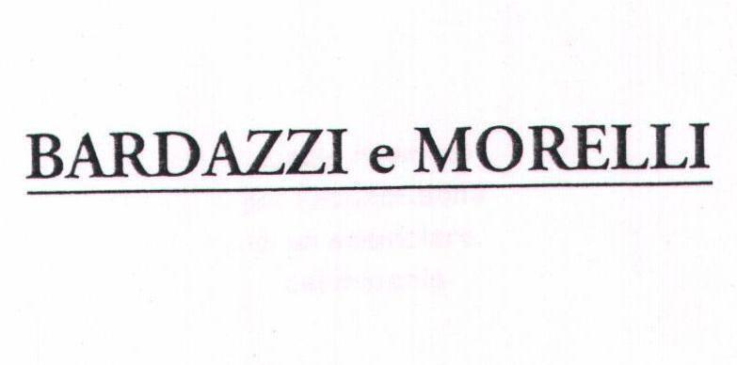  BARDAZZI E MORELLI | 35, 36 | LOW | LOW | N/A | ✓ | LOW
The cited mark is a long two-name Italian firm designation whose overall length and the added E MORELLI element clearly distinguish it, despite the shared BARDA- opening. Its Class 35 entry is a legacy "industrial and commercial affairs" wording that only generically touches business services and does not cover drinkware retail. The very different structure and commercial field make confusion improbable.
TMView: IT502000900895878
Baraka | 29, 30, 32, 35, 39 | LOW | MEDIUM | N/A | ✗ | LOW
BARAKA and BARDAK share the letters B-A-R-A-K but the absence of the D and the different vowel ending produce only a moderate phonetic echo, and the cited logo adds Georgian script and decorative fleur-de-lis elements. The cited registration covers foodstuffs, beverages, food export and delivery services, whereas the applicant sells drinkware and related retail, which are different commercial sectors. Confusion is unlikely.
TMView: WO500000001407465
BERDAC | 35, 42 | LOW | LOW | N/A | ✗ | LOW
BERDAC differs in its second letter and final consonant and is presented with a distinctive circular blue device, so both visual and aural impressions diverge. Its Class 35 services are limited to wholesale and retail of pill dispensers, medicines and medical packaging, a clearly separate sector from drinkware. No meaningful conflict arises.
TMView: EM500000018198023
BARDOU | 3, 8, 35, 41, 44 | MEDIUM | LOW | N/A | ✗ | LOW
BARDOU shares the BARD- opening but its -OU ending is pronounced very differently from -AK, so the aural impression is distinguishable. The cited scope is hair and beauty products, hairdressing implements, beauty training and salon services with matching retail in Class 35, none of which relates to drinkware or drinkware retail. Risk is minimal.
TMView: EM500000015043862
BARTEK | 10, 25, 35 | LOW | LOW | N/A | ✗ | LOW
BARTEK replaces the D with T and the A with E in the second syllable, and the cited logo uses a childlike blue lettering with a yellow sun, giving a very different overall impression. Its goods and services are footwear, clothing, orthopaedic footwear and shops selling those items, unconnected with drinkware. Confusion is not realistically foreseeable.
TMView: EM500000004628137
bartar | 29, 30, 31, 32, 35 | LOW | LOW | N/A | ✗ | LOW
The cited word ends in -TAR rather than -DAK and appears inside a dominant red rectangular device with a sun motif, so the overall impressions differ markedly. Its scope is food products, beverages and food retail services, a different sector from bottles and drinkware. No meaningful conflict.
TMView: EM500000017930586
baldağ | 30, 35 | LOW | LOW | N/A | ✗ | LOW
BALDAĞ shares only the initial BA- and a loose -DAĞ/-DAK resemblance, and its logo with a bee and mountains creates a distinct visual identity. The registration covers honey, propolis and the retail of those goods, entirely separate from drinkware. Risk is negligible.
TMView: WO500000001476973
Bartuke | 21 | LOW | LOW | N/A | ✓ | LOW
Both marks are in Class 21, but the cited specification is confined to pet-related articles such as cages, litter boxes, pet feeders and pet bowls, plus indoor aquaria and atomisers, which are only loosely related to human drinkware. The words differ in the second syllable and in the final -UKE versus -AK, so visual and aural similarity stay low. Even with related Class 21 goods, the low similarity keeps the risk low.
TMView: EM500000019067887
BARUTÇU | 5, 24, 25, 27, 35 | LOW | LOW | N/A | ✓ | LOW
BARUTÇU differs from BARDAK in its second syllable and ending and is presented with a figurative device, so the marks are readily distinguishable. Its Class 35 scope includes an open "bringing together of a variety of goods" retail wording that could formally touch drinkware retail, hence a related overlap in Class 35 only, while its goods classes cover diapers, textiles, clothing and prayer rugs. The latest recordal is a statement of grant of protection in Italy, so the mark is in force, but the low similarity keeps the conflict risk low.
TMView: WO500000001397008
Baalbak | 33, 35 | LOW | MEDIUM | N/A | ✗ | LOW
BAALBAK ends in -BAK and shares several letters, giving a moderate aural echo, but the doubled A and the missing R make the spelling clearly different. The cited registration covers alcoholic beverages and their retail and wholesale, a distinct sector from empty bottles, thermos mugs and drinkware retail. Confusion is unlikely.
TMView: EM500000018476310
BRADDOCK | 25, 35 | LOW | LOW | N/A | ✓ | LOW
BRADDOCK has no vowel after the B, a doubled D and a -OCK ending, so it looks and sounds clearly different from BARDAK. Its very broad Class 35 wording includes retail of household utensils and food preparation implements, which creates a related but not identical services overlap; its Class 25 goods are unrelated. The low degree of sign similarity keeps the risk low.
TMView: EM500000017999618
BRADDOCK | 3, 9, 14, 18, 25, 35 | LOW | LOW | N/A | ✓ | LOW
The second BRADDOCK filing shows the word in bold green lower case with a shamrock device, further separating the overall impressions. Its Class 35 wording expressly includes retailing of household and cooking utensils, giving a related services overlap, while its product classes cover cosmetics, eyewear, jewellery, leather goods and clothing. Because the words differ substantially in structure and sound, confusion remains unlikely.
TMView: EM500000015502537
BERTAKO | 7, 16, 17, 35, 42 | LOW | LOW | N/A | ✗ | LOW
BERTAKO differs in its vowels and adds a final -O, and its outlined block-letter logo with a circular O device gives a distinct visual character. The cited scope is industrial packaging, plastics, filling machines and the advertising, retail and design of containers and packaging for industry, addressed to professional buyers rather than consumers of drinkware. No meaningful conflict.
TMView: EM500000014784541
BirdDock | 21 | LOW | LOW | N/A | ✓ | LOW
Despite the common Class 21, the cited specification is limited to pet and livestock articles such as bird baths, feeders, cages and litter pans, only loosely related to human drinkware. BirdDock is a two-element English compound with a large stylised bird device, wholly different from BARDAK in appearance, sound and concept. Risk is low.
TMView: EM500000018816715
BARONPEAK | 3, 4, 5, 6, 7, 8, 9, 11, 12, 14, 16, 17, 18, 19, 20, 21, 25, 28 | LOW | LOW | N/A | IDENTICAL | LOW
The cited Class 21 list expressly includes drinking vessels, thermally insulated containers for food and insulating flasks, so the goods are identical to the applicant's drinkware. However BARONPEAK is a nine-letter two-element compound whose second half PEAK dominates the ending, and it shares only the BAR- opening with BARDAK, so visual and phonetic similarity are low. Under the applicable rules a single low-similarity profile with identical goods does not create actionable confusion, so the risk stays low.
TMView: EM500000019289904
BRATEK | 9, 11, 35 | LOW | LOW | N/A | ✓ | LOW
BRATEK lacks the vowel after B and ends in -TEK, so it neither looks nor sounds close to BARDAK, and the cited logo adds green and red bars with a bold blue logotype. Its Class 35 services are an online marketplace and retail-management services largely tied to electrical and plumbing goods, only generically related to drinkware retail. Confusion is unlikely.
TMView: EM500000018794147
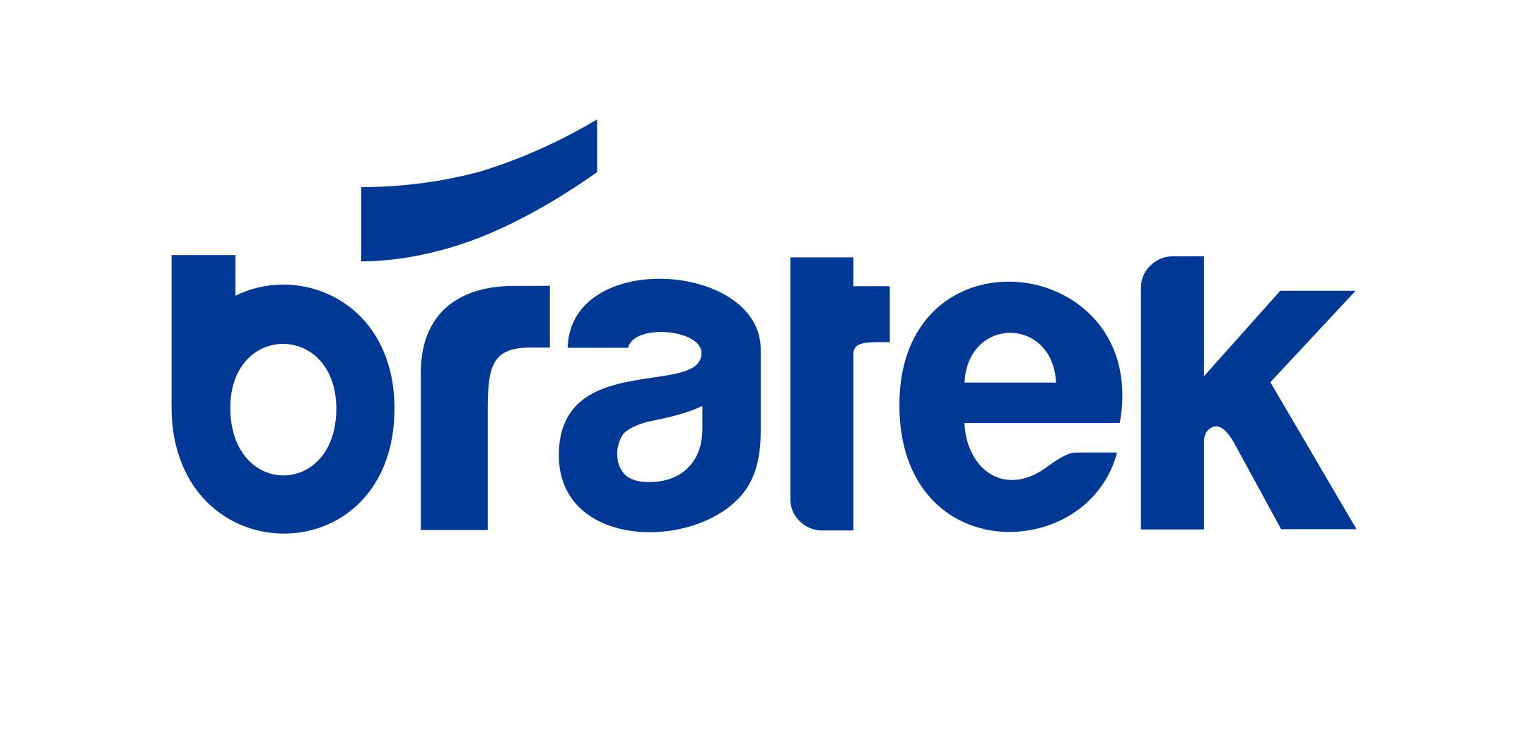  BRATEK | 35 | LOW | LOW | N/A | ✗ | LOW
This second BRATEK registration is confined to Class 35 retail and marketing of woodworking machinery, industrial cleaning apparatus and industrial chemicals, a clearly different commercial sector from drinkware retail. The word itself differs from BARDAK in structure and sound, and the lower-case blue logotype adds further separation. No meaningful conflict.
TMView: IT502022000088628
AK KARDAN | 7, 12, 35 | LOW | LOW | N/A | ✗ | LOW
The cited sign is a two-word mark beginning with AK and accompanied by a circular device; only the internal string -ARDA- loosely echoes the applicant's mark, and the beginnings, which consumers notice most, are entirely different. Its scope is machine tools, engines, vehicle transmission parts and the wholesale of such goods, addressed to professional buyers. No conflict arises.
TMView: EM500000013018023
PARTAKUS | 35, 38, 42 | LOW | LOW | N/A | ✗ | LOW
PARTAKUS begins with P, is eight letters long and ends in -KUS, so it is clearly distinguishable from BARDAK in both appearance and pronunciation. Its Class 35 services are business information, commercial intermediation and search engine optimisation, unrelated to drinkware retail. No meaningful conflict.
TMView: EM500000018190484
PARTAKUS | 35, 38, 42 | LOW | LOW | N/A | ✗ | LOW
This parallel PARTAKUS filing covers the same business-information, database-access and software services in Italian wording, again far from drinkware and its retail. The word differs from BARDAK in initial letter, length and ending. No meaningful conflict.
TMView: IT502020000008584
BARTOG | 3, 4, 12, 35 | LOW | LOW | N/A | ✗ | LOW
BARTOG shares only the BAR- opening; the T, the O and the final G give a clearly different spelling and sound. Its scope is glass and windscreen cleaning preparations, lubricants, inner tubes and rims plus retail of vehicles and car parts, an automotive sector unrelated to drinkware. No conflict.
TMView: EM500000018171819
BARTOG | 3, 4, 12, 35 | LOW | LOW | N/A | ✗ | LOW
The parallel BARTOG registration is shown in heavy black capitals with a blue arc device, reinforcing the visual distance from the applicant's rounded logotype and glass symbol. Its automotive goods and vehicle-parts retail services do not touch drinkware or drinkware retail. No conflict.
TMView: EM500000018171815
AKK KARDAN | 7, 12, 35 | LOW | LOW | N/A | ✗ | LOW
As with the related AK KARDAN filing, the sign starts with AKK and is a two-word combination with a circular device, so the beginnings differ entirely from BARDAK. The covered machine tools, vehicle transmission components and their wholesale are aimed at professional purchasers exercising high attention. No conflict.
TMView: EM500000013018031
PRODUX | 35, 42, 45 | N/A | N/A | N/A | ✗ | N/A
PRODUX shares no meaningful letters, structure or sound with BARDAK, and its services are business management, workflow and compliance software and regulatory compliance services. There is no overlap with drinkware or its retail, so no conflict exists.
TMView: EM500000018401086
PRODUX | 8, 9, 11, 17, 21, 22, 25, 28, 35, 42 | N/A | N/A | N/A | IDENTICAL | N/A
This registration covers Class 21 "household or kitchen utensils and containers" and Class 35 retail of household utensils and glassware, so the goods and services do overlap with the applicant's field. However PRODUX bears no resemblance whatsoever to BARDAK in spelling, sound or concept, and its presentation with a stylised X device is entirely different, so overlap alone creates no likelihood of confusion.
TMView: EM500000019016966

Assumptions and Limitations
Assumptions:
• ASSUMPTION: The Class 35 filing is understood as retail, online retail and promotion of the applicant's own product range of bottles, thermos mugs and drinkware. | WHY: The business description names only the products, without specifying the service wording for Class 35. | IMPACT: affects goods_overlap and conflict_risk for the Class 35 citations such as BARDARO, BRADDOCK and BARUTÇU, and the per_class_assessment scores for class 35.
• ASSUMPTION: Italian consumers perceive "bardak" as a meaningless invented word rather than recognising its Turkish meaning of "glass/tumbler". | WHY: Italian is the only language of the relevant public in Italy and the Turkish meaning is not generally known there. | IMPACT: affects distinctiveness_category, inherent_distinctiveness.risk_level and linguistic_cultural.risk_level.
Limitations:
None specified.

France
TRADEMARK REGISTRABILITY ASSESSMENT
Bardak
FR • NICE Classes: 21, 35 • July 30, 2026
Trademark register — data as of: June 16, 2026 · France — app 2026-06-16 / reg 2026-05-22 (pending + registered); EUIPO — app 2026-07-29 / reg 2026-07-03 (pending + registered); WIPO — app 2026-07-27 / reg 2026-06-25 (pending + registered)
Applicant origin: Portugal
Practical Outlook
Registration Outlook:
Fixable
The name can likely be registered, but something needs attention first — narrowing or changing the goods/services classes, adding a disclaimer, or adjusting an element of the mark. The name itself stays.
Summary:
Yes, Bardak can most likely be registered in France, but it is worth tightening your goods list before you file. The main challenge sits in Class 21: three earlier BARDANI registrations and a BARJAC registration already cover household containers, glassware and bottles, which is precisely your product area. This is overcomable because the French trademark office will not raise those marks itself — the risk is only that one of those owners objects after your mark is published — and because Bardak sounds and looks noticeably different from BARDANI (three syllables, open ending) and BARJAC (different middle and final letters). Your Class 35 side is in better shape, since the other BAR- marks in that class sell advertising, consultancy, food or clothing services rather than drinkware. The register is also full of BAR- names in France, which means none of these owners can claim a wide monopoly on that opening.
What to do before filing:
1. Narrow your Class 21 wording to insulated bottles, thermos mugs, drinking vessels and drinkware instead of broad household containers, so the overlap with BARDANI and BARJAC is as small as possible.
2. Limit your Class 35 wording to retail, wholesale and online sale of bottles, thermos mugs and drinkware, which keeps you clearly apart from the advertising and consultancy services of the BARAKA and BARDAMU marks.
3. File the mark in the composite form shown in your logo, with the stylised glass icon and the rounded lower-case lettering, since this adds visual distance from the cursive BARDANI logo and the plain-text BARJAC.
4. Prepare a short argument on the differences between Bardak, BARDANI and BARJAC now, so you can respond quickly if an objection is filed during the publication period.

Per-Class Assessment

ⓘ | How registration works: The trademark office examines each class separately. If they find a similar mark in any class, they will send a provisional refusal. This is a normal part of the process and you can respond with arguments about why your services are different.
Class | Status | Prov. Refusal Chance | Success Chance | Key Obstacle
21 | Provisional refusal possible | 45% | 70% | Three earlier BARDANI registrations and the BARJAC registration all cover Class 21 household containers, glassware and bottles, which is exactly the field of your bottles, thermos mugs and drinkware.
35 | Provisional refusal possible | 28% | 78% | Many earlier BAR- marks hold broad Class 35 advertising and retail rights, for example BARJAK', BARDAMU, the BARAKA family and the two BRADDOCK registrations whose retail lists even mention household utensils.

ⓘ | Estimated Timeline: A straightforward French application is typically registered in about five to seven months, including the publication and objection window. If the owner of BARDANI or BARJAC files an objection, add roughly six to twelve months for that procedure.

Detailed Analysis

Mark Analysis
Mark Type: | COMPOSITE
Distinctiveness Category: | ARBITRARY
Distinctiveness Scale
Generic | Descriptive | Suggestive | Arbitrary | Fanciful
← Weak | Strong →

ⓘ | • Generic: Common name for the goods/services category  • Descriptive: Immediately describes goods, services, or characteristics  • Suggestive: Hints at qualities but requires imagination to connect  • Arbitrary: Real word completely unrelated to the goods  • Fanciful: Invented word with no dictionary meaning
Reasoning:
The mark is a composite consisting of the lower-case word "bardak" in a rounded dark-blue sans-serif typeface, preceded by a small stylised drinking-glass device partially filled with an amber liquid. For French-speaking consumers "bardak" has no dictionary meaning and reads as an invented, arbitrary term, so it is inherently capable of distinguishing bottles, thermos mugs and drinkware in Class 21 and the related retail services in Class 35. The word is the dominant element; the glass device is small and, because it depicts a drinking glass, is a weak, descriptive-leaning allusion to the goods themselves and adds little independent distinctiveness. Because that figurative component merely evokes the goods, the mark cannot be treated as wholly free of weak matter, although the coined word carries the overall distinctive impression.

Assessment Summary
Prospects for registering the composite Bardak mark in France are reasonably good, with the main uncertainty coming from earlier rights rather than from the mark itself. On absolute grounds the position is clean: "bardak" has no meaning in French, so it functions as an arbitrary term for drinkware, and the only weak feature is the small drinking-glass icon, which merely depicts the goods and adds little of its own. The principal conflicts are the three BARDANI registrations and BARJAC, all of which cover Class 21 household containers, glassware and bottles, giving direct goods overlap with moderate rather than high sign similarity. Class 21 therefore carries the concentrated risk, while Class 35 is comparatively comfortable because the earlier BAR- marks in that class cover advertising, consultancy, food or clothing retail rather than drinkware. Mitigating factors are strong: the French register is heavily populated with BAR- prefixed marks, France does not examine earlier rights on its own initiative, and the endings -AK, -ANI and -AC are audibly different. A sensible path is to keep the figurative glass element in the filing and to draft both class specifications tightly around bottles, thermos mugs and drinkware and their retail.
Registration Probability: 74%

Recommendations
No specific recommendations.

ⓘ | Absolute grounds are inherent registrability criteria examined by the trademark office independently of any existing marks. These are legal requirements that every trademark must satisfy on its own merits.

Absolute Grounds Assessment
Overall Absolute Risk: LOW
Ground | Risk Level | Reason
Inherent Distinctiveness  Whether the mark is distinctive enough to identify the source of goods/services | LOW | "Bardak" has no meaning in French and functions as an arbitrary coined term for drinkware and related retail services, so no descriptiveness objection is expected under the French Intellectual Property Code. The only weak element is the small drinking-glass device, which merely depicts the goods and contributes little distinctive character; the word element carries the mark.
Deceptive/Misleading  Whether the mark could mislead consumers about the nature or quality of goods | No Risk Identified | -
Public Order Morality  Whether the mark contains content contrary to public order or accepted moral principles | No Risk Identified | -
Prohibited Elements  Whether the mark includes state emblems, flags, official symbols or other prohibited elements | No Risk Identified | -
Geographic Indications  Whether the mark contains protected geographic indications or misleading geographic terms | No Risk Identified | -
Linguistic/Cultural  Whether the mark has negative or problematic meanings in local languages or cultures | No Risk Identified | -
Personality Rights  Whether the mark infringes on another person's name, image, or identity rights | No Risk Identified | -
Well-Known Marks  Whether the mark conflicts with well-known marks that enjoy broader protection | No Risk Identified | -

ⓘ | Relative grounds assess potential conflicts with existing registered or pending marks. An examiner or third party may oppose your trademark if it is confusingly similar to a prior mark in the same or related goods/services.

Relative Grounds Assessment
Overall Relative Risk: MEDIUM
Analysis Notes: The French register is crowded with BAR-prefixed six-to-seven letter marks, and overlap was assessed from the actual goods/services texts supplied for each cited mark. The closest concerns are BARDANI (three registrations covering Class 21 household and kitchen utensils and containers, glassware) and BARJAC (Class 21 bottles, drinking glasses, household containers), both reaching MEDIUM; BARTANK and BARBAR also touch Class 21 drinkware but differ more clearly. The relevant public is general consumers of inexpensive everyday household goods, plus retail buyers, exercising an average level of attention.
Similar Marks Analysis:
Vis — Visual | Phon — Phonetic | Conc — Conceptual | Goods — Goods and services Overlap
Mark | Class | Vis | Phon | Conc | Goods | Risk
BARJAK' | 32, 33, 35 | MEDIUM | MEDIUM | N/A | ✓ | LOW
BARJAK' shares the BAR- opening and the -AK ending with Bardak, differing in the central consonant (J versus D), which is clearly audible in French. Its goods are beverages in Classes 32 and 33 plus broad advertising and business services in Class 35, which are not the drinkware goods of Class 21; only the general Class 35 business/retail-presentation services are loosely related to the applicant's retail activity. Both marks are coined terms, so no conceptual comparison applies, and with only moderate similarity and no product overlap the confusion risk stays low.
TMView: FR500000004175904
  Barack | 35, 36, 42 | LOW | MEDIUM | LOW | ✗ | LOW
Barack shares the BAR- beginning and a hard final consonant sound but differs in spelling and in the presence of the D in the applicant's mark. Its Class 35 services are business management and construction-project management, its Class 36 real-estate and Class 42 IT services, none of which relate to drinkware or to retail of drinkware. Barack is also strongly perceived as a given name, which further separates the commercial impression.
TMView: FR500000004723004
Barmad | 35, 41, 42 | LOW | LOW | N/A | ✗ | N/A
Barmad shares only the BAR- prefix; the second syllable (-mad versus -dak) differs in both spelling and sound. Its actual services are advertising, entertainment and software development, with no connection to drinkware or to retail of household goods. No meaningful conflict arises.
TMView: FR500000004269436
BARDARO | 3, 5, 14, 18, 25, 35 | MEDIUM | MEDIUM | N/A | ✗ | LOW
BARDARO shares the first five letters BARDA- but adds an extra syllable, giving a three-syllable Italianate rhythm versus the two-syllable Bardak. Its listed goods are cosmetics, pharmaceuticals, jewellery, bags and clothing, and its Class 35 retail services are expressly limited to clothing, footwear, bags, perfumery, jewellery and supplements — none of which covers drinkware. Absent goods proximity, the shared prefix alone does not create actionable confusion.
TMView: EM500000019320328
BARDANI | 21, 18, 22, 28, 20, 25 | MEDIUM | MEDIUM | N/A | IDENTICAL | MEDIUM
BARDANI shares the first five letters BARDA- with Bardak and its Class 21 specification covers household or kitchen utensils and containers and glassware, which directly encompasses bottles, mugs and drinkware. The endings differ meaningfully: Bardak ends in a hard -AK stop while BARDANI ends in an open two-syllable -ANI, giving three syllables against two in French pronunciation. With identical Class 21 goods but only moderate visual and phonetic proximity, this is a genuine but not decisive opposition risk; the stylised handwritten B logo of the cited mark further separates the visual impressions.
TMView: EM500000010531952
BARDANI | 21, 22, 24, 25, 26, 27, 5, 6, 8, 9, 12, 18, 20 | MEDIUM | MEDIUM | N/A | IDENTICAL | MEDIUM
This second BARDANI registration again covers Class 21 household or kitchen utensils and containers, glassware, chinaware, porcelain and earthenware, which overlaps directly with bottles, thermos mugs and drinkware. The shared BARDA- opening supports moderate visual and phonetic similarity, while the additional -NI syllable and the cited mark's cursive B device differentiate the overall impressions. The broad Class 21 wording of this earlier mark makes it the type of right most likely to be relied upon in an opposition.
TMView: EM500000016286262
BARDANI | 5, 6, 8, 9, 12, 18, 20, 21, 22, 24, 25, 26, 27 | MEDIUM | MEDIUM | N/A | IDENTICAL | MEDIUM
A third BARDANI filing with the same broad Class 21 wording covering household and kitchen utensils and containers and glassware, so the goods overlap with drinkware is direct. Similarity remains moderate rather than high because of the extra final syllable and the differing endings -AK versus -ANI. The repetition of this family of rights in Class 21 increases the practical likelihood that the owner would notice and react to a published Bardak application.
TMView: EM500000016286239
BARDAMU | 35, 38, 41 | MEDIUM | MEDIUM | N/A | ✓ | LOW
BARDAMU shares the BARDA- opening but ends in an open -MU syllable, producing a clearly different three-syllable sound. Its services are advertising, press agency and entertainment services; only the general Class 35 advertising and presentation-of-goods wording is loosely related to the applicant's retail activity, and none of it touches Class 21 goods. Overall the risk is low.
TMView: FR500000004221407
  BARDAGE.INFO | 9, 16, 35, 38, 41, 42 | LOW | LOW | LOW | ✓ | LOW
The cited sign is dominated by "Bardage" plus the ".INFO" suffix; "bardage" is an ordinary French building-cladding term, giving the earlier mark a weak, meaning-laden character quite unlike the coined Bardak. Its Class 35 services are general advertising and business administration, only loosely related to retail of drinkware, and there is no Class 21 cover. The descriptive nature of the earlier sign narrows its protection, keeping the risk low.
TMView: FR500000003913838
BARZAK BOATS | 12, 35, 39 | LOW | MEDIUM | LOW | ✓ | LOW
BARZAK BOATS shares the BAR- opening and -AK ending, but the Z versus D difference and the added word BOATS with a prominent nautical rope-and-monogram device create a very different overall impression. Its actual services concern boats, marinas and retail of clothing, sporting, headgear, footwear and diving equipment, none of which covers drinkware; only the generic advertising wording in Class 35 is loosely related. Risk remains low.
TMView: EM500000014543755
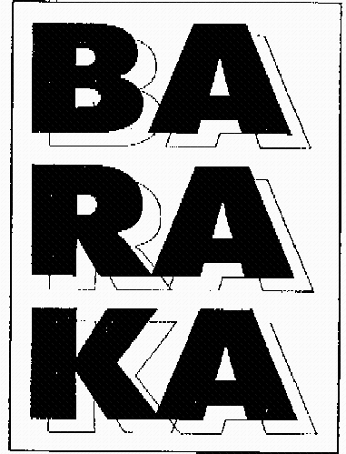  BARAKA | 28, 35, 36, 41 | MEDIUM | MEDIUM | N/A | ✓ | LOW
BARAKA shares four letters with Bardak but lacks the D and ends in an open vowel, so in French it is pronounced ba-ra-ka against bar-dak — a noticeably different rhythm. Its scope is games and toys, advertising and business administration, insurance, finance and lotteries; only the general Class 35 business wording is loosely related to the applicant's retail activity, and there is no Class 21 cover. The bold three-line block logo further distances the visual impression.
TMView: FR500000093494628
BARAKA | 9, 25, 28, 30, 32, 35, 41, 43 | MEDIUM | MEDIUM | N/A | ✓ | LOW
This BARAKA registration covers clothing, games, foodstuffs, beverages, electronics, advertising, entertainment and catering, but no Class 21 drinkware; only its broad Class 35 business and commercial intermediation services are loosely related. Phonetically ba-ra-ka differs from bar-dak through the absent D and the final open vowel. Absent overlap on the applicant's core goods, the risk is low.
TMView: FR500000005257366
BARAKA | 28, 35, 36, 41 | MEDIUM | MEDIUM | N/A | ✓ | LOW
A duplicate BARAKA filing with the same games, advertising, business administration, insurance and lottery scope. The similarity analysis is the same as for the other BARAKA rights: moderate letter overlap, different syllable structure, and no cover for drinkware, leaving only loose Class 35 proximity. Risk stays low.
TMView: FR500000093494629
  Baraka | 35, 36 | MEDIUM | MEDIUM | N/A | ✗ | LOW
This Baraka right covers only business-management consultancy in Class 35 and banking, credit and insurance in Class 36 — clearly a different commercial sector from retail of drinkware, so despite the shared class number the services are unrelated. The marks differ in the presence of the D and in ending sound. No meaningful confusion risk arises.
TMView: FR500000003466448
Baraka | 35, 39, 29, 30, 32 | MEDIUM | MEDIUM | N/A | ✓ | LOW
This Baraka right covers foodstuffs and beverages in Classes 29, 30 and 32, delivery and storage in Class 39, and Class 35 advertising, marketing and export-agency services for foodstuffs. Retail-type activity is limited to food export agency, not drinkware, so the overlap with the applicant's retail scope is loose at most. The composite logo with a Georgian-script element and fleur-de-lis ornaments adds further visual distance, keeping risk low.
TMView: WO500000001407465
BARAKA | 9, 35, 38 | MEDIUM | MEDIUM | N/A | ✗ | LOW
The Class 35 wording here is confined to telecommunications subscription services for third parties, and the remaining classes are electronic apparatus and telecommunications, none of which relates to drinkware or its retail. Even though the marks share four letters, the different syllable structure combined with unrelated services keeps the risk low.
TMView: FR500000004618947
BARJAC | 6, 11, 21 | MEDIUM | MEDIUM | N/A | IDENTICAL | MEDIUM
BARJAC's Class 21 specification expressly lists bottles, household and kitchen containers, tableware and drinking glasses, so the goods are effectively identical to the applicant's bottles, thermos mugs and drinkware. The signs share the BAR- opening and a six-letter, two-syllable structure ending in a hard consonant, but the central J versus D and the final C versus K produce audible and visual differences in French. Identical goods amplify this single moderate similarity dimension to a real but manageable opposition risk.
TMView: FR500000004956561
BERDAC | 35, 42 | MEDIUM | MEDIUM | N/A | ✗ | LOW
BERDAC shares the B-R-D-A-C letter skeleton but the vowel sequence differs (BER-DAC versus BAR-DAK) and the cited mark is presented with a distinctive blue circular device. Its Class 35 wholesale and retail activity is expressly limited to medicine and pill dispensers and pharmaceutical packaging, and Class 42 to software design, so the sectors are clearly different from drinkware retail. Risk is low.
TMView: EM500000018198023
BARDOU | 3, 8, 35, 41, 44 | MEDIUM | LOW | N/A | ✗ | LOW
BARDOU shares the BARD- stem but ends in the open French -OU sound, which is clearly distinguishable from -AK in speech. Its goods and services are cosmetics, hairdressing implements, beauty training, salon services and retail expressly limited to hair and beauty products, with no drinkware element. Risk is low.
TMView: EM500000015043862
BARTEK | 25, 35, 10 | LOW | MEDIUM | N/A | ✗ | LOW
BARTEK shares the BAR- prefix and a final -K but the middle vowel and consonant differ (T-E versus D-A), and the cited mark is presented in a childlike blue lettering with a yellow sun device. Its scope is footwear and clothing plus shops selling footwear and leather accessories and orthopaedic footwear — a different sector from drinkware. Risk is low.
TMView: EM500000004628137
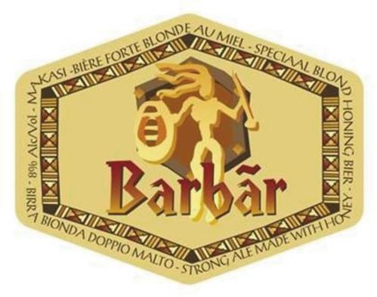  BARBAR | 16, 21, 32 | LOW | LOW | LOW | IDENTICAL | LOW
BARBAR covers glass bottles, carafes, drinking glasses and glass containers in Class 21, which is effectively the same field as the applicant's drinkware. However the marks diverge substantially: BARBAR is a reduplicated BAR-BAR with an ornate beer-label device, evoking the French word "barbare", whereas Bardak is a coined two-syllable term with a minimalist glass icon. With only low similarity on all dimensions the identical goods do not generate meaningful confusion.
TMView: FR500000004283352
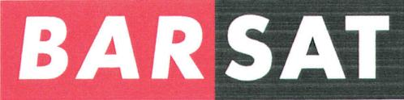  BARSAT | 9, 16, 28, 35, 38, 40, 41, 42, 43, 44, 45 | LOW | LOW | N/A | ✓ | LOW
BARSAT shares only the BAR- prefix; the -SAT ending differs in spelling and sound and the logo splits the mark into contrasting red and grey blocks, reinforcing a BAR + SAT reading. Its enormous specification is centred on media, telecommunications, publishing and general business services, with no drinkware goods and only generic advertising overlap with the applicant's retail scope. Risk is low.
TMView: FR500000098735420
bartar | 29, 30, 31, 32, 35 | LOW | LOW | N/A | ✗ | LOW
bartar shares the BAR- opening but ends in -TAR and is presented within a large red-and-orange composite device, producing a very different overall impression. Its goods are foodstuffs and beverages and its Class 35 services are retail relating to food, not drinkware. No meaningful conflict arises.
TMView: EM500000017930586
BARTANK | 7, 21, 32, 39 | LOW | LOW | LOW | ✓ | LOW
BARTANK's Class 21 items are beer mugs, beer glasses, coasters, drip trays and beer-line cleaning devices, which are related to but narrower than the applicant's bottles and thermos mugs and are clearly tied to draught-beer dispensing. The sign reads as BAR + TANK, an evocative combination for beer equipment, which narrows its protection, and it differs from Bardak in its middle consonants and its -ANK ending. Risk is low.
TMView: FR500000004270497
baldağ | 30, 35 | LOW | LOW | N/A | ✗ | N/A
baldağ shares only the initial B-A and a general two-syllable shape; the L versus R and the final ğ make it visually and phonetically distinct, and the logo features a bee and mountains. Its scope is honey, propolis and the retail of those goods, unrelated to drinkware. No meaningful conflict.
TMView: WO500000001476973
Bartuke | 21 | MEDIUM | LOW | N/A | ✓ | LOW
Bartuke is a seven-letter Class 21 mark sharing the BAR- opening and the letters A, R, K, but its -TUKE ending sounds clearly different from -DAK in French. Its Class 21 specification is confined to pet accessories, aquaria, atomisers and air-fragrancing apparatus, including pet feeding and drinking bowls, which is adjacent to but not the same as human drinkware. The limited similarity and narrow specification keep the risk low.
TMView: EM500000019067887
BARUTÇU | 5, 24, 25, 27, 35 | LOW | LOW | N/A | ✓ | LOW
BARUTÇU shares only the BAR- prefix; the -UTÇU ending with its cedilla is visually and phonetically remote from -DAK. Its goods are diapers, textiles, clothing and prayer rugs, with Class 35 covering advertising and a general bringing-together-of-goods retail formula that could theoretically extend broadly. A statement of grant of protection is recorded for France in 2018, so the right is in force, but the low similarity keeps the risk low.
TMView: WO500000001397008
Baalbak | 33, 35 | LOW | MEDIUM | LOW | ✗ | LOW
Baalbak ends in the same -BAK sound as Bardak's second syllable but the letter sequence BAAL- is visually distinct and evokes the Lebanese place name Baalbek. Its scope is alcoholic beverages and the retail and wholesale of alcoholic beverages, not drinkware, so the sectors do not meet. Risk is low.
TMView: EM500000018476310
BRADDOCK | 25, 35 | LOW | LOW | N/A | ✓ | LOW
BRADDOCK is an eight-letter surname-like sign with a different consonant cluster (BR- versus BAR-) and a -DOCK ending, so both the visual and phonetic impressions differ. Its Class 25 goods are clothing and footwear and its very broad Class 35 retail wording covers, among many sectors, household utensils, which is loosely related to drinkware retail. Given the clear difference between the signs, risk remains low.
TMView: EM500000017999618
BRADDOCK | 3, 9, 14, 18, 25, 35 | LOW | LOW | N/A | ✓ | LOW
This second BRADDOCK registration, shown in a green lower-case logo with a shamrock device, covers cosmetics, eyewear, jewellery, bags and clothing plus Class 35 retail and wholesale that expressly mentions household and cooking utensils, giving a loose relationship with drinkware retail. The signs nonetheless differ markedly in structure and sound, so no meaningful confusion is expected.
TMView: EM500000015502537

Assumptions and Limitations
Assumptions:
• ASSUMPTION: The Class 35 filing is treated as retail, wholesale and online sale services for the applicant's own product range of bottles, thermos mugs and drinkware. | WHY: The business description names only the products, without specifying the services covered by Class 35. | IMPACT: affects goods_overlap and conflict_risk for the Class 35-heavy cited marks such as BARJAK', BARDAMU, the BARAKA family and BRADDOCK, and the Class 35 entry in per_class_assessment.
• ASSUMPTION: "Bardak" is read by French consumers as a meaningless coined word with no recognised French meaning. | WHY: The term is not French, and its foreign-language meanings are not part of everyday French vocabulary. | IMPACT: affects distinctiveness_category, inherent_distinctiveness.risk_level and linguistic_cultural.risk_level.
Limitations:
None specified.

Germany
TRADEMARK REGISTRABILITY ASSESSMENT
Bardak
DE • NICE Classes: 21, 35 • July 30, 2026
Trademark register — data as of: July 27, 2026 · Germany — app 2026-07-27 / reg 2026-07-23 (pending + registered); EUIPO — app 2026-07-29 / reg 2026-07-03 (pending + registered); WIPO — app 2026-07-27 / reg 2026-06-25 (pending + registered)
Applicant origin: Portugal
Practical Outlook
Registration Outlook:
Fixable
The name can likely be registered, but something needs attention first — narrowing or changing the goods/services classes, adding a disclaimer, or adjusting an element of the mark. The name itself stays.
Summary:
Yes, you can most likely register "bardak" in Germany, but you should tighten your product and service lists before filing. The main challenge is in Class 21: three earlier German registrations for BARDANI and one for BATPAK already cover drinking cups, glassware and household containers, so those owners could object after your application is published. This is usually manageable, because the words differ clearly after "BAR", your logo with the amber-filled glass looks nothing like theirs, and the German register is already full of BAR-names, which means none of them holds a wide monopoly. Your Class 35 retail side looks noticeably cleaner, since the earlier BAR-marks in that class sell clothing, jewellery, cosmetics, food or packaging rather than drinkware. One point to be aware of: in Turkish "bardak" simply means "drinking glass", which is fine for German examination but makes the name a weaker asset among Turkish-speaking customers.
What to do before filing:
1. Narrow your Class 21 list to bottles, insulating flasks, thermos mugs and drinking vessels instead of claiming all household utensils and containers, so it overlaps less with BARDANI and BATPAK.
2. Write your Class 35 services as retail and online retail of bottles, thermos mugs and drinkware, so they are visibly different from the clothing, jewellery and food retail covered by the earlier BAR-marks.
3. File the mark as the full logo with the glass symbol and lowercase lettering, since that visual difference is your strongest argument against the calligraphic BARDANI sign.
4. Prepare a short comparison of your drinkware focus versus BARDANI's camping and furniture range, ready to use if that owner contacts you or files an objection.

Per-Class Assessment

ⓘ | How registration works: The trademark office examines each class separately. If they find a similar mark in any class, they will send a provisional refusal. This is a normal part of the process and you can respond with arguments about why your services are different.
Class | Status | Prov. Refusal Chance | Success Chance | Key Obstacle
21 | Provisional refusal possible | 50% | 65% | Several earlier German marks cover the same drinkware and household container goods with similar-looking names, above all the three BARDANI registrations and BATPAK.
35 | Provisional refusal possible | 30% | 78% | Many earlier BAR-prefixed marks are registered in Class 35, but their retail services relate to other sectors (clothing, jewellery, hearing aids, cosmetics, food, packaging), so the overlap with retail of drinkware is limited.

ⓘ | Estimated Timeline: German applications are typically examined within roughly 4 to 8 months, followed by a three-month period in which earlier owners can object once the mark is published. If an objection is filed and has to be argued or settled, add roughly another 12 to 24 months.

Detailed Analysis

Mark Analysis
Mark Type: | COMPOSITE
Distinctiveness Category: | ARBITRARY
Distinctiveness Scale
Generic | Descriptive | Suggestive | Arbitrary | Fanciful
← Weak | Strong →

ⓘ | • Generic: Common name for the goods/services category  • Descriptive: Immediately describes goods, services, or characteristics  • Suggestive: Hints at qualities but requires imagination to connect  • Arbitrary: Real word completely unrelated to the goods  • Fanciful: Invented word with no dictionary meaning
Reasoning:
The logo combines the lowercase wordmark "bardak" in a clean rounded navy typeface with a small figurative element: a stylised drinking glass partially filled with an amber liquid. For German-speaking consumers, "Bardak" has no dictionary meaning in German, so it functions as an arbitrary/coined term for drinkware and retail services. However, the word is the Turkish everyday noun for "glass/tumbler", i.e. exactly the product being sold (bottles, thermos mugs, drinkware), and the glass device in the logo reinforces that reading; for the substantial Turkish-speaking public in Germany the term is therefore descriptive of the goods themselves. Because German is the sole official language and the average German consumer will not decode the Turkish meaning, the mark remains registrable in principle, but this weak-for-part-of-the-public component keeps the distinctiveness floor above zero. The word element clearly dominates over the small glass icon.

Assessment Summary
Overall, "bardak" in its composite logo form has a reasonable prospect of registration in Germany, with the main uncertainty coming from earlier marks rather than from examination itself. On absolute grounds the sign is arbitrary for the German-speaking public; the only soft spot is that the word is the ordinary Turkish noun for a drinking glass and the logo depicts a glass, which makes the sign product-referential for part of the public in Class 21. On the conflict side no identical mark exists, but the three BARDANI registrations and BATPAK cover the very same drinkware and household container goods with visually and phonetically comparable names, which creates a moderate opposition exposure. Class 35 is the cleaner class because the numerous earlier BAR-marks in that class relate to retail of clothing, jewellery, cosmetics, food, hearing aids and packaging rather than drinkware. Mitigating factors are the crowded field of BAR-prefixed marks in Germany, which narrows each owner's scope of protection, the distinctive glass device and lowercase styling of your logo, and the fact that Germany does not refuse applications over earlier marks on its own initiative. The recommended approach is to keep the composite form, tighten the Class 21 and Class 35 wording to bottles, insulated flasks, thermos mugs, drinking vessels and their retail, and be prepared to argue the clear ending differences against BARDANI and BATPAK.
Registration Probability: 72%

Recommendations
• [GOODS_SCOPE] Consider limiting Class 21 to bottles, insulating flasks, thermos mugs, drinking vessels and drinkware instead of the broad "household or kitchen utensils and containers" heading — to shrink the overlap with the BARDANI registrations and with BATPAK, whose Class 21 list covers cups, dishes and containers — expected impact: converts part of the current identical overlap into a narrower area and weakens any opposition based on the full class heading.
• [GOODS_SCOPE] Consider wording the Class 35 services explicitly as retail, wholesale and online retail of bottles, thermos mugs and drinkware — to distinguish them from the Class 35 retail services of BARDARO, Barrah, BRADDOCK, Baraka and BERTAKO, which concern clothing, jewellery, food and packaging — expected impact: makes the services demonstrably different in sector and lowers conflict exposure in Class 35.
• [FILING_STRATEGY] Consider filing the mark in the composite form shown in the logo, including the amber-filled glass device and the lowercase rounded typeface, rather than as a plain word — to add visual matter that separates it from the calligraphic BARDANI presentation and from BATPAK's green leaf styling — expected impact: strengthens the differences in overall impression that would be decisive in any opposition.
• [DESIGN_ELEMENT] Consider giving the glass device more prominence or a more individual graphic treatment within the logo — to counterbalance the fact that the word alone names the product in Turkish and thus carries a weaker distinctive load for drinkware — expected impact: reinforces distinctiveness for the Class 21 goods where the sign is most product-referential.
• [COEXISTENCE] Consider preparing a coexistence or delimitation approach towards the owner of the BARDANI registrations, framed around your narrow drinkware focus versus their broad camping, furniture and textile portfolio — to defuse the most likely opposition before it escalates — expected impact: can remove the principal remaining obstacle in Class 21.

ⓘ | Absolute grounds are inherent registrability criteria examined by the trademark office independently of any existing marks. These are legal requirements that every trademark must satisfy on its own merits.

Absolute Grounds Assessment
Overall Absolute Risk: LOW
Ground | Risk Level | Reason
Inherent Distinctiveness  Whether the mark is distinctive enough to identify the source of goods/services | LOW | For the average German-speaking consumer "bardak" carries no meaning and functions as an arbitrary sign, so a §8(2) No. 1/2 MarkenG objection is unlikely. The residual risk stems from the fact that the word is the ordinary Turkish noun for a drinking glass and the logo depicts a glass, which makes the sign product-referential for a sizeable Turkish-speaking segment of the German public, particularly for the Class 21 drinkware.
Deceptive/Misleading  Whether the mark could mislead consumers about the nature or quality of goods | No Risk Identified | -
Public Order Morality  Whether the mark contains content contrary to public order or accepted moral principles | No Risk Identified | -
Prohibited Elements  Whether the mark includes state emblems, flags, official symbols or other prohibited elements | No Risk Identified | -
Geographic Indications  Whether the mark contains protected geographic indications or misleading geographic terms | No Risk Identified | -
Linguistic/Cultural  Whether the mark has negative or problematic meanings in local languages or cultures | LOW | German is the only official language of the target country and "Bardak" has no German meaning, offensive connotation or negative association, so the sign is neutral for the reference public. The only linguistic point worth noting is the Turkish meaning "drinking glass", which a Turkish-speaking part of the German public would recognise as directly naming the product; this supports a low, not a medium, risk because examination practice is anchored on the perception of the German-speaking public.
Personality Rights  Whether the mark infringes on another person's name, image, or identity rights | No Risk Identified | -
Well-Known Marks  Whether the mark conflicts with well-known marks that enjoy broader protection | No Risk Identified | -

ⓘ | Relative grounds assess potential conflicts with existing registered or pending marks. An examiner or third party may oppose your trademark if it is confusingly similar to a prior mark in the same or related goods/services.

Relative Grounds Assessment
Overall Relative Risk: MEDIUM
Analysis Notes: No cited mark reproduces "Bardak" identically; the closest sign-level neighbours are BARDANI (three registrations covering Class 21 household and kitchen utensils and containers, glassware), BATPAK (Class 21 drinkware including coffee cups and dishes) and BARDARO, while Baodan, Bartuke, BirdDock and BARONPEAK also cover Class 21 with lower sign similarity. The relevant public is general consumers of inexpensive everyday household goods plus retail customers, exercising average attention. Goods overlap was determined from the actual registry goods/services texts, not from class numbers alone.
Similar Marks Analysis:
No similar marks were analyzed.

Assumptions and Limitations
Assumptions:
• ASSUMPTION: The Class 21 filing is read as covering bottles, insulated flasks, thermos mugs and drinking vessels, and Class 35 as retail and wholesale of those goods. | WHY: The business description names the products but the actual filing wording is not provided. | IMPACT: affects goods_overlap and conflict_risk for BARDANI, BATPAK, Baodan, Bartuke, BirdDock and BARONPEAK, and the per_class_assessment scores for classes 21 and 35.
• ASSUMPTION: "Bardak" is pronounced by German speakers as BAR-dak with a hard final k. | WHY: The word has no German meaning and several pronunciations are conceivable. | IMPACT: affects the phonetic scores and therefore conflict_risk for Barak, BARDANI, BARDARO and BATPAK.
Limitations:
None specified.

United States
TRADEMARK REGISTRABILITY ASSESSMENT
Bardak
US • NICE Classes: 21, 35 • July 30, 2026
Trademark register — data as of: July 27, 2026 · United States — app 2026-07-27 / reg 2026-07-23 (pending + registered); WIPO — app 2026-07-27 / reg 2026-06-22 (pending + registered)
Applicant origin: Portugal
Practical Outlook
Registration Outlook:
Fixable
The name can likely be registered, but something needs attention first — narrowing or changing the goods/services classes, adding a disclaimer, or adjusting an element of the mark. The name itself stays.
Summary:
Yes, BARDAK looks registrable in the US, but you should tighten your goods and services wording before filing. The main challenge is a registered mark called "BARAAN" that covers drinkware and coffee mugs in Class 21 — exactly what you make — and its name also starts with BAR. That is overcomable because the second halves of the names look and sound quite different (BAR-DAK versus BA-RAAN), your logo includes a drinking-glass symbol, and the register is already full of BAR-names in household goods, so no single owner can claim a wide monopoly. Your Class 35 retail side is in better shape, especially if you say clearly that you retail bottles, thermos mugs and drinkware rather than using broad wording that bumps into marks like "BARDAN". One point to keep in mind: your name means "glass" in Turkish, which is not a language US examiners would usually apply here, but it is worth knowing if you later expand to Turkey or the EU.
What to do before filing:
1. Narrow your Class 21 list to bottles, thermos mugs, vacuum flasks and drinkware so it stops sitting directly on top of "BARAAN" and other household-goods marks.
2. Word your Class 35 services as retail and online retail of your own product type, so they read as clearly different from the broad retail cover of "BARDAN" and "BARAKA".
3. File the logo with the drinking-glass device and its colour scheme, since that presentation gives you extra visual distance from the plain-text marks cited against you.
4. Prepare a short comparison of BARDAK against BARAAN, BARDAN and BARDEAU (spelling, pronunciation, look) so you can reply quickly if the office raises one of them.

Per-Class Assessment

ⓘ | How registration works: The trademark office examines each class separately. If they find a similar mark in any class, they will send a provisional refusal. This is a normal part of the process and you can respond with arguments about why your services are different.
Class | Status | Prov. Refusal Chance | Success Chance | Key Obstacle
21 | Provisional refusal possible | 50% | 68% | "BARAAN", registered in Class 21 for drinkware and coffee mugs, covers the very same products you sell and shares the BAR- opening with your name. "BARDEAU ESSENTIALS" and "BARTEQ" add further pressure in the same class.
35 | Provisional refusal possible | 30% | 78% | "BARDAN" covers broad e-commerce and retail shop services and is visually close to your name, and there are several BARAKA/BARIKA retail-service marks in the same class.

Detailed Analysis

Mark Analysis
Mark Type: | COMPOSITE
Distinctiveness Category: | ARBITRARY
Distinctiveness Scale
Generic | Descriptive | Suggestive | Arbitrary | Fanciful
← Weak | Strong →

ⓘ | • Generic: Common name for the goods/services category  • Descriptive: Immediately describes goods, services, or characteristics  • Suggestive: Hints at qualities but requires imagination to connect  • Arbitrary: Real word completely unrelated to the goods  • Fanciful: Invented word with no dictionary meaning
Reasoning:
The logo combines the lowercase wording "bardak" in a clean rounded sans-serif with a small line-drawn drinking glass containing a tan liquid. For English-speaking US consumers "BARDAK" has no dictionary meaning, so it functions as an arbitrary/coined term for bottles, thermos mugs and drinkware and for retail of those goods. Note that in Turkish "bardak" means "glass/cup", which is exactly the applicant's product; however Turkish is not a language of the target country, so under US practice the doctrine of foreign equivalents is unlikely to be applied to a language not commonly spoken by an appreciable segment of US purchasers for these everyday goods, and the term stays registrable in principle. The drinking-glass device is a weak, product-descriptive figurative element that adds little distinctiveness, so protection effectively rests on the word.

Assessment Summary
BARDAK has a reasonable prospect of registration in the United States for both filed classes, since for English-speaking consumers the word is a coinage with no descriptive meaning and the logo adds a clean, recognisable presentation. On absolute grounds the only mild concern is that the small drinking-glass device merely depicts the goods and that the word means "glass/cup" in Turkish, a language unlikely to trigger the doctrine of foreign equivalents for everyday drinkware in the US. The main pressure comes from earlier marks: "BARAAN" is registered in Class 21 for drinkware and coffee mugs, the same products you sell, while "BARDAN" and the BARAKA/BARIKA family cover broad retail services in Class 35. Class 35 is the cleaner of the two once the service wording is tied to drinkware retail; Class 21 is where an office objection is most likely. Mitigating factors are the crowded field of BAR-prefixed marks, which limits how far each earlier mark reaches, and the audible difference between the endings DAK, RAAN, DAN and DEAU. The practical route is to file the logo version, keep the specifications tightly focused on drinkware, and be ready with a differentiation argument against BARAAN.
Registration Probability: 73%

Recommendations
• [GOODS_SCOPE] Consider limiting the Class 21 wording to bottles, thermos mugs, vacuum flasks and drinkware for beverages instead of broad household-utensil terms — to reduce the identical-goods overlap with "BARAAN" and the related overlap with "BARDEAU ESSENTIALS" and "BARTEQ" — expected impact: narrows the field of comparison and improves the odds of overcoming a Class 21 objection.
• [GOODS_SCOPE] Consider specifying the Class 35 services as retail and online retail store services featuring bottles, thermos mugs and drinkware — to move away from the broad e-commerce and retail wording of "BARDAN" and the general consumer-goods retail of "BARAKA" — expected impact: turns a potentially related retail overlap into a clearly distinct commercial sector.
• [FILING_STRATEGY] Consider filing the composite logo shown (the wording with the drinking-glass device and the specific two-colour treatment) rather than a bare word mark — to add visual separation from the plain-text citations "BARAAN", "BARDAN" and "BARTEQ" — expected impact: strengthens the differences in overall commercial impression relied on in a response.
• [DESIGN_ELEMENT] Consider strengthening the figurative part beyond the plain drinking-glass outline, for example with a more stylised or unique graphic device — to compensate for the fact that a glass merely depicts drinkware and adds little distinctiveness — expected impact: increases the distinctive weight of the logo as a whole.
• [COEXISTENCE] If a refusal citing "BARAAN" in Class 21 is issued, consider approaching that owner about a consent or coexistence arrangement with agreed differences in wording and presentation — to address the only citation whose goods are effectively identical to yours — expected impact: a filed consent is commonly the most direct way to remove this specific obstacle.
• [MARK_MODIFICATION] If differentiation arguments prove difficult, consider adding a distinctive second element to the wording (for example a coined house-name preceding BARDAK) — to increase the distance from "BARAAN", "BARDAN" and "BARDEAU" — expected impact: reduces visual and phonetic proximity to the closest citations.

ⓘ | Absolute grounds are inherent registrability criteria examined by the trademark office independently of any existing marks. These are legal requirements that every trademark must satisfy on its own merits.

Absolute Grounds Assessment
Overall Absolute Risk: LOW
Ground | Risk Level | Reason
Inherent Distinctiveness  Whether the mark is distinctive enough to identify the source of goods/services | LOW | The word "bardak" carries no meaning for US English consumers and is treated as arbitrary for drinkware, so no descriptiveness refusal is expected. The only weak element is the small drinking-glass device, which merely depicts the goods and contributes almost nothing to distinctiveness. A residual low risk exists because the word means "glass/cup" in Turkish, and an examiner aware of that could raise the doctrine of foreign equivalents.
Deceptive/Misleading  Whether the mark could mislead consumers about the nature or quality of goods | No Risk Identified | -
Public Order Morality  Whether the mark contains content contrary to public order or accepted moral principles | No Risk Identified | -
Prohibited Elements  Whether the mark includes state emblems, flags, official symbols or other prohibited elements | No Risk Identified | -
Geographic Indications  Whether the mark contains protected geographic indications or misleading geographic terms | No Risk Identified | -
Linguistic/Cultural  Whether the mark has negative or problematic meanings in local languages or cultures | No Risk Identified | -
Personality Rights  Whether the mark infringes on another person's name, image, or identity rights | No Risk Identified | -
Well-Known Marks  Whether the mark conflicts with well-known marks that enjoy broader protection | No Risk Identified | -

ⓘ | Relative grounds assess potential conflicts with existing registered or pending marks. An examiner or third party may oppose your trademark if it is confusingly similar to a prior mark in the same or related goods/services.

Relative Grounds Assessment
Overall Relative Risk: N/A
Analysis Notes: The register is crowded with BAR-/BA-prefixed marks, but none is close enough to BARDAK to be a blocking citation; the highest risks come from BARAAN and BARDEAU ESSENTIALS in Class 21 (drinkware and household goods) and from BARDAN and BARAKA in Class 35 retail. Goods overlap was assessed from the actual goods/services texts supplied for the cited marks rather than from class numbers alone. The relevant public is general consumers of inexpensive everyday drinkware exercising an average to low degree of attention, which slightly amplifies similarity in Class 21.
Similar Marks Analysis:
Vis — Visual | Phon — Phonetic | Conc — Conceptual | Goods — Goods and services Overlap
Mark | Class | Vis | Phon | Conc | Goods | Risk
BARDAN | 35, 5, 30 | HIGH | MEDIUM | N/A | ✓ | N/A
BARDAN and BARDAK share the first five letters and differ only in the final consonant, giving high visual similarity, while the ending N versus K makes them audibly distinguishable to a moderate degree. Its Class 35 cover is broad ("e-commerce stores, retail shop services, advertising, marketing"), which could plausibly encompass online retail of drinkware, so overlap with the target's Class 35 retail services is related. No overlap with the target's Class 21 goods. Both terms are meaningless coinages for US consumers, so no conceptual comparison applies.
TMView: US500000099855721
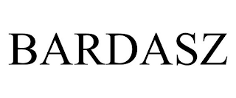  BARDASZ | 35, 40, 42 | MEDIUM | MEDIUM | N/A | ✗ | N/A
BARDASZ shares the BARDA- opening but adds the distinctive SZ ending, giving moderate visual and phonetic proximity. Its actual services are data processing, business data analysis and technical consulting for the oil, gas and geothermal sectors, which have no commercial connection with drinkware or drinkware retail even though Class 35 is shared. Same class number does not create related services here.
TMView: US500000097425510
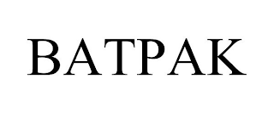  BATPAK | 21 | LOW | LOW | N/A | ✗ | N/A
BATPAK shares only the initial B and a final K with BARDAK; the internal letters and the two-part BAT-PAK rhythm are clearly different. The Class 21 goods are bat-removal kits for buildings, a completely different product field from bottles and drinkware, so consumers would not associate the undertakings.
TMView: US500000098407181
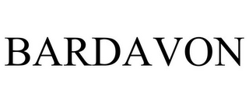  BARDAVON | 35, 42, 44 | MEDIUM | LOW | N/A | ✗ | N/A
The marks share the BARDA- opening but BARDAVON is markedly longer and pronounced in three syllables, so overall impressions diverge. The cited services are healthcare business consulting, medical data analytics and medical information services, wholly unrelated to drinkware or its retail.
TMView: US500000087056060
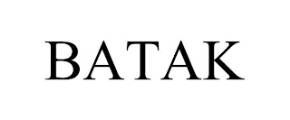  BATAK | 35 | MEDIUM | MEDIUM | N/A | ✗ | N/A
BATAK and BARDAK share the B-A opening and -AK ending and a similar rhythm, giving moderate similarity, though the missing R and D are noticeable. The cited services are limited to arranging and conducting promotional and advertising events, which is a different commercial sector from retail of drinkware.
TMView: US500000097859118
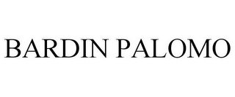  BARDIN PALOMO | 35, 41, 42 | LOW | LOW | N/A | ✗ | N/A
The dominant impression of BARDIN PALOMO is a two-word personal-name combination, quite different from the single word BARDAK despite the shared BARD- string. The services are event planning, party and wedding services and interior or packaging design, unconnected with drinkware or its retail.
TMView: US500000087237625
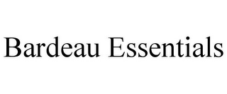  BARDEAU ESSENTIALS | 21 | MEDIUM | MEDIUM | N/A | ✓ | N/A
The dominant element is BARDEAU, since ESSENTIALS is a laudatory add-on with little source significance; BARDEAU shares BARD- with BARDAK but the French-looking -EAU ending is pronounced "bar-doh", which distances the sound. The Class 21 goods are combs and hair brushes, which are household/personal care articles in the same class family as drinkware and often sold through the same channels, so the overlap is related rather than identical. The weak ESSENTIALS component narrows the cited mark's overall scope only slightly, since BARDEAU itself is distinctive.
TMView: US500000088141123
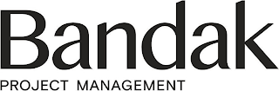  BANDAK PROJECT MANAGEMENT | 35, 37 | MEDIUM | MEDIUM | N/A | ✗ | N/A
The dominant element in the logo is the stylized word "Bandak", with PROJECT MANAGEMENT in small descriptive type; BANDAK differs from BARDAK by a single middle letter, so word-level similarity is appreciable. However the services are business and construction project management and procurement of construction materials, entirely separate from drinkware goods or drinkware retail, so confusion is unlikely.
TMView: US500000098332709
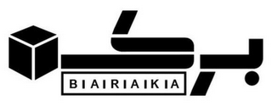  BARAKA | 35 | MEDIUM | MEDIUM | N/A | ✓ | N/A
BARAKA shares BAR-A-A structure with BARDAK but ends in a vowel and lacks the D, so both visual and phonetic similarity stay moderate; the cited logo also features a prominent cube device and Arabic script that further separate the overall impressions. Its services, online retail of a wide variety of consumer goods and marketing services, could cover retail of drinkware, so the Class 35 overlap is related. Only one moderate dimension against related services keeps risk in the lower band.
TMView: US500000087905760
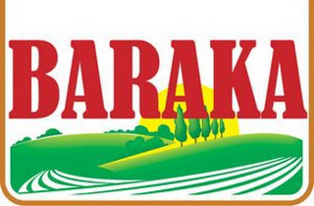  BARAKA | 35 | MEDIUM | MEDIUM | N/A | ✗ | N/A
This second BARAKA is presented as a colourful landscape label device, which markedly differs from the plain wording of the target logo. Its services are wholesale distributorships featuring groceries, a food-trade sector with no meaningful connection to retail of bottles and drinkware.
TMView: US500000077382780
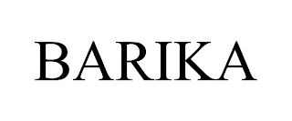  BARIKA | 35 | MEDIUM | MEDIUM | N/A | ✓ | N/A
BARIKA and BARDAK share the BAR- opening and a three-syllable cadence, but the I/A vowels and the missing D make them reasonably distinguishable. The cited services are retail store services for office products, a different product field from drinkware, yet both are retail store services in Class 35, so a limited related overlap is recognised at retail-service level. With a single moderate dimension and no product-field overlap, conflict remains low.
TMView: US500000098410850
BARTEK | 35, 25, 10 | MEDIUM | MEDIUM | N/A | ✗ | N/A
BARTEK shares BAR- and a final K with BARDAK, but the middle TE versus DA changes both look and sound, and the cited logo is a childlike hand-drawn script with a sun device. The goods and services are footwear, clothing, orthopedic footwear and their retail, unrelated to drinkware. The recordals show an initial refusal followed by partial protection and later a partial invalidation, so the mark retains some protection for part of its scope; this does not increase risk given the unrelated fields.
TMView: WO500000000906595
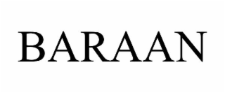  BARAAN | 21 | MEDIUM | MEDIUM | N/A | IDENTICAL | N/A
BARAAN and BARDAK share the BAR- beginning and a similar two-syllable rhythm, though the doubled A and final N versus the DAK ending keep similarity at a moderate level rather than high. The Class 21 specification expressly covers "Drinkware; coffee mugs", which is effectively the same scope as the applicant's bottles, thermos mugs and drinkware, so the goods are identical. Identical everyday goods bought with average to low attention amplify even moderate similarity, making this the strongest citation in Class 21.
TMView: US500000099386230
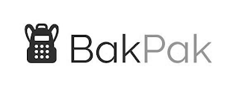  BAKPAK | 35 | LOW | LOW | N/A | ✗ | N/A
BAKPAK is a two-beat coinage evoking "backpack", visually and aurally distinct from BARDAK apart from the shared initial BA. The cited services are accounting services, entirely removed from drinkware retail, so no meaningful conflict arises.
TMView: US500000098258589
baldağ | 30, 35 | LOW | LOW | N/A | ✗ | N/A
Only the initial BA is shared; the L, the accented ğ and the bee-and-mountain device create a very different overall impression. The goods and retail services concern honey, propolis and bee products, unrelated to drinkware. The latest recordal confirms protection was granted in the US, but the unrelated fields keep risk negligible.
TMView: WO500000001476973
baymak | 11, 35 | LOW | LOW | N/A | ✗ | N/A
BAYMAK shares only the BA- opening and a final K with BARDAK and is presented with a distinctive blue script and device. Its goods and retail services relate to heating, cooking, air-conditioning apparatus and electronics, not drinkware; although the Class 35 wording is broad, it is expressly tied to those apparatus. The latest recordal indicates protection was granted in the US, which does not change the low assessment.
TMView: WO500000001399918
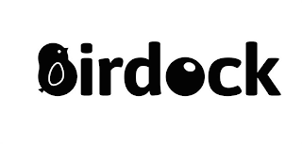  BIRDOCK | 21 | LOW | LOW | N/A | ✓ | N/A
BIRDOCK reads and sounds as "bird-ock", with a bird device in the logo, giving a clear conceptual and aural identity distinct from BARDAK despite the shared B, R and D letters. Its Class 21 goods are pet and aquarium articles, but they include "vacuum mugs", which is a drinkware item, so a related overlap exists. Low similarity on all dimensions keeps the conflict minimal.
TMView: US500000097196071
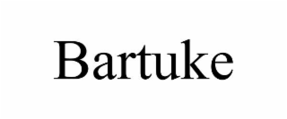  BARTUKE | 21 | MEDIUM | LOW | N/A | ✗ | N/A
BARTUKE shares the BAR- opening but the TUKE ending gives a three-syllable, clearly different pronunciation. The Class 21 goods are exclusively pet feeders, litter boxes and pet grooming articles, a distinct product field from human drinkware, so consumers are unlikely to associate the marks.
TMView: US500000098701483
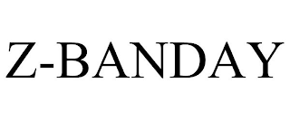  Z-BANDAY | 21 | LOW | LOW | N/A | ✓ | N/A
The leading Z- prefix and the BANDAY ending make this mark visually and aurally distant from BARDAK. Its Class 21 list includes containers for household or kitchen use, glass jars and glass storage jars, which are household containers related to bottles and drinkware, so a related overlap is recognised. Because all similarity dimensions are low, the conflict remains minimal.
TMView: US500000090055505
braddock | 35, 3, 14, 25, 18, 9 | LOW | LOW | N/A | ✗ | N/A
BRADDOCK is a recognised surname/place-style word with a shamrock device, pronounced "brad-ock", clearly different from BARDAK in structure and sound. Its Class 35 retail cover concerns clothing, footwear, perfumes, bags, cooking utensils and household linen rather than drinkware specifically. The most recent recordal is a total invalidation, so the mark is no longer an obstacle, which further reduces any risk.
TMView: WO500000001349964
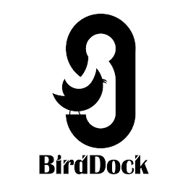  BIRDDOCK | 21 | LOW | LOW | N/A | ✓ | N/A
BIRDDOCK reads as the two English words "bird" and "dock" and the logo emphasises a bird device, producing an impression far removed from the coined BARDAK. Its Class 21 goods are pet and aquarium articles including "vacuum mugs", giving a related but narrow overlap with drinkware. Low similarity throughout means there is no meaningful confusion risk.
TMView: US500000097053215
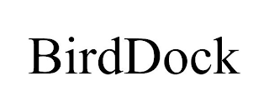  BIRDDOCK | 21 | LOW | LOW | N/A | ✗ | N/A
This second BIRDDOCK registration is limited to bird baths, bird cages, feeders, pet brushes and pet feeding dishes, with no drinkware for human use. The word is also conceptually and aurally distinct from BARDAK, so no conflict arises.
TMView: US500000097754613
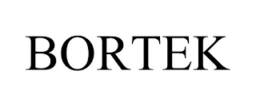  BORTEK | 1, 35, 3, 36, 16, 20 | LOW | LOW | N/A | ✗ | N/A
BORTEK shares only B, R and a final K with BARDAK; the O and TE core produce a different look and sound. Its Class 35 retail services are expressly restricted to industrial and municipal power cleaning equipment and cleaning supplies, a distinct commercial sector from drinkware retail.
TMView: US500000098342168
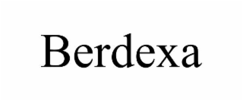  BERDEXA | 5, 31, 21 | LOW | LOW | N/A | ✗ | N/A
BERDEXA has a distinctive X and an -EXA ending that makes it look and sound clearly different from BARDAK. Its Class 21 entry is limited to finger brushes for pet dental care, and its other goods are pet treats, so there is no overlap with bottles, mugs or drinkware.
TMView: US500000099507860
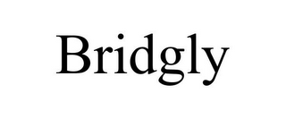  BRIDGLY | 35 | LOW | LOW | N/A | ✗ | N/A
BRIDGLY evokes "bridge" and has a wholly different letter sequence and ending from BARDAK. Its single service, business information management, has no commercial connection with retail of drinkware.
TMView: US500000087858225
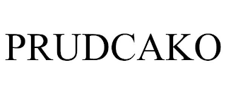  PRUDCAKO | 21 | LOW | LOW | N/A | IDENTICAL | N/A
PRUDCAKO begins with PR and is four syllables long, so it neither looks nor sounds like BARDAK despite a loose shared consonant pattern. Its Class 21 list covers cups, beer mugs and containers for household or kitchen use, which is effectively the same scope as the applicant's drinkware, but the marks are too different for confusion to arise even with identical goods.
TMView: US500000090854233
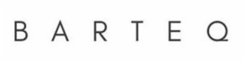  BARTEQ | 21 | MEDIUM | MEDIUM | N/A | ✓ | N/A
BARTEQ shares the BAR- opening and a hard final consonant with BARDAK, but TEQ versus DAK changes the second syllable in both spelling and sound. Its Class 21 registration is narrowly limited to dish drying mats, a kitchen article related to but distinct from bottles and drinkware. One moderate dimension against a narrow related specification keeps the conflict low.
TMView: US500000098595783
PRODUX | 35, 42 | N/A | N/A | N/A | ✗ | N/A
PRODUX bears no meaningful resemblance to BARDAK in spelling, sound or idea, and it alludes to "products" whereas BARDAK is a coinage. Its services are business management, regulatory compliance and SaaS analytics, unrelated to drinkware retail. The latest recordal confirms a total provisional refusal, so the mark is not protected in the US, reinforcing the absence of risk.
TMView: WO500000001581846
PARTXA | 35, 39, 7 | N/A | N/A | N/A | ✗ | N/A
PARTXA starts with P, contains the unusual TX cluster and shares no distinctive element with BARDAK. Its services concern auctioneering, procurement, warehousing and retail of OEM and aftermarket mining and earthmoving parts, a wholly different sector from drinkware retail, notwithstanding the shared Class 35.
TMView: WO500000001781463
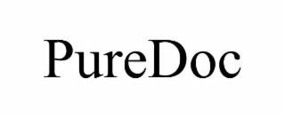  PUREDOC | 21 | N/A | N/A | N/A | ✗ | N/A
PUREDOC is a two-element English coinage ("pure" plus "doc") with no visual, aural or conceptual link to BARDAK. Its Class 21 goods are toilet brushes and plungers, unconnected with bottles, mugs or drinkware.
TMView: US500000099163657

Assumptions and Limitations
Assumptions:
• ASSUMPTION: The word element in the target logo is read and pronounced as an invented term with no meaning for US English speakers, rather than as the Turkish word for "glass/cup". | WHY: The target country's language is English and the doctrine of foreign equivalents is applied only where an appreciable segment of US purchasers would translate the term. | IMPACT: affects distinctiveness_category, inherent_distinctiveness.risk_level and the conceptual similarity scores for all cited marks.
• ASSUMPTION: Cited marks whose entries list only broad umbrella headings (for example "Receptacles", "Glassware", "Merchandise Not Otherwise Classified") were assessed on their specific Class 21 or Class 35 wording only. | WHY: The umbrella headings are registry classification labels and do not describe actual goods. | IMPACT: affects goods_overlap, goods_overlap_by_class and conflict_risk for the Class 21 citations such as "BARDEAU ESSENTIALS", "Z-BANDAY" and "BIRDOCK".
Limitations:
None specified.

Türkiye
TRADEMARK REGISTRABILITY ASSESSMENT
Bardak
TR • NICE Classes: 21, 35 • July 30, 2026
Trademark register — data as of: June 05, 2026 · Türkiye — app 2026-06-05 / reg 2026-07-28 (registered only); WIPO — app 2026-07-23 / reg 2026-06-22 (pending + registered)
Applicant origin: Portugal
Practical Outlook
Registration Outlook:
Critical
An identical or near-identical earlier mark in the same field, or a strong absolute-grounds problem (e.g. descriptiveness). Filing the name as-is is very likely to fail — consider a different name or a substantial change.
Summary:
Filing "Bardak" as-is for glasses, mugs, bottles and their retail in Turkey is very unlikely to succeed, because "bardak" is simply the Turkish word for a drinking glass — it is the product name, and no single company can own it for that product. The main challenge is not a competitor, it is the trademark office itself: examiners in Turkey check this point automatically and will send you a letter saying the name only tells consumers what you sell, in both Class 21 (the goods) and Class 35 (the shop services). Your logo helps a little, but the drawing of a partly filled glass repeats the same message instead of adding something new, so it does not rescue the word on its own. On top of that, the register is already full of names built on "bardak" — including "BARDAKSHOP", "BARDAKSEPETI.COM" and "HES BARDAK" for the same drinkware — which shows how commonly the word is used, and "BARMAK" is close in sound for Class 21 goods too. The realistic options are to build a real brand name around the word (a distinctive addition), redesign the logo so the picture carries its own character, or gather years of Turkish sales and advertising evidence to argue the public already recognises "Bardak" as your brand.
What to do before filing:
1. Add a distinctive coined or arbitrary word to "Bardak" so the name is more than the plain Turkish word for a glass.
2. File the design version of the mark rather than the plain word, and rework the glass symbol so it is more stylised and less literal.
3. Narrow the goods and services to the exact items you make and sell (thermos mugs, bottles, specified drinkware and their retail) to shrink the overlap with "BARDAKSHOP" and "BARDAKSEPETI.COM".
4. Collect Turkish sales figures, advertising and packaging covering several years if you want to argue the public already knows "Bardak" as your brand.

Per-Class Assessment

ⓘ | How registration works: The trademark office examines each class separately. If they find a similar mark in any class, they will send a provisional refusal. This is a normal part of the process and you can respond with arguments about why your services are different.
Class | Status | Prov. Refusal Chance | Success Chance | Key Obstacle
21 | Serious risk | 85% | 30% | "Bardak" is simply the Turkish word for a drinking glass, so for glasses, mugs and drinkware the office is very likely to say the name is the product itself and cannot be owned by one company. Several Class 21 marks such as "BARDAKSHOP", "HES BARDAK" and "BARDAKSEPETI.COM" also cover the same goods.
35 | N/A | — | 35% | For retail and online selling of drinkware, "Bardak" merely names what is being sold, so it is treated as a descriptive shop name. Marks like "BARDAKSHOP" and "BARDAKSEPETI.COM" already cover exactly this kind of retail service.

ⓘ | Estimated Timeline: Examination in Turkey typically produces a first result within roughly 4–8 months, followed by a two-month publication window in which others may object. If a refusal on the descriptive nature of the name has to be answered, add roughly a further 6–12 months, and longer if an appeal to the office's board becomes necessary.

Detailed Analysis

Mark Analysis
Mark Type: | COMPOSITE
Distinctiveness Category: | GENERIC
Distinctiveness Scale
Generic | Descriptive | Suggestive | Arbitrary | Fanciful
← Weak | Strong →

ⓘ | • Generic: Common name for the goods/services category  • Descriptive: Immediately describes goods, services, or characteristics  • Suggestive: Hints at qualities but requires imagination to connect  • Arbitrary: Real word completely unrelated to the goods  • Fanciful: Invented word with no dictionary meaning
Reasoning:
"Bardak" is the ordinary Turkish word for "glass/drinking cup" and is therefore the common name for a core product in the applicant's range of drinkware in Class 21. The attached logo reinforces rather than dilutes this meaning: the device is a simple line drawing of a partially filled drinking glass, so word and image convey exactly the same generic message. For Class 35 retail/wholesale of drinkware, the term directly designates the subject matter of the services and is descriptive rather than strictly generic. Because the weakest reading governs, the mark as a whole is treated as generic/descriptive for the filed scope; only the stylization (rounded lowercase navy typeface plus the glass device) contributes any distinctive matter.

Assessment Summary
Registration prospects for "Bardak" in Turkey are poor as filed, because the word is the ordinary Turkish name for a drinking glass and the application covers exactly drinkware and its retail. The dominant obstacle is absolute: the Turkish Office examines distinctiveness of its own motion under Industrial Property Code No. 6769 and regularly refuses signs that consist of the everyday name of the goods, and the glass device in the logo repeats rather than counteracts that message. On the conflicts side no single blocking citation emerges; the register is crowded with "BARDAK"-based marks, and the closest ones for the applicant's field are "BARDAKSHOP" (two registrations), "BARDAKSEPETI.COM", "HES BARDAK" and "BARDAKCI" in Class 21, plus the phonetically close "BARMAK". Both filed classes carry the same weakness, with Class 21 the weakest since the word is the literal product name there and Class 35 only marginally better. The mitigating factors are the crowded register, which narrows everyone's rights, and the stylised logo with its rounded navy typeface and glass symbol, which can support a composite filing. The practical path is to strengthen the sign itself, either by adding a genuinely distinctive element or by filing the composite version and accepting no exclusivity over the word.
Registration Probability: 33%

Recommendations
• [MARK_MODIFICATION] Consider adding a coined or arbitrary element to "Bardak" (for example a distinctive house name preceding it) — to overcome the inherent_distinctiveness objection that the word is the Turkish name for a drinking glass — expected impact: moves the sign away from the generic/descriptive category and creates matter the office can accept as source-identifying.
• [FILING_STRATEGY] Consider filing the composite version shown in the logo, with the navy rounded lowercase lettering and the glass device, rather than a plain word mark — to give the examiner distinctive figurative matter to hang the registration on — expected impact: improves the chance of acceptance, although protection would extend to the design as a whole rather than to the word "bardak".
• [DESIGN_ELEMENT] Consider making the figurative element less literal than the current partly filled drinking glass — to avoid the design merely repeating the descriptive message of the word — expected impact: increases the distinctive weight of the logo in the overall assessment of the composite mark.
• [GOODS_SCOPE] Consider narrowing Class 21 to the specific items actually produced (insulated thermos mugs, bottles, specified drinkware) and limiting the Class 35 wording to retail of those items — to reduce the identical overlap with "BARDAKSHOP", "BARDAKSEPETI.COM" and "HES BARDAK" — expected impact: shrinks the overlap that opponents could rely on after publication.
• [EVIDENCE_GATHERING] Consider compiling evidence of use of "Bardak" as a brand in Turkey (sales volumes, advertising, packaging, market presence over several years) — to answer the descriptiveness/genericness objection with an acquired-distinctiveness argument — expected impact: this is the only route to registering the plain word, and it requires substantial and long-standing Turkish use.
• [COEXISTENCE] Consider approaching the owners of "BARDAKSHOP" and "BARDAKSEPETI.COM" for a consent or coexistence arrangement covering your specific drinkware lines — to defuse the strongest post-publication objection risk in Classes 21 and 35 — expected impact: reduces the likelihood of opposition, since their own names rest on the same everyday word.

ⓘ | Absolute grounds are inherent registrability criteria examined by the trademark office independently of any existing marks. These are legal requirements that every trademark must satisfy on its own merits.

Absolute Grounds Assessment
Overall Absolute Risk: HIGH
Ground | Risk Level | Reason
Inherent Distinctiveness  Whether the mark is distinctive enough to identify the source of goods/services | HIGH | "Bardak" is the everyday Turkish noun for a drinking glass or cup, i.e. the generic name of the very goods (drinkware, mugs, bottles) covered in Class 21 and the subject of the Class 35 retail services. Under the Industrial Property Code No. 6769 the Turkish Office refuses signs consisting exclusively of the generic or descriptive name of the goods, and the glass device in the logo repeats the same message instead of adding distinctive matter. Registration of the word element alone is very unlikely without evidence of acquired distinctiveness.
Deceptive/Misleading  Whether the mark could mislead consumers about the nature or quality of goods | No Risk Identified | -
Public Order Morality  Whether the mark contains content contrary to public order or accepted moral principles | No Risk Identified | -
Prohibited Elements  Whether the mark includes state emblems, flags, official symbols or other prohibited elements | No Risk Identified | -
Geographic Indications  Whether the mark contains protected geographic indications or misleading geographic terms | No Risk Identified | -
Linguistic/Cultural  Whether the mark has negative or problematic meanings in local languages or cultures | HIGH | Turkish is the only relevant language in the target country, and in Turkish "bardak" means "glass/cup" without any secondary or figurative reading. For drinkware and drinkware retail the term is understood by every Turkish consumer as the product name itself, which is a genericness problem rather than an offensiveness problem.
Personality Rights  Whether the mark infringes on another person's name, image, or identity rights | No Risk Identified | -
Well-Known Marks  Whether the mark conflicts with well-known marks that enjoy broader protection | No Risk Identified | -

ⓘ | Relative grounds assess potential conflicts with existing registered or pending marks. An examiner or third party may oppose your trademark if it is confusingly similar to a prior mark in the same or related goods/services.

Relative Grounds Assessment
Overall Relative Risk: MEDIUM
Analysis Notes: The register is heavily crowded with marks built on the generic element "BARDAK", so no single citation stands out as a blocking mark; the highest risks come from the Class 21/35 drinkware-related marks "BARDAKSHOP" (both entries), "BARDAKSEPETI.COM" and "HES BARDAK", each of which adds its own distinguishing element. Goods overlap was determined from actual registry specifications for "BARDAKCI", "BARDAKLIKÇIM" and "BUZ BAR DAK BARDAKTAN GELEN SERİNLİK", and inferred from class scope for the remaining marks. The relevant public is general consumers of inexpensive household drinkware exercising average to low attention.
Similar Marks Analysis:
Vis — Visual | Phon — Phonetic | Conc — Conceptual | Goods — Goods and services Overlap
Mark | Class | Vis | Phon | Conc | Goods | Risk
bardak's | 35, 43 | HIGH | HIGH | HIGH | ✓ | MEDIUM
The mark is the target word plus a possessive apostrophe-s, so it is virtually identical in sight, sound and meaning. Its Class 35 services may plausibly relate to retail of drinkware, while Class 43 food and drink services are separate. Because the shared element "bardak" is generic for drinking glasses, the earlier mark enjoys only a narrow scope of protection, so the risk is reduced from HIGH to MEDIUM.
TMView: TR502021000177618
bardak6 | 35 | HIGH | HIGH | HIGH | ✓ | MEDIUM
"Bardak6" contains the target word in full, with only a trailing numeral to distinguish it, and Class 35 could cover retail of drinkware. The distinguishing numeral is weak but the shared word is the generic Turkish term for a glass, so the earlier mark's protection is narrow and the risk is downgraded one band to MEDIUM.
TMView: TR502024000123808
bardakçi | 5, 29, 30, 31, 35 | MEDIUM | MEDIUM | MEDIUM | ✓ | LOW
"Bardakçı" means glassmaker/glass seller and is also a common Turkish surname, giving an extra syllable and a different conceptual nuance. Its product classes are food, beverages and pharmaceuticals, unrelated to drinkware; only its Class 35 services could touch retail. The shared root is generic, so protection is narrow and the residual risk is LOW.
TMView: TR502001000021650
bardakci | 16, 21 | MEDIUM | MEDIUM | MEDIUM | IDENTICAL | MEDIUM
The registry specification expressly covers non-electric household and kitchen utensils, tableware and vessels in Class 21, which is the same scope as the applicant's drinkware, so overlap is identical there. The added "-ci" suffix creates a recognisable Turkish surname/occupational reading that separates the marks aurally and conceptually. Given identical goods but only moderate similarity resting on the generic root "bardak", the risk sits at MEDIUM.
TMView: TR502015000012861
bardakcı group | 15, 35 | MEDIUM | MEDIUM | MEDIUM | ✓ | LOW
The mark reads as a company name ("Bardakcı Group") with a surname plus the descriptive word "group", which is longer and conceptually different from the plain product word. Class 15 musical instruments are unrelated; only the Class 35 services could partially overlap retail. Protection over the generic root is narrow, so the risk stays LOW.
TMView: TR502022000048556
bardak buz | 30, 35 | MEDIUM | MEDIUM | MEDIUM | ✓ | LOW
"Bardak buz" (glass ice) points to ice products in Class 30 rather than to drinkware, and the second word clearly changes the overall impression. Only the Class 35 services create a theoretical retail contact point. Since the common element is generic for glasses, protection is narrow and the risk is LOW.
TMView: TR502024000048576
hes bardak | 21 | MEDIUM | MEDIUM | HIGH | IDENTICAL | MEDIUM
Registered in Class 21 alone, this mark most likely covers drinking glasses, so the goods are effectively the same as the applicant's drinkware. The distinctive part is the prefix "HES", which carries the source-identifying function, while "bardak" is the generic product word. Identical goods combined with the shared generic element justify MEDIUM rather than HIGH risk.
TMView: TR502022000101081
bardaksan | 16, 35 | MEDIUM | MEDIUM | LOW | ✓ | LOW
"Bardaksan" is a coined industrial-style name where the "-san" ending fuses with the root to form a single new word, reducing the chance that consumers isolate "bardak". Class 16 paper goods are unrelated and only Class 35 may touch retail. The risk is therefore LOW.
TMView: TR502022000047767
bardaklık | 35 | MEDIUM | MEDIUM | MEDIUM | ✓ | LOW
"Bardaklık" means a glass holder/rack, adding a syllable and a distinct product concept. Its Class 35 services may relate to retail of household items, giving some proximity to the applicant's retail activity. Both signs rest on a generic root, so the earlier right is weak and the risk is LOW.
TMView: TR502025000030774
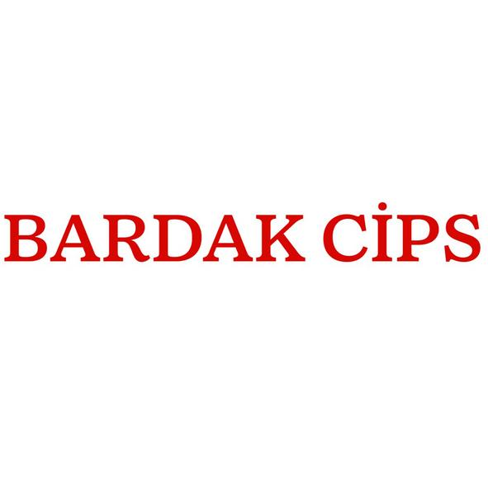  bardak cips | 29, 30, 35 | MEDIUM | MEDIUM | LOW | ✓ | LOW
The attached image shows the plain red word combination "BARDAK CİPS", i.e. snack chips served in a cup, which is conceptually a food product rather than drinkware. Classes 29 and 30 are unrelated to the applicant's goods and only Class 35 offers indirect retail contact. Risk is LOW.
TMView: TR502025000134549
e-bardak.com | 16, 35 | MEDIUM | MEDIUM | MEDIUM | ✓ | LOW
The "e-" prefix and ".com" suffix present the sign as an online shop domain, which visually and aurally lengthens it considerably. Its Class 35 services plausibly cover online retail of glasses, so there is some service proximity. As the shared element is generic, the scope of protection is narrow and the risk is LOW.
TMView: TR502016000030914
bardakshop | 16, 21, 35 | MEDIUM | MEDIUM | HIGH | IDENTICAL | MEDIUM
This mark covers both Class 21 and Class 35 and, judging from its wording, concerns the sale of drinking glasses, so the goods and retail services are effectively the same as the applicant's. "Shop" is itself descriptive, meaning the whole earlier mark is composed of weak elements and enjoys narrow protection. Identical scope with moderate similarity gives MEDIUM risk.
TMView: TR502023000187053
bardakshop | 21, 35 | MEDIUM | MEDIUM | HIGH | IDENTICAL | MEDIUM
A second registration of the same wording covering Class 21 goods and Class 35 retail, so the overlap with drinkware and drinkware retail is direct. The added descriptive "shop" is the only differentiator, but it is enough to prevent identity, and the earlier mark is built entirely on weak elements. Risk is MEDIUM.
TMView: TR502023000059884
bardak waffle | 30, 35 | MEDIUM | MEDIUM | LOW | ✓ | LOW
"Bardak waffle" designates a waffle served in a cup, a food concept far removed from manufacturing drinkware. Class 30 is unrelated and only Class 35 gives indirect retail proximity. With a weak shared root, the risk is LOW.
TMView: TR502025000044096
bardak evi .com | 35 | MEDIUM | MEDIUM | MEDIUM | ✓ | LOW
"Bardak evi" (house of glasses) with a ".com" element reads as an online store name and is markedly longer than the applicant's single word. Its Class 35 services likely cover retail of glasses, creating partial service proximity with the applicant's Class 35. Because both signs share only a generic term, the risk remains LOW.
TMView: TR502024000155258
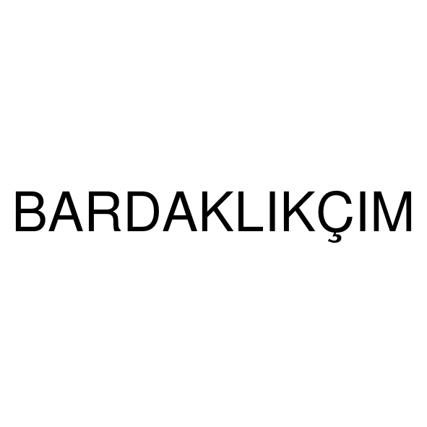  bardaklıkçım | 21 | LOW | LOW | MEDIUM | IDENTICAL | LOW
The registry text confirms broad Class 21 household and kitchen utensils including vessels, so the goods overlap with the applicant's drinkware. However the plain-text mark "BARDAKLIKÇIM" shown in the image is a long, four-syllable possessive formation ("my glass-holder maker") that looks and sounds clearly different from the single word "bardak". The similarity rests only on the generic root, so the risk is LOW.
TMView: TR502025000156083
sürprizli bardak | 30, 35 | LOW | LOW | MEDIUM | ✓ | N/A
"Sürprizli bardak" (surprise cup) is dominated by the leading distinctive word "sürprizli" and relates to confectionery in Class 30. Visual and aural differences are substantial and the only link is the generic noun. No meaningful conflict arises.
TMView: TR502025000072628
bardaksepeti.com | 20, 21, 35 | MEDIUM | MEDIUM | MEDIUM | IDENTICAL | MEDIUM
Covering Classes 21 and 35, this online-shop style mark most likely relates to drinking glasses and their retail, so the scope overlaps the applicant's directly. "Sepeti.com" (basket.com) lengthens the sign noticeably and carries the source-identifying weight together with the generic root. Identical scope with moderate similarity supports MEDIUM risk.
TMView: TR502022000175932
borosilikat bardak | 35 | LOW | LOW | MEDIUM | ✓ | LOW
The sign consists of two descriptive words describing borosilicate glassware, and its Class 35 services plausibly cover retail of such glasses, which is close to the applicant's retail activity. The dominant first word "borosilikat" makes the signs clearly distinguishable in sight and sound. Being composed only of descriptive matter, the earlier mark has minimal scope, so the risk is LOW.
TMView: TR502023000131363
buz bar dak bardaktan gelen serinlik | 21 | LOW | LOW | MEDIUM | IDENTICAL | LOW
The registry specification expressly lists cups, mugs, jugs and glasses in Class 21, so the goods coincide with the applicant's drinkware. The mark itself is a long slogan-like phrase ("coolness coming from the ice cup") whose overall impression is very different from the single word "bardak". With similarity limited to the generic term inside a much longer sign, the risk is LOW.
TMView: TR502024000092628
bardan | 20, 35 | MEDIUM | MEDIUM | N/A | ✓ | LOW
"Bardan" shares the first five letters but ends in -n, and it has no meaning in Turkish, so no conceptual comparison is possible. Class 20 furniture is not the applicant's field and only Class 35 offers possible retail proximity to household goods. The differences in the final sound and the absence of goods identity keep the risk LOW.
TMView: TR502022000073557
barmak | 8, 21 | MEDIUM | MEDIUM | N/A | ✓ | MEDIUM
"Barmak" and "bardak" differ by a single consonant and are close in rhythm, and the mark is registered in Class 21, which likely covers household utensils related to the applicant's drinkware. Neither sign is conceptually comparable because "barmak" has no standard Turkish meaning, and it does not consist of weak matter, so no downgrade applies. Moderate visual and phonetic similarity with related Class 21 goods gives MEDIUM risk.
TMView: TR502013000072981
ardaks | 6, 20, 35 | LOW | LOW | N/A | ✓ | LOW
"Ardaks" lacks the initial "b" and ends with an "s", producing a clearly different beginning and ending, which is where consumers focus most. Its metal goods and furniture classes are unrelated and only Class 35 gives a faint retail link. Risk is LOW.
TMView: TR502012000029394
barak | 19, 30, 32, 35, 36, 37, 43 | LOW | LOW | N/A | ✓ | LOW
"Barak" is a shorter two-syllable word lacking the internal "d", so it is distinguishable in normal speech. Its classes cover construction, food, beverages, finance and hospitality rather than drinkware, with only broad Class 35 services in common. Risk is LOW.
TMView: TR502022000172322
bardes | 9, 35, 37, 38, 42 | MEDIUM | LOW | N/A | ✗ | LOW
"Bardes" shares only the "bard" opening and ends quite differently, and its portfolio points to electronics, telecommunications and IT services. Those sectors have no plausible connection to drinkware manufacture or drinkware retail. Risk is LOW.
TMView: TR502003000001719
bartat | 29, 30, 35 | LOW | LOW | N/A | ✗ | N/A
"Bartat" only shares the "bar" opening and its double-t ending sounds quite different. The registrations cover foodstuffs and their trade, a sector unconnected with the applicant's drinkware. No meaningful conflict arises.
TMView: TR502002000008620
bardakcı grup | 15, 35 | MEDIUM | MEDIUM | MEDIUM | ✓ | LOW
This is the Turkish-spelled counterpart of the "Bardakcı Group" company name, again combining a surname with the descriptive word "grup". Class 15 musical instruments are unrelated and only Class 35 could touch the applicant's retail services. The similarity rests on a generic root, so the risk stays LOW.
TMView: TR502022000048550
balcak | 6, 8, 35 | LOW | LOW | N/A | ✓ | LOW
"Balcak" differs in its second and third letters and is pronounced distinctly from "bardak". Its metal goods and hand tools classes are outside the applicant's field, with only Class 35 providing a broad retail link. Risk is LOW.
TMView: TR502023000136348
chardak | 35 | MEDIUM | MEDIUM | N/A | ✓ | LOW
"Chardak" adds an initial "ch" cluster that changes both the appearance and the opening sound, and the word has no established Turkish meaning tied to glasses. Its Class 35-only registration gives no indication of the sector, so overlap with the applicant's retail of drinkware can only be assumed loosely. Risk is LOW.
TMView: TR502023000175236
chardak | 3, 5, 35 | MEDIUM | MEDIUM | N/A | ✓ | LOW
The second "Chardak" registration covers cosmetics and pharmaceutical goods plus Class 35 services, none of which concerns drinkware. The different initial cluster keeps the signs distinguishable visually and aurally. Risk is LOW.
TMView: TR502024000052095

Assumptions and Limitations
Assumptions:
• ASSUMPTION: The Class 35 scope was read as retail, wholesale and online sales of the applicant's own drinkware, since the business description covers only manufacturing of bottles, thermos mugs and drinkware. | WHY: The description does not state which services are claimed in Class 35. | IMPACT: affects goods_overlap and conflict_risk for the Class 35 citations such as "BARDAKSHOP", "BARDAKSEPETI.COM" and "BARDAK EVI .COM", and the per_class_assessment scores for Class 35.
• ASSUMPTION: For the cited marks with no registry specification (all except "BARDAKCI", "BARDAKLIKÇIM" and "BUZ BAR DAK BARDAKTAN GELEN SERİNLİK"), the scope was inferred from their class numbers and their wording. | WHY: The goods_services field is empty for those marks. | IMPACT: affects goods_overlap and conflict_risk for those cited marks and the relative_risk values in per_class_assessment.
• ASSUMPTION: "BARMAK" and the two "CHARDAK" registrations were treated as coined words with no established Turkish meaning. | WHY: Neither is a standard Turkish dictionary term in the relevant sense. | IMPACT: affects conceptual similarity and conflict_risk for those cited marks.
Limitations:
None specified.

Czechia
TRADEMARK REGISTRABILITY ASSESSMENT
Bardak
CZ • NICE Classes: 21, 35 • July 30, 2026
Trademark register — data as of: July 21, 2026 · Czechia — app 2026-07-21 / reg 2026-05-27 (pending + registered); EUIPO — app 2026-07-29 / reg 2026-07-03 (pending + registered); WIPO — app 2026-07-27 / reg 2026-06-25 (pending + registered)
Applicant origin: Portugal
Practical Outlook
Registration Outlook:
Fixable
The name can likely be registered, but something needs attention first — narrowing or changing the goods/services classes, adding a disclaimer, or adjusting an element of the mark. The name itself stays.
Summary:
Yes, your name looks registrable, but you should tighten your goods list before filing. The main challenge is BARDANI, an existing Czech registration in Class 21 that covers household and kitchen containers and glassware — the same territory as your bottles and mugs — and it shares your first five letters. It is overcomable: BARDANI has three syllables with a completely different ending and is used as a swirly script logo with a big letter B, while yours is a short, rounded lowercase name with a small glass symbol, so the two look and sound noticeably different. Your Class 35 retail services are in good shape, because the other similar-looking names in that class sell cosmetics, clothes, food, drinks or car parts rather than drinkware. Note also that Czech examiners do not raise earlier trademarks against you themselves — the only way BARDANI becomes a problem is if its owner objects after your application is published.
What to do before filing:
1. Narrow your Class 21 list to bottles, thermos mugs, insulated flasks and drinking vessels so it does not read as general household containers, which is where BARDANI's rights sit.
2. Describe your Class 35 services specifically as retail, wholesale and online sale of drinkware, to keep them clearly apart from the cosmetics, clothing and food retail claimed by other BAR- names.
3. File the mark in the logo form with the rounded lowercase lettering and the glass symbol, so your visual presentation is on record as different from BARDANI's script logo.
4. Prepare a short comparison of your name and BARDANI (different endings, different number of syllables, different design) so you can respond quickly if the owner objects after publication.

Per-Class Assessment

ⓘ | How registration works: The trademark office examines each class separately. If they find a similar mark in any class, they will send a provisional refusal. This is a normal part of the process and you can respond with arguments about why your services are different.
Class | Status | Prov. Refusal Chance | Success Chance | Key Obstacle
21 | Provisional refusal possible | 45% | 70% | The three BARDANI registrations cover household and kitchen containers and glassware in Class 21, which directly overlaps your bottles, mugs and drinkware, and they share the first five letters with your name.
35 | No obstacles | — | 80% | Several BAR-prefixed marks hold Class 35 retail services, but their retail lists cover cosmetics, clothing, food, alcohol, medicines or car parts rather than drinkware, so no close conflict arises.

ⓘ | Estimated Timeline: In the Czech Republic a straightforward application is typically examined and published within roughly 3 to 6 months, with a three-month window for third parties to object after publication. If BARDANI's owner does object, expect the process to extend by a further 6 to 12 months or more.

Detailed Analysis

Mark Analysis
Mark Type: | COMPOSITE
Distinctiveness Category: | ARBITRARY
Distinctiveness Scale
Generic | Descriptive | Suggestive | Arbitrary | Fanciful
← Weak | Strong →

ⓘ | • Generic: Common name for the goods/services category  • Descriptive: Immediately describes goods, services, or characteristics  • Suggestive: Hints at qualities but requires imagination to connect  • Arbitrary: Real word completely unrelated to the goods  • Fanciful: Invented word with no dictionary meaning
Reasoning:
The logo combines the lowercase word "bardak" in a rounded dark-blue sans-serif typeface with a small figurative element depicting a drinking glass partly filled with an amber liquid. "Bardak" has no meaning in Czech, so for Czech consumers it is an invented-sounding, arbitrary term for drinkware and retail services. It is worth noting that in Turkish "bardak" means "glass/cup" and in Russian/Ukrainian it is a colloquial word for "mess/disorder", but neither language is spoken by the relevant Czech public, so those readings do not weaken distinctiveness in the Czech Republic. The glass device is, however, a directly evocative depiction of the goods themselves and therefore adds little distinctive weight; the word element clearly dominates.

Assessment Summary
Prospects for registering the BARDAK logo in the Czech Republic are reasonably good, with the main uncertainty concentrated in Class 21. On absolute grounds the mark is strong: "bardak" carries no meaning for Czech consumers and functions as an arbitrary sign for drinkware, the only weak element being the small drinking-glass device that merely depicts the goods. The most significant earlier rights are the three BARDANI registrations, which cover household and kitchen containers and glassware in Class 21 and share the opening BARDA-, although their three-syllable ending and script styling keep the resemblance at a moderate level. Class 35 looks clean, because the numerous other BAR-prefixed marks in that class provide retail services for cosmetics, clothing, food, alcohol, medicines or vehicle parts rather than drinkware. Helpful factors include the crowded BAR-/BARD- landscape on the Czech register, which narrows the protection each of these names enjoys, the fact that Czech examiners do not raise earlier marks on their own initiative, and the distinctive lowercase logotype. A sensible approach is to file with a tightly drafted specification focused on bottles, thermos mugs and drinkware, keeping the differentiation arguments against BARDANI ready in case of an opposition.
Registration Probability: 75%

Recommendations
• [GOODS_SCOPE] Consider limiting Class 21 to bottles, thermos mugs, insulated flasks and drinking vessels instead of broad wording such as household or kitchen containers — to reduce the area of overlap with the BARDANI registrations, whose Class 21 wording covers household and kitchen utensils and containers and glassware — expected impact: a narrower field of overlap and a stronger position if an opposition is filed.
• [GOODS_SCOPE] Consider wording Class 35 precisely as retail, wholesale and online retail services for bottles, thermos mugs and drinkware — to keep a clear distance from the retail lists of BARDARO, BARDOU, BARTEK and BARTOG, which cover cosmetics, beauty goods, footwear and automotive products — expected impact: preserves the currently low conflict level in this class.
• [DESIGN_ELEMENT] Consider filing the mark in the composite form shown, with the rounded lowercase logotype and the drinking-glass symbol, rather than as a plain word — to create visual distance from the script-styled BARDANI logo and from BARDARO's spaced serif presentation — expected impact: adds a further point of differentiation in any comparison of overall impressions.
• [MARK_MODIFICATION] If maximum distance from BARDANI is a priority, consider pairing "bardak" with an additional distinctive word or house name in the applied-for sign — to weaken the impact of the shared BARDA- beginning — expected impact: reduces the visual and phonetic similarity that drives the moderate conflict in Class 21.
• [COEXISTENCE] Consider exploring a consent or coexistence arrangement with the owner of the BARDANI Class 21 registrations, defining that your use relates to drinkware and theirs to its own product range — to remove the only meaningful opposition threat identified — expected impact: could neutralise the principal obstacle in Class 21 before publication.

ⓘ | Absolute grounds are inherent registrability criteria examined by the trademark office independently of any existing marks. These are legal requirements that every trademark must satisfy on its own merits.

Absolute Grounds Assessment
Overall Absolute Risk: LOW
Ground | Risk Level | Reason
Inherent Distinctiveness  Whether the mark is distinctive enough to identify the source of goods/services | LOW | The word "bardak" is meaningless in Czech and functions as an arbitrary sign for drinkware and related retail services. The only weak component is the figurative drinking-glass device, which merely depicts the goods and contributes little distinctive character, so the protectable weight rests on the word. No descriptiveness objection is expected under the Czech Trademark Act's provisions on non-distinctive and descriptive signs.
Deceptive/Misleading  Whether the mark could mislead consumers about the nature or quality of goods | No Risk Identified | -
Public Order Morality  Whether the mark contains content contrary to public order or accepted moral principles | No Risk Identified | -
Prohibited Elements  Whether the mark includes state emblems, flags, official symbols or other prohibited elements | No Risk Identified | -
Geographic Indications  Whether the mark contains protected geographic indications or misleading geographic terms | No Risk Identified | -
Linguistic/Cultural  Whether the mark has negative or problematic meanings in local languages or cultures | No Risk Identified | -
Personality Rights  Whether the mark infringes on another person's name, image, or identity rights | No Risk Identified | -
Well-Known Marks  Whether the mark conflicts with well-known marks that enjoy broader protection | No Risk Identified | -

ⓘ | Relative grounds assess potential conflicts with existing registered or pending marks. An examiner or third party may oppose your trademark if it is confusingly similar to a prior mark in the same or related goods/services.

Relative Grounds Assessment
Overall Relative Risk: MEDIUM
Analysis Notes: The Czech register is busy with BAR-/BARD- prefixed marks, but only BARDANI (registered for household and kitchen utensils and containers, glassware in Class 21) creates a genuine MEDIUM-level concern because of the shared BARDA- opening combined with directly overlapping Class 21 goods; BARDARO and BARDOU are close in the word beginning but cover cosmetics, clothing and beauty-sector retail, so overlap is limited or absent. All overlap findings were made on the basis of the actual goods and services texts supplied for the cited marks rather than class numbers alone. The relevant public consists of general consumers buying inexpensive everyday drinkware with an average level of attention, plus some trade buyers for the retail services.
Similar Marks Analysis:
Vis — Visual | Phon — Phonetic | Conc — Conceptual | Goods — Goods and services Overlap
Mark | Class | Vis | Phon | Conc | Goods | Risk
BARDARO | 3, 5, 14, 18, 25, 35 | MEDIUM | MEDIUM | N/A | ✗ | LOW
Both marks share the opening BARDA-, but the cited mark ends in -RO against the target's -K, giving a different rhythm (bar-DA-ro versus BAR-dak) and a different visual silhouette; the cited mark is presented in an elegant spaced serif capital typeface, whereas the target is a rounded lowercase logotype with a glass device. The cited Class 35 services are expressly limited to retail of clothing, bags, perfumery, cosmetics, jewellery and dietary supplements, none of which covers drinkware retail, and the cited mark holds no Class 21. Mark similarity alone without goods proximity does not create actionable confusion risk.
TMView: EM500000019320328
BARDANI | 18, 20, 21, 22, 25, 28 | MEDIUM | MEDIUM | N/A | IDENTICAL | MEDIUM
The first five letters BARDA- coincide, and the cited Class 21 specification covers household or kitchen utensils and containers and glassware, which directly encompasses bottles, thermos mugs and drinkware. The endings differ clearly (-NI, three syllables, versus -K, two syllables) and the cited mark is a highly stylised script logo dominated by a large calligraphic B, which distances the overall impressions. Because exactly one pair of moderate visual and phonetic similarities coincides with identical goods, this is assessed as a moderate conflict rather than a blocking citation; the average attention of everyday drinkware buyers keeps it at MEDIUM.
TMView: EM500000010531952
BARDANI | 5, 6, 8, 9, 12, 18, 20, 21, 22, 24, 25, 26, 27 | MEDIUM | MEDIUM | N/A | IDENTICAL | MEDIUM
This is a broader BARDANI registration whose Class 21 wording again covers household or kitchen utensils and containers and glassware, chinaware, porcelain and earthenware, overlapping the target's bottles, mugs and drinkware. The shared element is the BARDA- beginning, while the tri-syllabic -NI ending and the dominant calligraphic B device in the cited logo differentiate the marks. Moderate similarity plus identical goods places this at a moderate conflict level; the cited mark covers no retail services corresponding to the target's Class 35.
TMView: EM500000016286262
BARDANI | 5, 6, 8, 9, 12, 18, 20, 21, 22, 24, 25, 26, 27 | MEDIUM | MEDIUM | N/A | IDENTICAL | MEDIUM
A further BARDANI filing with the same Class 21 wording covering household and kitchen containers and glassware, which overlaps the target's drinkware. Similarity again rests on the BARDA- opening, offset by the different three-syllable ending and, in the related filings, a distinctive script presentation. Moderate visual and phonetic similarity with identical goods yields a moderate conflict, concentrated exclusively in Class 21.
TMView: EM500000016286239
BARZAK BOATS | 12, 35, 39 | LOW | MEDIUM | N/A | ✗ | LOW
BARZAK shares the BAR- opening and the final -AK sound with the target, but the medial Z produces an audibly different centre and the mark is dominated by the additional word BOATS and a large nautical rope-and-monogram device. The cited Class 35 retail services concern clothing, sporting, diving and watercraft goods, not drinkware, and Class 12 and 39 are unrelated. Confusion is unlikely despite some phonetic echo.
TMView: EM500000014543755
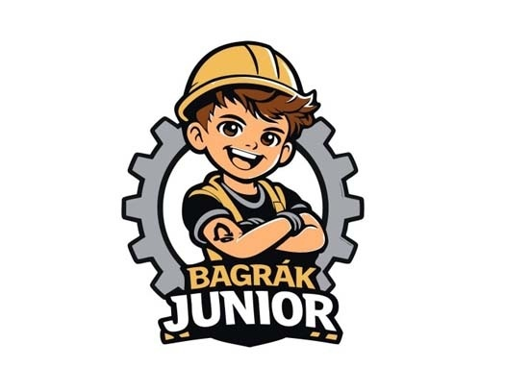  BAGRÁK JUNIOR | 9, 16, 21, 25, 32, 33, 35, 41, 43 | LOW | LOW | N/A | ✓ | LOW
The cited Class 21 wording covers glass and glassware, beer glasses, mugs and pocket flasks, which is commercially close to the target's bottles and mugs, and the Class 35 wording covers retail of promotional glassware. However BAGRÁK differs in its second syllable (-GRÁK against -DAK), reads as a Czech colloquial term for an excavator operator, and the mark adds JUNIOR plus a prominent cartoon construction-worker device, so the overall impressions are far apart. Low similarity across all dimensions keeps the risk minimal.
TMView: CZ500000000607917
BAGRÁK JUNIOR | 9, 16, 21, 25, 32, 33, 35, 41, 43 | LOW | LOW | N/A | ✓ | LOW
A parallel BAGRÁK JUNIOR filing with the same Class 21 glassware and mug wording and Class 35 promotional retail services, so goods are commercially related. The word differs materially in its second syllable and carries a clear Czech colloquial meaning absent from the target, and the composite cartoon presentation reinforces the distance. Overall risk remains low.
TMView: CZ500000000607919
BAGRÁK JUNIOR | 9, 16, 21, 25, 32, 33, 35, 41, 43 | LOW | LOW | N/A | ✓ | LOW
A third BAGRÁK JUNIOR record covering the same glassware, mugs and pocket flasks in Class 21 and promotional retail in Class 35. Only the BA- opening is shared; the -GRÁK ending, the additional JUNIOR element and the figurative character make the marks readily distinguishable in speech and in print. Low conflict.
TMView: CZ500000000607921
Baraka | 29, 30, 32, 35, 39 | MEDIUM | MEDIUM | N/A | ✗ | LOW
Baraka shares the BAR- start and the letters A and K, but the vowel-final structure (ba-ra-ka) gives a different cadence from BAR-dak and the target's medial D is absent. The cited mark is presented with Georgian script above the Latin word and fleur-de-lis ornaments, and its scope is foodstuffs, beverages, food export agency and delivery services, none of which touches drinkware or drinkware retail. No meaningful conflict.
TMView: WO500000001407465
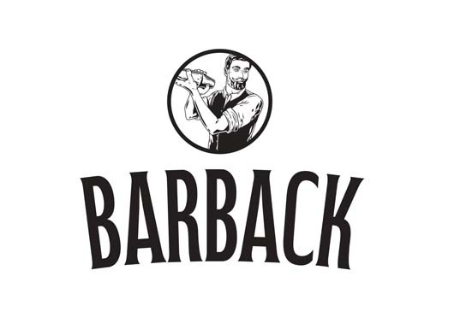  BARBACK | 32, 33, 35 | MEDIUM | MEDIUM | N/A | ✗ | LOW
BARBACK and BARDAK share the BAR- opening and a hard final K, but the repeated B and the -ACK ending create a different sound and appearance, and the cited mark is a composite with a bartender roundel device. The cited scope is beer, beverages and advertising for beverages only, with no drinkware goods and no drinkware retail. Similarity in the word beginning alone does not generate actionable risk here.
TMView: CZ500000000605001
BAGRÁK | 9, 16, 21, 25, 32, 33, 35, 41, 43 | LOW | LOW | N/A | ✓ | LOW
The cited Class 21 list covers glass and glassware, glass and ceramic cups, mugs and pocket flasks, which is commercially close to the target's bottles and mugs, and Class 35 covers retail of promotional glassware. Nevertheless BAGRÁK is pronounced with a distinctive -GRÁK and is understood in Czech as slang for an excavator/excavator driver, a concept entirely absent from the target; the target's rounded lowercase logotype with a glass device also looks quite different. Low conflict overall.
TMView: CZ500000000606304
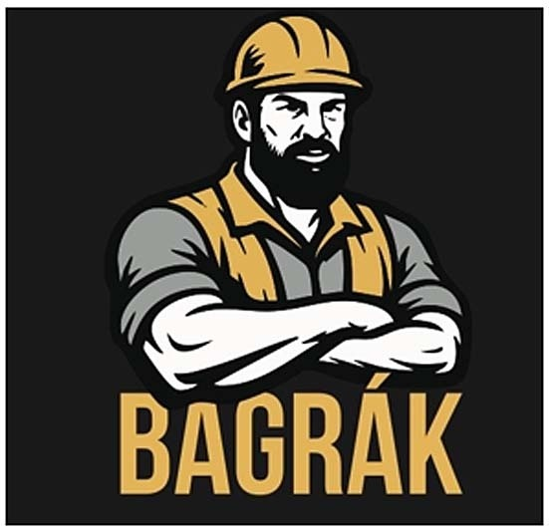  BAGRÁK | 9, 16, 21, 25, 32, 33, 35, 41, 43 | LOW | LOW | N/A | ✓ | LOW
A parallel BAGRÁK registration with the same glassware, mug and pocket-flask wording in Class 21 and promotional retail in Class 35, and in the figurative version a dominant bearded-workman device. The word differs clearly in its second syllable and in meaning for Czech consumers, so despite related goods the risk stays low.
TMView: CZ500000000606303
BERDAC | 35, 42 | MEDIUM | MEDIUM | N/A | ✗ | LOW
BERDAC and BARDAK share the B-R-D-A skeleton and a similar two-syllable rhythm, but the first vowel differs (BER versus BAR) and the endings -DAC and -DAK look and sound different in Czech; the cited mark also features a distinctive blue circular device. Its Class 35 scope is confined to wholesale and retail of medicine dispensers, pill packaging and medicines, a clearly separate commercial sector from drinkware retail, and Class 42 software design is unrelated. No meaningful conflict.
TMView: EM500000018198023
BARDOU | 3, 8, 35, 41, 44 | MEDIUM | MEDIUM | N/A | ✗ | LOW
The marks share BARD-, but BARDOU ends in an open vowel sound with a French flavour whereas BARDAK ends in a hard K, producing different overall impressions. The cited Class 35 retail services are expressly limited to soaps, perfumery, cosmetics, hair-care products and hairdressing implements, with no drinkware element, and the remaining classes concern beauty goods, training and salon services. Similarity in the word beginning without goods proximity does not create actionable risk.
TMView: EM500000015043862
BARTEK | 10, 25, 35 | MEDIUM | MEDIUM | N/A | ✗ | LOW
BARTEK shares the BAR- opening and a final K, but the T and the E vowel change both the look and the sound, and the cited mark appears as a childlike blue lettering logo with a sun device. Its Class 35 services concern shops and warehouses selling footwear, clothing and leather accessories, and its goods classes cover clothing and orthopaedic footwear, none of which relates to drinkware. Low risk.
TMView: EM500000004628137
BARBAR | 9, 16, 25, 35, 38, 41 | LOW | LOW | N/A | ✗ | N/A
BARBAR repeats the BAR syllable and has no final K, giving a clearly different structure and sound from BARDAK, and it carries the recognisable meaning of "barbarian". The cited services are advertising, publishing, telecommunications and printed matter, with no drinkware goods or drinkware retail. There is no meaningful conflict.
TMView: CZ500000000502182
bartar | 29, 30, 31, 32, 35 | LOW | LOW | N/A | ✗ | N/A
bartar shares only the BAR- opening; the -TAR ending has no K sound and the mark is dominated by a large red rectangular device with a sun motif. Its scope is foodstuffs, beverages and retail services relating to food, which does not extend to drinkware or drinkware retail. No meaningful conflict.
TMView: EM500000017930586
baldağ | 30, 35 | LOW | LOW | N/A | ✗ | N/A
baldağ differs in its second letter group (-LDAĞ against -RDAK) and is presented with a bee and mountain device. Its scope is honey, propolis and the bringing together of those goods for retail, a separate commercial sector from drinkware. No meaningful conflict.
TMView: WO500000001476973
Bartuke | 21 | LOW | LOW | N/A | ✓ | LOW
Both marks sit in Class 21, but the cited specification is confined to pet-related articles such as cages, litter boxes, pet feeders and pet feeding and drinking bowls, which is adjacent to rather than the same as human drinkware. Bartuke is a three-syllable word ending in a vowel and lacks the target's D, so visual and phonetic similarity is limited to the BAR- opening. Low conflict.
TMView: EM500000019067887
Baalbak | 33, 35 | MEDIUM | MEDIUM | N/A | ✗ | LOW
Baalbak ends in the same -BAK sound and shares several letters, but the doubled AA and the absence of an R change both appearance and pronunciation noticeably. Its scope is alcoholic beverages and the retail and wholesale of alcoholic beverages, with no drinkware goods or drinkware retail. Mark-level echo without goods proximity keeps the risk low.
TMView: EM500000018476310
BRADDOCK | 25, 35 | LOW | LOW | N/A | ✗ | N/A
BRADDOCK is a longer, clearly Anglo-Saxon surname-type word with a doubled D and an -OCK ending, so neither its appearance nor its pronunciation approaches BARDAK. Its Class 35 retail scope centres on clothing, footwear, bags, jewellery and cosmetics, and although the broad wording mentions household utensils among many other goods, the commercial focus is fashion retail rather than drinkware. No meaningful conflict.
TMView: EM500000017999618
BRADDOCK | 3, 9, 14, 18, 25, 35 | LOW | LOW | N/A | ✗ | N/A
The second BRADDOCK filing is presented as a green lowercase logotype with a shamrock device and covers cosmetics, leather goods, eyewear, jewellery, clothing and fashion-oriented retail. The word structure BRAD-DOCK is remote from BARDAK in both spelling and sound, and the goods and services lie in different sectors from drinkware. No meaningful conflict.
TMView: EM500000015502537
BERTAKO | 7, 16, 17, 35, 42 | LOW | LOW | N/A | ✗ | N/A
BERTAKO is a three-syllable word ending in O, with a different vowel in the first syllable and a T instead of a D, presented in an outlined block device. Its scope is industrial containers and packaging, baling and filling machines and related retail and design services, which addresses professional purchasers rather than consumers of household drinkware. No meaningful conflict.
TMView: EM500000014784541
BirdDock | 21 | LOW | LOW | N/A | ✓ | LOW
Both marks are in Class 21, but the cited specification covers bird baths, bird feeders, cages, litter pans and animal brushes, which is adjacent to rather than the same as human drinkware. BirdDock is an English compound with an obvious bird meaning reinforced by a large bird-and-letter device, so it is easily distinguished from BARDAK visually, aurally and conceptually. Low conflict.
TMView: EM500000018816715
BARONPEAK | 3, 4, 5, 6, 7, 8, 9, 11, 12, 14, 16, 17, 18, 19, 20, 21, 25, 28 | LOW | LOW | N/A | IDENTICAL | LOW
The cited Class 21 wording expressly covers drinking vessels, thermally insulated containers for food and insulating flasks, which is effectively the same scope as the target's bottles, thermos mugs and drinkware. However BARONPEAK is a long two-element compound of nine letters with three syllables and a clear BARON plus PEAK reading, so it is remote from the two-syllable BARDAK in appearance, sound and concept. Because only the BAR- opening is shared, confusion is unlikely even with identical goods.
TMView: EM500000019289904
BRATEK | 9, 11, 35 | LOW | LOW | N/A | ✗ | N/A
BRATEK begins with a consonant cluster BR- and has an E in the second syllable, so its spelling and pronunciation diverge from BARDAK; the mark is shown as a blue logotype with green and red bars. Its scope is electrical cables and telephone parts, plumbing fittings and retail-support and online marketplace services for those goods, unrelated to drinkware. No meaningful conflict.
TMView: EM500000018794147
Barrák club | 35, 41, 43 | LOW | MEDIUM | N/A | ✗ | LOW
Barrák shares the BAR- opening and a final K sound and is a Czech word for a shack or barracks, but the doubled R, the long á and the additional word "club" separate the marks visually and semantically. The cited services are concert promotion, musical entertainment, night clubs and catering, with no drinkware goods and no drinkware retail. Low risk.
TMView: CZ500000000582858
AK KARDAN | 7, 12, 35 | LOW | LOW | N/A | ✗ | N/A
AK KARDAN is a two-word mark beginning with AK and containing the technical term KARDAN, accompanied by a circular device; it neither looks nor sounds like BARDAK despite the shared letters. Its scope is machine tools, vehicle transmission parts and the bringing together of such goods for professional buyers, entirely separate from drinkware. No meaningful conflict.
TMView: EM500000013018023
PARTAKUS | 35, 38, 42 | LOW | LOW | N/A | ✗ | N/A
PARTAKUS starts with P, has three syllables and ends in -US, so it is clearly distinguishable from BARDAK. Its Class 35 services are business information, commercial intermediation, advertising and search engine optimisation, and its other classes cover database access and software, none of which relates to drinkware retail. No meaningful conflict.
TMView: EM500000018190484
BARTOG | 3, 4, 12, 35 | LOW | LOW | N/A | ✗ | N/A
BARTOG shares the BAR- opening but has a T, an O and a final G, producing a distinctly different word. Its scope is glass-cleaning preparations, lubricants, tyre inner tubes and rims, and retail and wholesale of vehicles and automotive parts and accessories, a clearly separate commercial sector from drinkware and drinkware retail. No meaningful conflict.
TMView: EM500000018171819

Assumptions and Limitations
Assumptions:
• ASSUMPTION: The Class 35 filing is taken to cover retail, wholesale and online retail of the applicant's own product category (bottles, thermos mugs, drinkware) rather than general advertising or business management services. | WHY: The business description names only the products, not the services, so the service scope had to be derived from the stated business. | IMPACT: affects goods_overlap and conflict_risk for the Class 35 cited marks such as BARDARO, BARDOU, BARTEK and BARTOG, and the relative_risk and probabilities for Class 35 in per_class_assessment.
• ASSUMPTION: "Bardak" is treated as meaningless for the Czech-speaking public, with its Turkish sense of "glass/cup" and its Russian colloquial sense of "mess" disregarded as not present in the target market. | WHY: Czech is the only relevant language for the Czech Republic and neither Turkish nor Russian is an official or widely used language there. | IMPACT: affects distinctiveness_category, inherent_distinctiveness.risk_level and linguistic_cultural.risk_level.
Limitations:
None specified.

Spain
TRADEMARK REGISTRABILITY ASSESSMENT
Bardak
ES • NICE Classes: 21, 35 • July 30, 2026
Trademark register — data as of: July 27, 2026 · Spain — app 2026-07-27 / reg 2026-03-31 (pending + registered); EUIPO — app 2026-07-29 / reg 2026-07-03 (pending + registered); WIPO — app 2026-07-27 / reg 2026-06-25 (pending + registered)
Applicant origin: Portugal
Practical Outlook
Registration Outlook:
Fixable
The name can likely be registered, but something needs attention first — narrowing or changing the goods/services classes, adding a disclaimer, or adjusting an element of the mark. The name itself stays.
Summary:
Yes, "bardak" can most likely be registered in Spain, but you should tighten the goods wording before you file. The main challenge is Class 21, where three earlier BARDANI registrations, BARAKA and BARONPEAK already cover kitchen containers, glassware and drinking vessels; if one of those owners notices your application they can object during the objection window after publication. That challenge is manageable because your name is shorter and ends in a hard "-dak" sound, while theirs run to three syllables, and your logo with the little filled glass looks completely different from their scripts and emblems. Your Class 35 retail side is in much better shape, since nearly all the similar-sounding service marks on the register sell clothing, food or industrial packaging rather than drinkware. Spain's office will not raise these earlier marks by itself, so the practical risk depends on whether an owner chooses to act.

Per-Class Assessment

ⓘ | How registration works: The trademark office examines each class separately. If they find a similar mark in any class, they will send a provisional refusal. This is a normal part of the process and you can respond with arguments about why your services are different.
Class | Status | Prov. Refusal Chance | Success Chance | Key Obstacle
21 | N/A | — | 68% | Three BARDANI registrations and the BARAKA coffee-utensils registration cover household and kitchen containers and glassware in the same class, so their owners could object to "bardak" for bottles and mugs.
35 | N/A | — | 78% | The register is busy with "BAR-" service marks, and the very broad retail wording of the two BRADDOCK registrations mentions household and cooking utensils, which touches retail of drinkware.

Detailed Analysis

Mark Analysis
Mark Type: | COMPOSITE
Distinctiveness Category: | ARBITRARY
Distinctiveness Scale
Generic | Descriptive | Suggestive | Arbitrary | Fanciful
← Weak | Strong →

ⓘ | • Generic: Common name for the goods/services category  • Descriptive: Immediately describes goods, services, or characteristics  • Suggestive: Hints at qualities but requires imagination to connect  • Arbitrary: Real word completely unrelated to the goods  • Fanciful: Invented word with no dictionary meaning
Reasoning:
The mark combines the word "bardak" in a rounded lower-case dark-blue typeface with a small figurative element depicting a stylized drinking glass partly filled with a tan-coloured liquid. For Spanish, Catalan, Galician and Basque speakers "bardak" has no dictionary meaning and reads as an invented or foreign-looking term, so it is arbitrary/coined for drinkware and for retail services relating to it. It is worth noting that in Turkish "bardak" literally means "glass/cup", but Turkish is not a language of the target country and the average Spanish consumer will not perceive that meaning, so it does not make the word descriptive in Spain. The glass device is, however, a weak component because it merely depicts the goods themselves (drinking vessels), so the distinctive weight rests on the word element.

Assessment Summary
Prospects for registering the composite mark "bardak" in Spain are reasonably good, with the main uncertainty concentrated in Class 21. On absolute grounds the position is comfortable: the word has no meaning for Spanish, Catalan, Galician or Basque speakers and is therefore treated as coined, the only weak feature being the small drinking-glass device that simply depicts the goods. On relative grounds the closest citations are the three BARDANI registrations and BARAKA, all of which cover household and kitchen containers and glassware in Class 21, together with BARONPEAK, which expressly lists drinking vessels and insulating flasks; none of these reaches near-identity with the target, so they generate medium rather than high risk. Class 35 is materially cleaner, since almost all of the "BAR-" service marks on the register cover retail of clothing, food, cosmetics, packaging or vehicle parts rather than drinkware. Helpful factors include the distinctive typography and glass symbol in the logo, the fact that Spain does not examine earlier marks on its own initiative, and the crowded "BAR-" landscape which narrows the protection each individual owner can claim. The recommended approach is to keep the Class 21 and Class 35 wording tightly focused on drinkware and its retail and to lean on the differing endings and visual presentation if any owner opposes.
Registration Probability: 73%

Recommendations
No specific recommendations.

ⓘ | Absolute grounds are inherent registrability criteria examined by the trademark office independently of any existing marks. These are legal requirements that every trademark must satisfy on its own merits.

Absolute Grounds Assessment
Overall Absolute Risk: LOW
Ground | Risk Level | Reason
Inherent Distinctiveness  Whether the mark is distinctive enough to identify the source of goods/services | LOW | The word "bardak" carries no meaning for the Spanish-speaking public and is therefore capable of distinguishing bottles, thermos mugs and drinkware. The only weak element is the small glass device, which merely depicts the goods and would not on its own support registration; the word element nevertheless carries sufficient distinctive character under Ley 17/2001.
Deceptive/Misleading  Whether the mark could mislead consumers about the nature or quality of goods | No Risk Identified | -
Public Order Morality  Whether the mark contains content contrary to public order or accepted moral principles | No Risk Identified | -
Prohibited Elements  Whether the mark includes state emblems, flags, official symbols or other prohibited elements | No Risk Identified | -
Geographic Indications  Whether the mark contains protected geographic indications or misleading geographic terms | No Risk Identified | -
Linguistic/Cultural  Whether the mark has negative or problematic meanings in local languages or cultures | LOW | Checked in the four languages of the jurisdiction: in Spanish, Catalan and Galician "bardak" has no recognised meaning and reads as a coined foreign word; in Basque the fragment "bard-" evokes nothing descriptive and the ending "-ak" merely resembles a Basque plural suffix, which does not create a descriptive or offensive reading. Spanish drives the overall assessment and produces no negative connotation; the only residual point is that Turkish-speaking residents would read the term as "glass", but Turkish is not a language of Spain and this does not affect examination.
Personality Rights  Whether the mark infringes on another person's name, image, or identity rights | No Risk Identified | -
Well-Known Marks  Whether the mark conflicts with well-known marks that enjoy broader protection | No Risk Identified | -

ⓘ | Relative grounds assess potential conflicts with existing registered or pending marks. An examiner or third party may oppose your trademark if it is confusingly similar to a prior mark in the same or related goods/services.

Relative Grounds Assessment
Overall Relative Risk: MEDIUM
Analysis Notes: No blocking near-identical citation was found; the closest conflicts are BARDANI (three registrations covering Class 21 household and kitchen utensils and containers, glassware) and BARONPEAK (Class 21 drinking vessels, insulating flasks, thermally insulated containers), which drive MEDIUM risk through shared "BAR-" openings combined with identical Class 21 goods. Overlap was assessed from the actual goods and services texts supplied for every cited mark rather than from class numbers alone, which shows that most Class 35 citations cover retail of clothing, food, cosmetics, packaging or vehicle parts and are commercially remote from drinkware retail. The relevant public is general consumers of inexpensive everyday household goods, exercising an average degree of attention.
Similar Marks Analysis:
Vis — Visual | Phon — Phonetic | Conc — Conceptual | Goods — Goods and services Overlap
Mark | Class | Vis | Phon | Conc | Goods | Risk
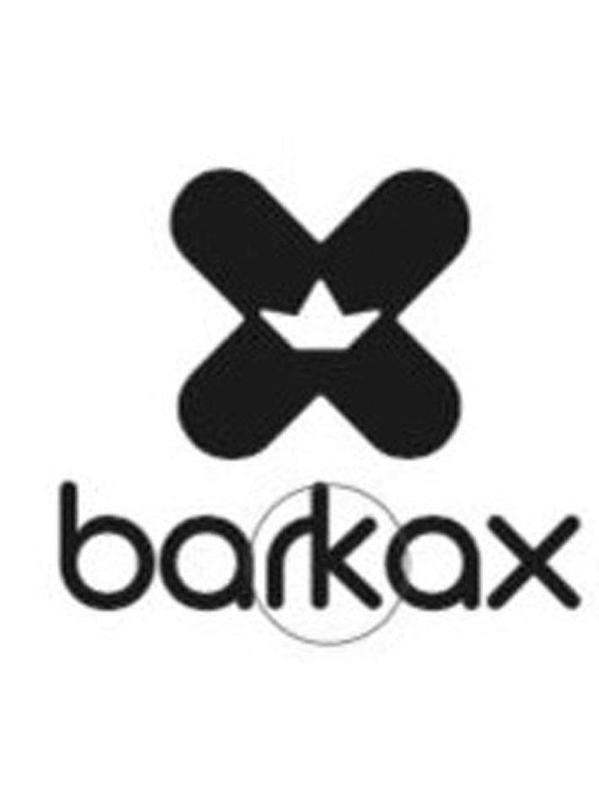  BARKAX | 25, 35 | LOW | LOW | N/A | ✗ | N/A
Both marks begin with "BAR" but the endings "-KAX" and "-DAK" differ clearly in spelling and sound, and the cited logo is dominated by a large X-with-crown device. The registration covers clothing, footwear and headgear together with retail of those goods only, which has no commercial connection with bottles, thermos mugs or drinkware retail.
TMView: ES500000003726724
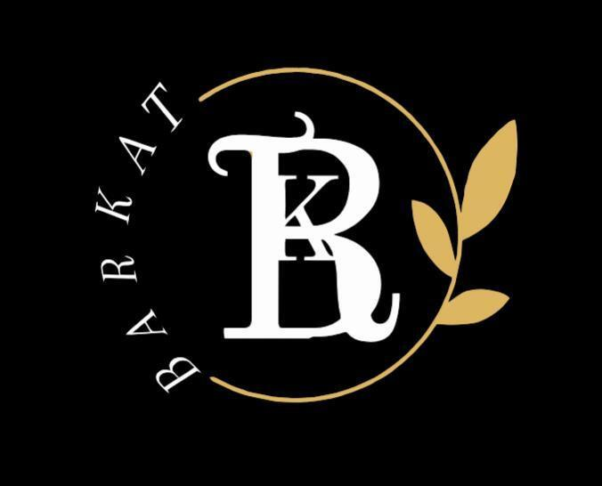  Barkat | 35 | LOW | MEDIUM | N/A | ✗ | LOW
"Barkat" and "Bardak" share the same two-syllable rhythm and the BAR- opening, giving moderate phonetic proximity, but the cited mark's services are advertising, business management and office functions, not retail of drinkware. The cited figurative mark is also dominated by an ornate B/K monogram, further separating the overall impressions, so risk stays low.
TMView: ES500000004250466
BARDARE | 35, 41, 42 | MEDIUM | LOW | N/A | ✗ | LOW
The first five letters "BARDA" coincide, but the cited mark has three syllables ending in "-RE" and is longer overall. Its Class 35 cover is advertising and marketing consultancy, a different commercial sector from retail of bottles and drinkware, so no meaningful likelihood of confusion arises.
TMView: ES500000004390599
BARDARO | 3, 5, 14, 18, 25, 35 | MEDIUM | LOW | N/A | ✗ | LOW
"BARDARO" shares the "BARDA" opening but adds a third syllable and ends in "-RO", and the cited mark is presented in an elegant serif typeface without a device. Its Class 35 retail cover is limited to clothing, footwear, bags, perfumery, cosmetics, jewellery and dietary supplements, none of which relates to drinkware, and it has no Class 21 goods.
TMView: EM500000019320328
BARDANI | 18, 20, 21, 22, 25, 28 | MEDIUM | MEDIUM | N/A | IDENTICAL | MEDIUM
The cited registration covers "household or kitchen utensils and containers" and "glassware, porcelain and earthenware" in Class 21, which directly encompasses bottles, mugs and drinkware, so the goods are identical. Visually and phonetically the marks share the sequence BARDA- but diverge in the endings "-NI" versus "-K" and in syllable count (three versus two), and the cited mark is presented as a large calligraphic B script. The combination of one shared opening element with identical goods keeps this at medium rather than high risk.
TMView: EM500000010531952
BARDANI | 5, 6, 8, 9, 12, 18, 20, 21, 22, 24, 25, 26, 27 | MEDIUM | MEDIUM | N/A | IDENTICAL | MEDIUM
This second BARDANI registration again covers Class 21 household and kitchen utensils and containers, glassware and chinaware, which overlaps identically with bottles, mugs and drinkware. The shared BARDA- beginning creates moderate visual and phonetic proximity, while the different third syllable and the distinctive calligraphic presentation reduce the overall closeness. Since the mark is a coined term with no descriptive content for its own goods, no weakness discount applies.
TMView: EM500000016286262
BARDANI | 5, 6, 8, 9, 12, 18, 20, 21, 22, 24, 25, 26, 27 | MEDIUM | MEDIUM | N/A | IDENTICAL | MEDIUM
A further BARDANI registration with the same Class 21 wording covering household and kitchen containers and glassware, therefore identical to the target's drinkware. The assessment mirrors the other BARDANI filings: moderate visual and phonetic similarity from the shared BARDA- string, offset by the different ending and syllable count, giving medium overall conflict risk.
TMView: EM500000016286239
BARZAK BOATS | 12, 35, 39 | LOW | MEDIUM | N/A | ✗ | LOW
"BARZAK" rhymes with "BARDAK" and shares the BAR- opening and final -AK, but the additional word BOATS and the prominent nautical rope-and-monogram device dominate the cited mark's overall impression. Its services cover boats, marina services and retail of clothing, sporting, diving and watercraft goods, which do not extend to drinkware, so risk remains low.
TMView: EM500000014543755
BARDOM INNOVATIONS | 19, 35 | LOW | LOW | N/A | ✗ | N/A
The cited mark is a two-word sign whose first element ends in "-DOM" and whose overall length is much greater than the target. Its goods and services concern non-metallic building materials, tiles and the import, export and retail of those materials, a wholly different commercial sector from bottles and drinkware.
TMView: ES500000004112963
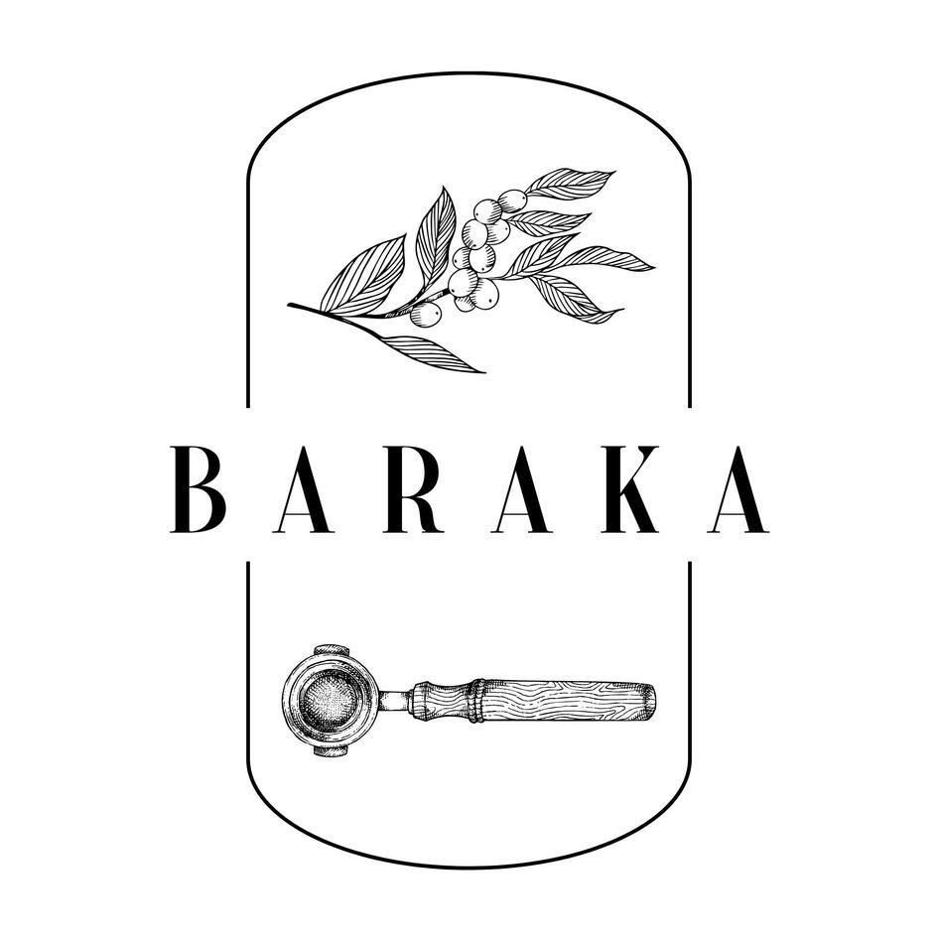  BARAKA | 21 | LOW | MEDIUM | N/A | IDENTICAL | MEDIUM
The cited Class 21 registration covers domestic and culinary utensils and containers, coffee services and coffee cups, which overlaps identically with mugs and drinkware. Phonetically "BA-RA-KA" and "BAR-DAK" share the BAR- opening and the -AK/-AKA sound, but the target has two syllables against three and inserts a clearly audible D, while the cited mark's overall impression is dominated by an elaborate coffee-branch and portafilter emblem. Identical goods combined with a single moderate similarity dimension places this at medium risk.
TMView: ES500000004253829
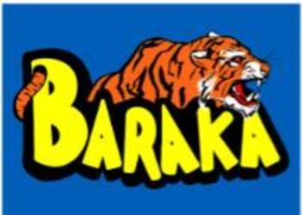  BARAKA | 28, 35, 42 | LOW | MEDIUM | N/A | ✗ | LOW
This BARAKA registration covers gaming miniatures, retail of games and game design, with a tiger-and-yellow-lettering logo that is visually far removed from the target. Despite the partial phonetic overlap in the BAR-/-AK sounds, the absence of any commercial connection with drinkware or its retail keeps the risk low.
TMView: ES500000004116864
Baraka | 29, 30, 32, 35, 39 | LOW | MEDIUM | N/A | ✗ | LOW
The cited mark covers foodstuffs, non-alcoholic beverages, export agency and delivery services, and is presented together with Georgian script characters. Beverages as such are not the same as the containers the target sells, and the Class 35 cover is export agency services for food rather than retail of drinkware, so the moderate phonetic overlap does not translate into a real conflict.
TMView: WO500000001407465
BERDAC | 35, 42 | MEDIUM | MEDIUM | N/A | ✗ | LOW
"BERDAC" and "BARDAK" share five of six letters in a similar order and a comparable two-syllable rhythm, but the vowel change in the first syllable is clearly perceptible and the cited mark carries a distinctive blue circular device. Its services are wholesaling and retailing of medicine dispensers and pill packaging plus software design, commercially remote from drinkware retail, so risk stays low.
TMView: EM500000018198023
BARDOU | 3, 8, 35, 41, 44 | MEDIUM | LOW | N/A | ✗ | LOW
The first four letters "BARD" coincide, but the endings "-OU" and "-AK" produce clearly different sounds. The cited registration covers cosmetics, hair implements, hairdressing training and salon services plus retail of beauty products, which has no overlap with bottles, mugs or drinkware retail.
TMView: EM500000015043862
BARTEK | 10, 25, 35 | LOW | LOW | N/A | ✗ | N/A
"BARTEK" differs in its second syllable vowel and consonants and is presented in a childlike blue lettering with a sun device. Its cover is footwear, clothing, orthopaedic footwear and the running of shops selling footwear and leather accessories, entirely separate from drinkware and its retail.
TMView: EM500000004628137
bartar | 29, 30, 31, 32, 35 | LOW | LOW | N/A | ✗ | N/A
"bartar" repeats the -AR sound and ends in R rather than K, giving a different overall sound and appearance, and its logo is a large red-and-orange composite device. The goods are foodstuffs and beverages with retail services relating to food, not containers or drinkware retail.
TMView: EM500000017930586
baldağ | 30, 35 | LOW | LOW | N/A | ✗ | N/A
Only the initial "BA" is shared; the L and the ğ produce a clearly different appearance and pronunciation, and the cited logo features a bee and mountain motif. The cover is honey, propolis and the retail bringing-together of those goods, unrelated to bottles or drinkware.
TMView: WO500000001476973
Bartuke | 21 | LOW | LOW | N/A | ✓ | LOW
Both marks sit in Class 21, but the cited specification is confined to pet-related articles such as cages, litter boxes, pet feeders and drinking bowls plus air fragrancing apparatus and indoor aquaria, which are only loosely related to human drinkware. The words differ in their second syllable and in length, so despite the class proximity the overall impressions remain distinguishable.
TMView: EM500000019067887
BARUTÇU | 5, 24, 25, 27, 35 | LOW | LOW | N/A | ✗ | N/A
"BARUTÇU" has three syllables, a distinctive Ç and an accompanying figurative device, giving a clearly different impression from the target. Its Class 35 cover is advertising, market studies and a general bringing-together of goods without reference to drinkware, and the goods classes concern diapers, textiles, clothing and prayer rugs. The registry shows a statement of grant of protection in Spain, so the mark is active there, but the absence of goods proximity means there is no meaningful conflict.
TMView: WO500000001397008
Baalbak | 33, 35 | LOW | MEDIUM | N/A | ✗ | LOW
"Baalbak" ends in the same -BAK sound and begins with BA-, giving some aural proximity, but the doubled A and different internal structure separate the marks visually. The registration covers alcoholic beverages and their retailing and wholesaling, a different sector from the manufacture and retail of drinking vessels.
TMView: EM500000018476310
BRADDOCK | 25, 35 | LOW | LOW | N/A | ✓ | LOW
The Class 35 specification includes very broad bringing-together and retailing of household utensils and beverages, which is at least loosely related to retail of drinkware, so a limited service overlap exists. However the marks differ markedly: BRADDOCK has no vowel between B and R, uses a doubled D and ends in -OCK, producing a clearly different sound and silhouette from "bardak".
TMView: EM500000017999618
BRADDOCK | 3, 9, 14, 18, 25, 35 | LOW | LOW | N/A | ✓ | LOW
This registration's Class 35 wording expressly covers retailing and wholesaling of cooking utensils and plates, which touches the target's retail of drinkware, and the mark appears in a bold green lower-case font with a shamrock device. Even so, the word BRADDOCK is structurally and aurally distant from "bardak", so the likelihood of confusion is low.
TMView: EM500000015502537
BERTAKO | 7, 16, 17, 35, 42 | LOW | LOW | N/A | ✗ | N/A
"BERTAKO" has three syllables, a different vowel in the first syllable and a final O, and is shown in an outlined boxed logo. Its cover concerns packaging materials, plastics, filling machines and the retail of containers and machine tools for packaging, which addresses industrial packaging rather than consumer drinkware.
TMView: EM500000014784541
BERTAKO | 35 | LOW | LOW | N/A | ✗ | N/A
The second BERTAKO registration covers advertising, business management, import-export and retail of industrial packaging and machine tools. Neither the word structure nor the services come close to "bardak" for drinkware or its retail.
TMView: ES500000002315120
BirdDock | 21 | LOW | LOW | N/A | ✓ | LOW
The cited Class 21 specification is limited to bird and pet articles, brushes, cages and feeding troughs, which are only broadly related to the target's drinkware within the same class. The mark is a two-element compound with an internal capital D and a large bird device, and is pronounced quite differently from "bardak", so confusion is unlikely.
TMView: EM500000018816715
BARONPEAK | 3, 4, 5, 6, 7, 8, 9, 11, 12, 14, 16, 17, 18, 19, 20, 21, 25, 28 | LOW | LOW | N/A | IDENTICAL | LOW
The Class 21 cover includes drinking vessels, insulating flasks and thermally insulated containers for food, which is identical to bottles, thermos mugs and drinkware. The signs themselves are far apart, however: BARONPEAK is a nine-letter, three-syllable compound whose dominant impression is "BARON" plus "PEAK", so only the initial BAR- is shared and both visual and phonetic similarity remain low despite the identical goods.
TMView: EM500000019289904
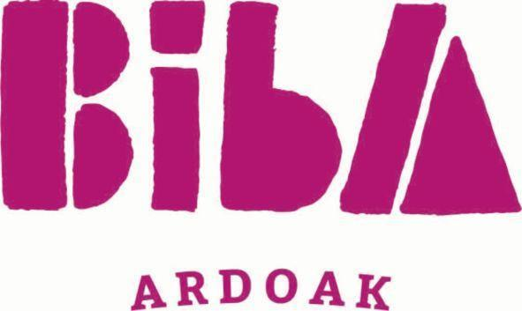  BIBA ARDOAK | 35, 39 | LOW | LOW | N/A | ✗ | N/A
The cited mark consists of two words dominated by the large stylised pink "BiBA", with "ARDOAK" (Basque for wines) in small type below. Its services concern wholesale, retail, storage and transport of organic Basque wines, which does not extend to drinkware, and the overall impression is clearly different from the target.
TMView: ES500000004024028
BRATEK | 9, 11, 35 | LOW | LOW | N/A | ✗ | N/A
BRATEK lacks the vowel between B and R and ends in -EK, producing a clearly different sound, and it is presented in a blue technical font with green and red bars. Its cover is electrical cables, telephone apparatus, plumbing fittings and online marketplace and consumer-information services, unrelated to drinkware or its retail.
TMView: EM500000018794147
BORDEGE | 35, 36, 38, 41 | LOW | LOW | N/A | ✗ | N/A
Only the B, R and D consonants are loosely shared; the vowels and the final -GE make BORDEGE clearly distinct in sight and sound. Its services cover business events, advertising, financial services, telecommunications and entertainment, with no connection to drinkware retail.
TMView: ES500000004349761
AK KARDAN | 7, 12, 35 | LOW | LOW | N/A | ✗ | N/A
The cited mark is a two-word sign beginning with "AK" and accompanied by a circular device, so its beginning differs from the target even though the letters ARDA appear inside the second word. Its cover is machine tools, engines, vehicle transmission parts and the retail bringing-together of those goods, wholly unrelated to drinkware.
TMView: EM500000013018023

Assumptions and Limitations
Assumptions:
• ASSUMPTION: The Class 21 filing is read as covering bottles, thermos flasks, mugs and other drinking vessels, and the Class 35 filing as retail, wholesale and online sale of those goods. | WHY: The business description names bottles, thermos mugs and drinkware but no formal specification was supplied. | IMPACT: affects goods_overlap and conflict_risk for the Class 21 citations BARDANI, BARAKA, BARONPEAK, Bartuke and BirdDock and for the Class 35 citations, and therefore the per_class_assessment probabilities.
• ASSUMPTION: The Spanish-speaking public perceives "bardak" as a coined word with no meaning rather than as the Turkish word for "glass". | WHY: Turkish is not a language of Spain and the country notes list only Spanish, Catalan, Galician and Basque. | IMPACT: affects distinctiveness_category, inherent_distinctiveness.risk_level and linguistic_cultural.risk_level.
Limitations:
None specified.

Poland
TRADEMARK REGISTRABILITY ASSESSMENT
Bardak
PL • NICE Classes: 21, 35 • July 30, 2026
Trademark register — data as of: July 28, 2026 · Poland — app 2026-07-28 / reg 2026-03-24 (pending + registered); EUIPO — app 2026-07-29 / reg 2026-07-03 (pending + registered); WIPO — app 2026-07-27 / reg 2026-06-25 (pending + registered)
Applicant origin: Portugal
Practical Outlook
Registration Outlook:
Fixable
The name can likely be registered, but something needs attention first — narrowing or changing the goods/services classes, adding a disclaimer, or adjusting an element of the mark. The name itself stays.
Summary:
Yes, "bardak" can most likely be registered in Poland, but it is worth tightening your goods list before you file. The main challenge is in Class 21: three earlier BARDANI registrations and one BARTEK registration cover household and kitchen containers, glassware and mugs, which is the same shelf your bottles and thermos mugs sit on. This is overcomable because the names are only partly similar — yours ends in a hard "-k", BARDANI ends in an open "-ni" and is used with a swirly handwritten logo, and Polish shoppers read BARTEK as a boy's first name while your word means nothing to them. It also helps that the Polish office does not raise earlier marks by itself, so the only real risk is an objection filed by one of those owners after your mark is published. Your Class 35 retail services look clean, because the similar names there sell cosmetics, clothes and shoes rather than drinkware.
What to do before filing:
1. Narrow your Class 21 wording to bottles, vacuum flasks, thermos mugs and drinking vessels instead of the broad "household and kitchen containers" wording that duplicates the BARDANI specification.
2. Add "relating to bottles, thermos mugs and drinkware" to your Class 35 retail and wholesale services so the different sector is clear against BARDARO, BARDOU and BRADDOCK.
3. File the mark in the composite form shown, keeping the word "bardak" clearly larger than the glass icon, to maximise visual distance from the BARDANI and BARTEK logos.
4. Prepare a one-page comparison of your product range against the BARDANI Class 21 list so you can respond quickly, or explore a coexistence arrangement, if that owner objects.

Per-Class Assessment

ⓘ | How registration works: The trademark office examines each class separately. If they find a similar mark in any class, they will send a provisional refusal. This is a normal part of the process and you can respond with arguments about why your services are different.
Class | Status | Prov. Refusal Chance | Success Chance | Key Obstacle
21 | Provisional refusal possible | 50% | 70% | Three BARDANI registrations and one BARTEK registration cover household and kitchen containers, glassware, mugs and plates in Class 21, which is exactly where your bottles, thermos mugs and drinkware sit.
35 | No obstacles | — | 80% | Several BAR-initial marks such as BARDARO, BARDOU and BRADDOCK hold broad retail services in Class 35, though none of them retails drinkware specifically.

ⓘ | Estimated Timeline: In Poland a straightforward application is usually examined within about 3 to 4 months, followed by a three-month window in which third parties can object, so registration typically takes around 6 to 9 months. If one of the earlier owners does object, add roughly 6 to 12 months for the proceedings.

Detailed Analysis

Mark Analysis
Mark Type: | COMPOSITE
Distinctiveness Category: | ARBITRARY
Distinctiveness Scale
Generic | Descriptive | Suggestive | Arbitrary | Fanciful
← Weak | Strong →

ⓘ | • Generic: Common name for the goods/services category  • Descriptive: Immediately describes goods, services, or characteristics  • Suggestive: Hints at qualities but requires imagination to connect  • Arbitrary: Real word completely unrelated to the goods  • Fanciful: Invented word with no dictionary meaning
Reasoning:
The mark combines the word "bardak" in a clean lowercase sans-serif navy typeface with a small figurative element depicting a stylised drinking glass partly filled with an amber liquid. "Bardak" has no meaning in Polish, the only official language of the target country, so for Polish consumers it functions as an invented, arbitrary sign; it is however the ordinary Turkish word for "glass/tumbler", which is not a language of the relevant Polish public and therefore does not make the word element descriptive in Poland. The figurative glass device, by contrast, directly depicts the type of product covered (drinkware, bottles, mugs) and is therefore a weak, non-distinctive component that will not on its own carry distinctiveness. Read as a whole, the word element dominates and gives the sign the required level of distinctive character for Classes 21 and 35.

Assessment Summary
"bardak" has a reasonable prospect of registration in Poland for drinkware and related retail services. On absolute grounds the position is comfortable: the word has no meaning for Polish consumers and is treated as a coined sign, the only weak element being the small drinking-glass icon that simply depicts the goods. The main pressure comes from earlier rights in Class 21, where three BARDANI registrations and one BARTEK registration cover household and kitchen containers, glassware and mugs — the same territory as bottles and thermos mugs — although none of these marks is close enough to "bardak" to be a blocking citation. Class 35 is materially cleaner, since the BAR-initial marks with broad retail services operate in cosmetics, clothing and footwear rather than drinkware. Mitigating factors include the crowded state of the Polish register for BAR-initial marks, which narrows each owner's effective scope, and the fact that Polish examiners do not raise earlier marks on their own initiative, so conflicts only materialise if a prior owner opposes. The recommended approach is to tighten the Class 21 and Class 35 wording to the actual drinkware business and to keep the distinctive word element visually dominant.
Registration Probability: 75%

Recommendations
• [GOODS_SCOPE] Consider replacing the broad Class 21 heading with a precise list such as bottles, vacuum flasks, thermos mugs, drinking vessels and their parts — to reduce the identical overlap with the Class 21 wording of the BARDANI registrations and of the BARTEK registration that lists mugs and plates — expected impact: shifts part of the overlap from identical to related and narrows the ground on which an opposition could be built.
• [GOODS_SCOPE] Consider specifying in Class 35 that the retail, wholesale and online sales services relate specifically to bottles, thermos mugs and drinkware — to distance them from the cosmetics, clothing and footwear retail services held by BARDARO, BARDOU and BRADDOCK — expected impact: makes the different retail sector evident on the register and lowers the chance of a Class 35 objection.
• [DESIGN_ELEMENT] Consider filing the mark in the attached composite form with the navy lowercase lettering and glass icon rather than as a bare word — to add visual separation from the ornate handwritten BARDANI logo and the childlike BARTEK sun logo — expected impact: increases the visual distance between the signs, which is one of the factors weighed in any opposition.
• [DISTINCTIVENESS] Consider keeping the word "bardak" clearly dominant in size over the drinking-glass device — because the glass icon merely depicts the goods and contributes nothing to distinctiveness under Polish absolute-grounds practice — expected impact: ensures the distinctive character of the sign rests on the protectable word element.
• [COEXISTENCE] Consider preparing, before filing, a short comparison of your drinkware range against the BARDANI Class 21 specification that could support a consent or coexistence approach if an opposition is filed — to address the one citation group whose goods are identical to yours — expected impact: gives you a ready path to settle the only MEDIUM-level conflict without abandoning Class 21.

ⓘ | Absolute grounds are inherent registrability criteria examined by the trademark office independently of any existing marks. These are legal requirements that every trademark must satisfy on its own merits.

Absolute Grounds Assessment
Overall Absolute Risk: LOW
Ground | Risk Level | Reason
Inherent Distinctiveness  Whether the mark is distinctive enough to identify the source of goods/services | LOW | The word "bardak" has no meaning for Polish-speaking consumers and is therefore distinctive for drinkware and related retail services. The only weak component is the figurative drinking-glass device, which merely depicts the goods; it will be treated as non-distinctive matter, but it does not undermine the mark as a whole under the Industrial Property Law's distinctiveness provisions.
Deceptive/Misleading  Whether the mark could mislead consumers about the nature or quality of goods | No Risk Identified | -
Public Order Morality  Whether the mark contains content contrary to public order or accepted moral principles | No Risk Identified | -
Prohibited Elements  Whether the mark includes state emblems, flags, official symbols or other prohibited elements | No Risk Identified | -
Geographic Indications  Whether the mark contains protected geographic indications or misleading geographic terms | No Risk Identified | -
Linguistic/Cultural  Whether the mark has negative or problematic meanings in local languages or cultures | LOW | Polish is the only relevant language: in Polish "bardak" carries no established dictionary meaning and reads as a coined, foreign-sounding word, so no descriptive or offensive reading arises for the Polish public. It should be noted only that in some neighbouring Slavic languages a similarly spelled colloquial word means "mess/disorder", and Polish consumers with passive exposure to those languages could perceive a faintly informal connotation; this is far below the threshold of offensiveness and does not affect registrability. Polish is therefore the language driving the LOW assessment.
Personality Rights  Whether the mark infringes on another person's name, image, or identity rights | No Risk Identified | -
Well-Known Marks  Whether the mark conflicts with well-known marks that enjoy broader protection | No Risk Identified | -

ⓘ | Relative grounds assess potential conflicts with existing registered or pending marks. An examiner or third party may oppose your trademark if it is confusingly similar to a prior mark in the same or related goods/services.

Relative Grounds Assessment
Overall Relative Risk: MEDIUM
Analysis Notes: The register is crowded with BAR-initial marks in Poland, but the closest citations for the target's actual goods are the three BARDANI registrations, which cover household and kitchen utensils and containers and glassware in Class 21 — identical territory to bottles, thermos mugs and drinkware — and, to a lesser extent, BARDARO and BARDOU in Class 35. No citation reaches near-identity with "bardak", so the highest conflict level is MEDIUM. Goods overlap was assessed from the actual goods and services texts supplied for each cited mark, not from class numbers. The relevant public is general consumers of inexpensive everyday drinkware exercising an average level of attention, plus trade buyers for the Class 35 services.
Similar Marks Analysis:
Vis — Visual | Phon — Phonetic | Conc — Conceptual | Goods — Goods and services Overlap
Mark | Class | Vis | Phon | Conc | Goods | Risk
BARDARO | 3, 5, 14, 18, 25, 35 | MEDIUM | MEDIUM | N/A | ✓ | LOW
Both marks share the first five letters BARDA-, but BARDARO is longer, has a serif all-capital presentation and ends in the resonant -RO, giving a three-syllable rhythm against the two syllables of "bardak" with its hard final -k. The cited Class 35 services are retail of clothing, footwear, perfumery, cosmetics, jewellery and supplements, which are only loosely related to retail of drinkware, and none of its goods classes touch Class 21. Neither mark has a meaning for Polish consumers, so conceptual comparison does not apply. With only moderate similarity and no identical goods, confusion risk stays low.
TMView: EM500000019320328
BARDANI | 18, 20, 21, 22, 25, 28 | MEDIUM | MEDIUM | N/A | IDENTICAL | MEDIUM
BARDANI shares the sequence BARDA- with "bardak" and its Class 21 specification covers household or kitchen utensils and containers and glassware, which directly encompasses bottles, mugs and drinkware, so the goods are identical in Class 21. The endings differ clearly, however: "bardak" closes on a hard consonant while BARDANI ends in an open -NI, and the cited mark is presented as a stylised handwritten monogram with a large flowing letter B, whereas the target uses plain lowercase type with a small glass device. Because exactly one dimension pair sits at MEDIUM against identical goods, the risk is assessed as MEDIUM rather than HIGH; the cited mark is coined for its goods and therefore enjoys a normal, not narrowed, scope of protection.
TMView: EM500000010531952
BARDANI | 5, 6, 8, 9, 12, 18, 20, 21, 22, 24, 25, 26, 27 | MEDIUM | MEDIUM | N/A | IDENTICAL | MEDIUM
This second BARDANI registration again covers household or kitchen utensils and containers and glassware in Class 21, which overlaps identically with bottles, thermos mugs and drinkware. Visual and phonetic similarity rest on the shared BARDA- opening, offset by the different endings and by the cited mark's ornate script logo with a dominant flourished B. No conceptual comparison is possible as neither word means anything in Polish. Identical goods combined with moderate similarity yields MEDIUM risk.
TMView: EM500000016286262
BARDANI | 5, 6, 8, 9, 12, 18, 20, 21, 22, 24, 25, 26, 27 | MEDIUM | MEDIUM | N/A | IDENTICAL | MEDIUM
A further BARDANI registration with the same Class 21 wording covering household and kitchen containers and glassware, so the overlap with drinkware is identical. Similarity is limited to the common BARDA- stem; the additional -NI ending and the three-syllable pronunciation distinguish the marks aurally, and no meaning is shared. The cumulative presence of three BARDANI rights covering Class 21 is the principal relative-grounds concern for this filing, assessed at MEDIUM.
TMView: EM500000016286239
BARZAK BOATS | 12, 35, 39 | LOW | MEDIUM | N/A | ✗ | LOW
BARZAK shares the B-A-R skeleton and the final -AK with "bardak", producing some aural resemblance, but the internal Z instead of D and the added word BOATS change the overall impression, reinforced by a large nautical rope-and-monogram device. The cited Class 35 services concern advertising and retail of water vehicles, diving equipment, clothing and footwear, which have no plausible connection to drinkware retail. Risk is therefore low.
TMView: EM500000014543755
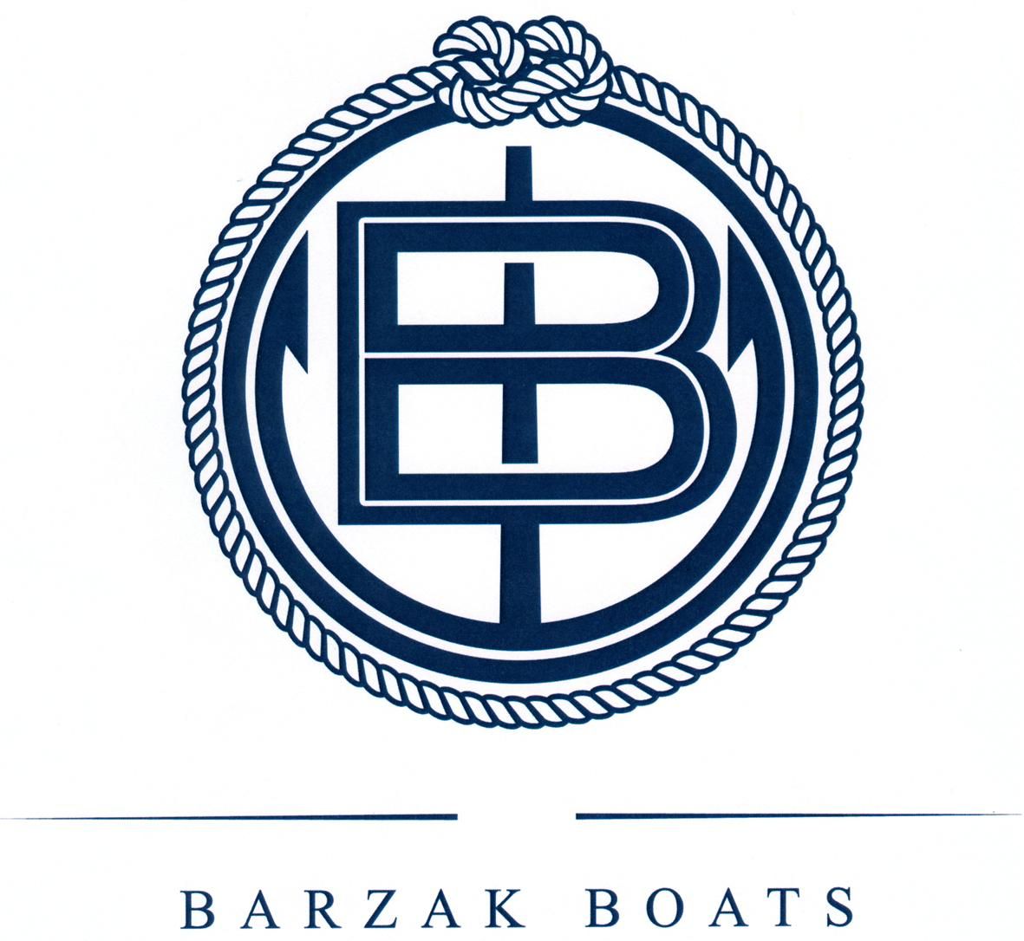  B BARZAK BOATS | 12, 35, 39 | LOW | MEDIUM | N/A | ✗ | LOW
The same BARZAK BOATS branding in a figurative form dominated by a circular rope emblem with an interlocking B monogram. The Class 35 wording covers sale of watercraft, their fittings and related clothing, unconnected to bottles and drinkware retail. Only a partial aural echo of the -AK ending links the signs, so confusion is unlikely.
TMView: PL500000000446640
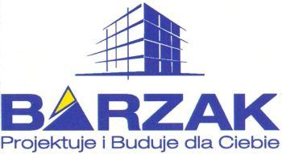  BARZAK Projektuje i Buduje dla Ciebie | 6, 35, 36, 37, 39, 42 | LOW | LOW | N/A | ✗ | N/A
This mark is dominated by the word BARZAK plus a Polish slogan and a building graphic, and its Class 35 services concern retail of construction materials, timber and furniture board together with import-export and advertising agency services. Neither the sign nor the commercial sector approaches the target's drinkware business, so no meaningful conflict arises.
TMView: PL500000000284460
Baraka | 29, 30, 32, 35, 39 | LOW | MEDIUM | N/A | ✗ | LOW
Baraka shares the opening BAR- and a similar rhythm but lacks the D and ends in an open vowel, and it is presented with Georgian-script lettering above the Latin word. Its Class 35 services are export agency services for foodstuffs and beverages, and its goods classes are food and drinks, none of which cover drinkware or retail of drinkware. Confusion risk is low.
TMView: WO500000001407465
BERDAC | 35, 42 | MEDIUM | MEDIUM | N/A | ✗ | LOW
BERDAC has the same B-R-D-C consonant skeleton and a comparable two-syllable cadence, but the first vowel is E rather than A and the mark appears with a distinctive blue circular device. Its Class 35 services are wholesaling and retailing of medicine dispensers, pill dispensers and medicine packaging, a completely different commercial sector from drinkware, and Class 42 software design is unrelated. Mark similarity alone without goods proximity does not create actionable risk.
TMView: EM500000018198023
BARDOU | 3, 8, 35, 41, 44 | MEDIUM | MEDIUM | N/A | ✓ | LOW
BARDOU shares the BARD- stem with "bardak" but ends in the French-styled -OU sound, giving a noticeably softer ending against the hard -ak. The cited Class 35 services are retail and online retail of soaps, perfumery, cosmetics, hair care goods and hairdressing implements — adjacent only in the general sense of being retail services, not in the drinkware sector — and its goods classes are cosmetics and hair tools. With one moderate dimension and merely related retail services, risk remains low.
TMView: EM500000015043862
BARTEK | 3, 9, 10, 14, 16, 18, 21, 22, 24, 25, 26, 28, 35, 37, 40, 42 | MEDIUM | MEDIUM | LOW | ✓ | LOW
BARTEK is a very familiar Polish diminutive of the forename Bartłomiej, so Polish consumers immediately read it as a personal name, whereas "bardak" has no meaning — a clear conceptual separation that reduces the impact of the shared BAR- opening and -k ending. Its Class 21 goods are limited to shoe-care implements such as shoe brushes, shoe horns and polishing cloths, and its Class 35 services cover shops selling footwear, clothing and leather goods, so overlap with drinkware is at most tangential. The strong name recognition of BARTEK for footwear further distances the signs, keeping risk low.
TMView: PL500000000313878
BARTEK | 10, 25, 35 | MEDIUM | MEDIUM | LOW | ✗ | LOW
This BARTEK registration covers footwear and clothing in Class 25, orthopaedic footwear in Class 10 and shops selling footwear and leather accessories in Class 35, with a childlike blue lettering and sun device. Neither the goods nor the retail services touch bottles, mugs or drinkware. The immediate reading of BARTEK as a Polish first name also separates it conceptually from the meaningless "bardak".
TMView: EM500000004628137
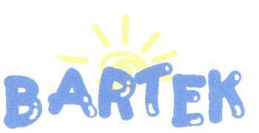  BARTEK | 3, 8, 9, 10, 14, 16, 18, 20, 21, 22, 24, 25, 26, 27, 28, 32, 35, 37, 40, 42 | MEDIUM | MEDIUM | LOW | IDENTICAL | MEDIUM
This BARTEK registration is the one whose Class 21 wording expressly lists plates, mugs, bowls and household containers, which overlaps identically with thermos mugs and drinkware, while its Class 35 covers shops selling footwear, clothing and leather goods. Visual and phonetic similarity rest on the shared BAR- start and final -k, but the middle letters differ (RT versus RD) and Polish consumers instantly recognise BARTEK as a common forename, whereas "bardak" conveys nothing — a conceptual gap that materially reduces confusion. The cited mark's childish blue lettering with a yellow sun also differs sharply from the target's minimal navy wordmark with a glass icon; on balance MEDIUM.
TMView: PL500000000247952
bartar | 29, 30, 31, 32, 35 | MEDIUM | MEDIUM | N/A | ✗ | LOW
bartar shares the BAR- opening and a two-syllable structure but repeats the R and lacks any D or final -k, and it is presented inside an elaborate red-and-orange logo with a sun motif. Its goods are foodstuffs and beverages and its Class 35 covers retail of food only, so there is no overlap with drinkware or drinkware retail. Risk is low.
TMView: EM500000017930586
baldağ | 30, 35 | LOW | LOW | N/A | ✗ | N/A
baldağ differs in its second and third letters and in its distinctive ğ ending, and it is presented with a bee and mountain device. Its scope is limited to honey, propolis and the retail of those goods, entirely outside the drinkware sector. No meaningful conflict arises.
TMView: WO500000001476973
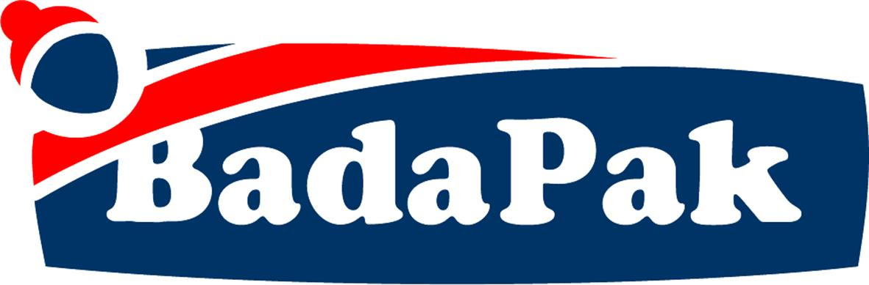  BadaPak | 5, 29, 30, 32, 35 | LOW | MEDIUM | N/A | ✗ | LOW
BadaPak echoes the vowel pattern and final -ak of "bardak" but is a two-part compound with a capital P in the middle, presented in a large navy and red banner logo. Its goods are vegan and vegetarian foods, drinks and dietetic products, and its Class 35 covers retail of tea, coffee and foodstuffs by mail order — no connection to drinkware. Risk is low.
TMView: PL500000000525391
Bartuke | 21 | MEDIUM | MEDIUM | N/A | ✓ | LOW
Bartuke shares the BAR- opening but continues with -tuke, adding a third syllable and a soft final vowel that sets it apart aurally and visually from "bardak". Although it sits in Class 21, its specification is confined to pet accessories — cages, litter boxes, pet feeders and drinking bowls for animals, aquaria and air fragrancing apparatus — which is a distinct commercial segment from human drinkware, so overlap is related at most. With one moderate dimension and only related goods, risk is low.
TMView: EM500000019067887
BARTICO | 35, 36, 37, 39 | LOW | LOW | N/A | ✗ | N/A
BARTICO is a three-syllable mark ending in the open -ICO, clearly distinguishable from the clipped "bardak". Its Class 35 services relate to grouping and selling construction, sanitary, lighting, furniture and household-appliance goods, together with commercial information and management consultancy, with no drinkware angle. No meaningful conflict.
TMView: PL500000000334223
Baalbak | 33, 35 | LOW | MEDIUM | N/A | ✗ | LOW
Baalbak ends in the same -bak sound and starts with Ba-, giving a partial aural echo, but the doubled AA and absence of R make the words look quite different. Its scope is alcoholic beverages and the wholesale and retail of alcoholic beverages, which does not extend to bottles, mugs or drinkware. Risk is low.
TMView: EM500000018476310
BRADDOCK | 25, 35 | LOW | LOW | N/A | ✓ | LOW
BRADDOCK has no vowel between B and R, a doubled D and a -DOCK ending, so it is pronounced quite differently from "bardak" and looks longer on the page. Its Class 35 wording is very broad and includes retail and wholesale of household utensils and of goods generally, which touches drinkware retail in a general way, but the marks themselves are too far apart for confusion. Risk is low.
TMView: EM500000017999618
BRADDOCK | 3, 9, 14, 18, 25, 35 | LOW | LOW | N/A | ✓ | LOW
The figurative version of BRADDOCK in green lowercase with a shamrock device covers, in Class 35, retailing and wholesaling of household utensils, cooking utensils and plates among many other goods, so there is a general retail relationship with drinkware sales. The signs nevertheless differ markedly in structure and pronunciation and the shamrock adds further visual distance, so confusion is unlikely.
TMView: EM500000015502537
BERTAKO | 7, 16, 17, 35, 42 | LOW | MEDIUM | N/A | ✗ | LOW
BERTAKO contains the -TAK- sequence and shares an initial B, producing a mild aural resemblance, but it has three syllables, an E as first vowel and an open final -O, and is presented in an outlined stencil logo. Its services concern advertising, business management, import-export and retail of industrial containers, packaging and machine tools — industrial packaging rather than consumer drinkware — so the sectors do not meet. Risk is low.
TMView: EM500000014784541
BirdDock | 21 | LOW | LOW | N/A | ✓ | LOW
BirdDock is a two-element English compound with a clear meaning and a prominent bird-and-letter device, quite unlike the single coined word "bardak". Its Class 21 specification is limited to pet and animal articles — bird baths, bird feeders, birdcages, pet brushes and litter pans — plus shoe horns and scrubbing brushes, so it does not cover drinkware. Risk is low.
TMView: EM500000018816715
BARONPEAK | 3, 4, 5, 6, 7, 8, 9, 11, 12, 14, 16, 17, 18, 19, 20, 21, 25, 28 | LOW | LOW | LOW | IDENTICAL | LOW
BARONPEAK expressly covers drinking vessels, thermally insulated containers for food, insulating flasks and containers for household or kitchen use in Class 21, so the goods overlap identically with bottles, thermos mugs and drinkware. The signs are nonetheless far apart: BARONPEAK is a long two-element English compound of four syllables conveying the ideas of a baron and a mountain peak, whereas "bardak" is a short meaningless two-syllable word, and the shared BAR- opening is a very common beginning on this register. Identical goods alone cannot bridge such low similarity, so risk stays low.
TMView: EM500000019289904
BRATEK | 9, 11, 35 | LOW | LOW | LOW | ✗ | N/A
BRATEK begins with the consonant cluster BR- and means "pansy" (and evokes "brother") in Polish, so it is both aurally and conceptually distinct from "bardak". Its scope covers electrical cables and telephone apparatus, plumbing fittings and online marketplace and consumer-advice services, none of which relate to drinkware. No meaningful conflict.
TMView: EM500000018794147
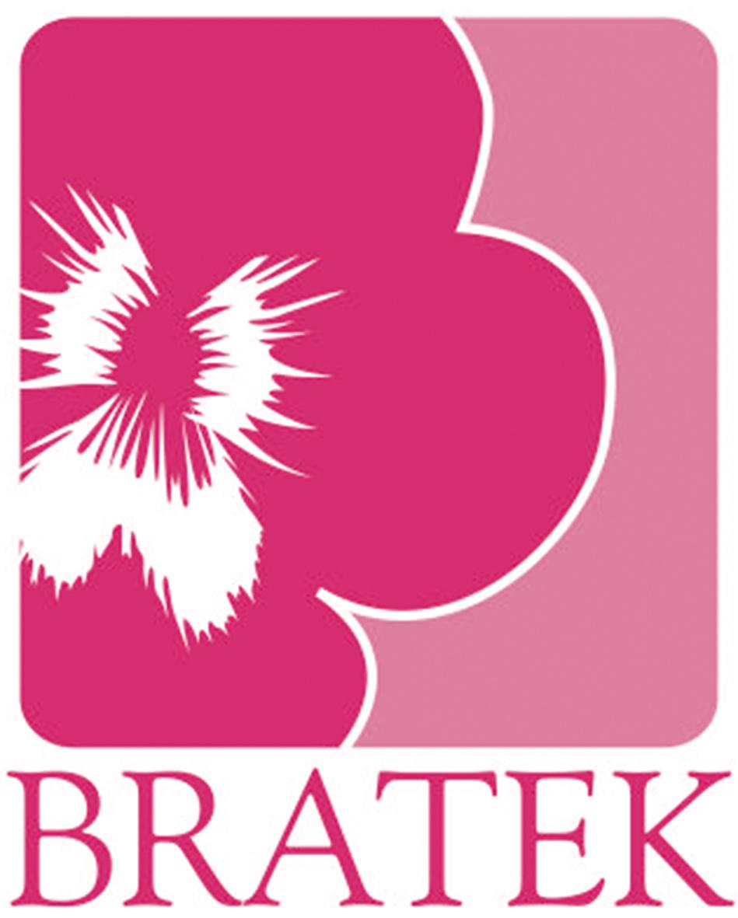  BRATEK | 16, 21 | LOW | LOW | LOW | ✓ | LOW
This BRATEK registration sits in Class 21 but is confined to sponges, cleaning cloths and scouring pads, a cleaning-articles segment distinct from drinkware, and is presented with a large pink flower device matching the Polish meaning "pansy". The BR- cluster and the clear Polish meaning separate it from the meaningless "bardak" on all dimensions. Risk is low.
TMView: PL500000000537559
AK KARDAN | 7, 12, 35 | LOW | LOW | N/A | ✗ | N/A
AK KARDAN is a two-word mark beginning with AK and referring to cardan shafts, presented with a circular technical device; it does not resemble "bardak" in structure or pronunciation despite a loose letter overlap. Its scope is machine tools, engine and vehicle transmission parts and the wholesale of such goods. No meaningful conflict.
TMView: EM500000013018023
PARTAKUS | 35, 38, 42 | LOW | LOW | N/A | ✗ | N/A
PARTAKUS starts with P, has three syllables and ends in -KUS, so it is clearly distinguishable from "bardak". Its Class 35 services are business information, commercial intermediation, advertising and search-engine optimisation, with database access and software development in Classes 38 and 42 — no retail of goods and no drinkware connection. No meaningful conflict.
TMView: EM500000018190484
BARTOG | 3, 4, 12, 35 | MEDIUM | MEDIUM | N/A | ✗ | LOW
BARTOG shares the BAR- opening and a two-syllable shape but has T instead of D and ends in -OG rather than -AK, which changes both the look and the sound. Its scope is glass and windscreen cleaning preparations, automotive lubricants and oils, inner tubes and wheel rims, and Class 35 retail and wholesale of vehicles and car parts — an automotive sector unconnected to drinkware retail. Risk is low.
TMView: EM500000018171819
BARTOG | 3, 4, 12, 35 | MEDIUM | MEDIUM | N/A | ✗ | LOW
The figurative BARTOG, shown in heavy black capitals with a blue wave-arc square device, has the same automotive specification: car-care preparations, lubricants, tyre inner tubes and rims, plus retail and wholesale of vehicles and car parts. The different middle consonant and -OG ending, together with the strong device, keep the marks apart, and the commercial sectors do not meet. Risk is low.
TMView: EM500000018171815

Assumptions and Limitations
Assumptions:
• ASSUMPTION: The Class 35 filing is taken to cover retail, wholesale and online sales services for the applicant's own product range of bottles, thermos mugs and drinkware. | WHY: The business description names only the products, not the services, and Class 35 is an umbrella covering many unrelated activities. | IMPACT: affects goods_overlap and conflict_risk for the Class 35 citations such as BARDARO, BARDOU and BRADDOCK, and the relative_risk and probabilities for Class 35 in per_class_assessment.
• ASSUMPTION: For Polish consumers "bardak" is pronounced as two syllables with a hard final -k and carries no dictionary meaning. | WHY: The word is not Polish, and its pronunciation determines how close it sounds to BARDANI, BARTEK and BARZAK. | IMPACT: affects the phonetic and conceptual scores and the conflict_risk assigned to the BARDANI and BARTEK citations.
Limitations:
None specified.

Slovakia
TRADEMARK REGISTRABILITY ASSESSMENT
Bardak
SK • NICE Classes: 21, 35 • July 30, 2026
Trademark register — data as of: July 29, 2026 · Slovakia — app 2026-07-29 / reg 2026-03-30 (pending + registered); EUIPO — app 2026-07-29 / reg 2026-07-03 (pending + registered); WIPO — app 2026-07-27 / reg 2026-06-25 (pending + registered)
Applicant origin: Portugal
Practical Outlook
Registration Outlook:
Fixable
The name can likely be registered, but something needs attention first — narrowing or changing the goods/services classes, adding a disclaimer, or adjusting an element of the mark. The name itself stays.
Summary:
Yes, your name can most likely be registered, but it is worth tightening your goods and services wording before you file. The main challenge is that other owners already hold Slovak rights for BARDANI and BRADAČ covering glassware, glasses, bottles and kitchen containers in Class 21, and BRADAČ also covers selling such goods in Class 35. This is overcomable: the Slovak office will not cite those marks against you by itself, and if an owner objects after your mark is published you can show that BARDANI ends in a clearly heard "-ni" and is written in a flourished handwritten style, while BRADAČ is dominated by a bearded-sailor picture and means "bearded man" to Slovak consumers. Your own presentation, a rounded lower-case word next to a small glass symbol, adds further separation. The word itself raises no problem in Slovak, so nothing in the wording of the mark should block you.
What to do before filing:
1. Narrow your Class 21 wording to bottles, thermos mugs, flasks and drinking vessels instead of claiming all household and kitchen utensils, so you overlap less with BARDANI and BRADAČ.
2. Word your Class 35 claim as retail, wholesale and online retail of bottles, thermos mugs and drinkware, which keeps you clear of the broad advertising and business-management services held by other owners.
3. File the composite logo with the glass symbol and the rounded lower-case lettering, since this presentation visibly separates you from the handwritten BARDANI script and the BRADAČ sailor emblem.
4. Prepare a short comparison of your mark against BARDANI and BRADAČ, ready to use if either owner objects during the publication period, and consider a consent or coexistence approach with the BARDANI owner if it does.

Per-Class Assessment

ⓘ | How registration works: The trademark office examines each class separately. If they find a similar mark in any class, they will send a provisional refusal. This is a normal part of the process and you can respond with arguments about why your services are different.
Class | Status | Prov. Refusal Chance | Success Chance | Key Obstacle
21 | Provisional refusal possible | 50% | 68% | Three earlier BARDANI registrations and the BRADAČ mark cover Class 21 household containers, glassware, glasses and bottles, and Bartuke covers pet drinking bowls, all in the same class as your bottles and mugs.
35 | Provisional refusal possible | 48% | 72% | BRADAČ covers retail and wholesale of glasses, beer glasses and bottles in Class 35, which is the same kind of service you would claim for selling your drinkware.

ⓘ | Estimated Timeline: Straightforward Slovak applications typically reach registration in roughly 6 to 10 months, including the publication period during which others can object. If the owner of BARDANI or BRADAČ files an objection, expect a further 6 to 12 months or more depending on whether the matter is settled by agreement.

Detailed Analysis

Mark Analysis
Mark Type: | COMPOSITE
Distinctiveness Category: | ARBITRARY
Distinctiveness Scale
Generic | Descriptive | Suggestive | Arbitrary | Fanciful
← Weak | Strong →

ⓘ | • Generic: Common name for the goods/services category  • Descriptive: Immediately describes goods, services, or characteristics  • Suggestive: Hints at qualities but requires imagination to connect  • Arbitrary: Real word completely unrelated to the goods  • Fanciful: Invented word with no dictionary meaning
Reasoning:
The logo combines the word "bardak" in a lower-case rounded navy typeface with a small stylized drinking-glass device partly filled with an amber liquid. "Bardak" has no meaning in Slovak, so for Slovak-speaking consumers it functions as an invented, arbitrary sign for bottles, thermos mugs and drinkware and for retail of such goods. Note that in Turkish "bardak" means "glass/tumbler", which is directly descriptive of the goods, and the glass device in the logo reinforces that meaning; however Turkish is not a language of the target public in Slovakia, so this reading does not make the mark descriptive there. The drinking-glass device is itself a weak, allusive element for drinkware, so distinctiveness rests mainly on the word, which remains meaningless and therefore protectable in Slovakia.

Assessment Summary
Prospects for registering "bardak" in Slovakia are reasonably good, with the main uncertainty coming from earlier marks rather than from the wording itself. On absolute grounds the word has no meaning in Slovak, so it functions as an invented sign for bottles, thermos mugs and drinkware; only the small drinking-glass symbol in the logo is weak because it merely alludes to the product. The most relevant prior rights are the three BARDANI registrations, which cover Class 21 glassware and household containers, the BRADAČ mark, which covers glasses and bottles as well as their retail, and Bartuke for pet drinking bowls; none of these is identical or near-identical to your sign. Both filed classes sit at a comparable medium level, with Class 21 marginally the more exposed because several earlier owners hold Class 21 rights there, while Class 35 benefits from the fact that most other Class 35 marks on the register operate in automotive, beauty, food, packaging and software sectors. Helpfully, the Slovak office does not raise earlier marks on its own initiative, so any conflict would have to be brought by an earlier owner, and the differing endings and highly individual graphic styles of BARDANI and BRADAČ give you solid distinguishing arguments. The recommended approach is to file the composite logo with a tightly drafted drinkware-focused specification in both classes.
Registration Probability: 70%

Recommendations
No specific recommendations.

ⓘ | Absolute grounds are inherent registrability criteria examined by the trademark office independently of any existing marks. These are legal requirements that every trademark must satisfy on its own merits.

Absolute Grounds Assessment
Overall Absolute Risk: LOW
Ground | Risk Level | Reason
Inherent Distinctiveness  Whether the mark is distinctive enough to identify the source of goods/services | LOW | For the Slovak-speaking public "bardak" carries no meaning and is treated as an invented word, so the mark is inherently registrable. The only weak component is the small drinking-glass device, which merely alludes to drinkware and adds little distinctive character; the word element carries the distinctiveness.
Deceptive/Misleading  Whether the mark could mislead consumers about the nature or quality of goods | No Risk Identified | -
Public Order Morality  Whether the mark contains content contrary to public order or accepted moral principles | No Risk Identified | -
Prohibited Elements  Whether the mark includes state emblems, flags, official symbols or other prohibited elements | No Risk Identified | -
Geographic Indications  Whether the mark contains protected geographic indications or misleading geographic terms | No Risk Identified | -
Linguistic/Cultural  Whether the mark has negative or problematic meanings in local languages or cultures | LOW | Slovak is the only relevant language under the country notes, and "bardak" has no established Slovak meaning, offensive or otherwise, so no cultural objection is expected under Act No. 506/2009 Coll. A very limited residual point is that in some other languages the word carries meanings (glass in Turkish, colloquially "mess" in Russian) that a small part of the Slovak public might recognise, but this does not affect the perception of the average Slovak consumer.
Personality Rights  Whether the mark infringes on another person's name, image, or identity rights | No Risk Identified | -
Well-Known Marks  Whether the mark conflicts with well-known marks that enjoy broader protection | No Risk Identified | -

ⓘ | Relative grounds assess potential conflicts with existing registered or pending marks. An examiner or third party may oppose your trademark if it is confusingly similar to a prior mark in the same or related goods/services.

Relative Grounds Assessment
Overall Relative Risk: MEDIUM
Analysis Notes: No cited mark is identical or near-identical to "bardak"; the highest exposure is MEDIUM and comes from the three BARDANI registrations and from BRADAČ, which cover Class 21 household containers, glassware, glasses and bottles (and, for BRADAČ, retail of those goods), plus Bartuke in Class 21 for pet drinking bowls and accessories. All overlap findings are based on the actual goods and services texts supplied for the cited marks rather than on class numbers alone, which is why the many Class 35 marks in unrelated sectors (automotive, beauty, food, packaging, software) are treated as unrelated. The relevant public consists of general consumers buying inexpensive everyday drinkware and, for the retail services, both consumers and trade buyers, with an average level of attention.
Similar Marks Analysis:
Vis — Visual | Phon — Phonetic | Conc — Conceptual | Goods — Goods and services Overlap
Mark | Class | Vis | Phon | Conc | Goods | Risk
Barkad | 35, 36, 39, 40, 43 | MEDIUM | MEDIUM | N/A | ✗ | LOW
"Barkad" shares the letters B-A-R plus K-A-D with the target but in transposed order (BARKAD vs BARDAK), giving moderate visual and aural resemblance. Its actual services are loyalty programme administration, securities, packaging and delivery, food processing and restaurants — none of which covers drinkware or retail of drinkware, so there is no goods proximity with the target's Class 21 goods or its Class 35 retail of drinkware. Both signs are meaningless in Slovak, so no conceptual comparison applies.
TMView: SK502017000079000
BARDARO | 3, 5, 14, 18, 25, 35 | MEDIUM | MEDIUM | N/A | ✗ | LOW
The marks share the opening string BARDA- but differ in ending (-RO vs -K) and length, and the cited mark is presented in an elegant spaced serif typeface while the target is a rounded lower-case logotype with a glass device. The cited Class 35 retail services are expressly limited to clothing, footwear, bags, perfumery, cosmetics, jewellery and dietary supplements, which do not cover drinkware retail, and its goods classes are cosmetics, pharmaceuticals, jewellery, leather goods and clothing. On that basis the commercial sectors do not meet.
TMView: EM500000019320328
BARDANI | 18, 20, 21, 22, 25, 28 | MEDIUM | MEDIUM | N/A | ✓ | MEDIUM
BARDANI and BARDAK share the first five letters BARDA-, so visual and aural resemblance is moderate, although the cited mark ends in the clearly audible -NI and is used in a handwritten script with a large flourished B, whereas the target is a rounded lower-case logotype with a glass device. Its Class 21 specification (household or kitchen utensils and containers, glassware, porcelain and earthenware) covers goods closely related to and partly encompassing bottles, mugs and drinkware. Since exactly one dimension pair is moderate with related and partly overlapping Class 21 goods, and the relevant public for inexpensive drinkware pays average attention, a medium risk is appropriate.
TMView: EM500000010531952
BARDANI | 5, 6, 8, 9, 12, 18, 20, 21, 22, 24, 25, 26, 27 | MEDIUM | MEDIUM | N/A | ✓ | MEDIUM
This is a broader filing of the same BARDANI sign, again shown in the flourished script, with a Class 21 list covering household and kitchen utensils and containers, glassware, chinaware, porcelain and earthenware, which is closely related to and partly covers bottles, thermos mugs and drinkware. Visual and aural resemblance rests on the shared BARDA- opening, tempered by the distinct -NI ending and the very different graphic presentation. Neither sign has a meaning in Slovak, so conceptual comparison does not apply.
TMView: EM500000016286262
BARDANI | 5, 6, 8, 9, 12, 18, 20, 21, 22, 24, 25, 26, 27 | MEDIUM | MEDIUM | N/A | ✓ | MEDIUM
A further registration of the same BARDANI sign with an identical Class 21 wording (household or kitchen utensils and containers, glassware, chinaware, porcelain and earthenware), which is related to the target's bottles, mugs and drinkware. The shared BARDA- opening produces moderate visual and aural similarity, while the -NI ending and the script presentation differentiate the overall impressions. Cumulatively the three BARDANI registrations strengthen this owner's position in Class 21 and make it the most relevant prior right.
TMView: EM500000016286239
Bardfa Cakes | 30, 32, 35, 45 | LOW | LOW | N/A | ✗ | N/A
The cited sign consists of BARDFA plus the word CAKES, which differs from BARDAK in its fourth letter onwards and adds a second word, so the overall impressions diverge. Its Class 35 services are advertising, marketing, sales support and trade fairs, not retail of drinkware, and its goods are confectionery and soft drinks. There is therefore no meaningful conflict.
TMView: SK502018000275800
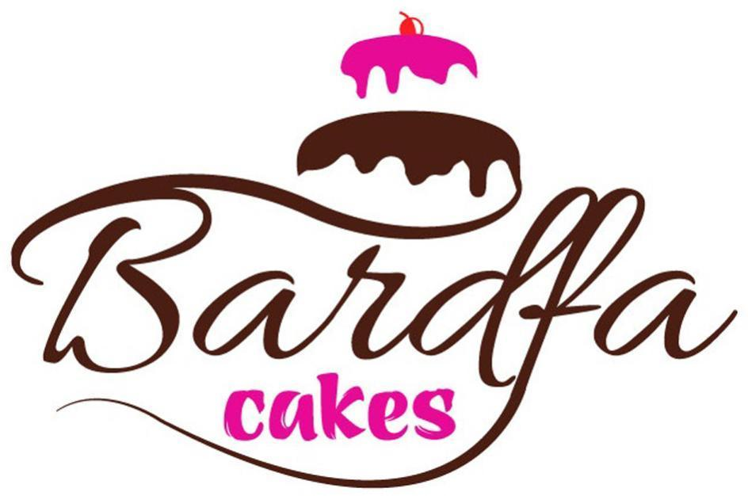  Bardfa cakes | 30, 32, 35, 45 | LOW | LOW | N/A | ✗ | N/A
This is the figurative version of the same sign, dominated by a large brown calligraphic "Bardfa" with a cake device and pink "cakes", an overall impression far removed from the target's plain rounded logotype with a small glass. The confectionery and advertising services do not touch drinkware or its retail. No meaningful conflict arises.
TMView: SK502018000275900
BARZAK BOATS | 12, 35, 39 | LOW | MEDIUM | N/A | ✗ | LOW
BARZAK shares the rhythm and the -AK ending with BARDAK, giving some aural resemblance, but the cited mark is a composite dominated by a nautical rope-and-monogram emblem with the additional word BOATS, so the visual impressions are clearly different. Its services relate to water vehicles, marinas and retail of sporting, diving and clothing goods, not drinkware. Goods proximity is therefore absent.
TMView: EM500000014543755
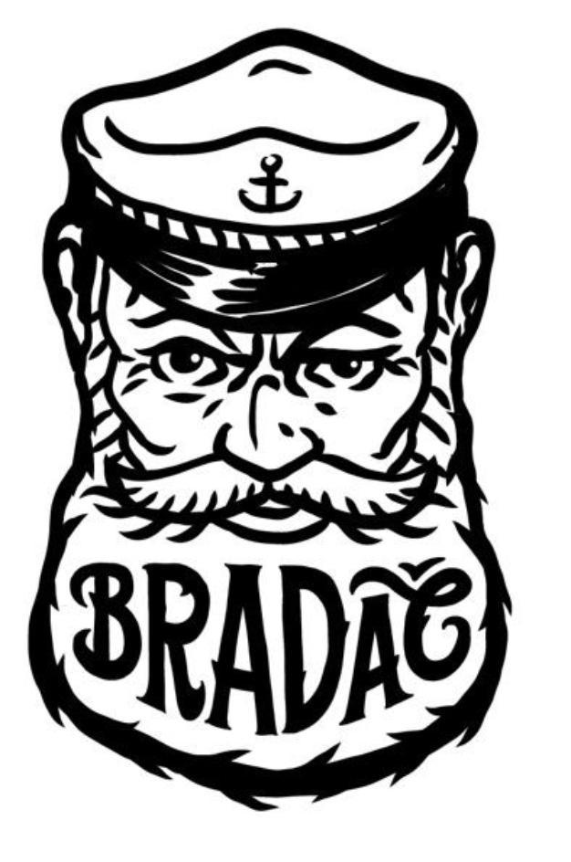  BRADAČ | 16, 21, 24, 25, 32, 33, 35, 41, 43 | MEDIUM | MEDIUM | LOW | ✓ | MEDIUM
BRADAČ and BARDAK contain the same letters B, R, A, D, A with a transposition and different final consonant, producing moderate visual and aural resemblance, though the cited mark is dominated by a striking bearded-sailor device and in Slovak conveys the idea of a bearded man, which the target does not. Its Class 21 list expressly includes glasses, beer glasses and bottles, and its Class 35 covers retail and wholesale of those Class 21 goods, so the goods and services are closely related to the target's drinkware and drinkware retail. The strong figurative element and the different Slovak meaning keep the risk at medium rather than high.
TMView: SK502026000116400
Baraka | 29, 30, 32, 35, 39 | MEDIUM | MEDIUM | N/A | ✗ | LOW
"Baraka" shares the BAR- opening and an -A-A vowel pattern with the target but lacks the D and ends in a vowel, and it is presented with an additional non-Latin script element above the word. Its services are advertising, business management, export agency and delivery of foodstuffs and beverages, and its goods are foodstuffs and drinks, none of which covers drinkware or drinkware retail. Goods distance keeps risk low.
TMView: WO500000001407465
BARLÁČ | 32, 33, 35 | LOW | LOW | N/A | ✗ | N/A
BARLÁČ shares only the BAR- opening with BARDAK and its distinctive -LÁČ ending with the Slovak diacritic gives a clearly different appearance and pronunciation. Its scope is beverages, spirits and business consultancy relating to drinks, not drinkware goods or their retail. No meaningful conflict.
TMView: SK502014000200200
BERDAC | 35, 42 | MEDIUM | MEDIUM | N/A | ✗ | LOW
BERDAC shares five letters with BARDAK in a similar sequence, though the E/A vowel difference and the C ending, plus the blue circular device in the cited logo, differentiate them. Its Class 35 wholesale and retail is expressly limited to medicine dispensers, pill dispensers, medicines and plastic packaging for medicines, and Class 42 is software design, so the commercial sectors are clearly different from drinkware and drinkware retail despite the shared Class 35 number.
TMView: EM500000018198023
BARDOU | 3, 8, 35, 41, 44 | MEDIUM | MEDIUM | N/A | ✗ | LOW
BARDOU shares the BARD- opening with BARDAK but ends in the open -OU sound, giving a different ending and rhythm. Its services and goods concern hair and beauty products, hairdressing tools, beauty training and salon services, and its Class 35 retail is confined to those goods, so there is no overlap with drinkware or its retail.
TMView: EM500000015043862
BARTEK | 10, 25, 35 | LOW | LOW | N/A | ✗ | N/A
BARTEK differs from BARDAK in its middle consonant and second vowel and is used in a childlike blue lettering with a sun device, so the overall impressions are distinct. Its business is footwear, clothing, orthopaedic footwear and shops selling those goods. No meaningful conflict with drinkware or drinkware retail.
TMView: EM500000004628137
BARBAR | 29, 30, 35, 39, 43 | LOW | LOW | N/A | ✗ | N/A
BARBAR repeats the BAR syllable and contains no D or K, so it looks and sounds clearly different from BARDAK. Its scope is salads, hamburgers, restaurant franchising administration, food delivery and restaurant services. There is no goods or service proximity to drinkware.
TMView: SK502021000278900
bartar | 29, 30, 31, 32, 35 | LOW | LOW | N/A | ✗ | N/A
"bartar" shares only the BAR- opening, has no D or K, and appears within a large red-and-orange figurative logo with a sun and wave device, so the impressions differ markedly. Its goods and services are preserved foods, spices, beverages and retail of food. No meaningful conflict.
TMView: EM500000017930586
baldağ | 30, 35 | LOW | LOW | N/A | ✗ | N/A
"baldağ" differs in its second consonant and in the diacritic ending, and its logo features a bee and mountains, giving a very different impression from the target. Its scope is honey, propolis and the retail of those goods only. No meaningful conflict.
TMView: WO500000001476973
Bartuke | 21 | MEDIUM | MEDIUM | N/A | ✓ | MEDIUM
"Bartuke" shares the BAR- opening and the letters T/K structure but has a different second syllable and a final -E, so similarity is moderate rather than strong. Its Class 21 specification is confined to pet and animal accessories such as feeders, cages, litter boxes and pet drinking bowls, which sit in the same class as, and are broadly related to, household containers and drinking vessels, although the target's human drinkware occupies a different market segment. Given the same class and average consumer attention, a medium assessment is appropriate, with the narrow pet-focused specification a strong differentiating argument.
TMView: EM500000019067887
Baalbak | 33, 35 | MEDIUM | MEDIUM | N/A | ✗ | LOW
"Baalbak" shares the B-A-...-B-A-K skeleton and the -AK ending with BARDAK, giving some resemblance, but the doubled A and absence of R and D change the appearance and rhythm. Its scope is alcoholic beverages and the retail and wholesale of alcoholic beverages, not drinkware or drinkware retail, so goods proximity is absent.
TMView: EM500000018476310
BRADDOCK | 25, 35 | LOW | LOW | N/A | ✗ | N/A
BRADDOCK is eight letters long with a doubled D and an -OCK ending, so it is clearly distinguishable from the short BARDAK both visually and aurally. Its Class 35 retail and wholesale services concern clothing, footwear, bags, jewellery, cosmetics and similar fashion goods and a broad marketplace offering, and its goods are clothing and footwear; household utensils appear only as part of an omnibus bringing-together list. The overall distance between the signs means no meaningful conflict arises.
TMView: EM500000017999618
BRADDOCK | 3, 9, 14, 18, 25, 35 | LOW | LOW | N/A | ✗ | N/A
This BRADDOCK filing is presented as a bold green lower-case logotype with a shamrock device, which together with the doubled D and -OCK ending places it far from BARDAK. Its goods are cosmetics, eyewear, leather goods, jewellery and clothing, and its Class 35 retail refers to cooking utensils and plates only within a long omnibus list dominated by fashion goods. The signs are too different for confusion.
TMView: EM500000015502537
BERTAKO | 7, 16, 17, 35, 42 | LOW | MEDIUM | N/A | ✗ | LOW
BERTAKO shares the B...TAK sequence, giving a degree of aural resemblance, but the E vowel, the extra final -O and the outlined block-letter presentation set it apart visually. Its business is industrial packaging materials, plastics, filling machines and the advertising, retail and design of containers and packaging for industry, which is a different sector from consumer drinkware and its retail.
TMView: EM500000014784541
BirdDock | 21 | LOW | LOW | N/A | ✓ | LOW
"BirdDock" is a two-element English compound with an I vowel, a doubled D and an -OCK ending, and it is dominated by a large bird-and-hook device, so it differs clearly from BARDAK in appearance and pronunciation. Its Class 21 goods are bird and pet accessories such as bird baths, feeders, cages and litter pans, which share the class with the target's drinkware but address a distinct pet market. The low similarity of the signs keeps the risk low despite the shared class.
TMView: EM500000018816715
BARONPEAK | 3, 4, 5, 6, 7, 8, 9, 11, 12, 14, 16, 17, 18, 19, 20, 21, 25, 28 | LOW | LOW | N/A | IDENTICAL | LOW
BARONPEAK is a long two-component sign whose overall impression (BARON + PEAK) is quite different from the short BARDAK, sharing only the BAR- opening and an -AK ending. Its Class 21 list does cover drinking vessels, thermally insulated containers for food and insulating flasks, which corresponds directly to the target's bottles and thermos mugs. Because the marks themselves are only faintly similar, the identity of goods alone does not create a real likelihood of confusion.
TMView: EM500000019289904
BRATEK | 9, 11, 35 | LOW | LOW | N/A | ✗ | N/A
BRATEK has a BRA- opening and an -EK ending and is shown as a blue capitalised logotype with green and red bars, so it is readily distinguishable from BARDAK. Its scope is electrical cables and telephone equipment, plumbing fittings and an online marketplace with retail management services for those goods. No meaningful conflict.
TMView: EM500000018794147
AK KARDAN | 7, 12, 35 | LOW | LOW | N/A | ✗ | N/A
"AK KARDAN" is a two-word sign beginning with AK and accompanied by a circular blue device, and although it contains the letters ARDA it reads and looks quite unlike BARDAK. Its business is machine tools, engines, vehicle transmission parts and the bringing together of such automotive goods. There is no proximity to drinkware or drinkware retail.
TMView: EM500000013018023
PARTAKUS | 35, 38, 42 | LOW | LOW | N/A | ✗ | N/A
PARTAKUS begins with P, is eight letters long and ends in -KUS, so it is clearly different from BARDAK. Its services are business information, commercial intermediation, advertising, database access and software development, which are unrelated to retail of drinkware despite the shared Class 35 number. No meaningful conflict.
TMView: EM500000018190484
BARTOG | 3, 4, 12, 35 | LOW | LOW | N/A | ✗ | N/A
BARTOG shares only the BAR- opening; the T, the O vowel and the final G give a different appearance and sound from BARDAK. Its scope is glass and windscreen cleaning preparations, lubricants, tyre tubes and rims, and retail and wholesale of vehicles and automobile parts and accessories, an entirely different sector from drinkware retail. No meaningful conflict.
TMView: EM500000018171819
BARTOG | 3, 4, 12, 35 | LOW | LOW | N/A | ✗ | N/A
This is the figurative version of BARTOG, shown in heavy black capitals with a blue square wave device, which increases the visual distance from the target's rounded lower-case logotype. Its automotive cleaning products, lubricants, tyre parts and vehicle retail services do not touch drinkware or its retail. No meaningful conflict.
TMView: EM500000018171815
AKK KARDAN | 7, 12, 35 | LOW | LOW | N/A | ✗ | N/A
"AKK KARDAN" is a two-word automotive sign with a circular device and reads quite differently from BARDAK. Its goods and services are machine tools, engines, vehicle transmission components and the bringing together of automotive parts. There is no relationship to drinkware goods or their retail.
TMView: EM500000013018031

Assumptions and Limitations
Assumptions:
• ASSUMPTION: The Class 35 services were taken to be retail, wholesale and online sale of the applicant's own product range (bottles, thermos mugs, drinkware) rather than general advertising or business-management services. | WHY: The business description names only the products and does not specify the service content of Class 35. | IMPACT: affects goods_overlap and conflict_risk for cited marks whose Class 35 covers unrelated retail sectors, and the relative_risk and probabilities for Class 35 in per_class_assessment.
• ASSUMPTION: Slovak consumers perceive "bardak" as a meaningless invented word rather than recognising its meaning in Turkish or its colloquial meaning in some Slavic languages other than Slovak. | WHY: The country notes list Slovak as the only relevant language, and the word is not part of standard Slovak vocabulary. | IMPACT: affects distinctiveness_category, inherent_distinctiveness.risk_level and linguistic_cultural.risk_level.
Limitations:
None specified.

Canada
TRADEMARK REGISTRABILITY ASSESSMENT
Bardak
CA • NICE Classes: 21, 35 • July 30, 2026
Trademark register — data as of: July 22, 2026 · Canada — app 2026-07-22 / reg 2026-04-29 (pending + registered); WIPO — app 2026-07-27 / reg 2026-06-25 (pending + registered)
Applicant origin: Portugal
Practical Outlook
Registration Outlook:
Clear
No similar earlier trademarks and no problems under absolute grounds. The name has a strong chance of registration in the requested classes as-is.
Summary:
Yes, your name looks registrable in Canada as it stands — this is a strong starting position. Nothing in the register comes close: the nearest names are BADRAKH ENERGY, which belongs to a nuclear energy business, and BARKAI.AI, which is an advertising and AI software service, and neither competes with bottles or mugs. Two very broad registrations, PROTEX and Protexport, do cover the same product category, but their names look and sound nothing like "bardak", so they should not block you. Class 21 for your actual products is the cleanest part of the filing; Class 35, where you protect the selling of those products, is a busier area, so it pays to describe those services precisely as retail of drinkware. Your logo's small glass picture adds little on its own, but the invented word does the work, so the overall package holds up well.
What to do before filing:
1. Describe your Class 35 services concretely as retail, wholesale and online sale of bottles, thermos mugs and drinkware, so the office sees no overlap with advertising or industrial-supply businesses.
2. List your Class 21 goods item by item rather than using the whole class heading, to keep away from the very broad coverage of PROTEX and Protexport.
3. File the mark in the composite form you supplied, with the navy lettering and the amber glass symbol, so the design differences count in your favour.
4. Prepare the Quebec-market packaging so that any descriptive wording next to the mark appears in French, since the brand word itself needs no translation.

Per-Class Assessment

ⓘ | How registration works: The trademark office examines each class separately. If they find a similar mark in any class, they will send a provisional refusal. This is a normal part of the process and you can respond with arguments about why your services are different.
Class | Status | Prov. Refusal Chance | Success Chance | Key Obstacle
21 | No obstacles | — | 85% | Two broad prior registrations, PROTEX and Protexport, nominally cover Class 21 household containers, but neither name resembles "bardak"; the only mild weakness is the plain glass picture in your logo, which depicts the goods themselves.
35 | Provisional refusal possible | 28% | 80% | Class 35 is crowded with prior marks (BARKAI.AI, BRADDOCK, PARTXA, PORTAGAS, PROTEX, Protexport), and BARKAI.AI is the closest-sounding of them, though it covers advertising and AI software rather than product sales.

ⓘ | Estimated Timeline: In Canada, first examination typically takes roughly 18 to 30 months from filing, followed by a two-month publication period for opposition. If an examiner's letter needs answering, add about a further 4 to 8 months.

Detailed Analysis

Mark Analysis
Mark Type: | COMPOSITE
Distinctiveness Category: | ARBITRARY
Distinctiveness Scale
Generic | Descriptive | Suggestive | Arbitrary | Fanciful
← Weak | Strong →

ⓘ | • Generic: Common name for the goods/services category  • Descriptive: Immediately describes goods, services, or characteristics  • Suggestive: Hints at qualities but requires imagination to connect  • Arbitrary: Real word completely unrelated to the goods  • Fanciful: Invented word with no dictionary meaning
Reasoning:
The mark consists of the word "bardak" in a lower-case rounded navy typeface, preceded by a small stylized drinking-glass device partly filled with an amber liquid. In both official languages of Canada (English and French) "bardak" has no dictionary meaning and does not describe bottles, thermos mugs or drinkware, so for the average Canadian consumer it functions as an invented-looking, arbitrary term. The figurative glass device is a simple, commonplace shape that alludes to drinkware and therefore adds only limited distinctive weight; the word element is clearly dominant. Because the word itself carries no descriptive meaning for Canadian consumers, the mark as a whole is treated as arbitrary rather than descriptive or suggestive.

Assessment Summary
Prospects for registering the composite mark "bardak" in Canada for drinkware and its retail look good: the word has no meaning in English or Canadian French, the register contains no closely similar name in the same field, and both filed classes assess at low combined risk. On the absolute side the only soft point is the plain glass device, which merely pictures the goods and adds little distinctiveness, while the word element carries the mark. On the relative side no cited mark comes close — BADRAKH ENERGY and BARKAI.AI show some letter and sound overlap but sit in nuclear energy and advertising software respectively, and the PROTEX and Protexport registrations that do reach Class 21 bear no resemblance to "bardak". Class 21 is the cleaner of the two classes; Class 35 is more crowded and merits precise service wording to keep the separation from advertising and industrial-supply services visible. A tightly drafted specification and reliance on the coined word as the dominant element form the practical path forward.
Registration Probability: 83%

Recommendations
• [GOODS_SCOPE] Consider wording the Class 35 entry narrowly as retail, wholesale and online store services for bottles, thermos mugs and drinkware — to keep a visible distance from the advertising services of BARKAI.AI and the industrial-supply services of PORTAGAS and PARTXA — expected impact: keeps goods overlap in Class 35 firmly unrelated and reduces the chance of any citation being raised.
• [DISTINCTIVENESS] Consider claiming the coined word "bardak" as the dominant element of the mark, rather than relying on the small glass symbol — to pre-empt any comment that the figurative part merely depicts drinkware (the inherent_distinctiveness point) — expected impact: strengthens the distinctiveness argument in Class 21 without altering the branding.
• [GOODS_SCOPE] Consider listing the Class 21 goods specifically (drinking bottles sold empty, insulated thermos mugs, drinking glasses and drinkware) instead of using broad class headings — to minimise nominal overlap with the wide Class 21 coverage of PROTEX and Protexport — expected impact: reduces the surface area for a relative-grounds citation in Class 21.
• [DESIGN_ELEMENT] Consider filing the mark in the composite form shown, with the navy rounded lettering and the amber-filled glass, rather than as bare text — to add a second layer of visual separation from letter-similar names such as BADRAKH ENERGY and BARKAI.AI — expected impact: increases the differences a comparison would rest on and supports coexistence with the crowded Class 35 register.
• [MARK_MODIFICATION] Consider avoiding any future addition of descriptive wording such as "bottles" or "drinkware" to the mark itself — to prevent introducing a descriptive component that would weaken the currently arbitrary character — expected impact: preserves the low absolute-grounds profile of the application.

ⓘ | Absolute grounds are inherent registrability criteria examined by the trademark office independently of any existing marks. These are legal requirements that every trademark must satisfy on its own merits.

Absolute Grounds Assessment
Overall Absolute Risk: LOW
Ground | Risk Level | Reason
Inherent Distinctiveness  Whether the mark is distinctive enough to identify the source of goods/services | LOW | The word "bardak" is meaningless in English and French and is therefore registrable on its own merits; however, the accompanying glass device is a plain, low-distinctiveness depiction of the very goods sold (drinkware), so it contributes little and the examiner may treat it as a weak figurative element. No descriptiveness objection under the Trade-marks Act is expected for the word portion in Classes 21 and 35.
Deceptive/Misleading  Whether the mark could mislead consumers about the nature or quality of goods | No Risk Identified | -
Public Order Morality  Whether the mark contains content contrary to public order or accepted moral principles | No Risk Identified | -
Prohibited Elements  Whether the mark includes state emblems, flags, official symbols or other prohibited elements | No Risk Identified | -
Geographic Indications  Whether the mark contains protected geographic indications or misleading geographic terms | No Risk Identified | -
Linguistic/Cultural  Whether the mark has negative or problematic meanings in local languages or cultures | LOW | Checked in both official languages: in English "bardak" has no meaning and reads as a coined term; in Canadian French (including Quebec usage) it likewise has no meaning and no offensive homophone was identified. A minor practical point rather than a registrability bar: under Quebec's French-language rules, generic or descriptive wording used alongside the mark on packaging and signage must appear in French, but the mark's own coined word is unaffected — English drives no risk and French drives only this LOW-level packaging consideration.
Personality Rights  Whether the mark infringes on another person's name, image, or identity rights | No Risk Identified | -
Well-Known Marks  Whether the mark conflicts with well-known marks that enjoy broader protection | No Risk Identified | -

ⓘ | Relative grounds assess potential conflicts with existing registered or pending marks. An examiner or third party may oppose your trademark if it is confusingly similar to a prior mark in the same or related goods/services.

Relative Grounds Assessment
Overall Relative Risk: LOW
Analysis Notes: No cited mark reaches medium or high conflict risk: the closest names (BADRAKH ENERGY, BRADDOCK, BARKAI.AI) differ clearly in sound and appearance and cover entirely different sectors such as nuclear energy, clothing and advertising software, while the PROTEX / Protexport / PARTXA / PORTAGAS / PORTAG3 group shares no meaningful letter sequence with "bardak". Overlap was assessed from the actual goods and services texts supplied by the registry, except for Protexport, where no specification text exists and class-scope inference was used. The relevant public is a mix of general retail consumers of drinkware (average attention) and, for the Class 35 retail/wholesale services, trade buyers with higher attention.
Similar Marks Analysis:
Vis — Visual | Phon — Phonetic | Conc — Conceptual | Goods — Goods and services Overlap
Mark | Class | Vis | Phon | Conc | Goods | Risk
BADRAKH ENERGY | 1, 19, 35, 37, 40, 41, 42, 45 | LOW | MEDIUM | N/A | ✗ | LOW
"BADRAKH ENERGY" shares the opening letters B-A-D/R with "bardak" and the first word could be pronounced with a broadly similar rhythm, but the transposed letters, the guttural ending "-khh" and the additional word ENERGY create a clearly different overall impression. Its registered services concern nuclear fuel chemicals, uranium mining, decontamination and nuclear engineering — no plausible connection with drinkware or its retail. Even the shared Class 35 heading covers no retail of household containers, so the goods and services are unrelated.
TMView: CA500000188791900
BRADDOCK | 25, 35 | LOW | LOW | N/A | ✗ | LOW
BRADDOCK is a two-syllable surname-style word with a doubled "D" and a hard "-OCK" ending, which is audibly and visually distinct from "bardak" despite the shared B-R-A letters. Its specification covers clothing, footwear, headgear and retail of fashion, cosmetics, jewellery and related goods; household utensils appear only as part of broad department-store style listings and not as drinkware retail. The commercial sectors are different, so confusion is unlikely.
TMView: CA500000218507600
BRADDOCK | 25, 35 | LOW | LOW | N/A | ✗ | N/A
This second BRADDOCK filing has the same fashion-focused specification and the same low similarity to "bardak". Its Canadian record shows a total provisional refusal of protection followed by confirmation of that refusal in August 2025, so on the latest event it is not protected in Canada. With no overlap in sector and no effective protection, there is no meaningful conflict.
TMView: WO500000001480712
BARKAI.AI | 35, 42 | MEDIUM | MEDIUM | N/A | ✗ | LOW
BARKAI.AI shares the BAR- opening and the letters B-A-R-K with "bardak", giving moderate visual and phonetic proximity, though the ".AI" suffix and the reversed K/D order distinguish them. Its services are advertising agency work and AI media-planning software, which have nothing in common with drinkware manufacture or drinkware retail; the Class 35 overlap is nominal only. Purchasers of advertising and AI platforms are professionals exercising high attention, which further reduces any risk.
TMView: CA500000247071700
PARTXA | 7, 35, 39 | LOW | LOW | N/A | ✗ | N/A
PARTXA begins with P and contains the unusual "TXA" ending, so it neither looks nor sounds like "bardak". Its scope is mining and earthmoving machinery, related retail and warehousing services, wholly unconnected with bottles and mugs. Canadian records show a provisional refusal in 2025 with no later grant, which only reinforces the absence of conflict.
TMView: WO500000001781463
PARTXA | 7, 35, 39 | LOW | LOW | N/A | ✗ | N/A
This parallel PARTXA filing carries the same mining-machinery and logistics specification and the same absence of visual or phonetic resemblance to "bardak". No target class is meaningfully touched, so there is no conflict to assess.
TMView: CA500000231674500
PORTAG3 VENTURES | 35, 36 | LOW | LOW | N/A | ✗ | N/A
PORTAG3 VENTURES is a two-element mark with a numeral and a financial descriptor, sharing only scattered letters with "bardak". Its services are venture-capital funding and business advisory work aimed at sophisticated investors. There is no overlap with drinkware goods or drinkware retail services.
TMView: CA500000180348600
PORTAGAS | 1, 4, 6, 9, 35, 37 | LOW | LOW | N/A | ✗ | N/A
PORTAGAS starts with P, is three syllables long and ends in "-GAS", so it is readily distinguishable from "bardak" in both sight and sound. Although its Class 6 covers metal containers, these are pressurised cylinders for industrial calibration gases, not consumer bottles or mugs, and its Class 35 services concern gas supply management. The sectors are clearly separate.
TMView: CA500000198296800
PROTEX | 1, 2, 3, 16, 18, 25, 35, 36, 37, 42, 45 | LOW | LOW | N/A | ✗ | N/A
PROTEX shares no dominant element with "bardak" — different first letter, different syllable count and a distinctive "-TEX" ending. Its specification covers paint protection film, window film, automotive body-shop services and related promotional items. Nothing in it approaches drinkware or drinkware retail.
TMView: CA500000160997200
PROTEX | 6, 9, 16, 19, 20, 22, 24, 35, 40, 43 | LOW | LOW | N/A | ✗ | N/A
This PROTEX registration covers tents, marquees, canopies, banners and their retail, printing and rental — an events and shelter business with no relation to bottles or mugs. The name itself bears no visual or phonetic resemblance to "bardak". No conflict arises.
TMView: CA500000173887300
PROTEX | 7, 8, 9, 11, 18, 20, 21, 22, 24, 28, 34 | LOW | LOW | N/A | ✓ | LOW
This PROTEX registration does reach Class 21 with cookware, tableware, empty water bottles and lunch boxes, which are related — arguably partly identical in kind — to the applicant's bottles and drinkware. However, the names are entirely different in appearance and pronunciation: "PROTEX" opens with PR-O and closes with the sharp "-TEX", whereas "bardak" opens with BA-R and closes in "-DAK", and neither shares a dominant element. With no meaningful visual, phonetic or conceptual similarity, the goods proximity alone does not create a likelihood of confusion.
TMView: CA500000212436000
Protexport | 1, 2, 3, 4, 5, 6, 7, 8, 9, 10, 11, 12, 13, 14, 15, 16, 17, 18, 19, 20, 21, 22, 23, 24, 25, 26, 27, 28, 29, 30, 31, 32, 33, 34, 35, 36, 37, 38, 39, 40, 41, 42, 43, 44, 45 | LOW | LOW | N/A | ✓ | LOW
Protexport is filed across all 45 classes, so nominal coverage of Classes 21 and 35 must be assumed; because no specification text is available, the scope was inferred from the class headings and treated as related rather than identical. The name is a four-syllable compound built on "protect/export" and shares neither structure nor sound with the two-syllable "bardak". The absence of any real similarity keeps the risk at the low end despite the broad class coverage.
TMView: CA500000091339500

Assumptions and Limitations
Assumptions:
• ASSUMPTION: The Class 35 services were read as retail, wholesale and online sale of the applicant's own drinkware products, since the description mentions production of bottles, thermos mugs and drinkware without naming the services. | WHY: The business description covers goods only, while Class 35 was filed. | IMPACT: affects goods_overlap and conflict_risk for the Class 35 marks BARKAI.AI, BRADDOCK, PARTXA, PORTAGAS, PROTEX and Protexport, and the Class 35 entry in per_class_assessment.
• ASSUMPTION: The scope of Protexport was inferred from its 45-class coverage because no goods and services text exists for it. | WHY: The registry record contains no specification wording for that mark. | IMPACT: affects goods_overlap (set to RELATED rather than IDENTICAL) and conflict_risk for the cited mark Protexport.
Limitations:
None specified.

